Please use this form to clearly and concisely report on project progress. The information included should reflect quantifiable results that can be used to evaluate and measure project success. Comments should be limited to the designated boxes. Technical reports, no longer than 4 pages, may be attached to this summary report.

Project Number:
Project Title: | Development of functional ultra-high stearic acid soybean germplasm
Organization: | University of Missouri
Principal Investigator Name: | Grover Shannon
Other investigators: | Dongho Lee
Report Period: | September 14, 2023 to December 7, 2023
Research update:
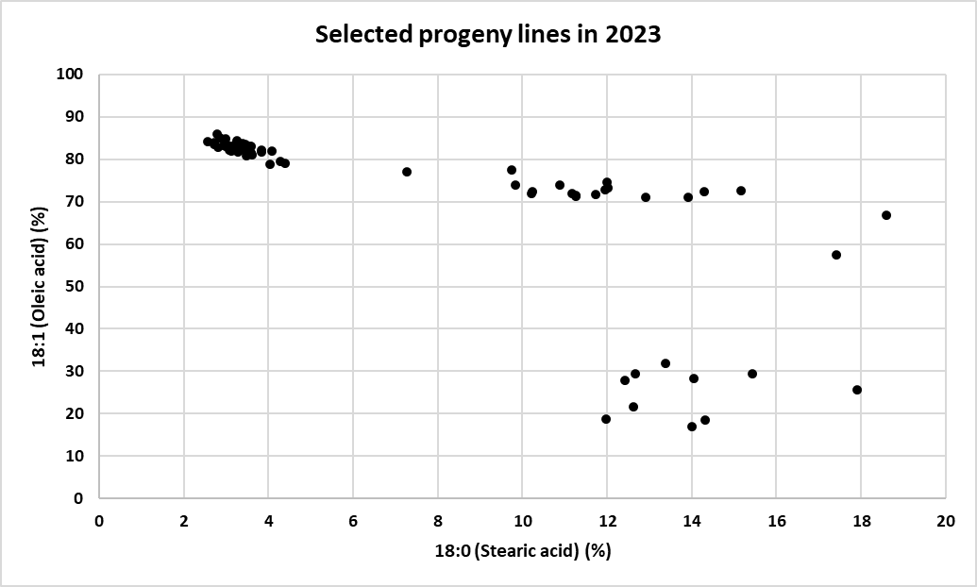
2023 progeny plots for the high stearic project.
Out of 10 high stearic populations (a total of 1,000 lines), 72 high stearic/oleic lines were selected based on maturity, plant height, growth habit, pod load, uniformity, and fatty acid profile. The distribution for oleic and stearic acid content of the selected lines are presented in Figure 1. We also selected high oleic lines (> 80% oleic acid) for future genetic sources. The most promising lines showed over 12% stearic and close to 70% oleic acid. Selected lines will be planted at Portageville, MO in four row plots (12 ft length and 2.5 ft width) in the preliminary yield trials at three to five locations in 2024. Since the fatty acid profiles of selected lines in Figure 1 were determined using F_{4:5} lines, the fatty acid profiles of each line will be confirmed and updated in the next report.
Figure 1. Oleic and stearic acid profiles of selected progeny lines.

2023 preliminary yield test for the high stearic project.
A total of 31 high stearic lines were harvested in preliminary yield trial and evaluated for yield performance (Figure 2). Most high stearic lines yielded more than 80% of commercial check yields (Xtend and Non-Xtend combined) in MOCO trials where dicamba damage was from little to none, while their performance was relatively depressed in Portageville locations due to severe dicamba damage during the crop season. Nevertheless, some lines still performed from 80 to almost 100% of commercial checks in both trials. Out of 31 lines, two lines (S22-23421 and S22-23581; red dots in Figure 2) were selected evaluate in 2024 advanced yield tests (AYT). Agronomic traits and yield performance will be evaluated in four row plots (12 ft length and 2.5 ft width) in advanced yield trial at multiple locations in 2024 (Table 1).
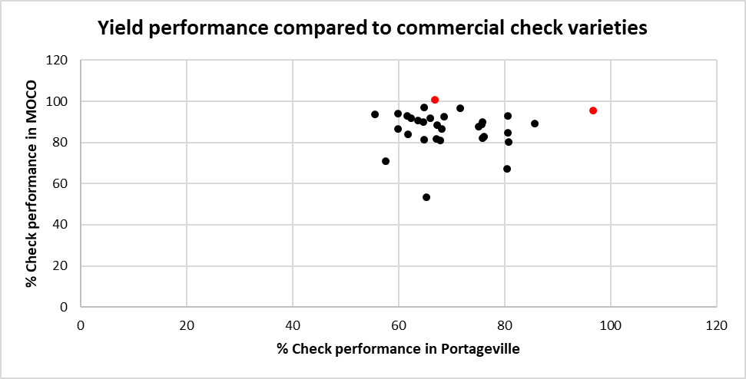
Figure 2. Yield performance of high stearic lines in preliminary yield trial compared to commercial checks (Xtend and Non-Xtend combined).

Table 1. Two high stearic lines selected from the preliminary yield trials in 2023.
Name | Pedigree | % Check (Portageville) | % Check (MOCO) | Stearic
S22-23421 | S19-19712 x S16-7922 | 96.7 | 95.6 | 8.7
S22-23581 | S19-19181 x S17CR-189R | 66.9 | 100.6 | 15.9

Breeding populations under generation advancement process.
Twelve to increase stearic acid crosses were made in 2022 summer. The hybridized F₁ seeds were harvested and shipped to an off-season nursery in Costa Rica for generation advancement. Roughly 100 F_{4:5} lines per population will be planted in the 2024 progeny plots in Portageville, MO.

New crosses in the 2023 summer
A total of six new crosses were successfully made in Summer 2023 (Table 2). The F₁ seeds were harvested at maturity and shipped to off-season nursery to advance generations. Roughly 100 F_{4:5} lines per population will be planted in progeny plots in Portageville, MO in 2025.

Table 2. New crosses made in 2023 crop season.
# | Female parent | Male parent
1 | S22-23407 (HS, 20.8%) | S19-10701
2 | S22-23407 (HS, 20.8%) | S19-14797
3 | S19-10701 | S22-23568R (HS, 22.4%)
4 | S19-14797 | S22-23568R (HS, 22.4%)
5 | S22-23373 (HS, 21.1%) | S16-7922
6 | S22-23373 (HS, 21.1%) | S16-11644
Note) HS, high stearic acid line.

Summary and Highlights:
- Out of 1,000 lines, 72 high stearic/high oleic progeny lines were selected and will be planted in preliminary yield trial in 2024.
- Out of 31 high stearic lines harvested in 2023, two high stearic lines were selected based on the yield performance and overall agronomic traits and will be planted in advanced yield trial in 2024.
- Twelve new high stearic populations are under generation advancement in off-season nursery.
- Six crosses were newly made for stearic project in Summer 2023 and harvested at maturity and shipped to off-season nursery to advance generations until F_{4:5}. Six populations will be planted in progeny plots in 2025.

