Adoption of Irrigation Management Practices in the Mid-South

A proposal to the Mid-South Soybean Board
Henry, C.G., Krutz, L.J. and R. Levy

PROJECT SUMMARY

Mississippi State University, University of Arkansas water management programs have identified a number of technologies and management practices that have the potential to reduce the overdraft on the Mississippi Valley Alluvial and Sparta Aquifers. Adoption of irrigation water management practices will ensure that soybean producers can achieve sustainable groundwater yields while maintaining overall profitability. Recent success with on-farm demonstrations in the region has shown a reduction in water use while maintaining yields, thus improving overall field profitability. A tremendous opportunity exists in the southern region to create awareness about modern irrigation practices. The first step to this is defining the starting point. This project will finish work started in 2014 to document the adoption of irrigation and management practices so that effective Extension programming and education resources can be directed to assist soybean irrigators towards sustainable water management. This project will condense, analyze, publish and disseminate the information gained from the mid-south irrigation survey funded by the project jointly funded by the Mid-south soybean promotion board and the United Soybean Board, “Irrigation Water Management for Southern Soybean Growers.” Already the data documents the adoption of practices and key information about irrigation unknown about the region.

BACKGROUND

The mid-south Board in cooperation with the United Soybean Board funded an irrigation survey as a component of “Irrigation Water Management for Southern Region Soybean Growers” in 2014. The survey was completed in 2016 representing the 2015 crop year. Funding, was eliminated after the first year and did not allow for the analysis of the survey data. This project aims to analyze and publish the results in journals, factsheets, presentation materials. The dataset is believed to be the most extensive irrigation survey conducted to date and will be a benchmark for Extension programming, education, and outreach in the mid-south region. The survey serves as a benchmark for soybean growers to demonstrate success and recent progress achieved toward sustainable water management.

SURVEY RESULTS
A total of 8,572 contacts were made to complete the mid-south irrigation survey. The response rate was between 26-32%, and the data represents 1.02 Million of the 13.3 Million irrigated acres in the Arkansas, Mississippi, Louisiana, and Missouri region. The margin of error was 4.6%. Figure 1. Shows an example of results from responses about when irrigators began to adopt Computerized Hole Selection (aka. PHAUCET, Pipe Planner). The PI’s have been active with Extension Programming for CHS and support from commodity boards began about around 2012. The impact of programming and other efforts by partners such as Delta Plastics, Delta F.A.R.M. and others, are resulting in the adoption of CHS in the region. Considerable data mining is possible with the data that may help explain and characterize the regions irrigation practices. Information about pumps, surface water, ground water, crops, costs, demographics and detailed information not collected by NASS such as information about rice production practices, cover crops, tillage, surge and poly pipe use was collected. While there is some overlap with NASS surveys, this survey was more detailed and details mid-south production practices.

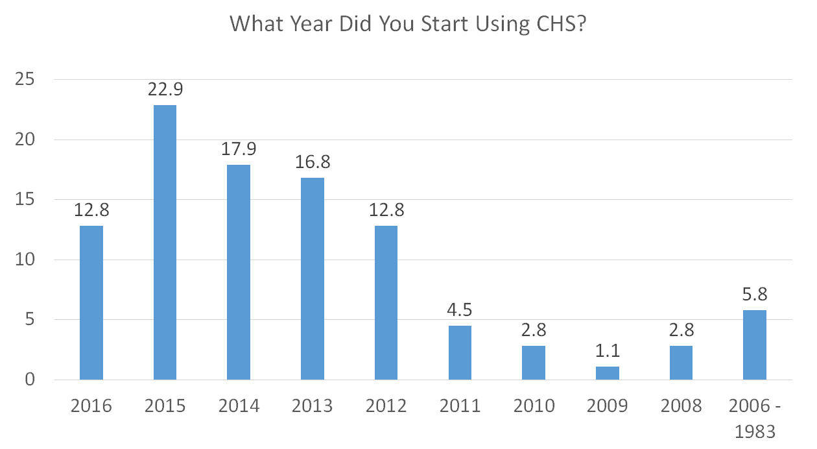
Figure 1. Survey results from the question of when did adopters of CHS start using it on their farm.

OTHER COOPERATORS/FUNDING SOURCES
The principle investigators have been unsuccessful in obtaining any additional resources from USB to finish the original project.

METHOD AND ACTIVITIES
The project will hire a postdoctoral associate to analyze and compile the results in to presentable formats for both the region and each state. Mid-south region and state specific publications will be developed both in the published literature (region) and Factsheets for state use. It is expected to take at least one year to complete the work. The associate will provide products specific to each state in the region.
BUDGET

Salary $60,000
Fringe $16,200
Travel $5,000
Supplies (publication) $5,000
Total $86,200

Principle Investigator: Chris G. Henry, Ph.D., P.E.
Assistant Professor and Water Management Engineer
University of Arkansas
Rice Research and Extension Center
2900 Hwy 130 E, Stuttgart, 72160
870-673-2661
cghenry@uark.edu

Co-Investigator: Dr. L. Jason Krutz
Organization: Mississippi State University, Delta Research and Extension Center
Address: P.O. Box 197
Stoneville, MS, 38776
Phone: 662-686-3215
jkrutz@ext.msstate.edu

Co-Investigator: Ronald Levy, Ph.D.
Assistant Professor
Louisiana State University
Alexandria, LA
RLevy@agcenter.lsu.edu

