Please use this form to clearly and concisely report on project progress. The information included should reflect quantifiable results that can be used to evaluate and measure project success. Comments should be limited to the designated boxes. Technical reports, no longer than 4 pages, may be attached to this summary report.

Project Number:
Project Title: | Whole Soy Food Acceptability and Market Viability Study
Organization: | B & B Legacy Farms, LLC
Project Lead Name: | Karen Ballard
Report Date: | June 15, 2022
National Soybean Checkoff Research Database https://www.soybeanresearchdata.com/ (public website funded by USB). Please include a non-technical project status along with your project status. The non-technical project status will be published to the website. If a non-technical project status is not provided, the contents of this entire report will be published.

Project Status:
Ongoing. 1st quarter report.
Project Period: April 1, 2022-March 31, 2023.
This project will produce a feasibility study for the potential development of a collaborative, whole, vegetable soy food system.

Objectives of the project include:
- Evaluation of the agronomic viability and profitability of food-grade soy cultivars that can be conventionally harvested through a meta-analysis of data from Arkansas, Mississippi, Louisiana, Missouri, and Texas.
- Evaluation of direct product acceptability of whole soy products through key informant interviews, surveys, and focus groups.
- Evaluation of regional market opportunities through key informant interviews with school nutrition program directors and USDA food and nutrition officials.
- Dissemination of study results to increase knowledge of producers and consumers regarding the value and sustainability benefits of regional soy food production and consumption.

Non-technical project status:
Key performance results during the first quarter include:
- Project operations planning, including identification and contacts with key collaborators, development of instruments and site-specific study protocols, and sourcing non-perishable supplies and services for product development and sensory testing.
- Consultation and Zoom meetings conducted with multi-state Extension soybean, nutrition and evaluation specialists to initiate collaborative, multi-state planning.
- Development of study database.

Key Metrics:
USDA child nutrition program market analysis
- Consultation and face-to-face planning meetings conducted this quarter with school nutrition directors in Arkansas to develop a prototype for fall student/teacher sensory testing of whole vegetable soybean food products.
Consumer acceptability testing
- Development of survey instruments, including semi-structured key informant interview questions and focus group protocols.
- Development and production of project communications and educational outreach materials regarding the value and benefits of whole vegetable soy foods.
- Face-to-Face consumer reaction tasting for whole vegetable soybean product formulations to be used in sensory study in fall 2022.
Producer market opportunities report
- Literature review of current market research to inform educational outreach material development.
- Market research sources reviewed this quarter included Mintel, the Good Food Institute, the Soy Nutrition Institute Global, and the Hartman Group (among others). Market size, drivers, segmentation and market forecasts were compiled to inform the market opportunities report for this study.
Market Forecast: 1st Quarter Update
Mintel’s 2021 Global Food and Drink Trends and the 2022 Global Consumer Trends market reports provide key insights into the continued increase in the plant-based food market.

Mintel forecasts that wellbeing (seeking physical and mental wellness) is one of the seven core drivers of future consumer behavior. With an ongoing world-wide health crisis, consumers want to gain control over their health.

Mintel reports that in food and drink, “consumer expectations have grown beyond stories and detailed claims; in 2022, consumers will want to see trustworthiness and measurable progress on health, environmental and ethical commitments. Consumers’ needs for protection will increase the demand for products that help both short- and long- term health goals.”

The Good Food Institute reported that “actual 2021 U.S. plant-based food retail sales grew 6% to hit $7.4B – outpacing total retail food sales despite supply chain interruptions and the pandemic creating volatility in the food industry.”

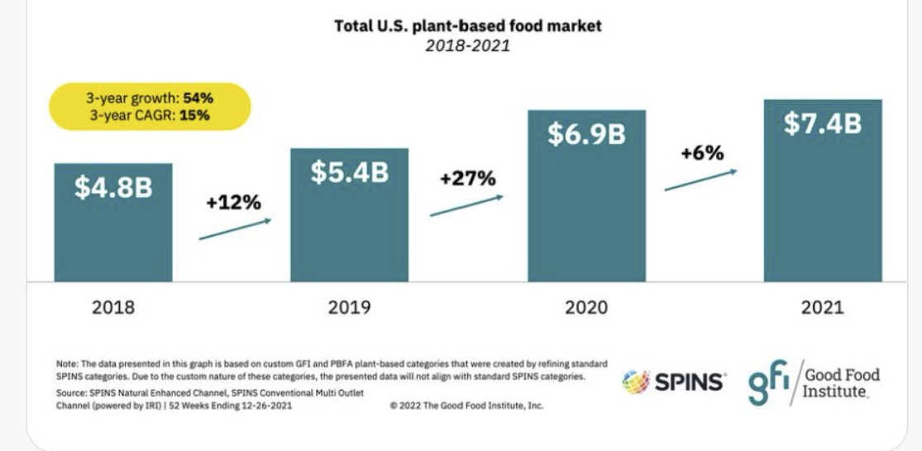

The Health and Wellness: Reimagining Well-Being Amid COVID-19 research report on the American landscape, produced by the Hartman Group, identified plant-based eating as one of four consumer priorities in 2021. Managing and maintaining weight has become a key pillar around American eating approaches. The Hartman Group study reported that, “Consumers are drawn to a “plant-based” approach as it aligns with key ideas in modern health and wellness.” A finding of special note is that, “Interest in animal-free alternatives hasn’t changed the cultural ambivalence toward soy (in America).”

Ernst & Young’s 2020 forecasted consumer shift is proving to be a market disrupter, with food and drink opportunities expanding for products aligned with desired product characteristics. Whole vegetable soy food products fit the bill on several desirability scales.

The evidence is clear and pervasive. Expanding a whole soy food market will require meeting the standards of a shifting marketplace. Proactive messaging must respond to specific consumer concerns undergirding the noted cultural ambivalence toward soy. Mintel predicts that “Honest and thorough communication with customers will be critical in this evolving culture.” The origins of the reported cultural ambivalence must be understood before we rush to message.

Profitability analysis for vegetable soybean groups
- Initial interviews and data review conducted during this quarter.

