Project Title |  | Development of functional ultra-high stearic acid soybean germplasms
PI’s Name |  | Pengyin Chen |  |  | E-mail | chenpe@missouri.edu
PI’s Title |  | Professor and Soybean Breeder |  |  | Institution: | University of Missouri – FDRC
Mailing Address |  | 147 State Highway T; Fisher Delta Research Center
City/State/Zip |  | Portageville, Missouri, 63873
Phone number |  | 573-379-6958
Additional PIs  For this project |  | Caio Canella Vieira (Research Specialist/PhD Student); canellavieirac@mail.missouri.edu  University of Missouri – FDRC
Research Locations |  | Portageville, MO
Timeline:  Current Year - FY22 |  |  | Multi-Year Project Information (if applicable)
 |  |  | Year 1 | Year 2 |  |  | Year 3
Start Date | Oct 1, 2021 |  | Oct 1, 2021 | Oct 1, 2022 |  |  | Oct 1, 2023
End Date | Sep 30, 2022 |  | Sep 30, 2022 | Sep 30, 2023 |  |  | Sep 30, 2024
Funds Requested | $25,000 |  | $25,000 | $25,000 |  |  | $25,000
Program Area (e.g., breeding, mngt.): Breeding for seed composition value
Objectives |  | Develop soybean germplasms adapted to the mid-southern U.S with functional ultra-high stearic acid content and little or no detrimental effects on agronomic traits
Justification |  | The industry’s standards for maximum oxidative stability consist of elevated concentrations of stearic and oleic acids and a reduction of the concentration of linolenic acid.
Exp Setup |  | Two mapping populations to identify the regions of the soybean genome conferring high stearic acid content; Yield trials and germination assays to screen for deleterious effects.
Summary |  | Overcoming the negative agronomic traits resulted from large mutation-induced deletions may allow the development of functional soybean varieties with ultra-high stearic acid content. This can give U.S soybean farmers a competitive edge in both the food and biodiesel industry by offering soybean lines with the highest achievable oxidative stability
Key Metrics |  | Capacity in molecularly characterizing genotypes; Field performance and germination assays; Number of functional genotypes advanced in the pipeline.
Expected Deliverables |  | Functional germplasms that can serve as parental lines in public and private breeding programs; enhanced knowledge in mutations and the dynamics of fatty acid profiles in soybean.
Benefit to midsouth farmers |  | Give midsouth soybean farmers a competitive edge in both the food and biodiesel industry by offering soybean lines with the highest achievable oxidative stability. This novel fatty acid profile could result in attractive premiums attached to a high-yielding soybean line with added value for the specialty niche market.
Progress Made |  | Genotyping of 260 mapping lines with Soy6K SNP chip; 3-years of fatty acid profile data; 1-year of yield performance and germination of promising high stearic lines.
Signature of Principle Investigator |  |  |  |  |  | Date:
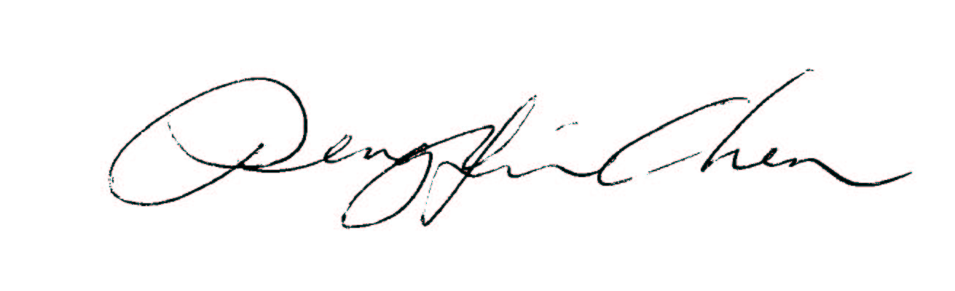 |  |  |  |  |  | 8/2/2021

