Please use this form to clearly and concisely report on project progress. The information included should reflect quantifiable results that can be used to evaluate and measure project success. Comments should be limited to the designated boxes. Technical reports, no longer than 4 pages, may be attached to this summary report.

Project Number:
Project Title: | Screening and Selecting Non-Extend Soybeans for Dicamba Tolerance
Organization: | University of Missouri - Fisher Delta Research Center
Principal Investigator Name: | Dr. Pengyin Chen
Other investigators: | Caio Canella Vieira

Report Period:

Project Status: On-going

(What key activities were undertaken and what were the key accomplishments during this quarter? Please use this field to clearly and concisely report on project progress).
Summary and Highlights:

- Over 7,400 plots screened visually and drone equipped with multispectral camera
- Several hundreds of genotypes being sequenced for further molecular studies
- Identification of high levels of tolerance in exotic germplasms (PIs)
- Developed two populations using tolerant PIs
- Forward crossing combinations to develop high-yielding tolerant lines
- Presentation at the MU-Fisher Delta Research Center Field Day.

Field tolerance screening:

We screened over 7,400 plots for their response to off-target Dicamba damage in two stages: late vegetative/early reproductive and mid-late reproductive stages. All plots were visually screened on a 1-5 scale, where 1 represents no dicamba damage and 5 represents severe damage. At the same time, plots were screened using a drone with a multispectral camera. The objective is to enhance our ability to precisely characterize each line’s response to off-target Dicamba damage. We are growing yield trials using elite genotypes developed by our program, as well as mapping populations that will be later used for genetic studies.

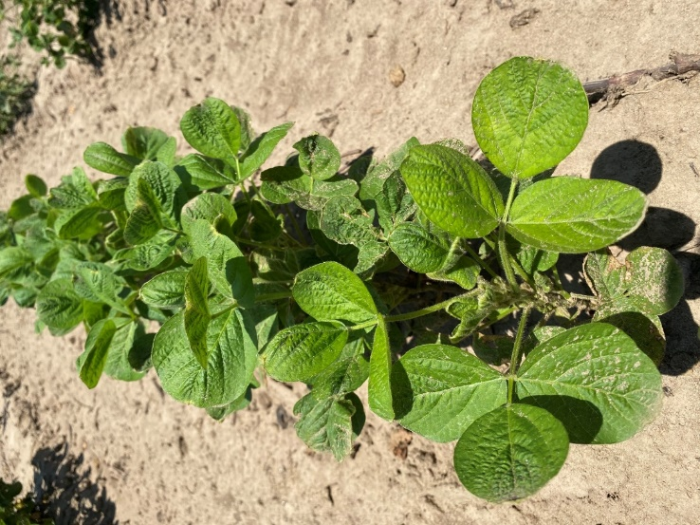
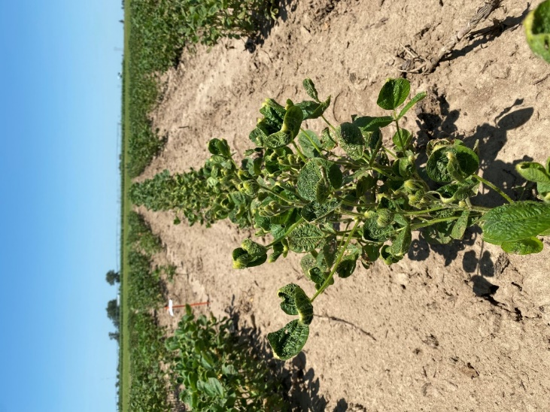
We also screened 370 exotic soybean lines (PI – plant introductions) and found some extreme differential response to off-target Dicamba among them (Figure 1). These lines have been genotyped and sequenced with the Soy50K SNP chip, and the data will be used to perform molecular studies on the ability to recover to dicamba exposure.
Susceptible
Tolerant
Figure 1. Differential response to off-target Dicamba damage among exotic soybean germplasms.
Genotyping and molecular studies:

We genotyped 3 mapping populations that showed phenotypic segregation for off-target Dicamba damage response among over 300 lines (Figure 2). These are in the process of being sequenced using a Soy6K SNP chip, and the data will be used to perform genome-wide association analysis to identify possible regions of the genome regulating tolerance. Once identified, these can be used to efficiently deploy tolerant lines. We are also sequencing the elite genotypes (over 440 advanced lines from 2019 and 2020 AYT) with the Soy6K SNP chip to better understand the molecular interaction between dicamba exposure and yield performance.
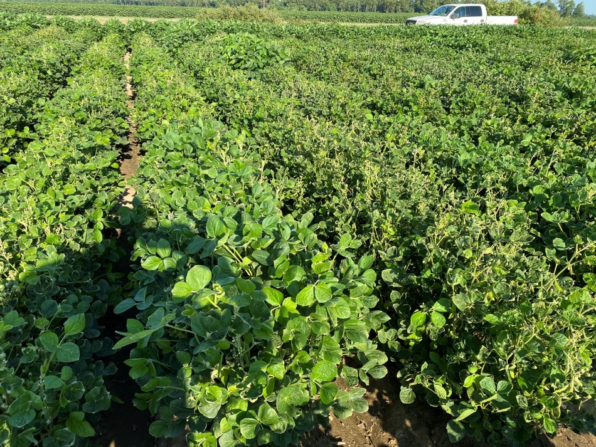
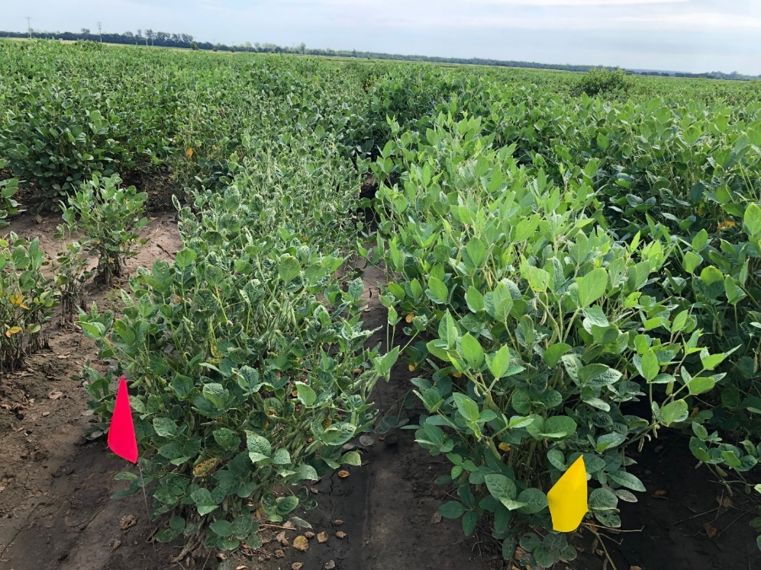
Susceptible
Tolerant
Tolerant
Susceptible
Figure 2. Segregation in progeny rows among sister lines in 2019 (left) and 2020 (right).

Population development and new crosses:

We developed two additional mapping populations using the two most tolerant PIs and the two most susceptible elite lines from our program. These will be advanced in off-season nursery and will be screened for dicamba tolerance once reaching F5 stage. We also attempted 10 crossing combinations using the most tolerant lines from our 2019 screening. These will also be advanced in off-season nursery and will be planted as progeny rows in 2022.

