Please use this form to clearly and concisely report on project progress. The information included should reflect quantifiable results that can be used to evaluate and measure project success. Comments should be limited to the designated boxes. Technical reports, no longer than 4 pages, may be attached to this summary report.

Project Number:
Project Title: | Identification and confirmation of natural tolerance to off-target Dicamba damage in non-Xtend soybeans
Organization: | University of Missouri
Principal Investigator Name: | Pengyin Chen
Other investigators: | Caio Canella
Report Period: | December 16, 2021 to March 15, 2022
Research updates:

Over this last quarter, the team has accomplished two major milestones of this project and the results have been summarized and submitted for publication. The first study aimed to estimate yield losses caused by prolonged off-target dicamba exposure and to identify genotypes with varying responses to off-target damage. A total of 553 soybean genotypes derived from 239 unique bi-parental populations were evaluated in nine environments over three years. A yield penalty of 8.8% was observed for every increment in damage score on a 1-4 scale with losses as high as 40% (Table 1). Although the interaction between damage and maturity group (MG) significantly affected yield, genotypes showing the most tolerance had similar yields independent of their MG (Figure 1). This indicated that natural tolerance to off-target dicamba may be conferred by physiological mechanisms other than the length of the recovery window. The manuscript has been submitted to Crop Science and is currently under revision.
Table 1. Summary of a linear mixed-effects model explaining the effects of off-target dicamba damage on yield of diverse soybean genotypes in nine environments over three years.
Predictors | Yield (% Xtend Control)
 | Estimates |  | Confidence Interval (95%)¹ | p-value
Intercept² | 101.9 |  | 94.2 – 109.5 | <0.001***
Dicamba Score³ | -8.8 |  | -10.6 – -7.0 | <0.001***
MG [4M]⁴ | -1.3 |  | -7.6 – 4.9 | 0.682
MG [4L]⁴ | -6.9 |  | -12.9 – -0.8 | 0.027**
MG [5E]⁴ | -6.6 |  | -11.5 – 0.6 | 0.037**
MG [5M]⁴ | -6.1 |  | -12.9 – 1.5 | 0.114
Dicamba Score * MG [4M]⁵ | 1.9 |  | -0.4 – 4.1 | 0.113
Dicamba Score * MG [4L]⁵ | 4.6 |  | 2.4 – 6.9 | <0.001***
Dicamba Score * MG [5E]⁵ | 6.1 |  | 3.8 – 8.4 | <0.001***
Dicamba Score * MG [5M]⁵ | 6.5 |  | 3.6 – 9.4 | <0.001***
Variance of Random Effects
σ² |  | 86.4
τ₀₀ _{Genotype:Environment} |  | 223.3
τ₀₀ _{Year} |  | 26.1
τ₁₁ Genotype:Environment - Dicamba Score |  | 31.1
τ₁₁ Row (y):Column (x) - Dicamba Score |  | 0.2
Observations |  | 6110
Marginal R² / Conditional R² ⁶ |  | - / 0.73
**Significant at the .01 probability level. ***Significant at the .001 probability level.
¹Confidence interval at 95% probability for each fixed parameter of the model. ²Predicted yield when all covariates are equal to zero. In this case, it would refer to the average yield of soybean genotypes of maturity group 4 early with no symptoms of dicamba damage. ³Off-target dicamba damage scores on a 1 to 4 scale where 1 represents similar plant growth and development as the DT control cultivar with none to minimal visual dicamba damage and 4 indicates extreme dicamba damage symptoms with an extensive reduction in vegetative growth and canopy coverage. ⁴Maturity group of soybean genotypes including groups 4-E, 4-M, 4-L, 5-E, and 5-E. ⁵The effect of the interaction between off-target dicamba damage score and maturity groups. ⁶The marginal R² considers only the variance of the fixed effects, while the conditional R² takes both the fixed and random effects into account.
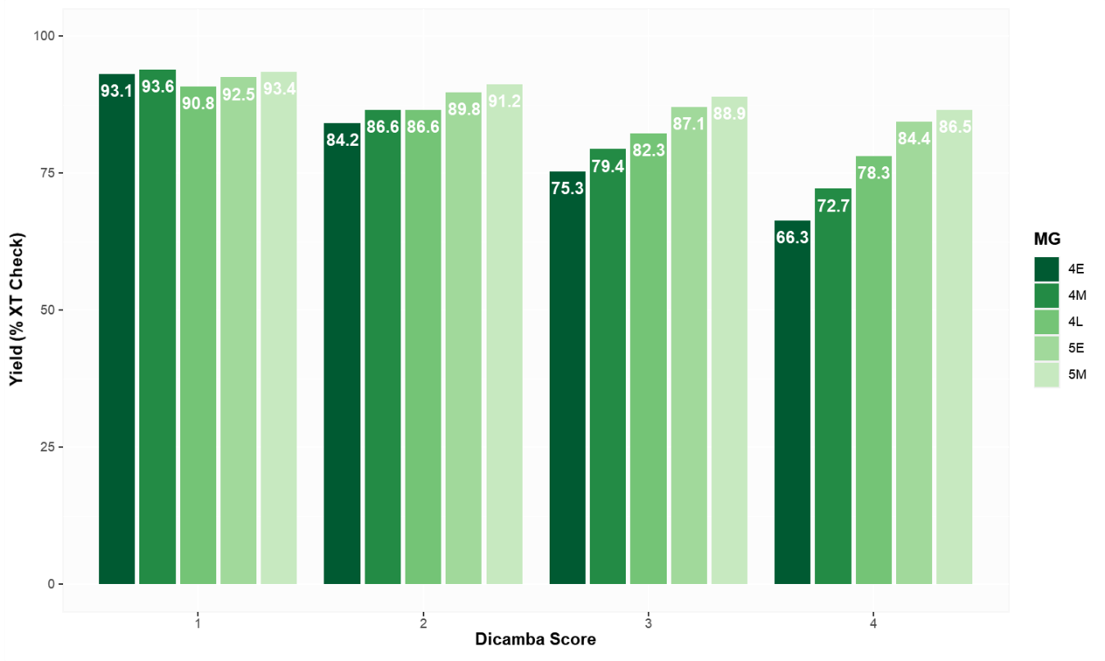
Figure 1. Predicted relative yield of soybean genotypes across different MG and dicamba damage scores. Genotypes with high tolerance to off-target dicamba damage (score 1) had equivalent predicted yield independent of the MG, whereas in sensitive class (score 3 and 4) late-maturing genotypes showed higher yields.

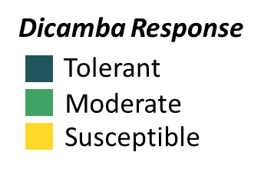
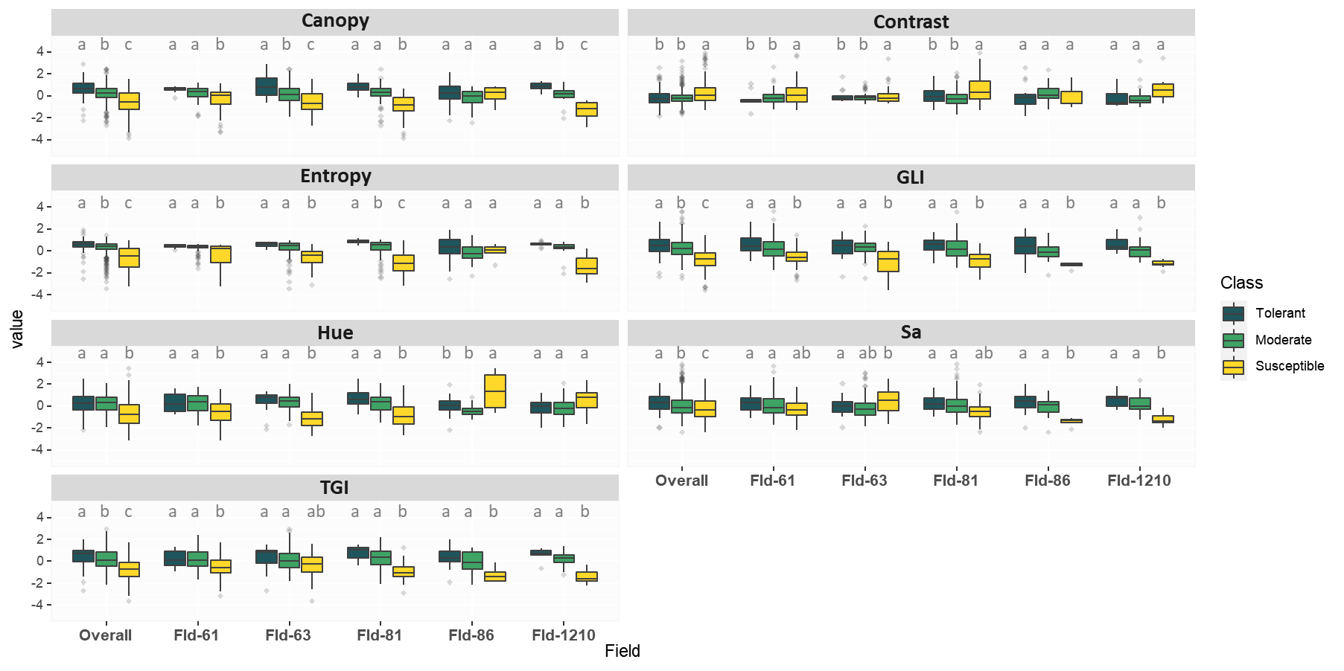
The second milestone was the development of a methodology to differentiate soybean response to dicamba using unmanned aerial vehicle-based imagery and machine learning models. Seven image features were extracted for each plot, including Canopy Coverage, Contrast, Entropy, Green Leaf Index, Hue, Saturation, and Triangular Greenness Index (Figure 2). The models were able to precisely distinguish tolerant and susceptible lines with an overall accuracy of 0.89 and 0.85, respectively (Table 2). The imagery-based classification model can be implemented in a breeding program to effectively differentiate phenotypic dicamba response and identify soybean lines with tolerance to off-target dicamba damage. This manuscript has been submitted to Remote Sensing and has been accepted with minor revisions on March 9th 2022.

Figure 2. Standardized features distribution across all fields and dicamba response classes. Overall, significant differences among classes were identified for all features, of which higher values for Canopy Coverage, Entropy, GLI, Hue, Sa, and TGI indicate tolerance to dicamba, whereas higher values of Contrast indicate susceptibility.

Table 2. Confusion matrix and model’s performance metrics for dicamba response classification using RGB-based image features and RF classifier.
Dicamba Class | Overall¹ |  |  | Fld-61 |  |  | Fld-63 |  |  | Fld-81
 | Tol | Mod | Sus | Tol | Mod | Sus | Tol | Mod | Sus | Tol | Mod | Sus
Tolerant | 18 | 11 | 0 | 0 | 1 | 0 | 4 | 0 | 0 | 0 | 1 | 0
Moderate | 51 | 420 | 69 | 9 | 114 | 34 | 8 | 137 | 21 | 14 | 129 | 17
Susceptible | 3 | 40 | 121 | 0 | 18 | 37 | 2 | 11 | 30 | 0 | 16 | 36
Class Accuracy | 0.89 | 0.77 | 0.85 | 0.95 | 0.71 | 0.76 | 0.95 | 0.81 | 0.84 | 0.93 | 0.78 | 0.85
Overall Accuracy² | 0.75 |  |  | 0.71 |  |  | 0.80 |  |  | 0.77
¹Overall is the combined analysis including Fld-61, Fld-63, Fld-81, Fld-86, and Fld-1210. ²Overall accuracy is the average of 5-fold cross-validation results.
Summary and Highlights:

- Two major milestones of this project have been completed and submitted for peer-review publication in Crop Science and Remote Sensing.
- The team is currently planning dose-response experiments for the upcoming season.
- Molecular analyzes are ongoing and preliminary results should be available for the next quarterly report.
- Dicamba-tolerant breeding lines have been entered in regional trials and may be proposed for release by the end of this season pending satisfactory performance.

