Please use this form to clearly and concisely report on project progress. The information included should reflect quantifiable results that can be used to evaluate and measure project success. Comments should be limited to the designated boxes. Technical reports, no longer than 4 pages, may be attached to this summary report.

Project Number:
Project Title: | Identification and confirmation of natural tolerance to off-target Dicamba damage in non-Xtend soybeans
Organization: | University of Missouri
Principal Investigator Name: | Pengyin Chen
Other investigators: | Caio Canella
Report Period: | March 15 to June 15, 2021
2021 Research and Field Trials update: We completed field planting for the 2021 season despite the cool and wet conditions, and all previously reported planting plans were successfully executed. All field experiments have a fairly good stand. Some of the field trials are showing early symptoms of off-target dicamba exposure and differences among genotypes can already be observed (Figure 1). We will start taking visual notes and collect drone image data as appropriate.
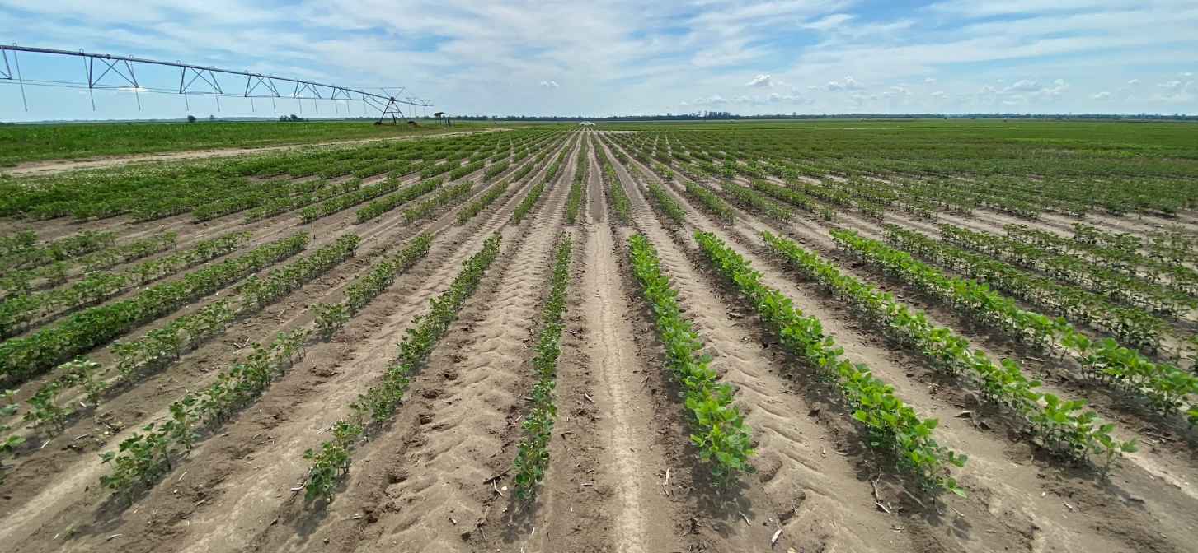
Figure 1. Early symptoms of off-target dicamba injury and differential response among genotypes in the 2021 season.

Genotyping updates: We have successfully concluded DNA extraction of plant samples from three bi-parental mapping populations and over 700 advanced breeding lines used to assess the impact of off-target dicamba damage on yield performance. These are currently being genotyped with the Soy6K SNP chip at the USDA facility and data should be available in the next 3-4 weeks. These data (yield performance over the last two years and molecular markers) will be used to identify regions of the soybean genome conferring tolerance to dicamba.
Phenomics updates: We are currently processing and analyzing the UAV-based data collected in the 2020 season. Imaging features will be implemented in a machine learning model to classify genotypes for their response to off-target dicamba damage and ground-obtained data will be used to validate the model. We have also started the 2021 flights to detect the early response of genotypes to dicamba.
Greenhouse screening updates: Forty lines displaying contrasting tolerance to dicamba in field situations were selected for screening to known dosages of dicamba in a greenhouse. These included two Xtend and one RR commercial checks, and 38 breeding lines. The selected dosages were 1/5000th and 1/10000th of a normal field usage rate (22 fl.oz./ac. Roundup Xtendimax). Five seeds from each line were planted into 6” pots with two replications. Plants were sprayed in the V3 growth stage and evaluated for dicamba injury symptoms, including leaf deformation (cupping, callus, and parallel venation), shortened internodes, height reduction, and possible death of the apical growing point. Initial applications failed to produce crop response 10 days after treatment (DAT). Treatments were repeated with no crop response. Application rates were increased to 1/10th and 1/100th of the field use rate for three consecutive weeks. Lines showed vast differences in symptomology from no symptoms to extreme epinasty, node stacking, and stunted growth (Figure 2). We plan to evaluate these lines in a field environment in two locations beginning in mid-July. These evaluations will be planted after the label-mandated cutoff date for dicamba applications for soybeans to minimize the chances of drift/volatility contamination.
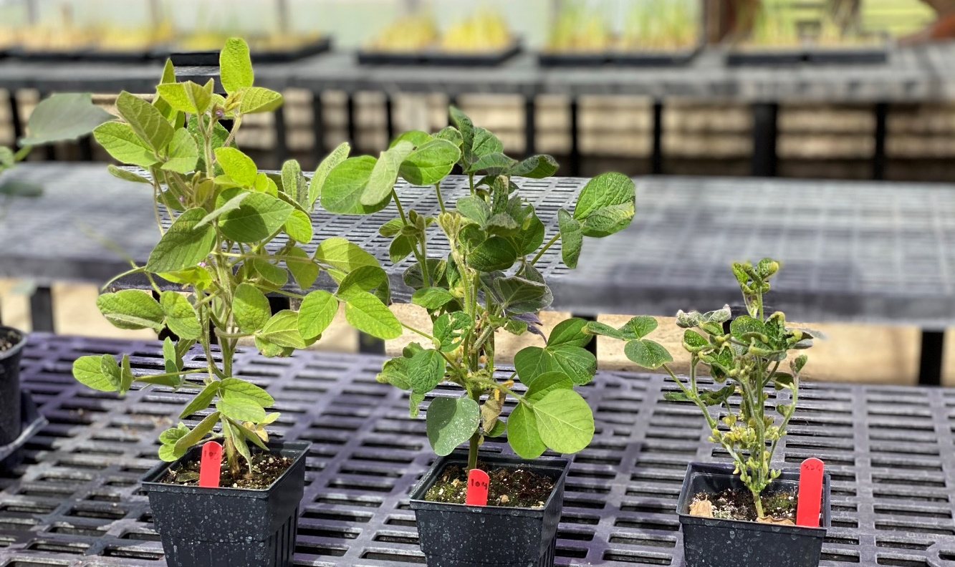
Figure 2. Response of differential genotypes to 1/10 of the dicamba dose. The genotype on the left is an Xtend check, the genotype in the middle is a field-tolerant conventional line, and on the right is a field-susceptible conventional line.

Summary and Highlights:

- Great progress in obtaining molecular data from mapping populations and differential lines used in all previously reported dicamba experiments.
- Differential responses to controlled dicamba doses were observed in the greenhouse and were consistent with field ratings.

