Please use this form to clearly and concisely report on project progress. The information included should reflect quantifiable results that can be used to evaluate and measure project success. Comments should be limited to the designated boxes. Technical reports, no longer than 4 pages, may be attached to this summary report.

Project Number:
Project Title: | Identification and confirmation of natural tolerance to off-target Dicamba damage in non-Xtend soybeans
Organization: | University of Missouri
Principal Investigator Name: | Pengyin Chen
Other investigators: | Caio Canella
Report Period: | June 16 to September 15, 2021
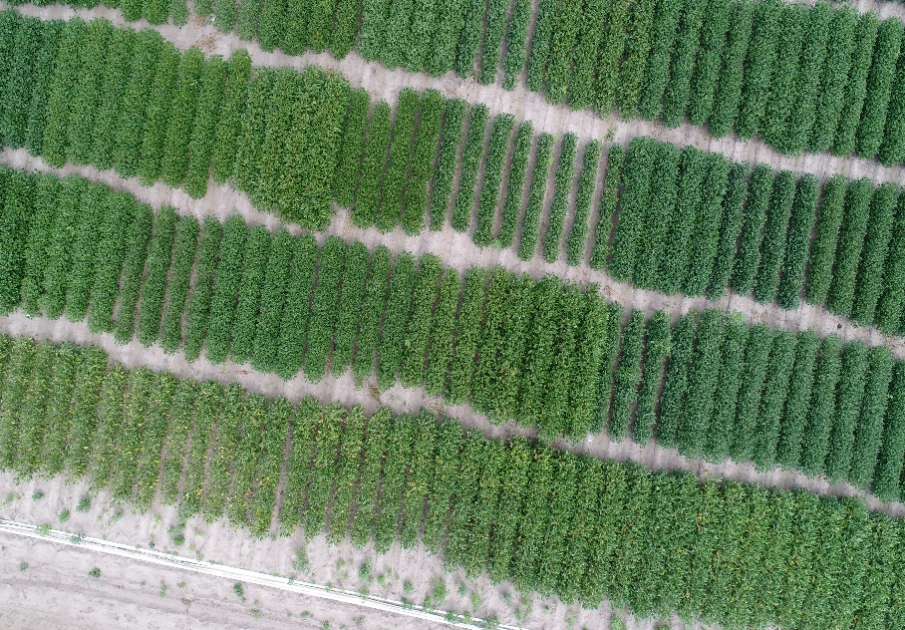
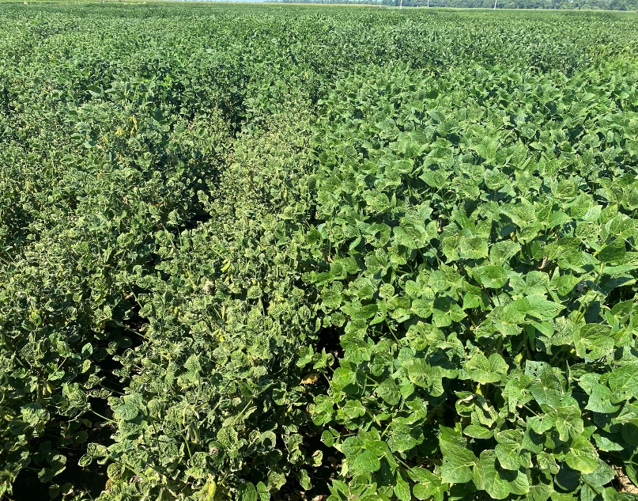
2021 Data Collection: We finalized all proposed data collection plans for the 2021 season, including visual assessment of off-target dicamba damage, UAV-based phenotyping, and the genotyping of all tested lines with the Soy6K SNP chip (please refer to the March report for reference). The DIC-4/5YT trials, which are the extreme genotypes selected from the 2019 advanced yield trials, showed consistent response to dicamba for the 3rd year, confirming the differential response of genotypes to off-target dicamba damage (Figure 1).
Figure 1. Differential response of genotypes from the DIC-4/5YT trial around growth stage R5. On the left, two extreme lines (susceptible on the left, tolerant on the right); on the right, a UAV shot showing canopy differences among many entries in the same trial.

The GS-SW trial, which are plant introductions representing the genetic diversity available in soybean, showed consistent extreme responses for the 2nd year (Figure 2). Preliminary mapping results show highly significant regions on the soybean genome, which will contribute to our efforts in identifying potential genes regulating the differential response and marker-assisted selection techniques to speed up the development of tolerant lines.
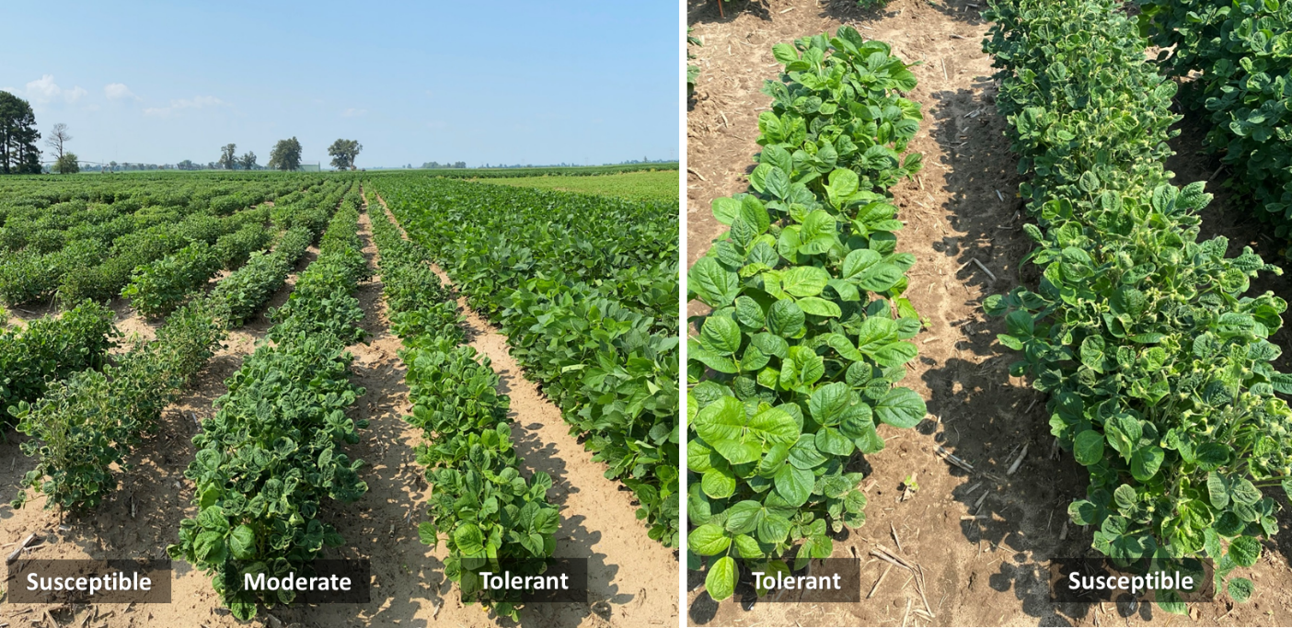
Figure 2. Differential response of exotic soybean lines to off-target dicamba exposure in Clarkton, MO.

The DPS-3/4/5 mapping populations also showed consistent results with 2019 and 2020 data (Figure 3). As we advance the genotyping of these lines, mapping analysis will be conducted to confirm the genomic regions identified from the GS-SW set, as well as potentially identify new QTLs/genes regulating tolerance.

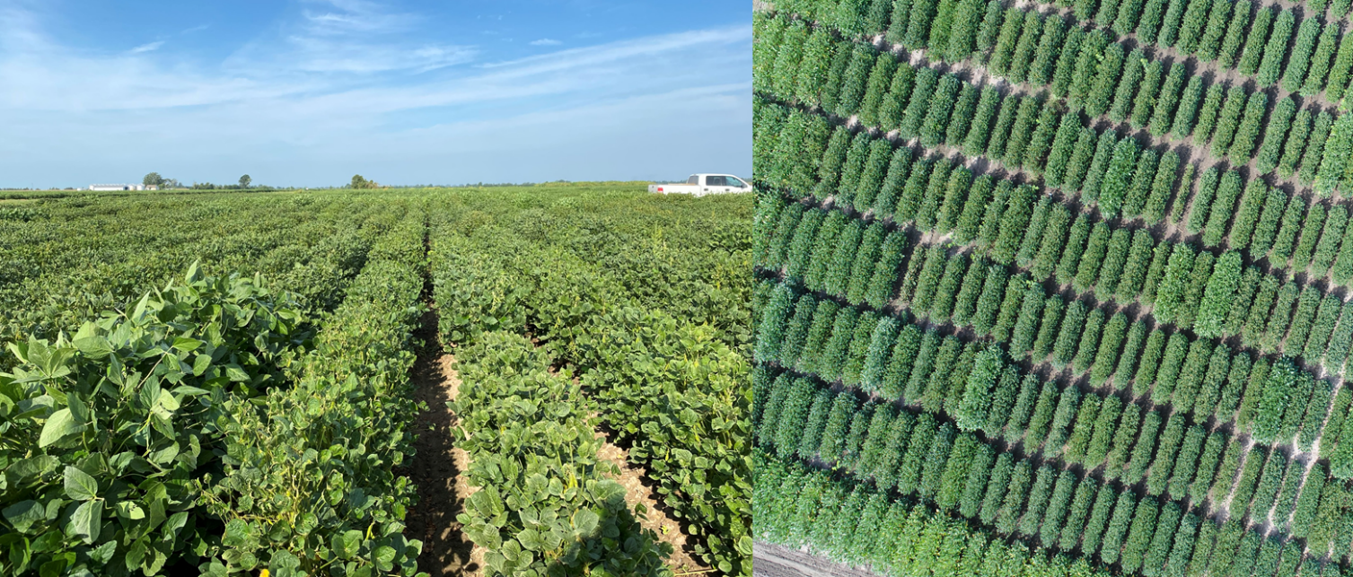
Figure 3. Differential response of genotypes from the DPS-3/4/5 mapping populations around growth stage R5.

We also phenotyped all the 2021 advanced breeding lines for their response to off-target dicamba and coolected canopy injury data needed. We are switching efforts to the harvest season, and once yield data is collected, tolerant lines with high-yielding potential will be entered in the USDA uniform trials, which upon satisfactory performance, can be proposed for release in 2023 or 2024. In addition, we have 15 advanced lines entered in the 2021 USDA preliminary and uniform tests with tolerant and moderate response to off-target dicamba damage based on two years of field screenings. These lines, upon satisfactory performance, may be proposed for release in 2022 or 2023.

Summary and Highlights:

- All data collection proposed for the season has been completed.
- As we transition to the harvest season for yield data collection, tolerant lines with high-yielding potential will be advanced to the USDA uniform trials.
- Consistency and reliability of the response to off-target dicamba across multiple environments have been confirmed in the 3rd year of this study.
- Preliminary mapping results show highly significant regions of the soybean genome regulating the tolerance to off-target dicamba damage.

