Please use this form to clearly and concisely report on project progress. The information included should reflect quantifiable results that can be used to evaluate and measure project success. Comments should be limited to the designated boxes. Technical reports, no longer than 4 pages, may be attached to this summary report.

Project Number:
Project Title: | Screening soybean germplasm and breeding soybeans for flood tolerance
Organization: | University of Missouri-Fisher Delta Research Center
Principal Investigator Name: | Dr. Pengyin Chen
Other investigators: | Drs. M. Liakat Ali, Leandro Mozzoni, Daryl Chastain, Tessie Wilkerson and Blair Buckley
Report Period: | December 16, 2020 to March 15, 2021

Project Status: On-going

(What key activities were undertaken and what were the key accomplishments during this quarter? Please use this field to clearly and concisely report on project progress).
Missouri:

Overall, the filed for all flood tests in 2020 was well managed throughout the season except for the extended rainfall after flood treatment was terminated. Therefore, the stress was more than we anticipated. However, we were able to collect good data on flood injury and yield.
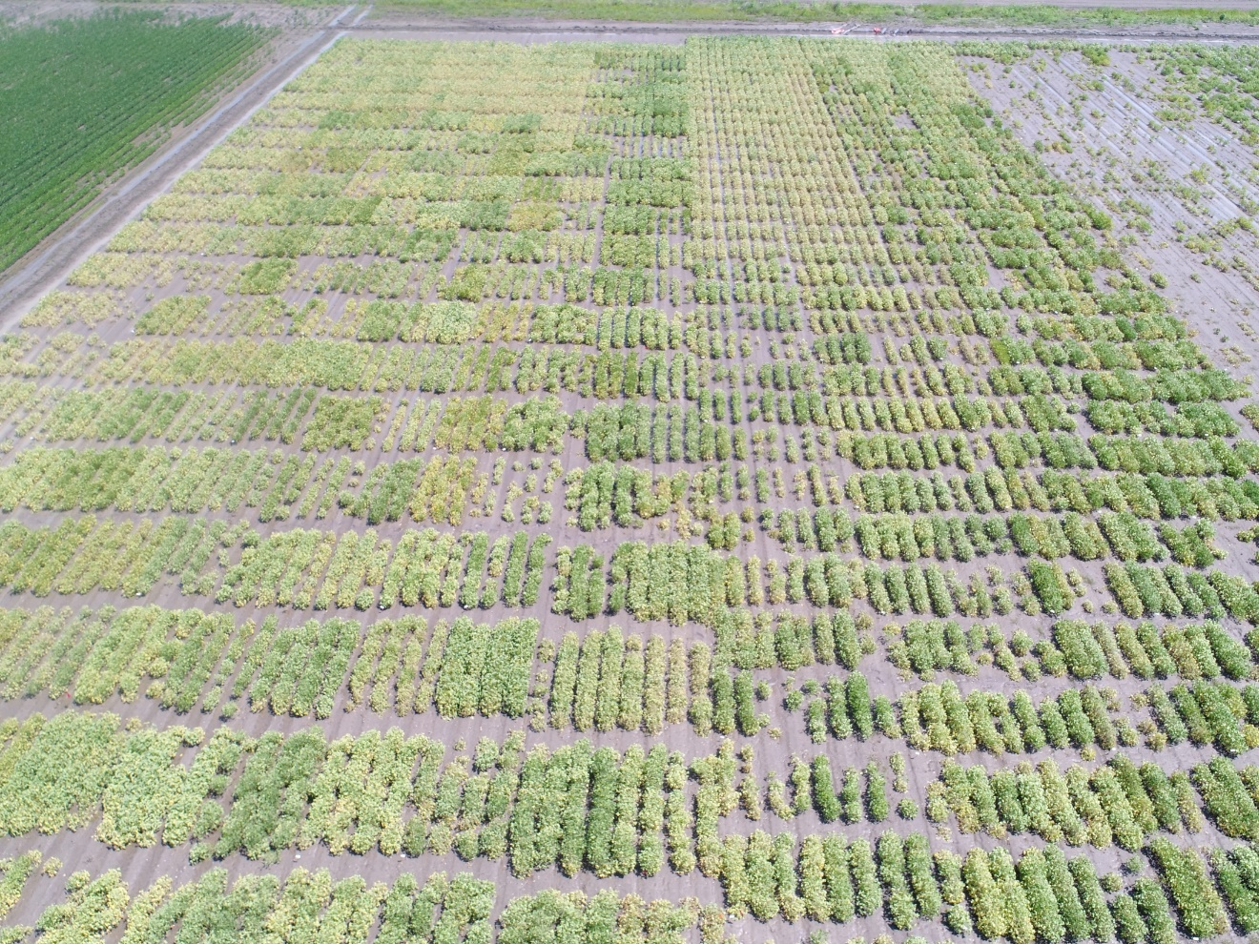

1. Evaluation of breeding lines for flooding tolerance and yield to develop commercial varieties.
i) Advanced yield trials: A total of 40 advanced breeding lines in two groups: MG-4 (20 lines) and MG-5 (20 lines) will be evaluated for yield and flooding tolerance in 2021. The test lines include selections from 2020 flood advanced yield trials, 2020 preliminary yield trials and elite breeding lines that are entered in the 2021 USDA Uniform Tests. The tests will be planted in 4-row plots with 3 replications under both flooding stress and non-stress conditions. One flood sensitive check and 3 commercial varieties will also be included in each test. Flood injury and yield data will be collected.

ii) Preliminary yield trial: A total 21 MG 5 breeding lines selected from 2020 progeny row testing will be evaluated for flooding tolerance and yield. The test entries will be planted in 4-row plots in 2 replications in flooded and non-flooded fields. Several commercial varieties and sensitive lines will also be included as checks in the trial.

2. Yield evaluation of selected tolerant and sensitive lines in flooded and non-flooded field: A set of 20 lines (about one half was previously known to be tolerant and the other half was known to be sensitive) will be evaluated for flood tolerance and yield under flooding stress while under normal irrigation condition only yield performance will be tested. The test entries will be planted in 12’ 4-row plots in 3 replications. The lines will be exposed to flooding stress during R1/R2 (mid-season). These lines will also be grown in other locations (AR, MS, and LA). The effect of flooding stress on yield and seed composition will be evaluated.

3. Screening recently developed elite lines for flood tolerance: A set of 105 breeding lines, recently developed at the University of Missouri-Delta Research Center and at the University of Arkansas and five commercial cultivars as checks, will be evaluated for flood tolerance in 2021. The test lines will include new promising breeding lines and the lines that exhibited good flood tolerance in 2020 flood tolerance screening tests. Lines will be grown in 7’ single row plots in three replications and will be subjected to flood water during RI stage for a period of about 7 days.

4. Missouri commercial variety testing for flood tolerance: A set of about 100 commercial varieties (the exact entry number is not yet known) developed by different seed companies will be evaluated for flooding tolerance. The test entries will be planted in 7-ft single row plots in 3 replications and will be subjected to flood water during RI stage for a period of about 7 days.

5. Selection of new breeding lines from progeny row testing: About 1100 single plant progeny lines from 13 populations (the list of the crosses given in Table 1) are expected to be grown in progeny row testing nursery. The F₄ seeds are expected to arrive Portageville, MO in May 2021 from winter nursery.

Table 1. List of the crosses made in 2019 are under generation advance in winter nursery.
Cross # | Parentage | Generation | Year of evaluation
S19-822 | S11-16653 x R04-342 (FT) | F₄ | 2021
S19-823 | S15-10879 x PI 597459 C (FT) | F₄ | 2021
S19-829 | S14-16331 (FT_) x S15-10434C | F₄ | 2021
S19-832 | R07-6669 (FT) x S15-3772RY | F₄ | 2021
S19-833 | S14-16235 (FT) x S16-8898C | F₄ | 2021
S19-836 | R10-4892 (FT) x S13-3851C | F₄ | 2021
S19-837 | RIL 48 (FT) x S11-20356GT | F₄ | 2021
S19-838 | S13-15999 (FT) = x S11-20337GT | F₄ | 2021
S19-839 | R11-6870 (FT) x S11-20195GT | F₄ | 2021
S19-851 | S13-3851C x PI 597459 (FT, G. soja) | F₄ | 2021
S19-853 | S15-5904RY x PI 597459 ((FT, G. soja) | F₄ | 2021
S19-854 | S15-5904RY x PI 407229 (FT, G. soja) | F₄ | 2021
S19-855 | S13-2743LL x PI 424102A (FT, G. soja) | F₄ | 2021

6. New crosses made in 2020 season: A total of 7 new crosses have been made between flood tolerant lines and elite high-yielding breeding lines during the 2020 season. Three crosses involved flood tolerant and high protein parents. The F₁ seeds of these crosses have been sent to the winter nurseries in Puerto Rico and Costa Rica for generation advance from F₁ to F₄ (currently in F₂ stage).

Table 2. List of the crosses made in 2020 are generation advance from F1 to F4 in winter nursery.
Cross | Pedigree | Generation | Year of evaluation
S20-311 | S14-16267 (FT)x S12-1362 (FT) | F₂ | 2022
S20-312 | S12-1362 (FT) x R04-342 (FT) | F₂ | 2022
S20-313 | RIL 123 (FT) x R04-342 (FT) | F₂ | 2022
S20-314 | R11-6870 x S12-1362 (FT) | F₂ | 2022
S20-320 | S14-16267 (FT)x UA5814HP (Protein) | F₂ | 2022
S20-321 | S12-1362 (FT) x Osage (Protein) | F₂ | 2022
S20-322 | RIL 123 (FT) x R11-7999 (Protein) | F₂ | 2022

8. Crossing plan in 2021 season: About 10 new crosses between flood tolerant PIs/lines and elite breeding lines will be made with a view to develop high-yielding flood tolerant varieties.

