Please use this form to clearly and concisely report on project progress. The information included should reflect quantifiable results that can be used to evaluate and measure project success. Comments should be limited to the designated boxes. Technical reports, no longer than 4 pages, may be attached to this summary report.

Project Number:
Project Title: | Development of functional ultra-high stearic acid soybean germplasm
Organization: | University of Missouri
Principal Investigator Name: | Grover Shannon
Other investigators: | Dongho Lee
Report Period: | December 15, 2022 to March 29, 2023
Research updates:
2023 progeny plots for the high stearic project.
A total of 10 high stearic populations made in the Summer of 2021 have arrived at Fisher Delta Research Center after four generations advancement under off-season nursery condition. Roughly 100 F_{4:5} lines per population (1000 total) will be planted at Portageville. MO in single 7 ft long progeny rows for selection based on agronomic appearance and stearic acid content.

2023 preliminary yield test for the high stearic project.
A total of 45 high-stearic soybean lines were selected from 2022 progeny plots based on fatty acid profiles and overall agronomic traits, including uniformity, pod load, and plant structure. The yield performance of the selected lines will be tested with commercial soybean checks in the 2023 preliminary yield trial. Stearic is normally around 3-4%. The selected lines in 2023 yield tests have three to five-fold more Stearic acid content than commodity beans. The list of these entries and their palmitic, stearic, and oleic acid contents are on the table below:
High Stearic FA
 |  | MG | Name |  | Source | Project | Palmitic | Stearic | Oleic | 18:02 | 18:03
 |  | 4L | S22-23568 |  | PR20-040 | HSTER | 9.4 | 22.4 | 20.3 | 41.2 | 6.7
 |  | 4L | S22-23373 |  | CR20-132 | HSTER | 9.9 | 21.1 | 15.3 | 46.1 | 7.7
 |  | 4L | S22-23589 |  | PR20-040 | HSTER | 9.4 | 21 | 17.5 | 45.6 | 6.6
 |  | 4L | S22-23537 |  | PR20-040 | HSTER | 9.7 | 20.8 | 17.2 | 45.3 | 6.9
 |  | 4L | S22-23407 |  | CR20-133 | HSTER | 9 | 20.8 | 13.2 | 47.3 | 9.7
 |  | 4L | S22-23549 |  | PR20-040 | HSTER | 9.3 | 20.3 | 18.1 | 45.6 | 6.6
 |  | 4L | S22-23579 |  | PR20-040 | HSTER | 9.6 | 20 | 17.1 | 46.3 | 7
 |  | 4L | S22-23571 |  | PR20-040 | HSTER | 10.1 | 18.1 | 18.2 | 46.8 | 6.8
 |  | 4L | S22-23582 |  | PR20-040 | HSTER | 10.2 | 16.8 | 18.1 | 47.8 | 7.2
 |  | 4L | S22-23566 |  | PR20-040 | HSTER | 9.7 | 16.8 | 19.6 | 47 | 6.9
 |  | 4E | S22-23363 |  | CR20-132 | HSTER | 9.9 | 16.6 | 16.9 | 48.1 | 8.4
 |  | 4L | S22-23581 |  | PR20-040 | HSTER | 9.9 | 15.9 | 18.0 | 48.6 | 7.4
 |  | 4E | S22-23501 |  | PR20-039 | HSTER | 10.1 | 15.6 | 19.7 | 47.7 | 6.9
 |  | 4L | S22-23533 |  | PR20-040 | HSTER | 9.1 | 15.2 | 16.5 | 49.9 | 9.3
 |  | 4E | S22-23513 |  | PR20-039 | HSTER | 10.4 | 14.3 | 20.9 | 47.7 | 6.7
 |  | 4L | S22-23514 |  | PR20-039 | HSTER | 10.4 | 14.1 | 17.5 | 50.3 | 7.8
 |  | 4L | S22-23491 |  | PR20-039 | HSTER | 9.5 | 13.9 | 17.2 | 51.2 | 8.2
 |  | 4E | S22-23541 |  | PR20-040 | HSTER | 8.7 | 13.8 | 35.9 | 33.9 | 7.7
 |  | 4E | S22-23721 |  | PR20-044 | HSTER | 9.3 | 13.5 | 19.8 | 47.8 | 9.6
 |  | 4E | S22-23360 |  | CR20-132 | HSTER | 9.5 | 13.4 | 16.4 | 52 | 8.8
 |  | 4L | S22-23523 |  | PR20-040 | HSTER | 8.9 | 13.3 | 25.6 | 45.9 | 6.3
 |  | 4L | S22-23345 |  | CR20-132 | HSTER | 9.4 | 13 | 16.5 | 52.2 | 8.8
 |  | 4L | S22-23365 |  | CR20-132 | HSTER | 10.5 | 12.5 | 16.2 | 51.8 | 9
 |  | 4L | S22-23441 |  | PR20-038 | HSTER | 8.9 | 11.1 | 21.4 | 54.2 | 4.4
 |  | 4L | S22-23482 |  | PR20-039 | HSTER | 9.5 | 8.9 | 20 | 53.2 | 8.4
 |  | 4E | S22-23421 |  | CR20-133 | HSTER | 10.5 | 8.7 | 18 | 54.4 | 8.5
 |  | 4L | S22-23564 |  | PR20-040 | HSTER | 10.2 | 8 | 26.3 | 49.9 | 5.6
 |  | 4E | S22-23487 |  | PR20-039 | HSTER | 11.3 | 6.8 | 22.4 | 52.6 | 6.9
 |  | 4L | S22-23443 |  | PR20-038 | HSTER | 10.9 | 4.9 | 24.5 | 52.6 | 7.1
HOLL FA & Stearic
%
 |  | Line | 22 Expt. | RM | Type | 23 Trial | Palmitic | Stearic | Oleic | 18:02 | 18:03
 |  | S20-17527 | S420_HO | 4.1 | RR1 | UP4E | 7.8 | 3.4 | 77.4 | 8.5 | 2.8
 |  | S20-17501 | S420_HO | 4.3 | RR1 | UP4E | 7.5 | 3.2 | 78 | 9.1 | 2.2
 |  | S20-18805 | S420_HO | 4.5 | RR1 | UP4E | 9.2 | 4.4 | 76.4 | 7.8 | 2.3
 |  | S19-19741 | UT4L | 4.6 | CONV | UT4L | 7.3 | 3.6 | 78 | 8.8 | 2.4
 |  | S19-19923 | UT5E | 5 | CONV | UT5E | 7.4 | 4.1 | 76.3 | 9.7 | 2.6
 |  | S19-19764 | UP5E | 5.2 | CONV | UT5E | 7 | 3.5 | 75.4 | 11.5 | 2.6

Breeding populations under generation advancement process.
A total of 12 new crosses were successfully made in 2022 summer. The hybridized F₁ seeds were harvested and shipped to an off-season nursery in Costa Rica for generation advancement. Roughly 100 F_{4:5} lines per population will be planted in the 2024 progeny plots in Portageville, MO.

New crosses in the 2023 summer
We are planning to design crossing blocks for the 2023 high stearic project.

Molecular analysis
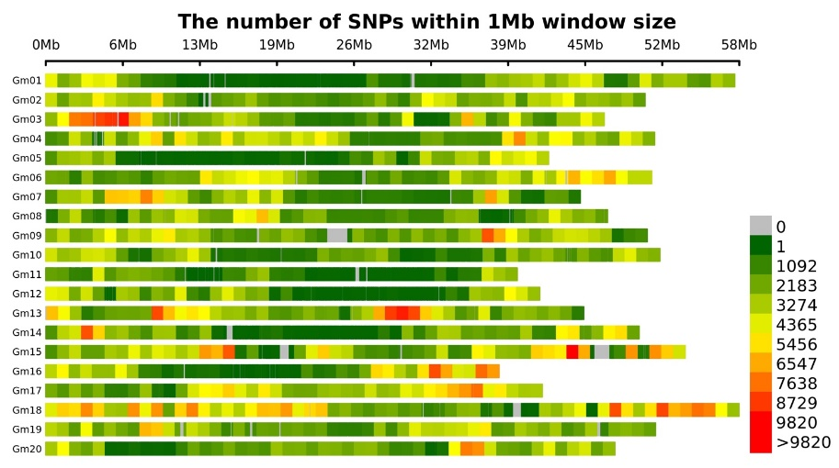
The purpose of molecular analysis is to dissect unknown 2 Mbp deletion in extremely high stearic soybean lines by identifying any structural variations in the deletion. The high-quality reads for 17 stearic acid lines were aligned to Wm82 v4 genome. Genome-wide variant identification has been accomplished using BCFtools, and we are using a haplotype-based GATK approach to accurately identify InDels. We have identified a total of 2,508,414 high-quality SNPs and annotated these to analyze their effects. The SNPs density plot shows that the SNPs are evenly distributed across all the chromosomes with some regions highly diverse (Figure 1). A maximum number of SNPs were identified for LL05-14, followed by S19-19712 (Table 1). Detailed sequence variations (SNPs and InDels) of the candidate genes and haplotype analysis is ongoing.
Figure 1. The SNPs density plot shows the distribution of SNPs across the soybean chromosomes.

Table 1. A summary of genome-wide SNPs identification for the 17 stearic acid content associated lines.

Sample | Stearic profiles (%) | No of reference  homozygous calls | No of alternate  homozygous calls | No of  heterozygous calls | Total number  of SNPs
S19-19188 | 21.1 (2Mb deletion) | 1,800,917 | 609,623 | 69,374 | 678,997
S19-19187 | 20.5 (2Mb deletion) | 1,633,304 | 580,767 | 277,017 | 857,784
S19-19715 | 19.2 (2Mb deletion) | 1,538,599 | 413,759 | 543,221 | 956,980
S19-19185 | 14.2 (2Mb deletion) | 1,757,161 | 638,396 | 84,377 | 722,773
S19-19181 | 16.6 (2Mb deletion) | 1,623,621 | 514,149 | 354,288 | 868,437
S19-19712 | 16.5 (2Mb deletion) | 1,014,133 | 238,635 | 1,246,159 | 1,484,794
S19-18842 | 3.5 (No deletion) | 1,149,773 | 319,899 | 1,029,870 | 1,349,769
S19-18829 | 3.4 (No deletion) | 1,515,188 | 406,181 | 573,427 | 979,608
S19-20072 | 3.3 (No deletion) | 1,709,946 | 653,594 | 124,152 | 777,746
S19-20086 | 3.2 (No deletion) | 1,545,136 | 430,068 | 517,806 | 947,874
S19-20088 | 3.1 (No deletion) | 1,823,456 | 510,806 | 152,230 | 663,036
S19-20018 | 3.1 (No deletion) | 1,673,834 | 494,440 | 317,867 | 812,307
LL05-14 | 9.1 (No deletion, pedigree) | 910,537 | 413,230 | 1,173,512 | 1,586,742
30-1947-1 | 7.7 (2Mb deletion, pedigree) | 2,204,329 | 33,150 | 266,190 | 299,340
A6 | 22.0 (6Mb deletion) | 1,328,704 | 1,040,238 | 103,211 | 1,143,449
S13-10590C | 3.0 (No deletion, parent) | 1,297,031 | 397,875 | 795,600 | 1,193,475
S14-9017R | 3.0 (No deletion, parent) | 1,527,476 | 694,543 | 264,107 | 958,650

Summary and Highlights:
- Ten high stearic breeding populations will be tested in the 2023 progeny field.
- Forty-five high stearic soybean lines will be tested for yield performance in the 2023 preliminary yield trial.
- Twelve new high stearic populations are under generation advancement in off-season nursery.
- Bioinformatic analysis is on-going.

