Please use this form to clearly and concisely report on project progress. The information included should reflect quantifiable results that can be used to evaluate and measure project success. Comments should be limited to the designated boxes. Technical reports, no longer than 4 pages, may be attached to this summary report.

Project Number:
Project Title: | Development of functional ultra-high stearic acid soybean germplasm
Organization: | University of Missouri
Principal Investigator Name: | Grover Shannon
Other investigators: | Dongho Lee
Report Period: | March 29, 2023 to June 9, 2023
Research updates:
2023 progeny plots for the high stearic project.
Seed from a hundred F_{4:5} lines each from ten high stearic populations (a total of 1,000 lines) are being evaluated for high stearic acid content. Lines with high stearic acid content will be planted at Portageville, MO in single 7 ft long progeny rows for selection based on agronomic appearance and stearic acid content. Desirable lines will be selected and bulk-harvested at maturity for preliminary yield test in 2024.

2023 preliminary yield test for the high stearic project.
A total of 45 high-stearic soybean lines were selected from 2022 progeny plots based on fatty acid profiles and overall agronomic traits, including uniformity, pod load, and plant structure. These lines were evaluated for stearic acid content. Among the 45 lines, twenty-four lines ranged from 12% to 20% with six lines having 20% acid. Normal stearic acid is 3 to 4% is the average in commodity grown soybeans. These lines were planted in four row plots (12 ft length and 2.5ft width) in preliminary yield trials at three to five locations. These lines will be evaluated for yield agronomic and disease traits.

Breeding populations under generation advancement process.
A total of 12 new crosses for developing high stearic acid were successfully made in 2022 summer. The hybridized F₁ seeds were harvested and shipped to an off-season nursery in Costa Rica for generation advancement from the F1 to the F5 generation. Roughly 100 F_{4:5} lines per population will be planted in the 2024 progeny plots in Portageville, MO.

New crosses in the 2023 summer
Six high stearic lines were selected and will be crossed with high-yielding elite breeding lines in 2023. The list of six high stearic lines is described in Table 1.

Table 1. The list of high stearic lines in 2023 crossing block.
# | Name | Maturity group | Palmitic  Acid | Stearic Acid | Oleic  Acid
 |  |  | (%)
1 | S19-19186 | 4E | 10.4 | 18.5 | 20
2 | S22-23407 | 4L | 9 | 20.8 | 13.2
3 | S22-23568 | 4L | 9.4 | 22.4 | 20.3
4 | S22-23373 | 4L | 9.9 | 21.1 | 15.3
5 | S22-23589 | 4L | 9.4 | 21 | 17.5
6 | S22-23537 | 4L | 9.7 | 20.8 | 17.2

Molecular analysis
The high-quality reads for 17 stearic acid lines were aligned to Williams 82 version 4 (Wm82 v4) genome. The whole genome SNPs (Single Nucleotide Polymorphisms) analysis and haplotype analysis revealed several synonymous, intronic and UTR regions SNPs present in the genes coding for proteins with function “Acyl-[acyl-carrier-protein] desaturase” Glyma.02G138100, Glyma.07G207200, Glyma.13G038600 and Glyma.14G121400. Two synonymous variations were observed: one on 14739176 on Chr 2 (T->C; Glyma.02G138100 gene) and other on 34452736 at Chr 14 (C->T; Glyma.14G121400; Figure 1). We have completed the identification of short Indels and structural variations (SVs) including the large insertions, deletions, duplications., We identified 9563 deletions, 871 duplications and 2 insertion events when compared with Wm82 v4 genome (Table 1). Based on these genomic analyses, we identified unique variations in the SACPD high stearic acid gene derived from the LL05-14 and 30-1947-1 mutant lines versus the historical high stearic line A6

Figure 1: Haplotype visualization of SNPs identified in the acyl-[acyl-carrier-protein] desaturase gene on Chr 2 - Glyma.02G138100
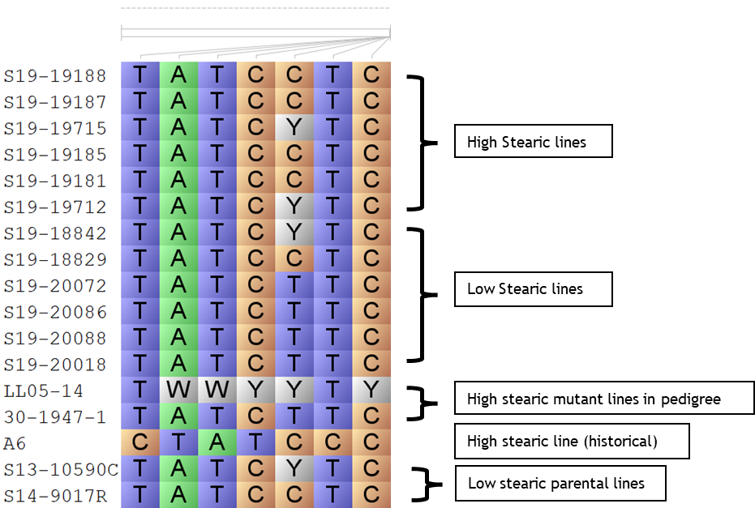
Table 1: Summary of length of different classes of SVs identified for the 17 stearic acid content associated lines.

Length of variation | Deletions | Duplication | Insertions
50 - 100bp | 2550 | 0 | 2
100 - 1000bp | 3662 | 449 | 0
1000 - 10000bp | 2668 | 258 | 0
10000+bp | 683 | 164 | 0

Summary and Highlights:
- Ten high stearic breeding populations consisting of 1000 lines were evaluated for stearic acid content. Lines with >12% stearic acid will be planted in 2023 progeny and for agronomic traits.
- Forty-five high stearic soybean lines (six lines were 20% or more in stearic acid content versus 4% in commodity beans) were planted in 2023 preliminary yield trials to be tested for yield performance compared to commodity checks of similar maturity.
- Twelve new high stearic populations are under generation advancement in the off-season nursery.
- New crosses are planned with up to six high stearic parental lines for use in crosses with high yielding, disease resistant elite lines.
- Overall Indels and structural variations were identified in SACPD genes indicating unique high stearic genes from two mutant sources versus the historical high stearic line A6.

