Please use this form to clearly and concisely report on project progress. The information included should reflect quantifiable results that can be used to evaluate and measure project success. Comments should be limited to the designated boxes. Technical reports, no longer than 4 pages, may be attached to this summary report.

Project Number:
Project Title: | Screening soybean germplasm and breeding soybeans for flood tolerance
Organization: | University of Missouri-Fisher Delta Research Center
Principal Investigator Name: | Dr. Feng Lin
Other investigators: | Drs. Caio Vieira, Tessie Wilkerson, David Moseley, Chengjun Wu, Francia Ravelombola
Report Period: | June 15, 2024 to September 15, 2024

Project Status: On-going

(What key activities were undertaken and what were the key accomplishments during this quarter? Please use this field to clearly and concisely report on project progress).
Research plan for 2024:

- Releasing conventional flood tolerant germplasm line
- Converting high yield and flood tolerant lines into XtendFlex (XF) in Winter Nursery
- Testing for flood tolerance at early vegetative and reproductive stages for advanced breeding lines from MO and AR and promising lines in the USDA Preliminary and Uniform Trials across 4 different states including AR, MO, LA, MS
- Screening for flood tolerance at reproductive stage of different lines from different companies in MO, AR, LA, MS entered in the Variety Test
- Developing new flood tolerant population to feed the flood breeding pipeline

University of Missouri (Lin):

The 2024 Flood breeding pipeline at the University is summarized in Table 1.

Table 1. 2024 Flood breeding summary in Missouri
Test/Line | Description | Entry #
S12-1362 | Germplasm release | 1
S17-1146 | Germplasm release | 1
UT | USDA Regional Uniform trials | 1
AYT-FLD | Flood advanced yield trials | 5
PYT-FLD | Flood preliminary yield trails | 23
MSSB_FLD | Advanced breeding lines and promising lines | 130
MOCVT_FLD | Variety Test Flood Screening | 60
Progeny | Visual Selection | ~400
Population | F₁ to F₄ generation | 4
New Crosses | Population development | 6-7

1. 2024 Conversion flood tolerant line into herbicide trait: S20-1492, identified as a potential flood-tolerant soybean line (FDS<2 at V2 and R1) was entered in the 2024 UT, and has been sent to the winter nursery for conversion to XF. It will undergo three backcrosses to incorporate the herbicide trait.

2. 2024 Flood-tolerant germplasm potential release: The high-yielding and flood-tolerant line S12-1362 (MG5) will soon be available as conventional germplasm. Its registration manuscript is currently undergoing processing and will be published in the Journal of Plant Registrations. This line has been shared with various soybean programs via a Material Transfer Agreement (MTA). Similarly, the line S17-1146 (MG4L), high yields and flood tolerance, will also be released as conventional germplasm. Its registration manuscript is also in progress and scheduled for publication in the Journal of Plant Registrations. Like S12-1362, this line has been exchanged with different soybean programs under an MTA.

3. 2024 Regional trials: We entered S20-1492, a potentially flood tolerant line in the USDA Southern Uniform Trials. S20-1492 exhibit a flood damage score FDS<2 at V2 and R1, with yield under flooded >20 bu/ac both at V2 and R1, and high yielding (70.1 bu/ac) that not significantly different from the commercial checks under non-flooded conditions. If seed yield is satisfactory, it has the potential to be released in 2025. Preliminary results of 2024 showed a flood damage score FDS<2 at V2 (FDS=1.5) and R1 (FDS=1.3).

4. 2024 Flood advanced yield trials: A total of 10 MG4L, and 11 MG5E were evaluated for flooding tolerance and yield. The test lines include selections of lines with stable flood damage score and potential high yielding lines from 2023 flood advanced yield trials. One tolerant check and sensitive commercial varieties along with conventional checks have also been included.
The tests were conducted in 4-row plots with 3 replications under both flooding stress conditions (at V2 and R1 stages) and non-stress conditions (non-flooded field). Flood scores were recorded at V2 and R1 stages, and the data has been analyzed. The plots will be harvested for seed yield evaluation.

5. 2024 Flood preliminary yield trials: A total of 28 MG4 breeding lines including one tolerant check (S17-1146) along with commercial checks (AG 40XF1, P42A84E, AG 43XF2, P47A64LX) were evaluated for flooding tolerance and yield. The test entries were planted in 4-row plots in 2 replications in flooded (V2 and R1) and non-flooded fields. Among those 28 lines, four lines showed high protein concentration ranging from 37.5 % to 38.8 % (% 13 moisture). Data has been analyzed and plots will be harvested soon.

6. 2024 Flood Tolerant Progeny rows: Approximately 400 F₄ plant rows from 4 crosses will be planted at Portageville, MO as a single row at the Lee Farm, Portageville, MO. Lines with best agronomic traits will be visually selected for further evaluation under drought in 2025.

7. 2024 Breeding population advancement: Four flood tolerant breeding populations were developed in 2023. The F₁ seeds of these crosses were sent to the winter nurseries where the populations will be advanced to F₄ for progeny row testing in 2025.

8. 2024 crosses for Flood tolerance: We attempted 7 new crosses for the season of 2024.

9. 2024 Missouri commercial variety testing for flood tolerance: We evaluated at total of 60 commercial varieties developed by different seed companies with 3 replications under flooding stress for at R1/R2 stage during and non-flooded treatment the summer of 2024 at the Lee Farm Portageville, MO (heavy clay soil). Flood scores were recorded at V2 and R1 stages, and the data has been analyzed. The plots will be harvested for seed yield evaluation.

10. 2024 MSSB Flood screening for flood tolerance: The 2024 MSSB test includes 250 advanced and promising breeding lines from the University of Missouri, specifically selected for flood tolerance, along with advanced and promising lines from the University of Arkansas. These lines will undergo genotyping. Flood tolerance screening was conducted at the V2 and R1 growth stages, with three replications across multiple states, including Arkansas, Missouri, Louisiana, and Mississippi, and drone data was collected. The collected data will be analyzed.

11. Marker data analysis: Marker analysis for flood tolerance revealed that some lines possess markers on both Chromosome 3 and Chromosome 13 (Table 2).

Table 2. Soybean Breeding lines in the Preliminary Yield Trials that possess markers on both Chromosome 3 and Chromosome 13
Name | FT-Chr. 3 | FT-Chr. 13
S22-14160 | T | T
S22-14345 | T | T
S22-14004 | T | T
S22-14106 | T | T
S22-14124 | T | T
S22-14129 | T | T
S22-14161 | T | T
S22-14165 | T | T

University of Arkansas (Vieira):
All flood screening trials have been successfully completed. Significant differences among genotypes have been observed in both early season V2 and mid-season R2 screening. Trials are being harvested for grain yield, and data is currently being processed and will guide population development decisions

2024 Flood Tolerance Breeding in Arkansas
Three pre-commercial MG5 lines (R20-1429, R21KB-05522, and R21KB-05122) with flood-tolerant pedigrees and 15 preliminary lines (11 soybean and 4 soybean x soja lines) are being evaluated for yield in multiple locations. A total of 722 progeny rows with flood-tolerant pedigrees are being evaluated in Kibler, AR. About 30 breeding populations derived from flood-tolerant parents are being advanced in winter nursery. Fifteen new crosses including flood-tolerant parents and other value-added traits have been made in Fayetteville, AR (Table 1).
Table 1. New flood-tolerant crosses made in 2024
Crosses | Pedigree | Parental Traits
CB24-112 | R19-4593/R21KB-05522 | SCN SRKN SC SALT FLS FLOOD
CB24-119 | S19-12537/R21KB-05522 | SCN SRKN SC SALT FLS BSR FLOOD
CB24-120 | R16-45/R11-171 | FLOOD SC SALT FLS
CB24-130 | R21KB-06382/R21KB-05522 | DROUGHT SCN SRKN SC SALT FLS BSR FLOOD
CB24-118 | R19C-1081/R21KB-05522 | SCN SRKN SC SALT FLS FLOOD
CB24-113 | R19C-1035/R21KB-05522 | SCN SRKN SC SALT FLS FLOOD
CB24-128 | R19C-1081/R19-42848 | SC FLS FLOOD DROUGHT
CB24-114 | R16-45/R19C-1081 | SC FLS FLOOD
CB24-111 | R19-45980/R21KB-05522 | SCN SRKN SC SALT FLS FLOOD
CB24-116 | R16-45/S11-20124 | FLOOD SCN SRKN SC FLS
CB24-117 | R16-45/S18-6013C | FLOOD SCN SRKN SC FLS BSR
CB24-115 | R16-45/R21KB-05522 | FLOOD SCN SRKN SC SALT FLS
CB24-127 | R16-45/R19-42848 | FLOOD SC FLS DROUGHT
CB24-129 | R16-45/R21KB-05776 | FLOOD SCN SC FLS DROUGHT
CB24-110 | R18C-13665/R21KB-05522 | SCN SRKN SC SALT FLS FLOOD
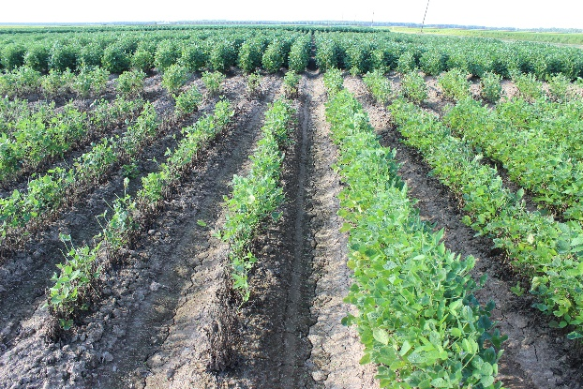
Commercial flood yield trial: A total of 84 MG4 and MG5 commercial varieties and lines developed by industry companies and the Arkansas Soybean Breeding Program were evaluated for flood tolerance at the early V5 stage under 5-day flooding stress in Stuttgart, AR. Fifty-four commercial and lines had flood tolerance performances with flood damage score (FDS ≤ 2.0) at V5 stage and eight varieties/lines (Progeny P4999E3S, Progeny P4775E3S, Progeny P4947XFS, R19C-1081, R21KB-05522, Dyna-Gro S43XF85S, Revere 46-E67, and DELTA GROW DG43XF65STS) showed high flood tolerance with FDS = 1.0 (Figure 1). The yield evaluations of these 84 commercial varieties and lines under irrigated and flooded conditions are ongoing and will be reported in the next report.
Figure 1. Flood-susceptible (left side 4 rows) and flood-tolerant (right side 4 row) commercial varieties under 5-day flooding stress at the V5 stage.

Genomic prediction and GWAS for early season flooding tolerance: A study including 254 genetically diverse PIs screened for flooding tolerance at the early V2 stage has been concluded and publication is ongoing. Significant marker-trait associations were detected on chromosomes 4, 17, and 20. In addition, genomic prediction models based on RandomForest and Support Vector Machine have been developed and are shown to accurately predict tolerance at the V2 stage, significantly outperforming a rrBLUP model (Figure 2). This study is planned to be submitted for publication by the end of September.
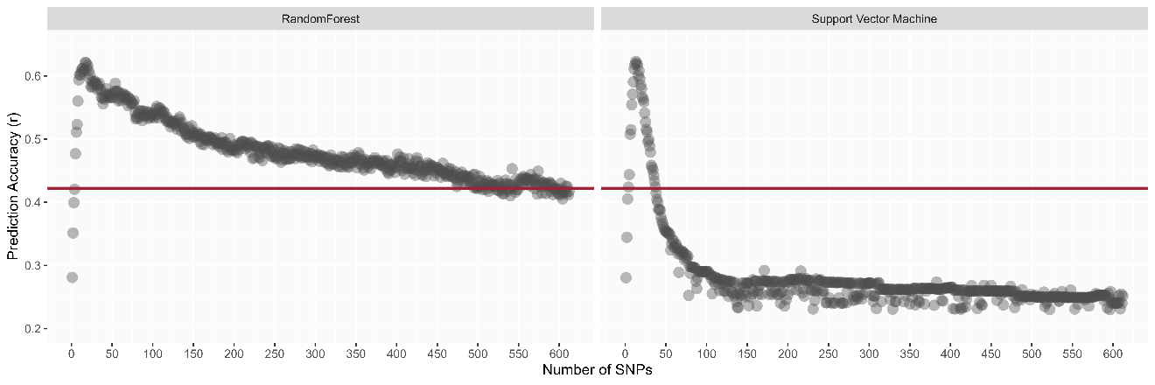
Figure 2. Random Forest and Support Vector Machine genomic prediction models based on a stepwise SNP filtering show a peak accuracy of ~0.60 compared to a regular rrBLUP showing a ~0.40 accuracy.

Mississippi State University (Wilkerson)
One complete set of the Mississippi State University official variety trial was planted on June 14, 2024. Plots were planted 2 rows wide and 20 ft in length to allow for harvest. Plots were flooded on August 7, 2024 at R1/R2 growth stage for 120 hours (Figure 1). Flood severity was evaluated 7 days post flood removal according to designated rating scale (1-5). Within the 128 entries and 6 maturity groups, flood scores ranged from a minimum score of 1 to a maximum score of 4.7 with an average score of 2.9 on the 1-5 rating scale. Plots will be allowed to mature and harvested for yield.
Plots consisting of breeding line seed sent from both Arkansas and Missouri were also established on June 14, 2024 as single rows with 3 replications. Plots were flooded on August 7, 2024 at R1/R2 growth stage for 120 hours (Figure 2). Flood severity was evaluated 7 days post flood removal according to designated rating scale (1-5). Within the 245 entries, flood scores ranged from a minimum score of 1 to a maximum score of 3.7 with an average score of 1.7 on the 1-5 rating scale.
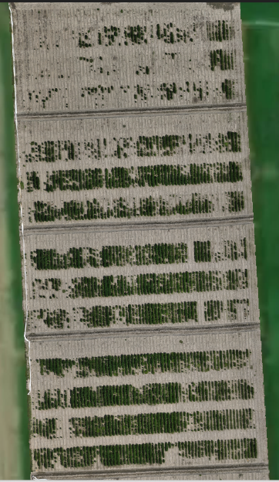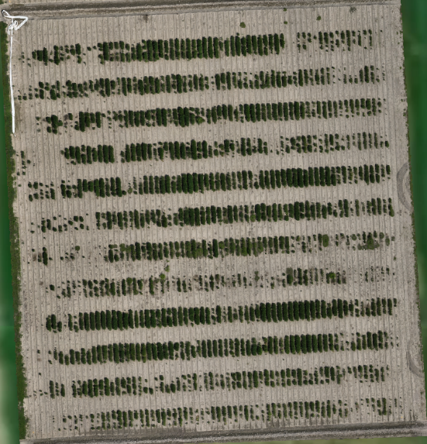
Figure 1 Figure 2

