Please use this form to clearly and concisely report on project progress. The information included should reflect quantifiable results that can be used to evaluate and measure project success. Comments should be limited to the designated boxes. Technical reports, no longer than 4 pages, may be attached to this summary report.

Project Number:
Project Title: | Screening soybean germplasm and breeding soybeans for flood tolerance
Organization: | University of Missouri-Fisher Delta Research Center
Principal Investigator Name: | Dr. Grover Shannon
Other investigators: | Drs. Caio Vieira, Tessie Wilkerson, David Moseley, ChengjJun Wu, Francia Ravelombola
Report Period: | September 15, 2023 to December 15, 2023

Project Status: On-going

(What key activities were undertaken and what were the key accomplishments during this quarter? Please use this field to clearly and concisely report on project progress).
Outline of MSSB Flood Tolerance Report
- Complimentary Research from Co-PIs of this project
  - A) Arkansas- Breeding and Screening R1-R2 and V2-V4
  - B) Missouri- Breeding and Screening R1-R2 and V2-V4
  - C) Louisiana- Screening
  - D) Mississippi- Screening
- Picture of 2023 flood screening trials at the R2 stage at Portageville, MO
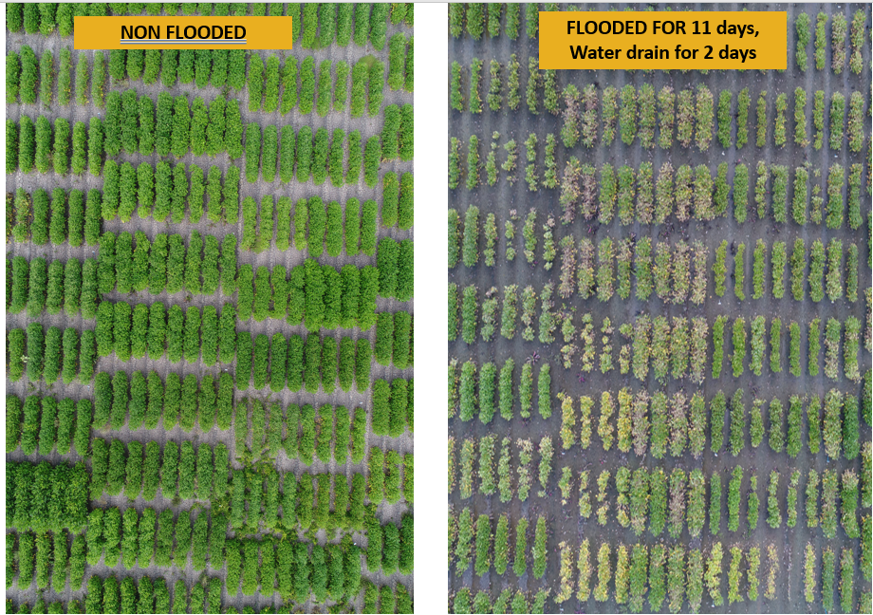

- Picture of different soybean lines at the R2 stage at Portageville, MO showing different levels of flood injury
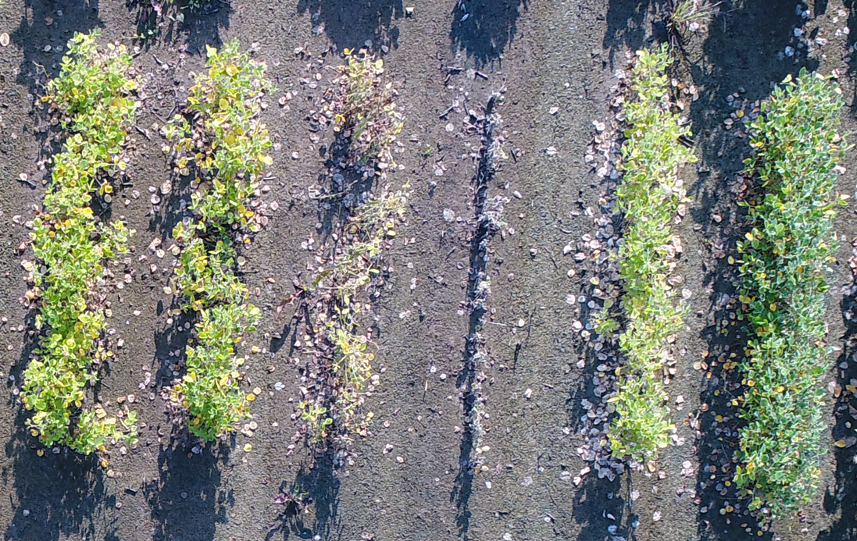

Arkansas (Vieira):
2023 Flood-tolerant germplasm release:
The conventional germplasm R16-45 with high-yielding and flood-tolerance traits was released in 2023. The manuscript for R16-45 registration was accepted in July and is being processed for publication in the Journal of Plant Registrations. The purified seeds of R16-45 with buff hilum color are being increased in Fayetteville, AR, and will be submitted to the ARS Seed Storage in October.

2023 Flood tolerance evaluation for AR and MO elite lines at R1/R2 stages:

A total of 90 elite lines developed by the breeding programs in AR and MO were evaluated for flood tolerance at R1/R2 growth stages in Stuttgart, AR with three replications. Sixteen lines showed high tolerance under 7-day flooding stress (Table 1).

Table 1. Flood-tolerant lines entered in the 2023 MSSB flood test
Line | FDS | Line | FDS
S19-12459 | 3.3 | R19-45980 | 4.0
R18CR-287 | 3.3 | R18-11770 | 4.0
S19-2082 | 3.3 | S19-17667 | 4.0
S17-17644 | 3.3 | R18-10919 | 4.0
R19C-1081 | 3.3 | R18CR-83 | 4.0
S19-1176 | 3.3 | R19-4593 | 4.0
R19C-1035 | 3.7 | S20-1492 | 4.0
S20-15411 | 3.7 | S19-19741 | 4.0

2023 Flood tolerance evaluation for AR and MO lines at V2/V3 stages:

Forty-three advanced lines from AR and MO were evaluated for flood tolerance at early V2/V3 growth stages in Stuttgart, AR with three replications. Twelve lines showed good tolerances under 11-day flooding stress (Table 2).

Table 2. Flood-tolerant lines entered in the 2023 GXE V2 flood test
Line | FDS | Line | FDS
UA5014C | 1.3 | R19-42848 | 3.0
R16-259 | 2.7 | R19C-1081 | 3.3
R07-6669 | 2.7 | S18-6005 | 3.7
S16-7922 | 3.0 | S12-1362 | 3.7
S14-4034 | 3.0 | R06-4433 | 3.7
R19-43217 | 3.0 | R19C-1001 | 3.7

2023 Arkansas advanced yield and flood trials:

A total of 19 advanced lines (7 MG4 and 12 MG5) with flood-tolerant pedigrees were evaluated for flood tolerance under 7-day flooding conditions at R1/R2 growth stages in Stuttgart, AR. Five lines showed good flood tolerance (Table 3). Additionally, these 19 advanced lines are being evaluated for yield and other agronomic traits in replicated trials in four Arkansas (Marianna, Pine Tree, Rohwer, and Stuttgart) and one Missouri (Fisk) locations. The purified breeder seeds of these lines are being increased in Fayetteville, AR.

Table 3. Flood-tolerant breeding lines entered in the 2023 Flood Finals Trial
Line | Pedigree | MG | FDS
R21KB-05522 | R16-141/R13-13997 | 5E | 3.3
R20-353 | RA-452/R05-3239 | 5E | 3.7
R20-393 | RA-452/R05-3239 | 5E | 3.7
R21KB-01732 | R07-6669/PI614732 | 5E | 4.0
R20-440:002i | S13-15764/R05-3239 | 4L | 4.0

2023 Progeny Rows:

A total of 136 new lines derived from flood-tolerant pedigree (R16-45/R15-2422) were evaluated as single progeny rows in Kibler, AR. Lines will be selected based on pod load and overall agronomic traits and will be entered in 2024 preliminary yield trials for yield and flood tolerance evaluations.

2023 Population advancement and development:

A total of 37 breeding populations (F1 to F4 generation) with flood-tolerant pedigrees are being advanced in the U.S. and off-season nurseries. Eight new crosses between flood-tolerant and elite/value-added parental lines were made at Fayetteville, AR in the 2023 summer season. F1 seeds will be sent to an off-season nursery for generation advancement and will return as F4:5 progeny rows in 2025.

2023 Commercial varieties evaluation for yield and flood tolerance:

A total of 86 commercial varieties (60 MG4 and 26 MG5) are being evaluated for yield and flood tolerance under 5-day flooded and non-flooded conditions (side-by-side tests) at early V2/V3 growth stages in Stuttgart, AR. Nineteen varieties exhibited good flood tolerances with lower FDS < 4.0 under 5-day flooded stress. The yields of these commercial varieties under both flooded and non-flooded conditions will be obtained in harvesting season and reported in the next quarterly report.

Missouri (Shannon et al.)
2023 Flood-tolerant germplasm potential release:
The line S12-1362 with high-yielding and flood-tolerance traits will be released as conventional germplasm. The manuscript for S12-1362 registration is in process and will be published in the Journal of Plant Registrations. This line has been exchanged with different soybean programs through a Material transfer agreement (MTA).

2023 Missouri commercial variety testing for flood tolerance: A total of 55 MG4 and MG5 commercial varieties developed by 13 different seed companies along with Missouri flood tolerant lines were planted in single 7-ft long row plots with 3 replications under flooding stress for at R1/R2 at the Lee Farm Portageville, MO. Lines were waterlogged at R1/R2 stages. Results showed that the three (3) most advanced lines S12-1362, S19-17667, S17-1146 from the University of Missouri, HS 47E30, and P42A84E from two companies were the most tolerant at the reproductive stage with a flood damage score (FDS) of 1.5 (scale of 1 to 5: 1 no yellowing and 5 plant death).

2023 Yield evaluation of selected tolerant and sensitive lines in flooded and non-flooded field: A set of 9 tolerant and 9 sensitive lines for flood from MO, AR and NC, along with 2 commercial checks were planted in 4-row plots in 3 replications for flood tolerance and yield under flooded (R1/R2 stage) and non- flooded conditions at the Lee Farm, Portageville, MO. The same set was planted in Arkansas and North Carolina. Results from the Portageville, MO location showed that 4 lines (R11-6870, R16-45, S17-1146, and S19-17667) had a FDS <2 with yields under flood conditions of > 20bu/ac. These lines demonstrated a yield exceeding 150% check yield in flooded conditions and within 98% of check yield in non-flood conditions. Flood-induced damage had a noticeable impact on plant height, with soybean lines experiencing stunted growth in flooded conditions (Table 1). The analysis of protein and oil concentrations is currently ongoing.

Table 1. Tolerant soybean lines from Arkansas and Missouri were evaluated under flooded conditions at the R2 growth stage and rated for damage (FDS 1 to 5 scale, scale of 1 to 5 with 1 no yellowing and 5 plant death). Height was measured in inches and yield was recorded in BU/A under flooded conditions under non-flooded conditions and also recorded as a percent of check yield
 | FDS | Height (in) |  | Yield (bu/ac) |  | % Check Yield
 |  | Flood | Non-Flood | Flood | Non-Flood | Flood | Non-Flood
R11-6870 | 1.8 | 18 | 25 | 20.8 | 36.8 | 155 | 99
R16-45 | 1.7 | 18 | 24 | 21.2 | 41.2 | 158 | 112
S17-1146 | 1.5 | 18 | 21 | 25.4 | 44.7 | 189 | 121
S19-17667 | 1.5 | 27 | 34 | 28.6 | 38.8 | 213 | 105
Check* | 3.6 | 25 | 33 | 13.4 | 37.0
*Checks are composed by AG48X9 and AG56XF2

2023 Advanced Flood Yield Tests
A total of 24 and 28 elite advance breeding lines in maturity group IV (MGIV) and V (MGV), respectively were evaluated under both flooded (V2-V4 early vegetative and R2-R3 reproductive growth stages) and non-flooded conditions at the Lee Farm Portageville, MO. For the MG IV, 3 lines demonstrated flood tolerance at early and reproductive stages (Table 2). For the MG V, 2 lines showed a flood tolerance at early and reproductive stages with seed yield greater than 30 bu/ac under both flooded conditions (Table 3)

Table 2. MGIV Tolerant soybean lines from Advanced Yield Flood test in Portageville, MO with flood score damage (FDS 1 to 5 scale, scale of 1 to 5: 1 no yellowing and 5 plant death), yield under flooded conditions at early vegetative (CLAY FLD V2) reproductive stages (CLAY FLD R1) yield under non-flooded conditions (CLAY Non FLD and LOAM Non FLD)

MGIV | FDS |  | YIELD (bu/ac)
Name | V2 | R1 | CLAY FLD V2 | CLAY FLD R1 | CLAY Non FLD | LOAM Non FLD
S19-12459 | 1.3 | 1.7 | 17.3 | 14.1 | 31.5 | 62.0
S20-13444LL | 1.8 | 1.8 | 23.8 | 13.9 | 36.7 | 65.6
S20-7117 | 1.5 | 1.7 | 18.6 | 11.1 | 15.5 | 67.1
Non Xtend Check | 1.8 | 2.0 | 19.6 | 16.2 | 31.1 | 68.4
Xtend Check | 3.3 | 4.5 | 9.2 | 5.5 | 24.0 | 80.7
Average | 2.1 | 2.2 | 15.3 | 11.2 | 25.7 | 62.8
S12-1362 | 1.8 | 2.0 | 17.2 | 11.8 | 27.7 | 51.8
S99-2281 | 2.1 | 2.6 | 16.9 | 11.9 | 24.1 | 59.6
*Non Xtend Check: P48A14E
*Xtend Check: AG 43XF2
S12-1362: Tolerant line
S99-2281: Susceptible line

Table 3. MGV Tolerant soybean lines from the Advanced Yield Flood test in Portageville, MO were evaluated at the V2 and R2 growth stages. Flood damage was rated on a 1 to 5 scale (FDS 1 to 5 scale, scale of 1 to 5: 1 no yellowing and 5 plant death). Seed yield was measured under flooded conditions at early vegetative (CLAY FLD V2), reproductive stages (CLAY FLD R1), seed yield under non-flooded conditions (CLAY Non FLD and LOAM Non FLD under ideal growing conditions)

MGV | FDS (1-5) |  | YIELD (bu/ac)
Name | V2 | R1 | CLAY FLD V2 | CLAY FLD R1 | CLAY Non FLD | LOAM Non FLD
S19-14307 | 1.7 | 1.5 | 35.4 | 30.7 | 38.9 | 56.8
S20-1492 | 2.0 | 1.5 | 32.2 | 33.3 | 46.5 | 70.1
Non Xtend Check | 2.4 | 2.4 | 25.8 | 23.3 | 21.0 | 72.1
Xtend Check | 3.3 | 4.2 | 28.9 | 18.0 | 29.2 | 77.1
Average | 2.4 | 2.5 | 25.2 | 24.4 | 28.8 | 63.1
S12-1362 | 2.0 | 2.8 | 19.6 | 20.6 | 26.9 | 49.9
S99-2281 | 2.8 | 3.0 | 25.7 | 23.0 | 27.0 | 61.3
*Non Xtend Check: P48A14E and P49T62E
*Xtend Check: AG 52XF0 and AG 53XF2
S12-1362: Tolerant line
S99-2281: Susceptible line

2023 Preliminary Flood Yield Tests
A set of 23 MG4 breeding lines, visually selected from progeny rows in 2022, were planted in 4-row plots with 2 replications along with a tolerant check, susceptible check and 2 commercial checks. The soybean breeding lines were planted at the Lee Farm in Portageville, MO, and were subjected both flooded conditions (V2/V4 and R1/R2) and non-flooded conditions. Results from the flooded conditions during the early vegetative stage and reproductive stage revealed that six (6) promising lines exhibited flood tolerance at both growth stages. The selected lines best lines had an FDS of less than 2.0, coupled with a seed yield exceeding 20 bu/ac in both vegetative and reproductive flooded conditions. Notably, these chosen soybean lines surpassed the check yield by more than 10% in both vegetative and reproductive flooded conditions. Additionally, these lines exhibited a yield of over 98% of the check yield under non-flooded conditions on a clay soil (Table 4). These promising lines will be included in the 2024 Advanced Flood Yield Trials for further evaluation, aiming to assess the consistency of their flood tolerance.

Table 4. Tolerant soybean lines from Preliminary Yield Flood test in Portageville, MO with flood damage scores (FDS 1 to 5 scale, scale of 1 to 5: 1 no yellowing and 5 plant death),. Yield was recorded under flooded conditions at early vegetative (CLAY FLD V2) reproductive stages (CLAY FLD R1) as well as yield under non-flooded conditions (CLAY Non FLD and LOAM Non FLD under ideal growing conditions)

 | FDS |  | YIELD (bu /ac)
Name | V2 | R1 | CLAY FLD V2 | CLAY FLD R1 | CLAY Non FLD | LOAM Non FLD
S22-14004 | 1.8 | 1.8 | 28.6 | 31.5 | 37.3 | 53.6
S22-14012 | 1.5 | 2.0 | 33.3 | 33.0 | 30.1 | 61.7
S22-14038 | 1.3 | 1.8 | 38.1 | 47.0 | 29.7 | 56.3
S22-14289 | 1.5 | 2.0 | 29.2 | 25.0 | 38.3 | 63.5
S22-14345 | 1.8 | 2.0 | 24.7 | 26.1 | 46.1 | 58.7
S22-14388 | 1.8 | 1.8 | 33.9 | 26.9 | 42.1 | 52.6
Non Xtend Check | 2.0 | 2.0 | 21.9 | 21.4 | 30.4 | 71.6
Xtend Check | 3.3 | 4.5 | 17.0 | 15.5 | 30.0 | 89.0
S12-1362 | 3.0 | 2.5 | 24.2 | 17.5 | 28.1 | 55.6
S99-2281 | 2.5 | 3.3 | 27.2 | 20.7 | 29.7 | 60.5
*Non Xtend Check: P48A14E
*Xtend Check: AG 43XF2
S12-1362: Tolerant line
S99-2281: Susceptible line

2023 Flood tolerance evaluation for AR and MO elite lines at R1/R2 stages (MSSB-test):
A total of 100 elite lines developed by the breeding programs in AR and MO along with commercial checks were evaluated for flood tolerance at R1/R2 growth stages at Portageville, MO with three replications. Lines were scored for flood tolerance. Those 100 sets were planted also in Arkansas, Louisianna, and Tennessee. The goal is to find newer tolerant elite lines with better agronomic traits versus checks and lines with known tolerance. Results from Portageville, MO showed that S17-1146, R18CR-144, R19C-1035, R19C-1081, S20-17501, S20-17527 had a FDS ≤1.5. It is worth mentioning that S17-1146 showed a flood tolerance in the flood yield evaluation with 189% check yield under flooded conditions at R1. Data from other states will be combined to assess flood tolerance stability over years and locations.

2023 Flood Tolerant Progeny rows
Two hundred F_{4:5} plant rows from two crosses were planted at Portageville, MO from crosses to improved flooding tolerance Two lines based on visual appearance and other agronomic traits were selected for 2024 yield tests.

Breeding population advancement: Four flood tolerant breeding populations were developed in 2022. The F₁ seeds of these crosses were sent to the winter nurseries where the populations will be advanced to F₄ for progeny rowr testing in 2024.

2023 crosses for Flood tolerance
A total of six (6) crosses were made during the summer of 2023 at improving flooding tolerance are as follows:
Crosses | Pedigree
S23-545 | S17-1146 x S19-17693
S23-546 | S17-1494 x S19-17313
S23-547 | S17-1494 x S19-17693
S23-571 | S19-10701 x PI 407788A
S23-572 | S12-1362 x PI 407788A
S23-573 | S12-1362 x PI 567305
F₁ seeds were sent to winter nursery Costa Rica/Puerto Rico for population advancement.

Mississippi State University- Wilkerson
One complete set of the Mississippi State University official variety trial was planted on June 1, 2023. Plots were planted 2 rows wide and 12 ft in length to allow for harvest. Plots were flooded on August 28, 2023 at R3/R4 growth stage for 96 hours (Figure 1). Flood incidence and severity will be evaluated 7 days post flood removal according to previous year scale (1-5). Plots will be allowed to mature and harvested for yield. Hill plots consisting of seed sent from both Arkansas and Missouri were also established (hand planted) on June 1, 2023 with 3 replications. Plots were flooded on August 28, 2023 at R3/R4 growth stage for 96 hours (Figure 2). Flood incidence and severity will be evaluated 7 days post flood removal according to previous year rating scale (1-5).

Louisiana State University- Moseley
Flooding tolerance scores were taken on the official 2023 LSU variety tests based on a scale of on a 1 is good and 5 is very poor. In addition, about 90 lines from Missouri and Arkansas with known or potential tolerance to excess water were evaluated for flood tolerance. Data is being tabulated with results to be provided in the next report. Flooding scores from 2022 variety tests as well as 2022 entries from Arkansas and Missouri soybean breeding programs were analyzed in a genotype by environment study across AR, MO, and LA locations. Lines with the best tolerance scores across sites and growth stages the two are listed in the tables below:

Lines from AR and MO with best tolerance across locations from AR, LA and MO at R1-R2 and V2-V4
List of breeding lines with the best mean flood damage scores based on a scale of 1.0 is best and 5.0 is worst at R1-R2 across LA, AR and MO locations from 2022 trials.
Mean scores showing lines with best overall flooding tolerance across three locations at R1-R2 is shown in the table below:

LINE | FL SCORE-AR | FL SCORE-LA | FL Score-MO | MEAN Score 3 states
R18-16839 | 2.3 | 2.4 | 1.7 | 2.2
R18-13387 | 2.2 | 2.4 | 2.0 | 2.2
R18-67F | 2.0 | 2.6 | 1.7 | 2.1
S17-1494 | 2.3 | 2.3 | 1.2 | 1.8
S19-17313 | 1.7 | 2.3 | 1.2 | 1.7
S20-24521 | 2.2 | 2.5 | 1.3 | 2.0
S20-24524 | 1.2 | 3.2 | 1.3 | 1.9

Identification of AR and MO breeding lines based on 2022 data with flood tolerance across locations (MO, AR) from a genotype x environment analysis at the V2-V4 and R1-R2 growth stages.
List of flood tolerant lines flooded at both V2-V4 and R1 R2 growth stages averaged from AR and MO flood tests.
Breeding lines averaged for tolerance at V1-V2 and R1-R2 growth stages and the average across both grow stages are as follows: Several lines showed cross tolerance to flooding at both growth stages. This indicates that lines can show flood tolerance at both early vegetative and the early reproductive growth stages.

Line | Mean flood score from MO & AR at V2-V4 | Mean flood score from MO & AR at R1-R2 | Mean flood score from MO & AR across V2-V4 and R1-R2
S16-7922 | 1.1 | 2.1 | 1.6
S17-2066 | 1.8 | 2.4 | 2.1
S18-13892 | 1.9 | 1.9 | 1.9
S12-1362 | 2.3 | 1.7 | 2.0
S19-6013 | 1.6 | 2.2 | 1.9
S14-4034 | 1.9 | 2.1 | 2.0
S18-6005 | 1.7 | 2.4 | 2.1
S16-14869 | 1.3 | 2.1 | 1.7
R14-1422 | 1.4 | 1.8 | 1.6
R18-13309 | 1.3 | 2.1 | 1.7
R07-6669 | 1.9 | 2.2 | 2.1
R04-342 | 1.5 | 1.9 | 1.7
R16-45 | 2.1 | 2.3 | 2.2
S17-1931 | 1.8 | 2.4 | 2.1
S17-13496 | 1.8 | 2.3 | 2.1

