Title of Project with MSSB Project No.:
Relay Intercropping Soybean into Wheat: An Integrated Pest Management (IPM) Tool for Sustainable Weed Management
Name of PI(s) and Email Address(es):
Jason K. Norsworthy, jnorswor@uark.edu
Background and Objectives
The Midsouth soybean industry faces an escalating challenge from herbicide-resistant weeds, particularly aggressive species like Palmer amaranth (Amaranthus palmeri), which threaten yield stability and farm profitability. Decades of reliance on herbicide-centric weed management have accelerated resistance, revealing the limitations of this approach and underscoring the urgent need for innovative, diversified strategies. Previous research has provided preliminary insight into the relay intercropping—where soybean is planted into standing wheat before their harvest—and offers a promising integrated pest management (IPM) solution for Palmer amaranth. By leveraging a dense, competitive wheat canopy to suppress weed emergence, relay intercropping reduces weed seed bank replenishment and disrupts the life cycles of certain problematic species. Beyond weed control, relay intercropping has the potential to enhance soil health through increased organic matter and reduced erosion, optimize land-use efficiency by producing two crops in a single season, and bolster economic resilience for producers facing volatile markets and rising input costs.
Funded by the Mid-South Soybean Board (MSSB), this study builds on encouraging results from a previous study to validate further and refine the weed suppressive potential of relay intercropping wheat and soybean. It pursues the following objectives:
- Quantify weed suppression potential and system yields of wheat-soybean relay intercropping in the Midsouth, compared to conventional full-season and double-crop soybean systems.
- Disseminate practical findings to promote relay intercropping as a sustainable weed management strategy.
Report of Progress/Activity
A field trial was conducted during the 2023-24 growing season at the Pine Tree Research Station near Colt, Arkansas, a site mirroring Midsouth soybean production conditions. Using a randomized complete block design with four replications, the study compared three systems: 1) full-season soybean: managed with a three-pass herbicide program (preemergence, early postemergence, late postemergence), 2) wheat-soybean relay intercropping: wheat planted with skipped rows for soybean (three rows of wheat followed by a skip row for soybean), followed by a single post-wheat-harvest herbicide application, and 3) double-crop soybean: wheat harvested, then soybean planted with a three-pass herbicide program. The timeline schematic of the three systems showing relative planting dates, herbicide programs, and application timings are shown in Figure 1.
Plots measured 20 ft x 100 ft, with wheat sown at 7.5-inch row spacing (skipped rows at 30-inch intervals for soybean) and soybean planted in 30-inch wide rows. Weeds in the full-season and double-crop soybean systems were managed conventionally with a three-pass herbicide program. In the relay intercrop system, a one-pass herbicide mix—Roundup PowerMax 3 (glyphosate at 1.12 lb ae/A), Enlist One (2,4-D at 0.95 lb ae/A), with or without Dual Magnum (S-metolachlor at 1.25 lb ai/A)—was applied post-wheat harvest. Nontreated checks were included for all systems. Palmer amaranth plants were counted in four 1-m² quadrants at soybean plantings, at wheat harvest, in late July, and in mid-August. Wheat and soybean crops were harvested at maturity. Data were subjected to ANOVA, and means were separated with Fisher’s LSD at α = 0.05. Below are the key findings:
Weed Suppression: Palmer amaranth emergence in the relay intercrop system remained below detectable levels at soybean planting time in either system (data not shown). Compared to the nontreated full-season soybean, the relay intercrop system sustained 70-75% suppression of Palmer amaranth density through late July without herbicide intervention. By mid-August, the suppression reached 85%, matching the conventionally-managed double-crop system (Figures 2 and 3). With the one-pass herbicide application, the relay intercropping system provided 93-97% suppression, similar to the conventionally-managed full-season system (97% suppression) that received three passes of herbicide applications. The wheat canopy contributes substantial physical and competitive suppression, significantly reducing Palmer amaranth density.
Yield Outcomes: Wheat in the relay intercrop system yielded 40 bu/A, 70% of the double-crop’s 57.5 bu/A, reflecting skipped rows and competition in a research-plot setting, yet still providing a solid harvest. Intercropped soybean yielded 35.7 bu/A (60% of full-season’s 59.6 bu/A), rivaling double-crop’s 33.4 bu/A (56% of full-season).
A major challenge was soybean top clipping during wheat harvest, where standard combine headers severed upper plant portions, reducing photosynthesis and pod set. This limited yields in the research-plot setting, where equipment precision is more challenging to optimize. In large commercial fields, however, advanced tools like higher-cutting headers, narrower designs, or GPS guidance could minimize damage, potentially boosting soybean yields by 5-10% to 38-40 bu/A—or higher with near-elimination of clipping. Simple tweaks, like raising the cutter bar a few inches, could preserve soybean integrity while harvesting wheat efficiently.
Mitigating this issue would enhance relay intercropping’s appeal, offering Midsouth producers 36-40 bu/A projected increase in soybean yield alongside 50+ bu/A wheat. This dual output diversifies revenue, cuts input needs, and supports sustainable intensification, making it a scalable, transformative option with precision technology.
Impacts and Benefits to Mid-South Soybean Producers
This research delivers actionable insights for Midsouth soybean producers grappling with herbicide resistance and rising production costs. Relay intercropping demonstrably suppresses Palmer amaranth—a weed that has evolved resistance to multiple herbicide modes of action—reducing the need for repeated applications and preserving the utility of remaining effective chemistries. By achieving weed control comparable to conventional systems with reduced herbicide inputs, this approach lowers herbicide costs, reduces herbicide selection pressure and mitigates environmental impacts like herbicide runoff.
Economically, relay intercropping provides dual revenue streams (wheat and soybean) within a single year, enhancing land-use efficiency and buffering producers against market fluctuations. The system’s soybean yields, comparable to double-cropping, paired with wheat output, suggest a competitive profitability profile, especially if harvest efficiencies improve. Ecologically, the prolonged ground cover from wheat reduces soil erosion, while crop diversity may enhance microbial activity and long-term soil fertility—benefits that resonate with growing consumer and regulatory demands for sustainable agriculture.
By integrating these agronomic, economic, and environmental advantages, relay intercropping shows promise as an IPM tool for managing Palmer amaranth. Its adoption could slow the spread of herbicide resistance, stabilize yields in weed-prone areas, and position Midsouth producers as leaders in sustainable soybean production.
End Products
Results were showcased via a poster presentation titled "Wheat-Soybean Relay Intercropping: System Yield and Palmer Amaranth Suppression" by Godar AS and JK Norsworthy at the 2025 Southern Weed Science Society Annual Meeting (Charleston, SC). Additionally, Jared Smith, my graduate study, presented findings at the Arkansas Crop Protection Association meeting in Fayetteville, AR, highlighting findings from this research. This dissemination reached crop consultants, weed science professionals, and regional stakeholders. During these outreach efforts, the MSSB was acknowledged for providing financial support to the project.
Graphics/Tables
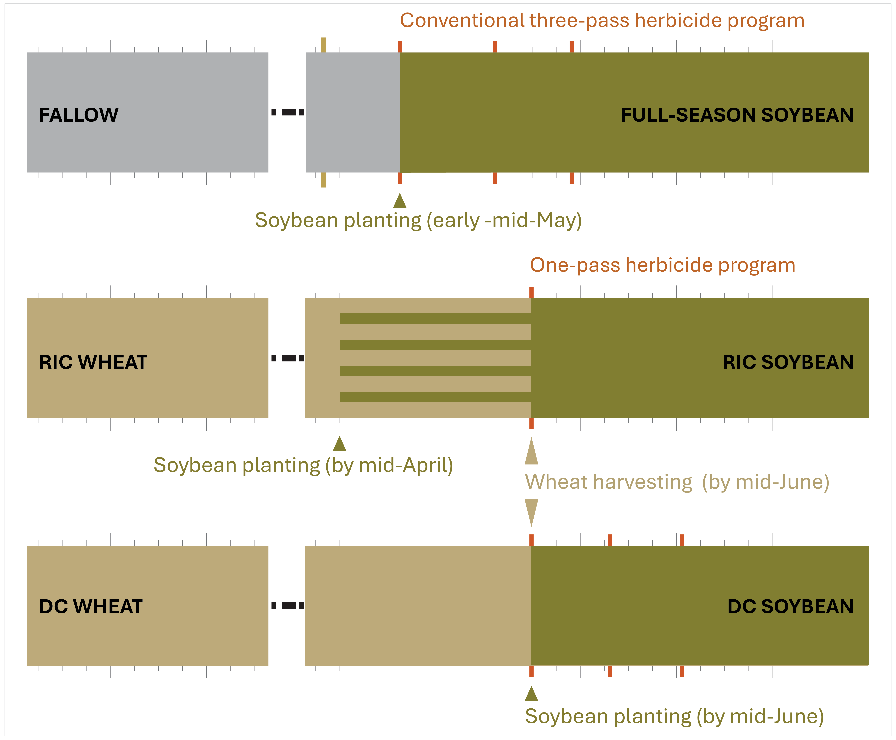
Figure 1. Timeline schematic of the three systems (full-season soybean, relay intercrop, double-crop), showing relative planting dates, herbicide programs (3-pass vs. 1-pass), and application timings. DC, double crop, RIC: relay intercrop.

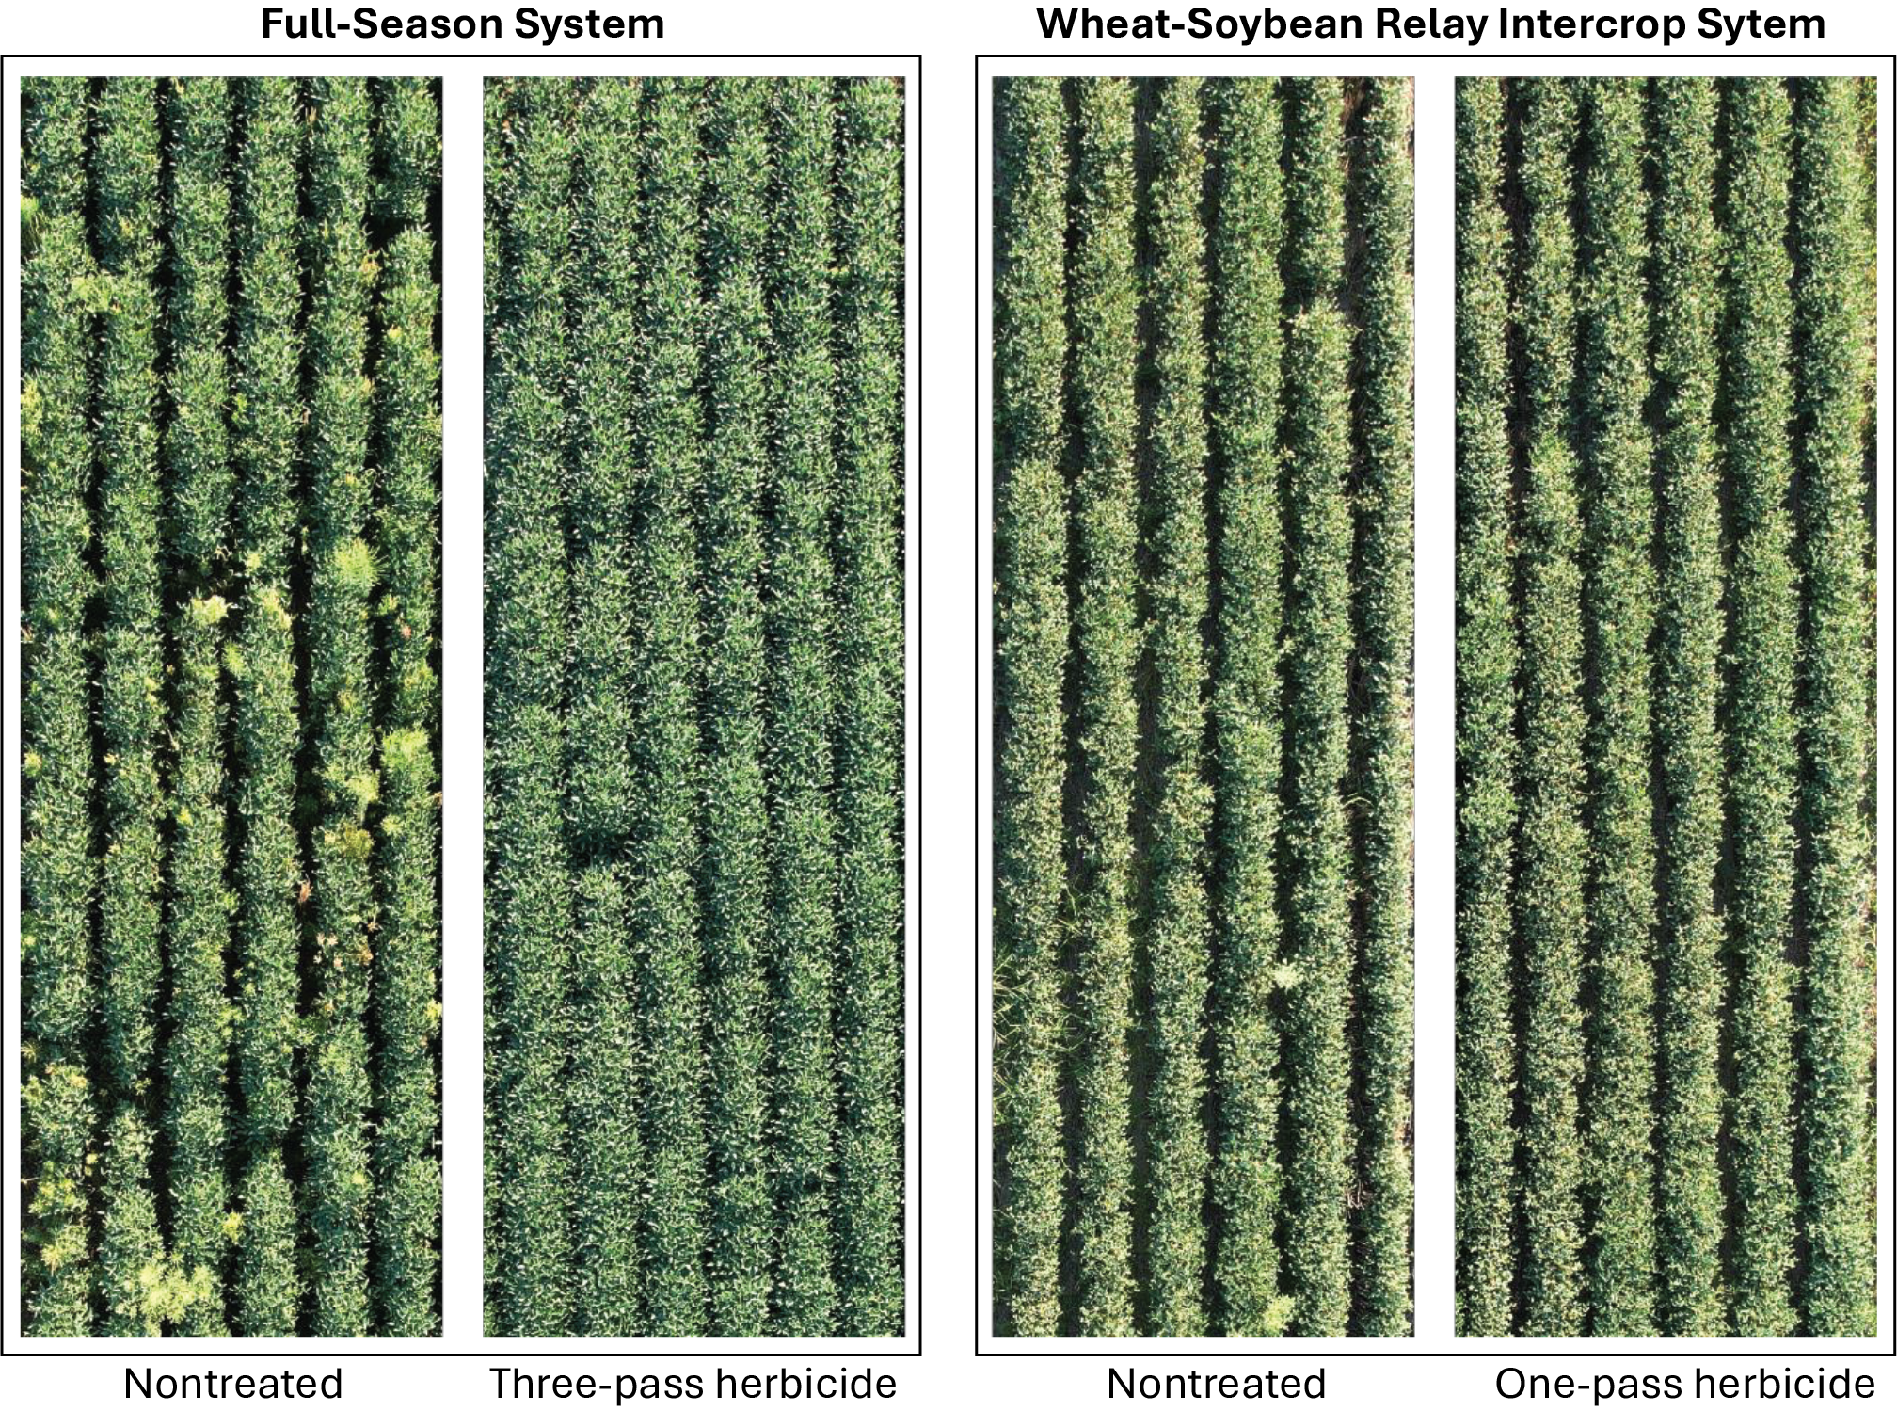
Figure 2. Aerial photo of research plots (August 12, 2024), showing 6 of 8 soybean rows.

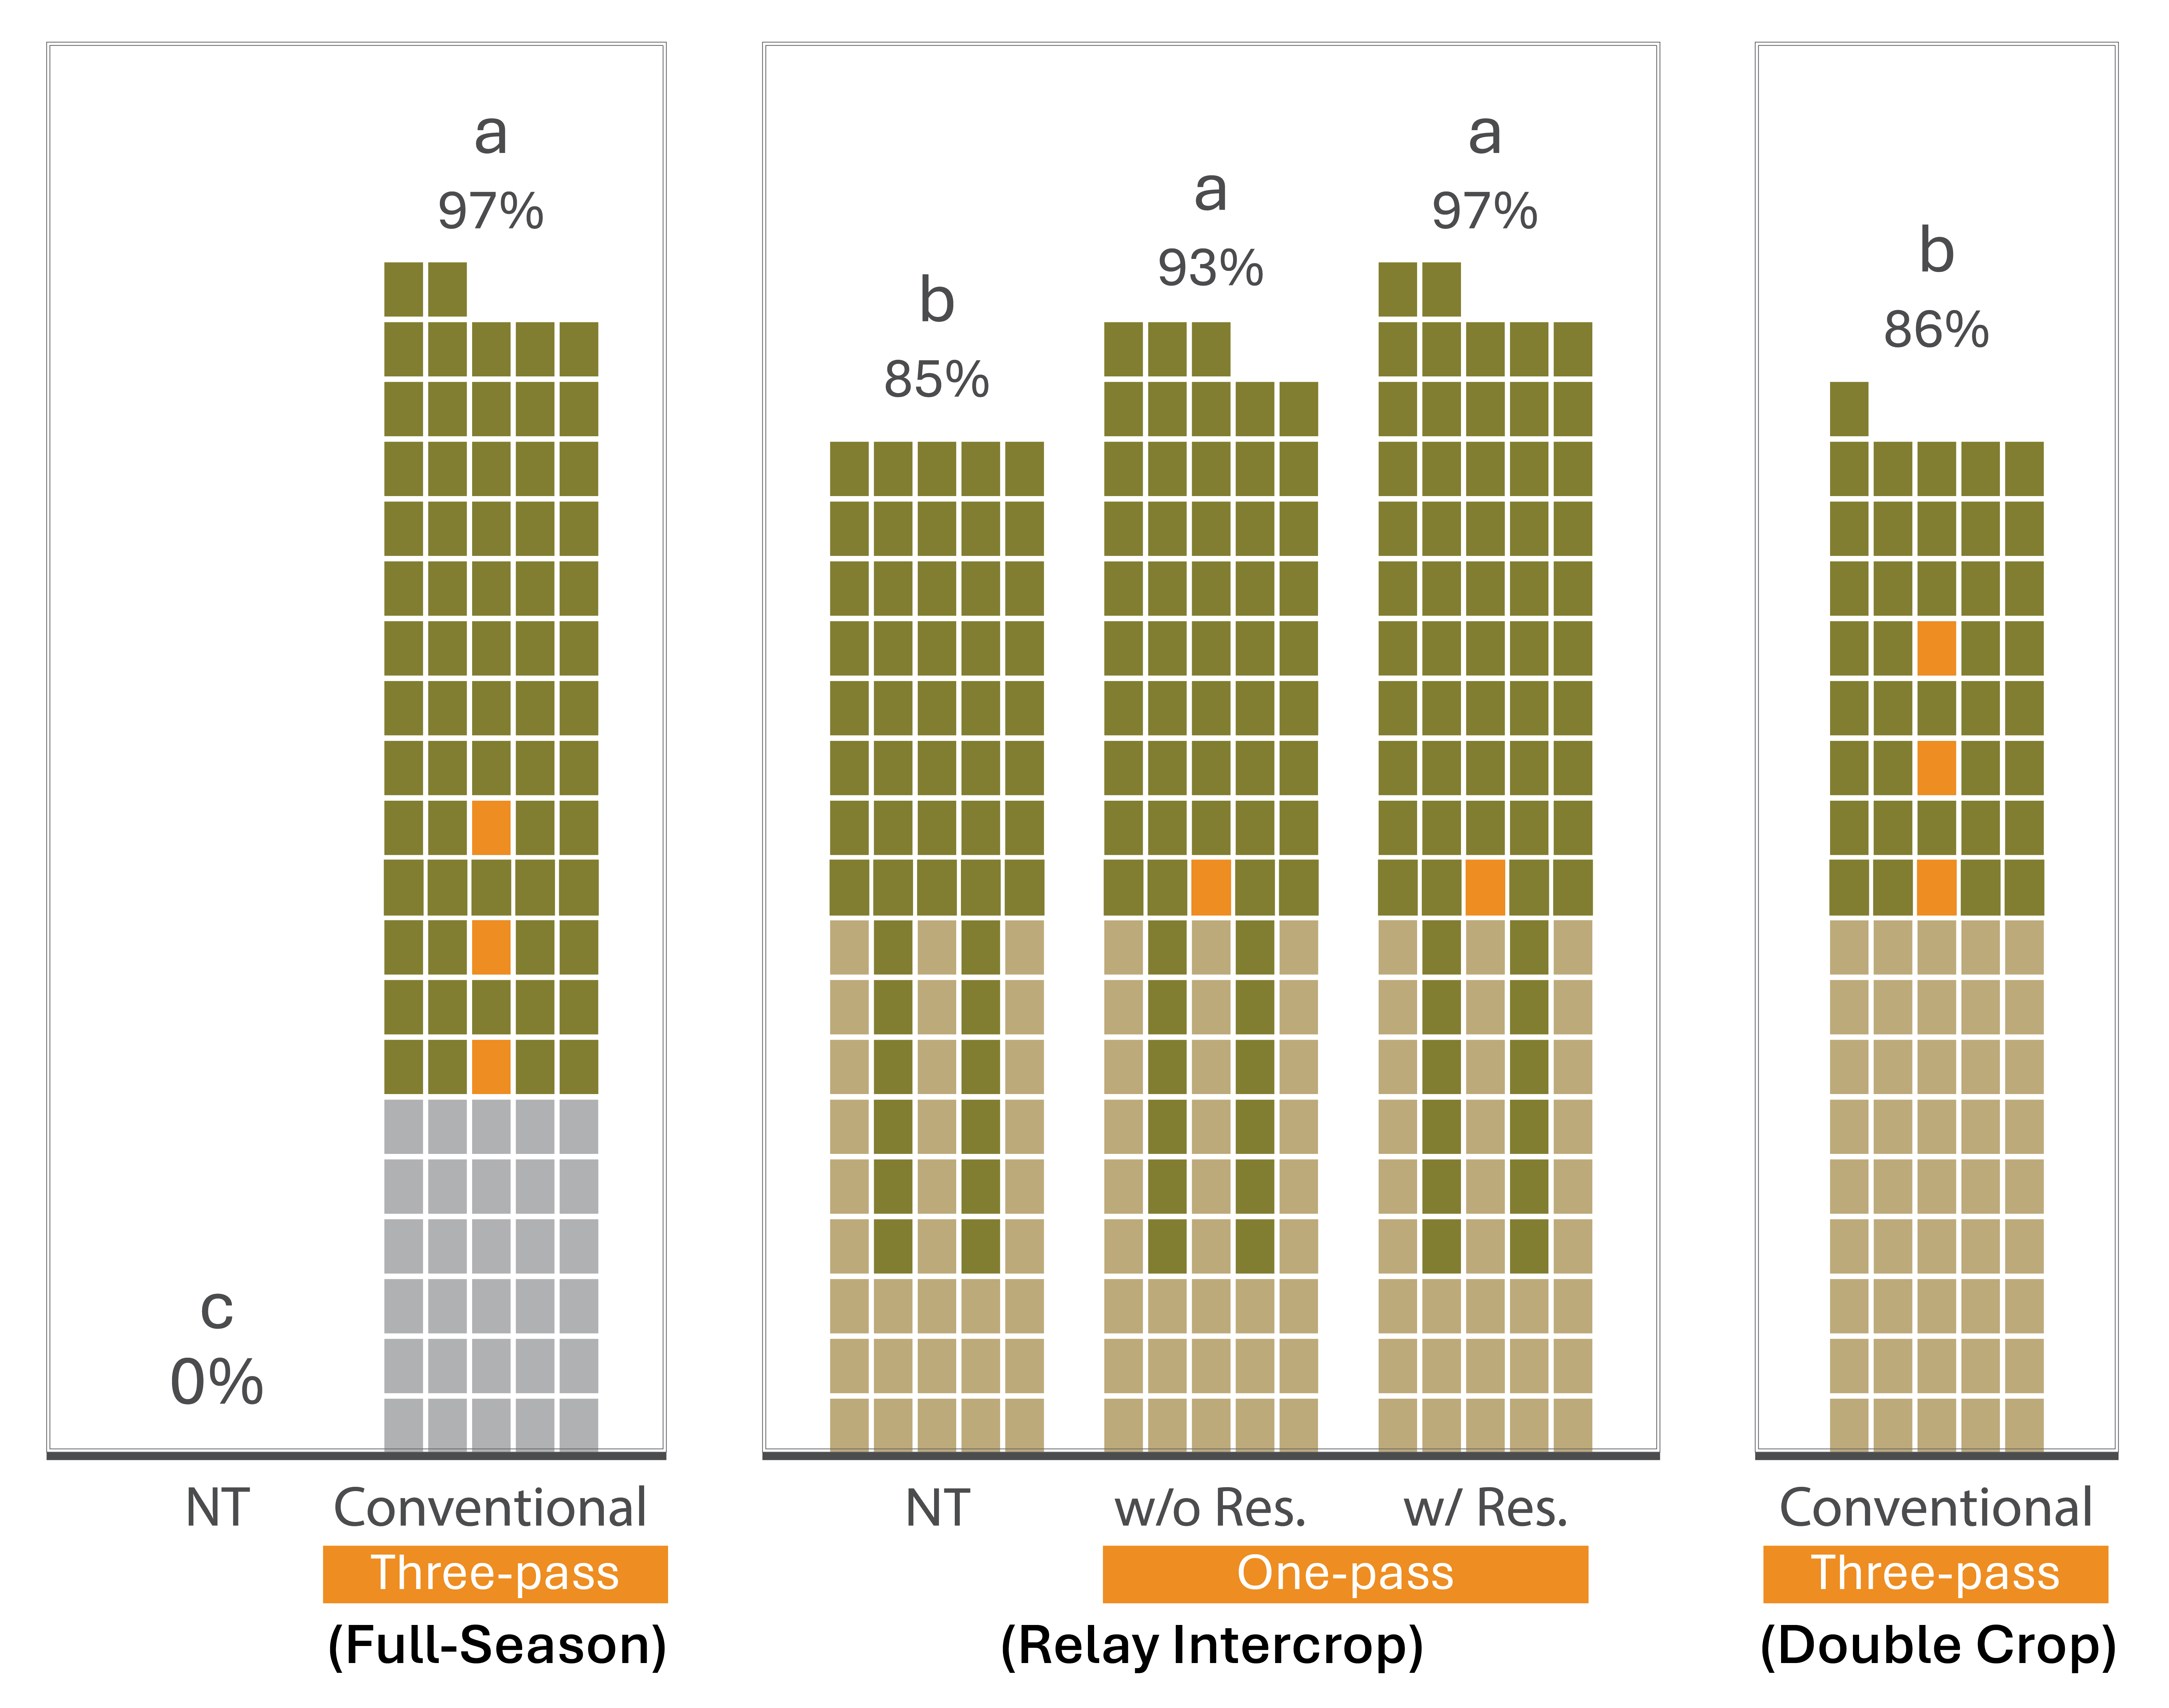
Figure 3. Palmer amaranth density reduction under full-season soybean, relay intercrop, and wheat-soybean double-crop systems. Means with similar letters are not significantly different at α = 0.05. NT, nontreated (no herbicide applied); Res., residual herbicide.

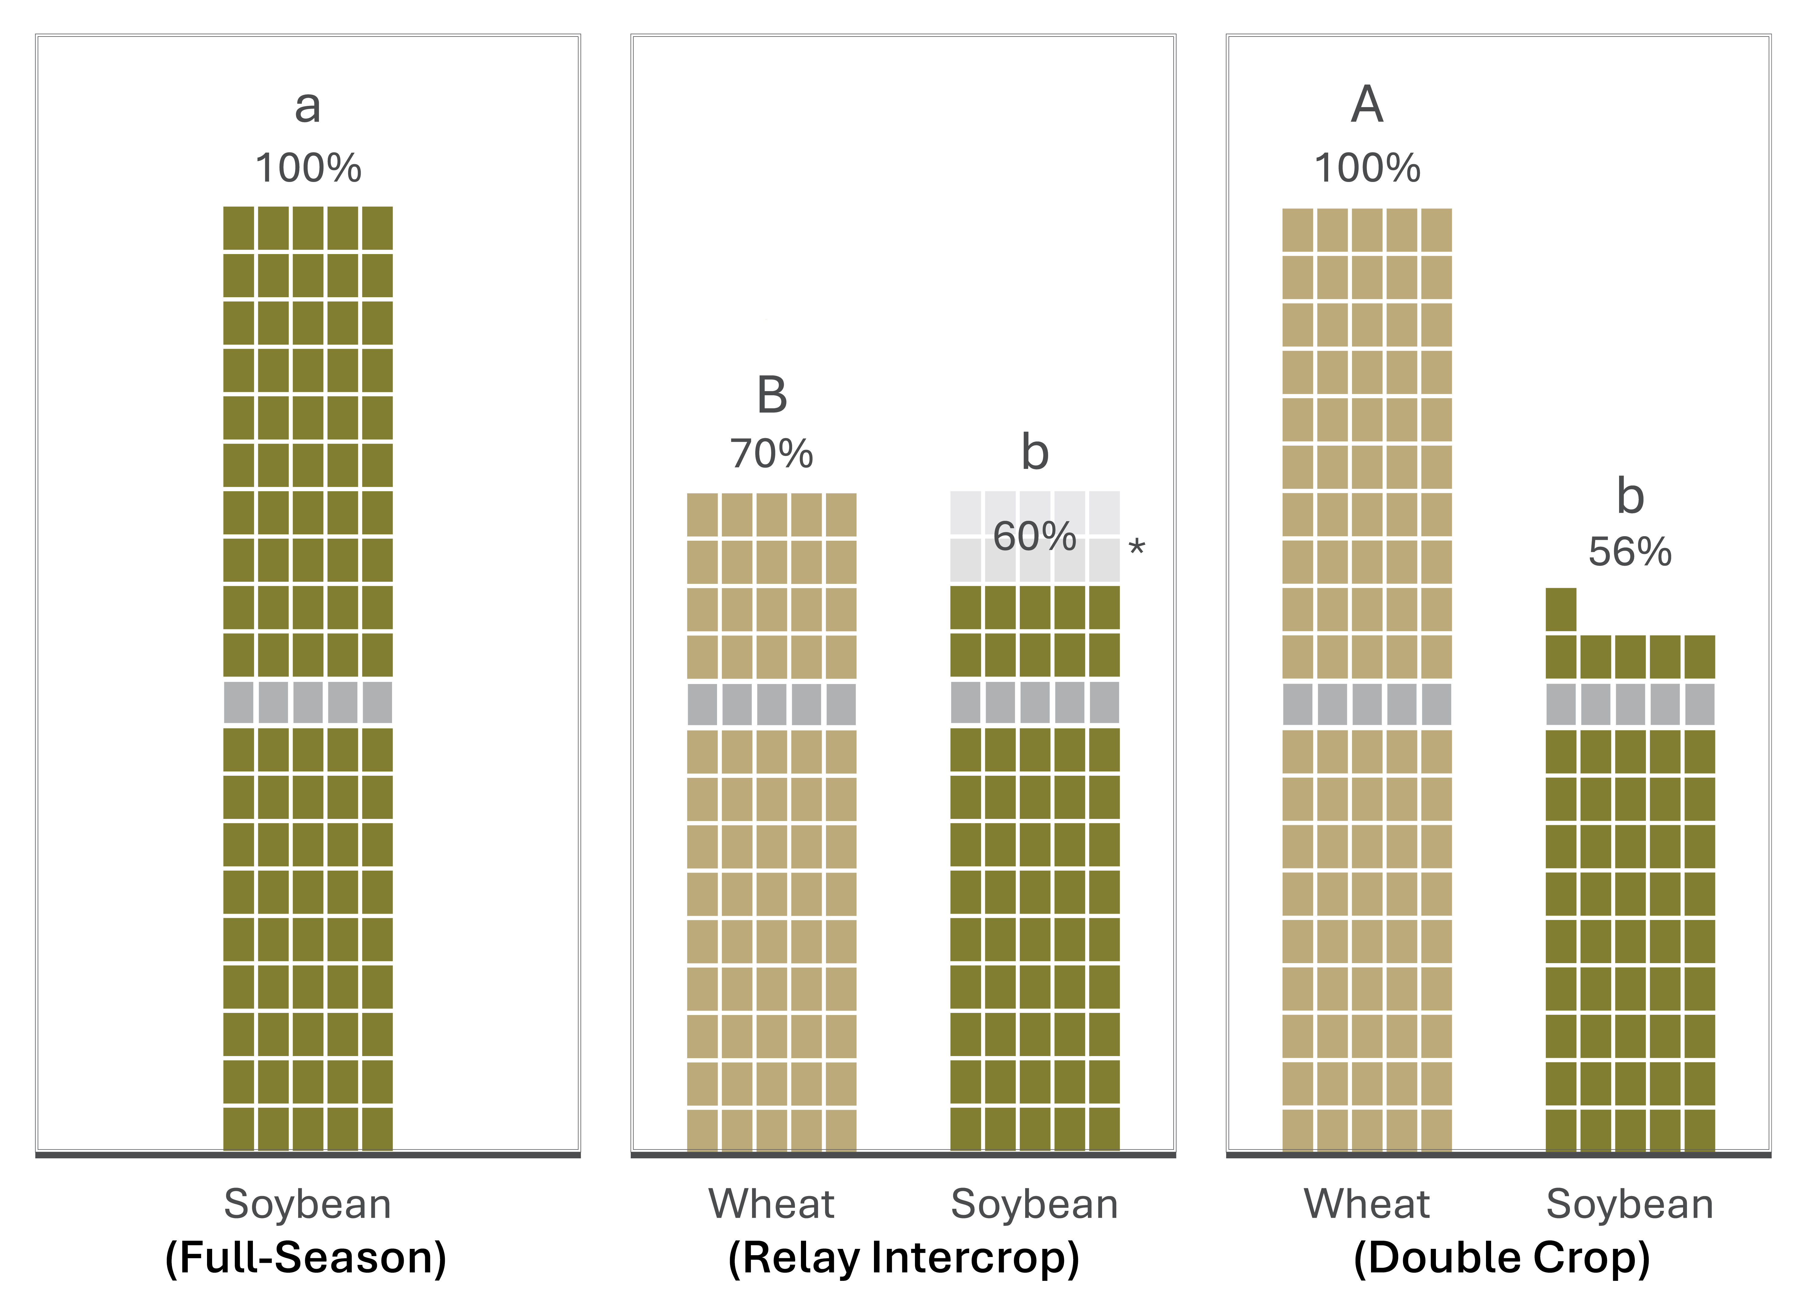
Figure 4. Wheat and/or soybean yield under full-season soybean, relay intercrop, and wheat-soybean double-crop systems. Means with similar letters are not significantly different from each other at α = 0.05. *Projected 5-10 percentage point increase in soybean yield, assuming clipping of soybean top during wheat harvest is eliminated.

