Please use this form to clearly and concisely report on project progress. The information included should reflect quantifiable results that can be used to evaluate and measure project success. Comments should be limited to the designated boxes. Technical reports, no longer than 4 pages, may be attached to this summary report.

Project Number:
Project Title: | Identification and confirmation of natural tolerance to off-target Dicamba damage in non-Xtend soybeans
Organization: | University of Missouri
Principal Investigator Name: | Grover Shannon
Other investigators: | Caio Vieira
Report Period: | September 15, 2023, to December 15, 2023
Research updates:
All field trials conducted in 2023 were harvested and data is being processed.

OBJECTIVE 1: Identification and selection of high-yielding tolerant advanced lines

1. Development of Enlist-E3 materials with off-target dicamba tolerance: Seven populations are being developed at the University of Arkansas consisting of a high-yielding Enlist-E3 line and a non-GMO dicamba-tolerant source (Table 1). Populations will be advanced until F4 and tested under off-target dicamba exposure in summer 2025. The goal is to develop MG 4 Enlist-E3 materials that can coexist in a predominantly dicamba-based cropping system.

Table 1. Enlist-E3 materials being crossed to non-GMO dicamba-tolerant genetic sources.
Name | Type | MG | 2024 Trials | 23 Yield | 23 %E3 CK
R23PR-00100 | Enlist-E3 | 4E | USDA UP 4E, AR-OVT | 61.9 | 101.5
R23PR-00043 | Enlist-E3 | 4E | USDA UP 4E, AR-OVT | 68.2 | 107.0
R23PR-00037 | Enlist-E3 | 4L | USDA UP 4L, AR-OVT | 69.2 | 106.6
R23PR-00068 | Enlist-E3 | 4L | USDA UP 4L, AR-OVT | 65.2 | 107.0
R23PR-00089 | Enlist-E3 | 4L | USDA UP 4L, AR-OVT | 67.6 | 93.2
R23PR-00035 | Enlist-E3 | 5E | USDA UP 5E, AR-OVT | 68.5 | 107.5
R23PR-00055 | Enlist-E3 | 5E | USDA UP 5E, AR-OVT | 70.1 | 107.9

2. Promising lines in regional test: Up to 32 high yielding, MG IV to early group V breeding lines with potential dicamba tolerance were entered into the 2023 USDA Southern Uniform Trials. These lines were previously exposed to dicamba in previous tests across the US Delta and were selected for high yield and lower damage and less yield loss to Dicamba. Based on yield performance and tolerance to Dicamba, the best lines will be proposed for release. Local data in Portageville, MO and 4 locations across different states has been analyzed and is being compiled to determine which lines to test for broad adaptation across more environments.

3. Advanced yield trials: A total of 72 advanced breeding lines were planted in Portageville, MO (4 local environments) and 6-8 locations across different states (OH, IL, AR, LA, OH, TN, MO). One non-GMO line (Figure 1.) showed excellent tolerance to Dicamba. Parental lines and sister lines were sent to Dr Jason Norsworthy’s lab in Arkansas for screening in the greenhouse at different dicamba rates and length of exposure. Selected lines from the advanced trials will be entered into 2024 USDA Uniform trials based on yield performance.
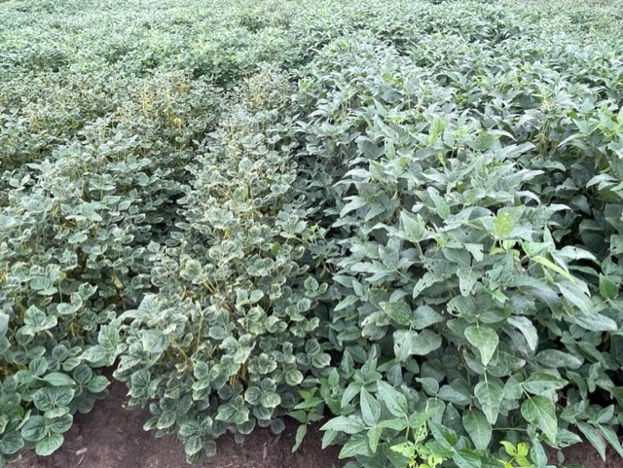
Figure 1. Line on the left dicamba sensitive, line of the right natural tolerance to dicamba

4. Preliminary yield trials: A total of 1,224 soybean late III to Late IV breeding lines were planted in Portageville, MO (3 local environments) and two outside locations in AR and MO. Based on yield performance, 120 lines will be evaluated in 2024 advanced yield trials at up to 10 locations in Missouri, Arkansas, and Tennessee.

5. Progeny row selections
F_{4:5} single plant progenies from 8 crosses involving dicamba tolerant parents were grown in single rows in the progeny testing nursery in 2023. A total of 53 soybean lines were visually selected based on pod load and agronomic traits. Those lines will be evaluated in our 2024 preliminary yield trials at up to five locations and will be screened visually after off-target exposure to Dicamba.

5. Breeding populations advancements: Seven breeding populations to improve off target damage from Dicamba are being advanced from F₁-F₄ in winter nurseries in Costa Rica, which are expected to produce at least 700 new breeding lines to be evaluated in progeny rows in 2024.

6. New crosses 2023: We made 17 new crosses between Dicamba tolerant and elite breeding lines during the summer of 2023 to develop new high yielding, dicamba tolerant, elite lines with high yield potential and multiple pest resistance. Two crosses were made using S16-12774 (tolerant) crossed to tolerant PIs, 424298 and 438335 to combine and map genes for greater tolerance to Dicamba. Emphasis will be to develop lines primarily in late III to late IV maturity groups.
CROSS | PEDIGREE
S23-416 | LG19-4084 x S13-3851
S23-419 | LG19-4084 x S19-10701
S23-426 | K19-2402 x S16-13165
S23-427 | K19-2402 x S17-17644
S23-430 | SA18-12086 x S13-3851
S23-431 | SA18-12086 x S19-10701
S23-434 | SA18-12086 x S19-12409
S23-435 | SA18-12086 x S19-14797
S23-452 | S13-2743 x PI 438335
S23-453 | PI 424298 x S13-2743
S23-454 | S16-12774 x PI 438335
S23-455 | S16-12774 x PI 424298
S23-456 | S16-12774 x S19-10701
S23-457 | S16-12774 x S13-3851
S23-459 | S16-12774 x S19-12409
S23-592 | S16-12774 x S22-9065
S23-594 | S19-7867R x S22-9065

OBJECTIVE 2: Genomic studies to identify significant marker-trait associations to dicamba tolerance.

Dicamba QTL mapping populations: Two RIL mapping populations were visually phenotyped at the R3-R4 growth stages for dicamba tolerance during the summer of 2023. Data from tolerance ratings on each genotype are being utilized for detailed mapping analysis, providing a deeper comprehension of the genetic factors contributing to non-GMO tolerance. Preliminary results from the phenotypic data from Marianna, AR and Portageville, MO showed a wide range in tolerance levels among genotypes. The mapping populations are being tested for a third year in 2024 in Marianna, AR and Portageville, MO.

