REQUEST FOR FUNDING OF RESEARCH
2019-2020 FUNDING CYCLE

TITLE: Screening and Selecting Non-Xtend Soybeans for Dicamba Tolerance

INVESTIGATORS:
Caio Vieira (Graduate Student)
Pengyin Chen (Advisor)
Professor and Soybean Breeder
University of Missouri – Delta Center
573-379-6958
Chenpe@missouri.edu

PROGRAM AREA (check all that apply):

_x_ Management of weeds, to include resistance management and economics
___Irrigation/water management
___Quality of harvested seed—Phomopsis/Seed rot
___ Disease Management/Control
___ Fertility needs (especially P and K) for optimum and economical yield
___ Insect management/Control, especially late-season populations
___ Harvest aids
___ Iron Chlorosis
___ Nematode management/control
___ Rotations using soybeans
_x_ Research Validation or Demonstration
_x_ Producer Communications
_x_ Variety Trials
_x_ Economics
___ Other (Identify)

PROJECT STATUS:

New __x__ (1 of 3)

Renewal ____ (Year of )

Stand alone _x_ or cross-commodity ___ (additional funding from other sources?)

2019 FUNDING REQUEST ___$65,500___

BUDGET FOR 2019 MSSB RESEARCH PROJECT
CATEGORY (see below for guidelines) |  | ORIGINAL
A. | Personnel (No Permanent Salaries)
 | 1. Salaries (See Addendum B)
 | 2. Wages (hourly workers) | $19,500
 | 3. GRA (include tuition) | $34,500
B. | Fringe Benefits (% used to calculate) | $405 (7.5%)
C. | Travel | $3,500
D. | Contractual Services
E. | Subcontracts
F. | Commodities (materials and supplies) | $2,500
G. | Publication Costs | $595
H. | Other Costs (plot fees) | $4,500
TOTAL COST |  | $65,500
(MSSB does not allow indirect costs/overhead charges)
Personnel: Show number of hours x hourly rate for each category. GRA cost to include tuition and books. MSSB does not pay salaries of principal investigators or cooperating scientists (USB Compliance Manual, Sect. 17, Part 2-D).
Fringe Benefits: Amount and rate for indicated salaries, wages, and GRAs must be shown.
Travel: Out-of-pocket and per diem expenses (hotel and meals) for site visits, travel to and from meetings (e.g. airfare, vehicle mileage not to exceed the IRS rate), etc.
Contractual Services: External lab fees, consultants, etc.
Commodities: Expenses related to the conduct of the project (e.g., seed, fertilizers, pesticides, lab supplies).
Additional Details: Provide for each budget category in addendum if necessary.
Reminder: All payments for project activities are on a reimbursable basis based on an itemized invoice submitted to MSSB each quarter along with a progress report.
Budget Transfers: The MSSB follows USB guidelines, which state “The PI may transfer funds amongst budget categories only with MSSB’s prior written consent if (i) the amount transferred exceeds 10% of any one general budget category (per annual period) or (ii) the funds transferred are travel related. PI shall request permission from MSSB for all budget reallocations and account for them in his/her financial report.”
Additional Instructions: See Addendum B.
TECHNICAL SUMMARY

Dicamba, a benzoic acid herbicide with auxin-like activity, has recently gained popularity after the development and commercialization of genetically modified dicamba-tolerant soybeans in 2016. Since then, the adoption of this technology has widespread across the United States along with many reports of off-target drift damaged in non-tolerant soybean fields. The United States Department of Agriculture reported over 2,700 official Dicamba-related injury investigations in soybean in 2017, of which over 2,300 were placed in Mid-south US states with Missouri Bootheel being most affected. Soybeans are naturally susceptible to Dicamba, and exposure to this herbicide results in plant stunting and abnormal leaf development known as cupping. The severity of the symptoms and yield penalty will vary based on the growth stage, dosage of exposure, and potentially genetic background. Reports in the literature indicate that soybeans are more sensitive to dicamba exposure at flowering stage when compared to vegetative growth stages, however no literature is available on the genetic variations causing different responses to dicamba exposure. In 2019, a field assay in 650 plots exposed to severe Dicamba off-target drift damage at the University of Missouri – Delta Center Soybean Breeding indicated distinct degrees/severity of symptoms across different genotypes. The differentiation in response to Dicamba represents an opportunity to select naturally dicamba-tolerant soybeans, as well as identify the genetic variations underlying the natural tolerance. Therefore, the objectives of this research proposal is to use phenotypic and genotypic approaches to characterize natural variation in response to Dicamba drift and select and develop soybean varieties adapted to mid-south United States with enhanced natural tolerance to the Dicamba herbicide. A set of 200 high-yielding soybean lines developed at the University of Missouri - Delta Center Soybean Breeding will be tested for yield performance at three locations (sand, clay and loam soils) in two different planting dates (Late-April and Mid-May) with three replications. The experimental design will be randomized complete block. Dicamba injuries will be scored at vegetative (V4) and reproductive growth stages (R1 and R5). Scores will range from 1 to 5, where 1 represents no visible symptoms and 5 represents severe symptoms of Dicamba injury. To identify regions of the soybean genome regulating tolerance to Dicamba, a genome-wide association study will be conducted using the genotypic platform SoySNP6K. A mixed-linear model will account for genotypic and environmental variability, enhancing the ability to detect regions in the genome regulating Dicamba tolerance. A haplotype conferring the desired tolerance trait will be designed by selecting the most efficient subset of SNPs and validated by prediction accuracy through cross-validation. In addition, the dicamba injury data will be correlated to the yield data for selecting most tolerant and high yielding lines as compared to the Xtend check varieties. The selection and development of natural tolerant soybean varieties to Dicamba could potentially benefit Mid-south US growers that are growing conventional or alternative herbicide-tolerant varieties. The identification of haplotypes conferring tolerance to Dicamba could also benefit public breeding programs that do not have legal authorization to incorporate the Xtend technology.

OUTLINE OF RESEARCH

RATIONALE/JUSTIFICATION FOR RESEARCH:

Dicamba is a benzoic acid herbicide with auxin-like activity widely used in agricultural crops and pasture. It was first described in 1958, and later approved for use in the United States in 1962. Dicamba has recently gained popularity after the US Environmental Protection Agency (EPA) approval of a formulation to be used on dicamba-tolerant soybean in 2016. Since then, the adoption of this technology has widespread across the United States along with several reports of off-target damage in non-tolerant soybean fields. In 2017 the United States Department of Agriculture (USDA) reported 2,708 official Dicamba-related injury investigations in soybean, of which over 2,300 were filed in Mid-south US states. This represented over 2.8 million soybean acres in Mid-south US that experienced some degree of drift injuries.

Soybeans are naturally susceptible to Dicamba, and penalty in yield can be observed under doses as low as one twenty-thousandths of the 1x rate of 0.5 pounds of acid equivalent formulation per acre. The most prominent symptoms are the abnormal leaf development known as cupping and plant stunting. The severity of the symptoms and yield penalty will vary based on the growth stage, dosage of exposure, and potentially genetic background. Reports in the literature indicate that soybeans are more sensitive to dicamba exposure at flowering stage as compared to vegetative stages. Visible injury symptoms of 30% in vegetative stages were unlikely to cause yield penalty greater than 5%. However, injury symptoms as little as 12% in reproductive stages were likely to cause yield penalty greater than 5%.

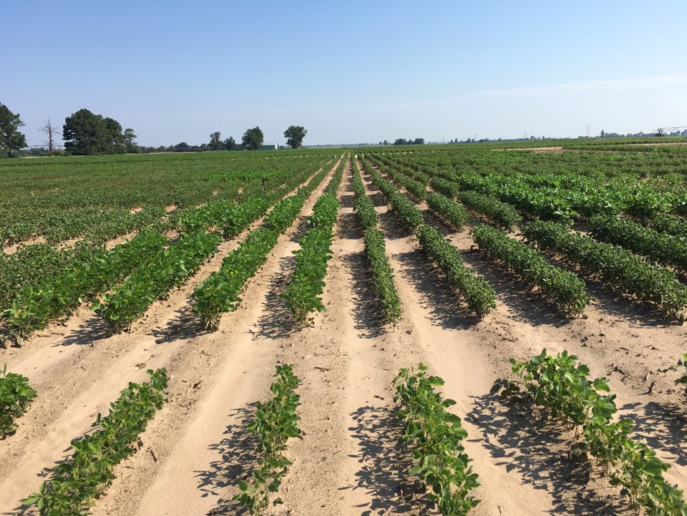

Figure 1. Soybean field with tests plots in Clarkton affected by Dicamba off-target damage.

Figure 2. Soybean response to dicamba off-target exposure evaluated across 650 field plots in 2019.
A consistent different level of response to off-target dicamba exposure has been observed at the University of Missouri – Delta Center. In 2019, a field assay across 650 soybean yield plots exposed to severe Dicamba off-
target damage in vegetative stage V4 indicated that severity of symptoms in non-Xtend soybeans ranged from mild (2) to severe (5), while dicamba-tolerant checks consistently demonstrated absence of symptoms (1) (Figures 1-3). This differentiation in response represents an opportunity to select natural dicamba-tolerant soybeans and to identify the genetic variations underlying the differential response. Currently, no literature is available on the genetic variations causing different responses to dicamba exposure.

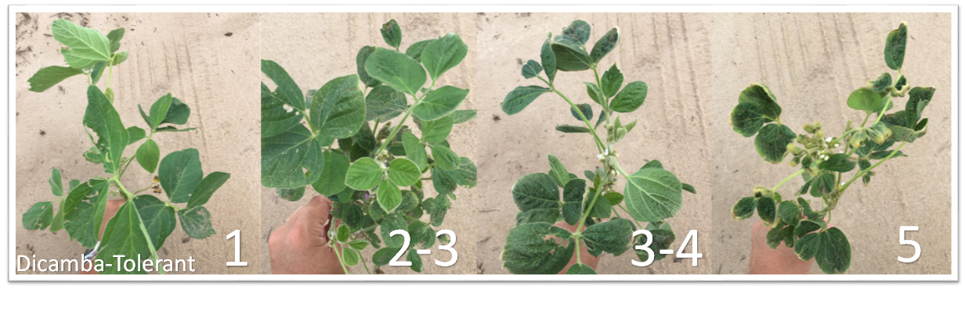
Figure 3. Representation of different degrees of off-site injury caused by Dicamba in a 1-5 scale.

OBJECTIVE(S):

The objectives of this research proposal are to 1) characterize the differential response to Dicamba drift damage, 2) identify regions of the soybean genome regulating tolerance to Dicamba through genome wide association studies; 3) select and develop soybean lines adapted to mid-south United States with enhanced natural tolerance to Dicamba; and 4) design and implement haplotypes tolerant to Dicamba to fasten the development of tolerant soybean cultivars.

APPROACH AND EXPERIMENT CONDUCT:

The overall objective of this research proposal is to select and develop soybean lines adapted to mid-south United States with enhanced natural tolerance to the Dicamba herbicide. We will use both phenotypic and genotypic approaches to precisely and efficiently characterize plant differential responses and select tolerant lines. A set of 200 high-yielding soybean lines developed at the University of Missouri - Delta Center Soybean Breeding program will be tested for yield performance at three locations (sand, clay and loam soils) in two different planting dates (Late-April and Mid-May) with three replications. The experimental design will be randomized complete block design (RCBD). Plots will be monitored for dicamba injuries and harvested for yield data.

Dicamba injuries will be scored in vegetative (V4) and reproductive growth stages (R1 and R5). Scores will range from 1 to 5, where 1 represents no visible symptoms and 5 represents severe symptoms of Dicamba injury (Figure 3). This approach will enable the identification of yield penalty due to severity of Dicamba injury, as well as the ability of specific genotypes to recover throughout the season. Once the tolerant lines are identified, they will also be tested in controlled environments under different Dicamba dosage exposures.

To identify regions of the soybean genome regulating tolerance to Dicamba, a genome-wide association study will be conducted using the single nucleotide polymorphism (SNP) package SoySNP6K. It will be used as response both injury scores (field and controlled environment) and yield penalty. A mixed-linear model will account for genotypic and environmental variability, enhancing the ability to detect regions in the genome regulating Dicamba tolerance.

Haplotypes will be designed by selection of the most efficient subset of SNPs conferring the desired tolerance trait. Confirmation of superior subset will be assessed by prediction accuracy through cross-validation. Haplotypes will be implemented early in the pipeline to efficiently select tolerant lines. Selected lines will be re-tested in the following year to confirm the natural tolerance.

PROJECTED IMPACT OF RESULTS ON MID-SOUTH SOYBEAN PRODUCTION

The United States Department of Agriculture reported over 2,700 official Dicamba-related injury investigations in soybean in 2017, of which over 2,300 were placed in Mid-south US states. This represented over 2.8 million soybean acres in Mid-south US that experienced some degree of injuries. The selection and development of natural tolerant soybean varieties to Dicamba could potentially benefit Mid-south US growers that are either growing conventional or alternative herbicide-tolerant varieties. Additionally, public breeding programs do not have the access to the Xtend technology for breeding purposes. Therefore, the identification and design of haplotypes with natural enhanced Dicamba tolerance represents a powerful tool to public breeding programs to maintain the flux of their cultivar development pipeline.

EXPECTED END PRODUCT(S)

The expected end products of this research project will include: 1) well characterized differential response in soybean to dicamba drift injuries, 2) high-yielding soybean lines adapted to Mid-south US with enhanced tolerance to Dicamba; 3) identified genomic regions responsible for enhanced Dicamba tolerance and respective haplotypes; and 4) a journal publication reporting the impact of Dicamba injury on soybean yield, and 5) a poster presentation for graduate students at professional conference to share the research findings with the scientific community.

