Please use this form to clearly and concisely report on project progress. The information included should reflect quantifiable results that can be used to evaluate and measure project success. Comments should be limited to the designated boxes. Technical reports, no longer than 4 pages, may be attached to this summary report.
Project Title: | Soybean yield components and seed nutrient concentration responses among nodes to phosphorus fertility
Organization: | University of Arkansas & Louisiana State University
Principal Investigator Name: | Gerson L. Drescher, gldresch@uark.edu  Collaborators:  Nathan A. Slaton, nslaton@uark.edu  Trent Roberts, tlrobert@uark.edu  Rasel Parvej, mrparvej@agcenter.lsu.edu
Report Period: | final

Project Status: finalized (year 3 of 3)

NON-TECHNICAL ABSTRACT
The project's objectives were to evaluate the effects of phosphorus (P) nutrition on irrigated soybean seed yield, selected yield components (seed weight, pod and seed numbers, and seed abortion among nodes), the patterns of tissue-P concentration across time, and seed nutrient concentration among nodes. The project was conducted from 2021 to 2023 on soils having low soil-test P at the Louisiana State University AgCenter’s Macon Ridge Research Station in Winnsboro, LA, and the University of Arkansas Division of Agriculture’s Rice Research Extension Center, near Stuttgart, AR, and the Pine Tree Research Station, near colt, AR. Results from six site-years consistently show that plants receiving no-fertilizer P have lower leaf-P concentrations at early reproductive stages, smaller leaf area and canopy coverage, lower seed weight, and fewer pods and seeds across node sections than the fertilized treatments. Seed abortion followed a similar trend as soybean yield components, with the highest-yielding node sections also having the greatest seed abortion indicating potential competition for P or other resources among developing seeds. Soybean seed weight, seed-P concentration, and grain yield were significantly affected by P deficiency, suggesting that adequate P availability is key for profitable soybean production. Results from this project will assist producers in diagnosing in-season P deficiency and fine-tuning fertilizer-P management for optimal soybean yield.

TECHNICAL SUMMARY
Soybean [Glycine max (L.) Merrill] is one of the most widely grown leguminous crops in the world and is an important source of protein, oil, and micronutrients in human and animal diets. Soybean is widely cultivated on arable soils with limited phosphorus (P) availability. Investigating whether soybean yield, yield components, and the seed nutrient concentration among nodes are affected differently by P deficiency will help to develop more efficient fertilization practices or lead to improved methods for monitoring plant P nutrition and yield potential. Field trials were carried out from 2021 to 2023 in long-term sites varying in soil P availability (low to high) in Arkansas and P-deficient sites in Louisiana. We evaluated leaf-P concentration across time and soybean seed yield, individual seed weight, pod and seed numbers per plant, seed abortion, and seed nutrient concentrations among nodes at maturity of soybean grown under different soil and fertilizer P availability levels created after several years of P fertilization with different fertilizer-P rates. Our results show the patterns of tissue P concentration across time, how P and other nutrients are allocated among seeds at different positions, and which yield components and nodes are affected by P deficiency. Soybean removes the equivalent of 0.8 lb P₂O₅/bu which sums to 40 and 60 lb P₂O₅/ac for yields of 60 and 75 bu/ac, respectively. Failure to replace the nutrient removal by the harvested grain with adequate fertilizer rates contributes to soil nutrient depletion and eventual nutrient deficiencies that will limit soybean yield. Having more information on how soybean yield components are affected at different soil P levels is paramount for profitable and sustainable farming. The results of this study will be summarized and used in state, regional, and nation-wide educational programs to improve grower and consultant awareness of how P fertilization can affect soybean yield potential. Final results will be published in an appropriate peer-reviewed journal (e.g., Agronomy Journal), and were already shared in experiment station research series and presented in professional meetings.

OUTLINE OF RESEARCH
INTRODUCTION
Soybean [Glycine max (L.) Merr.] is a major row crop worldwide because of its nutritional value for both human and animal consumption (Esper Neto et al., 2021). It is also of great importance for the economies of the mid-Southern United States. Soybean yield potential is related to several production factors, such as cultivar, environmental conditions, and soil physical, chemical, and biological properties. When the soil has a limited capacity to supply enough nutrients to satisfy the plants' demand for adequate growth, fertilization is necessary. Among the nutrients with low availability in the soil, special attention is given to phosphorus (P) due to its complex and dynamic nature in the soil system, high adsorption capacity to the soil mineral phase, and importance in plant metabolism.
A recent summary of Arkansas soil-test results shows that 41% of the acres cropped to soybean have soil-test P <25 ppm and 14% of the acres test <16 ppm (DeLong et al., 2021), where yield responses to fertilization may occur. Phosphorus is required in relatively large amounts for proper soybean yield. Harvested soybean seed removes the equivalent of 0.8 lb P₂O₅ per bushel (Esper Neto et al., 2021) and accounts for the removal of about 70% of the plants' aboveground P content at maturity. Soybean yields of 50 and 75 bu/ac remove 40 and 60 lb P₂O₅/ac which are valued at $33.2 and $49.8, respectively, when priced as fertilizer nutrients ($764/ton of triple superphosphate, average price of January-July 2022). Failure to replace the nutrient removal by the harvested grain with adequate fertilizer rates contributes to soil nutrient depletion and eventual nutrient deficiencies that will limit crop yield and soil productivity in the long term (Mozaffari et al., 2020). In contrast, overfertilization can increase production cost and result in soil-P build-up, which can contribute to increased P loss and adverse effects on the environment. Therefore, the challenge is to provide sufficient amounts of nutrients so that crops can express their maximal productivity while being economically viable and environmentally safe.
Compared with potassium (K) deficiency, soybean is relatively tolerant to P deficiency and the published literature has limited information describing the effect of P deficiency on soybean growth and yield. A better understanding of how low soil-P availability influences soybean growth and yield components among nodes is important for developing more efficient fertilization practices and improving methods for monitoring plant P nutrition, yield potential, and seed quality. Our objectives were to evaluate the effects of P fertility on soybean seed yield, selected yield components (individual seed weight, pod and seed numbers, and seed abortion among nodes), the pattern of tissue P concentration across time, and seed nutrient concentration among nodes. Specifically, we aimed to identify how seed yield, individual yield components, leaflet-P concentration, and seed nutrient concentrations are affected by P deficiency.

APPROACH AND EXPERIMENT CONDUCT
The research was performed from 2021 to 2023 in a long-term P trial established in 2007 at the University of Arkansas System Division of Agriculture (UADA) Rice Research and Extension Center (RREC-21, RREC-22, and RREC-23), near Stuttgart, AR., in 2023 on a long-term P trial established in 2013 at the UADA Pine Tree Research Station (PTRS-23), near Colt AR, and two single site-years established in 2021 and 2023 on soils with low soil-test P at the Louisiana State University AgCenter’s Macon Ridge Research Station (MRRS-21 and MRRS-23), near Winnsboro, LA, totalizing six field trials. The soils are mapped as a Dewitt silt loam at the RREC, as a Calloway silt loam at PTRS, and as a Gigger-Gilbert silt loam at MRRS (NRCS USDA, 2024). Two additional trials were established at the MRRS in 2022 and 2023, but the trials were irrigated with groundwater rich in salts (i.e., 2,131 ppm) which caused severe plant injury and compromised the experiments. Therefore, the investigators decided to abandon the trials and not analyze the leaf samples that were collected and not measure yield components among node sections.
The long-term experiment at RREC is a randomized complete block design with 6 blocks that contain 5 fertilizer-P rates (0, 40, 80, 120, and 160 lb P₂O₅/ac/year) applied as triple superphosphate (TSP; 0-46-0) annually. The research area contains adjacent and duplicate trials that allow both rice (Oryza sativa L.) and soybean to be grown each year. Individual plots measure 15-ft wide and 25-ft long, which allows 2 passes with a small plot (8-row) drill with 7.5-in. row spacings. The research area has been managed with no-tillage since the beginning of the trial, is flood-irrigated, and rotated with rice. The same P-fertilizer treatments have been applied annually to each plot since the trial was initiated with applications made to the soil surface as early as February (pre-plant) to as late as immediately following crop planting. Ample rates of fertilizer-K are applied uniformly to the trial area to ensure that only P is potentially limiting crop growth. The mean Mehlich-3 P concentration (0- to 4-in. depth) among the 5 annual fertilizer-P rates ranges from 10 to 114 ppm.
The PTRS experiment is a randomized complete block design with 4 blocks that contain three fertilizer sources [monoammonium phosphate (MAP, 11-52-0) only (no potash), MAP + muriate of potash (MOP; 0-0-60), or MicroEssentials SZ (12-40-0-10S-1Zn) + Aspire (0-0-58-0.5B)] with each fertilizer-P source applied at 0, 30, 60, 90, and 120 and lb P₂O₅/ac/year. The MOP and Aspire are applied at a uniform rate to provide 120 lb K₂O/acre/year. The trial also contains two no-P controls with one receiving 120 lb K₂O/acre/year as MOP and one receiving no potash (N only when cropped to corn). The site is furrow irrigated (30-inch bed spacing) and cropped with a 1:1 soybean and corn (Zea mays L.) rotation. The mean soil-test P among the four annual fertilizer-P rates ranges from 8 to 45 ppm.
The experiments located at MRRS had a randomized complete block design with 4 blocks. Each experimental plot was 35-ft long x 13.33-ft wide and contained 4 rows. Fertilizer-P rates (0, 40, 80, 120, and 160 lb P₂O₅/ac as TSP) were broadcast on the top of the seedbed on the same day as soybean planting. Based on initial soil-test results, before setting up the trial, the 2021 trial area received 2 tons/ac of lime (87% calcium carbonate equivalent (CCE); applied in fall 2020 and incorporated with tillage) and was fertilized 20 lb sulfur (S)/ac (gypsum; 16% S), and 10 lb zinc (Zn)/ac (zinc sulfate; 20% Zn and 5% S) at planting. In addition, the MRRS-21 and MRRS-23 were fertilized with 80 and 120 lb K₂O/ac as MOP to ensure adequate amounts of K for plant development, according to the Louisiana State University guidelines for soybean production. Both trials were furrow irrigated (40-in. bed spacing). Selected soil chemical properties for the RREC, PTRS, and MRRS trials are presented in Table 1.
For trials in Arkansas, Pioneer (Pioneer Hi-Bred International, Johnston, Iowa) P52A43L, P52A14SE, and P52A05X soybeans were planted on 21 May 2021, 6 June 2022, and 16 May 2023 at the RREC, respectively, and the P45A40LX cultivar was planted on May 31 at PTRS. For trials in Louisiana, Pioneer 48A60X soybeans were planted on 27 April 2021 and Progeny P4604XFS (Progeny Ag Products, Wynne, Arkansas) soybeans were planted on 9 May 2023, at the MRRS, respectively.
The annual soil-test results and prior-year crop yield results (up to and including 2020) were used to select 3 annual fertilizer-P rates that produce different growth and yield and represent Deficient (0 lb P₂O₅/ac/year), Low (30 or 40 lb P₂O₅/ac/year), and Optimal (80 or 90 lb P₂O₅/ac/year) P availability for soybean yield production to evaluate soybean yield components among node sections. At maturity (R8), six whole mature plants were collected (cut at the soil surface) from a middle row of each plot to evaluate selected soybean yield components as affected by main-stem and branch node locations and P fertility levels. Thereafter, the four most uniform plants/plot were selected and their nodes were numbered from the topmost node (node 1) to the bottom node. Selected plants were dissected from the top of the plant to the bottom, and tissues from each plot were composited by node section, each consisting of two nodes and two internodes. Tissues from each dissected node section were separated into i) stem and branch internodes, ii) pods, and iii) seeds to evaluate selected yield components (number of pods, number of seeds, and seed weight) responses among nodes to P fertility. Branches were separated into the same plant components as described for the main stem and the yield components (number of pods, number of seeds, and seed weight) were added to the associated main stem node section where the branch was located.
Soybean pods were examined, and the number of filled and unfilled seed cavities was recorded to evaluate the distribution of the total percentage of seed abortion among node sections [(total number of unfilled cavities per node section/total number of cavities per plant) × 100]. Soybean seeds were counted and weighed to evaluate the total seed weight from each node section after discarding the aborted and/or malformed seeds.
Data for the maturity group (MG) 4 (MRRS-21, MRRS-23, and PTRS-23) and 5 (RREC-21, RREC-22, and RREC-23) cultivars were analyzed separately due to different growth habits (e.g., number of branches and number of nodes). For canopy coverage and grain yield, only the main effect of fertilizer rate was evaluated. For the 2021 individual yield components, each fertility study was conducted as a factorial with 3 fertilizer-P rates and 8 (RREC 3×8 factorial) or 11 (MRRS 3×11 factorial) node sections. At each site, plots were arranged in a randomized complete block design with 4 replications (only 4 of the 6 replicates were sampled at RREC). Soybean seed weight, selected yield components, and seed abortion data were subjected to analysis of variance (ANOVA) using the GLIMMIX procedure in SAS (v9.4, SAS Inst., Cary, N.C.). When the F test was significant (P ≤ 0.10), the means were compared using Fisher’s protected least significant difference at the 0.10 probability level. The correlation (Pearson linear correlation coefficient) between soybean pod number and seed abortion was also evaluated using the CORR procedure in SAS. Regression analysis was performed to evaluate the pattern of seed-P and leaf-P concentration and individual seed weight distribution among node sections for each fertilizer-P rate.

RESULTS AND DISCUSSION
Field experiments were carried out from 2021 to 2023 and data collected for this project encompassed six site years (RREC-21, RREC-22, and RREC 23, MG 5 soybean cultivars; and MRRS-21, MRRS-23, and PTRS-23, MG 4 soybean cultivars), totalizing 716 leaf samples, and 1449 seed samples. Due to the large dataset and the intent to keep this report simple and informative, the present report includes information on individual yield components and seed-P concentration for two site years (RREC-21 and MRS-21), seed weight and individual seed weight among node sections for five site-years (RREC-21, RREC-22, RREC-23, MRRS-21, and MRRS-23), canopy coverage for four site-years (RREC-21, RREC-22, RREC-23, and PTRS-23), and grain yield for all six site-years. Additional data will be provided upon request and included in peer-reviewed manuscripts currently under preparation.
The overall number of nodes/plant varied among soybean MG but was relatively consistent among fertilizer-P rates (average of 16, 17, and 16 nodes for the MG 5 soybean grown at the RREC-21, RREC-22, and RREC-23, respectively, and 21, 22, and 20 nodes for the MG 4 soybean plants at MRRS-21, MRRS-23, and PTRS-23), resulting in 8 to 12 node sections where soybean yield components and seed abortion were evaluated. Our observation while conducting the trials is that plants growing in the no-P control were visibly shorter than plants from the 40 and 80 lb P₂O₅/ac rate treatments. Soybean plants grown in the unfertilized treatment at RREC and PTRS also had smaller leaves which resulted in a lower canopy coverage at the V6 (except for RREC-21) and R1 development stages (Figures 1 & 2), indicating that the sub-optimal P availability limited plant growth and development.
Soybean pod number, seed number, and seed weight were affected (P ≤ 0.10) by fertilizer-P rate and node section at RREC and MRRS in the 2021 growing season (Table 2). The MG 5 soybean receiving 80 lb P₂O₅/ac at RREC-21 increased the number of pods, seeds, and seed weight by about 33%, 33%, and 30%, respectively, compared to the control and 40 lb P₂O₅/ac treatments, which did not differ from each other (Table 2). Likewise, fertilized treatments, regardless of rate, at MRRS-21 increased the number of pods, seeds, and seed weight of soybean plants by 19%, 19%, and 23%, respectively, in relation to the control. Although not statistically compared, the distribution of yield components among node sections varied between soybean MG. The MG 5 soybean had the greatest number of pods, seeds, and seed weight at node section 7, where branches were frequently observed (especially for the 40 and 80 lb P₂O₅/ac treatments), followed by the uppermost node sections 2, 3, and 1 (Table 2). On the other hand, the MG 4 soybean had the greatest number of pods, seeds, and seed weight at the intermediate node sections (node sections 5, 6, 4, and 7). These node sections (1, 2, 3, and 7 for the MG 5 cultivar, and 4, 5, 6, and 7 for the MG 5 cultivar) were responsible for 72% and 53% of the plants’ total seed weight, respectively. Regardless of the MG, the no-P control consistently had fewer pods and seeds across node sections than P-fertilized treatments, resulting in a lower mean seed weight node/section. The plant’s total seed weight was significantly (P ≤ 0.10) different between fertilizer-P rates at both RREC-21 and MRRS-21, with the lowest seed weight being observed in the no-P control (Table 2).
Overall, the greatest amount of seed weight was allocated on the plant main stem for the MG 4 cultivars (average of 66-76% of total seed weight per plant; Figure 3), but a greater number of branches were present at MG 5 soybean, especially at the bottom of the plant (node sections 5 to 8), that had substantial contribution (20-66%) to the plant total seed weight (Figure 4). There was an increasing number of pods and seeds (data not shown) on branches with increasing P availability, which resulted in greater seed weight on branches and overall seed production per plant (Figures 3 & 4). Beyond increasing seed weight, it is worth noting that adequate P availability contributed to an increased number of branches, which is paramount to compensate for potential soybean stand issues.
There was a significant P rate × node section interaction (P = 0.0314) for seed abortion in the RREC trial (Table 3). The MG 5 soybean at RREC-21 had the greatest relative seed abortion (1.3%–2.1%) in node sections 7 and 2 for the 80 lb P₂O₅/ac treatment, node section 4 for the no-P control, and node section 2 for the 40 lb P₂O₅/ac treatment (Table 3). For the MG 4 soybean at MRRS-21, only the main effect of node section was significant (P ≤ 0.10) for seed abortion with the greatest abortion (1.15%–1.56%) being observed in node sections 5, 3, 4, and 7 (Table 3). Overall, the total seed abortion/plant was about 6.3% for the MG 5 at RREC-21 and 11.0% for the MG 4 at MRRS-21. There was a positive correlation between pod number (r = 0.79 and 0.57) and seed abortion (n = 96 and 132) with P < 0.001 for RREC-21 and MRRS-21, respectively, as the greatest seed abortion was observed in the node sections that showed the highest pod and seed number. This behavior is probably related to the plant's inability to fill all seed cavities as a result of competition for P and other nutrients among developing seeds in these sections with an increased number of pods.
Soybean grain yield was significantly (P ≤ 0.10) affected by fertilizer-P rates in two out of six trials, where fertilized treatments produced 15-23% greater yield than the no-P control (Figure 5B & C), highlighting the importance of adequate P management for high soybean yield potential. In addition, numerical differences were observed in the MRRS-23 trial (Figure 5E). Individual seed weight fluctuated among node sections and fertilizer-P rates, with the no-P control showing smaller seed weight at MRRS-21, MRRS-23, RREC-22, and RREC-23 (smaller slope and consistent lower weight across node sections; Figures 6 & 7). A similar trend was also observed for seed-P concentration in the main stem and branch nodes for trials carried out in 2021, where the unfertilized control consistently showed lower seed-P concentration across branch and main stem node sections (Figure 8). These results indicate that P-deficient soybeans tend to produce fewer pods, less seed per pod, and seeds with lower weight and P concentration. Seed-P reserves, such as phytate which accounts for up to 50% of P in legume seeds, provide the germinating seed with a source of P for the synthesis of membrane lipids and nucleic acids (Rengel et al., 2022). Hence, below-optimum P availability not only impacts seed size and grain yield but also inorganic P accumulation, which may impact seed vigor, germination, and initial plant stand establishment.
Soybean leaf-P concentration is dynamic across time and declines as reproductive growth progresses, regardless of P fertilization and soybean MG (Figures 9, 10, and 11). Leaf-P concentration was consistently different among fertilizer-P treatments (80 > 40 > 0 lb P₂O₅/ac), with the greatest differences being observed at early reproductive stages (R1-R3). These results are consistent with the research of Slaton et al. (2021) who determined critical soybean leaf-K concentration. The authors highlight the importance of recognizing that critical tissue-K concentration is dynamic across time and greater accuracy in diagnosing K-deficient soybean is observed at early soybean reproductive development. Our results from five site-years indicate that leaf-P concentration is affected by P availability (either soil or fertilizer-P) and may be a good predictor of soybean grain yield potential. Leaf-P data is currently being summarized to calibrate critical leaf-P concentrations for optimal soybean production, which will be an invaluable tool to assist soybean growers in diagnosing soybean P nutritional status and determining the adequacy of fertilizer-P management.

PRACTICAL APPLICATIONS
Our results show that P availability significantly affects soybean growth and yield components among node sections. Specifically, we identified that sub-optimal P supply (via soil or fertilization) reduces plant height, canopy coverage, and the number of pods, seeds, and seed weight per plant and seed-P concentration. The soybean yield components and seed abortion followed a similar pattern across node sections, with the uppermost node sections plus node sections 5, 6, and 7 (where branches were frequently present) in the MG 5 cultivar and the middle portion of the MG 4 cultivar presenting the highest values. This trend is comparable to the results reported by Parvej et al. (2016) for soybean yield responses to K nutrition in determinate and indeterminate cultivars, indicating that both P and K are major nutrients that may influence soybean yield potential. Sub-optimal P availability compromised adequate plant growth and development, which is evidenced by the reduced plant height, yield components, seed weight, and seed-P concentration in soybean growing in the no-P control treatment. These results suggest that an adequate P-fertilizer management program is paramount to maximizing soybean production and profitability. While our research shows the importance of adequate P supply for optimum soybean growth and yield potential, additional research needs to be performed to validate the critical leaf-P concentration currently being developed and to investigate the window of opportunity to correct P-deficient soybean with in-season fertilization.

ACKNOWLEDGMENTS
This research was funded by the Mid-South Soybean Board, Arkansas Soybean Check-off funds, Arkansas Soil Test Review Board, and the University of Arkansas System Division of Agriculture.

PUBLICATIONS AND PRESENTATIONS SINCE 2021
Drescher, G.L., Slaton, N.A., Parvej, Md.R., Smartt, A.D., & Roberts, T.L. (2022). Soybean yield components among nodes are influenced by phosphorus fertility. In: J. Ross (ed.). Arkansas Soybean Research Studies 2021. University of Arkansas Agricultural Experiment Station Research Series 689:166-171. Available at: https://bpb-us-e1.wpmucdn.com/wordpressua.uark.edu/dist/3/599/files/2022/12/689_Arkansas_Soybean_Research_Studies_2021.pdf
Drescher, G.L., Slaton, N.A., Parvej, R., Roberts, T.L., & Smartt, A.D. (2022). Soybean yield components among nodes and temporal tissue-P concentration responses to phosphorus fertility [Abstract]. ASA, CSSA, SSSA International Annual Meeting. November 6-9, Baltimore, MD. https://scisoc.confex.com/scisoc/2022am/meetingapp.cgi/Paper/142649
Drescher, G.L., Slaton, N.A., Parvej, R., Roberts, T.L., & Smartt, A.D. (2022). Soybean yield components and seed nutrient concentration responses among nodes to phosphorus fertility. 25th Annual National Conservation Systems Cotton & Rice Conference. January 31-February 2, Jonesboro, AR.
Drescher, G.L., Slaton, N.A., Roberts, T.L., & Parvej, R. (2024). Soybean yield components and seed nutrient concentration responses among nodes to phosphorus fertility. 2024 Mid-South Soybean Board Winter Meeting. January 29, Jonesboro, AR.
Drescher, G.L., Slaton, N.A., Parvej, R., Roberts, T.L., & Smartt, A.D. (2023). Soybean yield components and seed nutrient concentration responses among nodes to phosphorus fertility. 2023 Mid-South Soybean Board Summer Meeting. August 29, Arlington, TX.
Slaton, N.A., Drescher, G.L., Parvej, R., Roberts, T.L., & Smartt, A.D. (2023). Soybean yield components and seed nutrient concentration responses among nodes to phosphorus fertility. 2023 Mid-South Soybean Board Winter Meeting. January 30, Baton Rouge, LA.
Slaton, N.A., Drescher, G.L., Parvej, R., Roberts, T.L., & Smartt, A.D. (2022). Soybean yield components and seed nutrient concentration responses among nodes to phosphorus fertility. 2022 Mid-South Soybean Board Summer Meeting. August 25-26, Newport, AR.
Drescher, G.L., Slaton, N.A., Parvej, R., Roberts, T.L., & Smartt, A.D. (2022). Soybean yield components and seed nutrient concentration responses among nodes to phosphorus fertility. 2022 Mid-South Soybean Board Winter Meeting. January 31. Jonesboro, AR.
Slaton, N.A., Drescher, G.L., Parvej, R., Roberts, T.L., & Smartt, A.D. (2021). Soybean yield components and seed nutrient concentration responses among nodes to phosphorus fertility. 2021 Mid-South Soybean Board Summer Meeting. September 8, Monroe, LA. (virtual)

LITERATURE CITED
DeLong, R.E., Slaton, N.A., Herron, C.G., & Lafex, D. (2021). Arkansas soil-test summary for samples collected in 2019. In: N.A. Slaton (ed.). W.E. Sabbe Arkansas Soil Fertility Studies 2020. University of Arkansas Agricultural Experiment Station Research Series 675:5-22. Available at: https://agcomm.uark.edu/agnews/publications/675_Sabbe_Arkansas_Soil_Fertility_Studies_2020.pdf
Esper Neto, M., Lara, L.M., Oliveira, S.M., Santos, R.F., Braccini, A.L., Inoue, T.T., & Batista, M.A. (2021). Nutrient removal by grain in modern soybean varieties. Frontiers in Plant Science, 12, 615019. https://doi.org/10.3389/fpls.2021.615019
Mozaffari, M., Wilson Jr., C.E., Hays, Z.M., Hedge, J.M., Mann, M.G., Perkins, K.M., Wimberley, R.A., & Sayger, A.M. (2020). Corn grain yield response to soil-applied phosphorus and potassium in Arkansas. In: N.A. Slaton (ed.). W.E. Sabbe Arkansas Soil Fertility Studies 2019. University of Arkansas Agricultural Experiment Station Research Series 666:51–55. Available at: https://agcomm.uark.edu/agnews/publications/666_Sabbe_Arkansas_Soil_Fertility_Studies_2019.pdf
NRCS USDA. (2024). Natural Resources Conservation Service, United States Department of Agriculture. Web Soil Survey. Available at: http://websoilsurvey.sc.egov.usda.gov/
Parvej, M.R., Slaton, N.A., Purcell, L.C., & Roberts, T.L. (2016). Soybean yield components and seed potassium concentration responses among nodes to potassium fertility. Agronomy Journal, 108, 854-863. https://doi.org/10.2134/agronj2015.0353
Renger, Z., Cakmak, I., & White, P.J. (Eds.). (2023). Marschner’s mineral nutrition of plants. Academic Press.
Schulte, E.E., & Hopkins, B.G. (1996). Estimation of soil organic matter by weight loss-on-ignition. In Magdoff F.R. et al. (Eds.), Soil organic matter: Analysis and interpretation (pp. 21–31). Madison, WI: SSSA.
Sikora, F.J., & Kissel, D.E. (2014). Soil pH. In Sikora F.J. and K.P. Moore (Eds.), Soil test methods from the southeastern United States (pp. 48–53). Southern Cooperative Service. Bulletin 419. Available at: http://aesl.ces.uga.edu/sera6/PUB/MethodsManualFinalSERA6.pdf
Slaton, N.A., Drescher, G.L., Parvej, Md.R., & Roberts, T.L. (2021). Dynamic critical potassium concentrations in soybean leaves and petioles for monitoring potassium nutrition. Agronomy Journal, 113, 5472–5482. https://doi.org/10.1002/agj2.20819
Zhang, H., Hardy, D.H., Mylavarapu, R., & Wang, J.J. (2014). Mehlich-3. In Sikora F.J. and K.P. Moore (Eds.), Soil test methods from the southeastern United States (pp. 101–110). Southern Cooperative Service Bulletin 419. University of Georgia. Available at: http://aesl.ces.uga.edu/sera6/PUB/MethodsManualFinalSERA6.pdf

TABLES AND FIGURES

Table 1. Soil chemical properties in the 0- to 4-inch depth at the Rice Research and Extension Center (RREC), Stuttgart, AR, Pine Tree Research Station (PTRS), near Colt, AR, and Macon Ridge Research Station (MRRS), Winnsboro, LA, prior to fertilizer-P treatment application in 2021, 2022, and 2023.
Location | P rate | SOMª | pH^{b} | Mehlich-3 extractable nutrients^{c}
 |  |  |  | P^{d} | K | Ca | Mg | S | Na | Fe | Mn | Zn | Cu | B
 | lb P₂O₅/ac | % | - | -----------------------------------------------pm---------------------------------------------
RREC-21e | 0 | 2.2 | 5.4 | 12c | 91 | 843 | 115 | 9 | 23 | 508 | 97 | 6.5 | 1.1 | 0.2
 | 40 | . | 5.4 | 25b | 93 | 882 | 111 | 8 | 22 | 553 | 84 | 7.1 | 0.8 | 0.2
 | 80 | . | 5.4 | 56a | 99 | 903 | 112 | 8 | 21 | 616 | 71 | 7.2 | 0.7 | 0.2
RREC-22e | 0 | 2.4 | 5.2 | 9c | 141 | 808 | 137 | 11 | 26 | 488 | 97 | 8.0 | 1.2 | 0.4
 | 40 | . | 5.3 | 23b | 121 | 828 | 130 | 11 | 26 | 534 | 81 | 7.1 | 0.9 | 0.4
 | 80 | . | 5.3 | 51a | 139 | 926 | 139 | 10 | 28 | 605 | 68 | 8.7 | 0.7 | 0.4
RREC-23e | 0 | 2.4 | 5.5 | 11c | 98 | 797 | 122 | 9 | 36 | 425 | 92 | 5.3 | 1.4 | 1.5
 | 40 | . | 5.5 | 24b | 102 | 858 | 123 | 9 | 34 | 469 | 89 | 4.8 | 1.1 | 1.6
 | 80 | . | 5.5 | 57a | 105 | 948 | 129 | 9 | 35 | 526 | 84 | 5.9 | 0.8 | 1.8
PTRS-23^{ef} | 0 | 2.4 | 7.0 | 8c | 85 | 1258 | 271 | 8 | 27 | 134 | 286 | 0.9 | 1.1 | 0.2
 | 30 | . | 7.0 | 18b | 93 | 1219 | 266 | 9 | 22 | 151 | 282 | 2.6 | 1.0 | 0.4
 | 90 | . | 7.0 | 32a | 87 | 1232 | 264 | 10 | 22 | 163 | 266 | 4.9 | 1.0 | 0.4
MRRS-21e | . | 2.1 | 4.7^{g} | 15 | 72 | 1087 | 236 | 21 | 76 | 187 | 114 | 1.3 | 1.0 | 0.3
MRRS-23e | . | 1.1 | 5.7^{g} | 12 | 59 | 1162 | 117 | 19 | 61 | 157 | 245 | 1.4 | 1.1 | 0.4
ª SOM = soil organic matter (Schulte and Hopkins, 1996).
^{b} Sikora and Kissel (2014).
^{c} Zhang et al. (2014).
^{d} Mehlich-3 soil-test P at RREC and PTRS trials is an effect of long-term fertilizer-P rates application. Mean soil-test P followed by different lowercase letters are statistically different at the 0.10 probability level.
^{e} Soil-test values prior to fertilizer-P treatment application and trial set up.
^{f} Soil test values from fertilizer-P rate treatments applied as MicroEssentials (MESZ).
^{g} Lime (2 ton/ac with 87% calcium carbonate equivalent (CCE)) was applied and incorporated with tillage before setting up the trial to increase soil pH to adequate levels for soybean growth.

Table 2. Soybean pod number, seed number, and seed weight as affected by fertilizer-P rate and node section at the Rice Research and Extension Center (RREC), Stuttgart, AR, and Macon Ridge Research Station (MRRS), Winnsboro, LA, in 2021.
Node Sec.ª | Pod Number |  |  |  | Seed Number |  |  |  | Seed Weight
 | P₂O₅rate (lb/ac) |  |  | Avg^{b} | P₂O₅rate (lb/ac) |  |  | Avg | P₂O₅rate (lb/ac) |  |  |  | Avg
 | 0 | 40 | 80 |  | 0 | 40 | 80 |  | 0 | 40 | 80
# | ------------------------------------------------- # ------------------------------------------------ |  |  |  |  |  |  |  | ------------------------- g ------------------------
 | -------------------------------------------------------------------------- RREC --------------------------------------------------------------------------
1 | 9.3 | 9.9 | 10.0 | 9.7 bc ^{c} | 21.6 | 22.7 | 23.1 | 22.5 bc | 3.01 | 2.94 | 3.14 | 3.0 a
2 | 10.3 | 12.4 | 13.6 | 12.1 ab | 23.8 | 27.7 | 31.1 | 27.5 ab | 3.20 | 3.56 | 3.79 | 3.5 a
3 | 8.5 | 11.6 | 10.8 | 10.3 bc | 20.2 | 25.6 | 25.0 | 23.6 b | 2.74 | 3.21 | 3.07 | 3.0 a
4 | 8.4 | 6.9 | 8.2 | 7.8 cd | 16.8 | 13.9 | 18.9 | 16.5 cd | 2.03 | 1.61 | 2.27 | 2.0 b
5 | 2.8 | 4.5 | 9.6 | 5.6 de | 6.3 | 9.6 | 19.8 | 11.9 de | 0.77 | 1.22 | 2.28 | 1.4 bc
6 | 3.9 | 2.9 | 4.1 | 3.6 e | 8.1 | 5.8 | 10.1 | 8.0 e | 1.10 | 0.61 | 1.10 | 0.9 c
7 | 8.4 | 15.2 | 20.4 | 14.7 a | 18.3 | 32.3 | 42.7 | 31.1 a | 2.28 | 3.75 | 5.02 | 3.7 a
8 | 0.5 | 0.0 | 9.6 | 3.4 e | 1.2 | 0.0 | 19.8 | 7.0 e | 0.15 | 0.00 | 2.35 | 0.8 c
Avg | 6.5 B | 7.9 B | 10.8 A |  | 14.5 B | 17.2 B | 23.8 A |  | 1.9 B | 2.1 B | 2.9 A
Total ^{d} | 52 C | 63 B | 86 A |  | 116 C | 137 B | 190 A |  | 15 B | 17 B | 23 A
CV(%) | 8.8 |  |  |  | 10.1 |  |  |  | 10.0
 | --------------------------------------------------------------------------- MRRS -------------------------------------------------------------------------
1 | 2.9 | 4.3 | 4.4 | 3.9 e | 7.0 | 9.7 | 9.7 | 8.8 e | 0.74 | 1.14 | 1.12 | 1.00 f
2 | 3.0 | 4.1 | 3.7 | 3.6 e | 7.3 | 9.4 | 8.3 | 8.3 e | 0.82 | 1.07 | 1.10 | 1.00 f
3 | 5.4 | 6.6 | 6.1 | 6.0 d | 11.9 | 14.8 | 13.3 | 13.3 d | 1.37 | 1.74 | 1.66 | 1.59 e
4 | 7.3 | 9.2 | 8.1 | 8.2 ab | 17.2 | 21.6 | 19.1 | 19.3 bc | 1.99 | 2.67 | 2.38 | 2.35 bc
5 | 9.0 | 9.6 | 9.4 | 9.3 a | 21.4 | 22.5 | 22.9 | 22.3 a | 2.51 | 2.73 | 2.97 | 2.73 a
6 | 8.4 | 9.4 | 9.4 | 9.1 ab | 19.4 | 22.2 | 22.3 | 21.3 ab | 2.35 | 2.81 | 2.88 | 2.68 ab
7 | 7.4 | 8.3 | 8.3 | 8.0 bc | 16.8 | 18.6 | 19.9 | 18.5 cd | 2.16 | 2.40 | 2.61 | 2.39 bc
8 | 6.3 | 6.9 | 6.4 | 6.5 d | 14.9 | 16.9 | 16.1 | 16.0 de | 1.90 | 2.10 | 2.18 | 2.06 cd
9 | 6.1 | 6.9 | 7.7 | 6.9 cd | 13.4 | 16.1 | 17.6 | 15.7 ef | 1.62 | 1.89 | 2.31 | 1.94 d
10 | 2.1 | 4.2 | 7.6 | 4.6 e | 3.9 | 9.3 | 15.8 | 9.6 g | 0.53 | 1.08 | 2.03 | 1.21 ef
11 | 0.8 | 2.5 | 0.8 | 1.4 f | 2.0 | 4.4 | 1.7 | 2.7 h | 0.05 | 0.38 | 0.17 | 0.20 g
Avg | 5.3 B | 6.5 A | 6.5 A |  | 12.3 B | 15.0 A | 15.1 A |  | 1.46 B | 1.82 A | 1.95 A
Total ^{d} | 59 B | 72 A | 72 A |  | 135 B | 166 A | 167 A |  | 16 B | 20 A | 21 A
CV(%) | 11.3 |  |  |  | 11.3 |  |  |  | 14.9
ª Node sections (two nodes and two internodes) are numbered from the top to the bottom of the plant.
^{b} Average.
^{c} Uppercase and lowercase letters compare the main effects of fertilizer-P rate and soybean node section, respectively, at the 0.10 probability level.
^{d} Total (sum of across node sections) number of pods and seeds, and seed weight plant⁻¹ for each fertilizer-P rate.

Table 3. Soybean seed abortion as affected by fertilizer-P rate and node section at the Rice Research and Extension Center (RREC), Stuttgart, AR, and Macon Ridge Research Station (MRRS), Winnsboro, LA, in 2021.
Node Section ª | P₂O₅rate (lb/ac) |  |  | Average
 | 0 | 40 | 80
# | ----------------------------------------------- Seed Abortion ^{b} (%) ----------------------------------------------
 | -------------------------------------------------------- RREC --------------------------------------------------------
1 | 1.06 bcde^{c} | 0.88 bcdefg | 0.74 cdefgh | 0.89
2 | 1.25 bc | 1.30 bc | 1.50 ab | 1.35
3 | 0.69 cdefghi | 1.23 bc | 1.07 bcde | 1.00
4 | 1.38 abc | 0.76 cdefg | 0.28 fghi | 0.81
5 | 0.20 ghi | 0.23 fghi | 0.96 bcdef | 0.46
6 | 0.16 ghi | 0.16 ghi | 0.37 efghi | 0.23
7 | 0.50 defghi | 1.18 bcd | 2.10 a | 1.26
8 | 0.04 hi | 0.00 i | 0.84 bcdefg | 0.29
Average | 0.66 | 0.82 | 0.98
Total ^{d} | 5.3 | 5.7 | 7.9
CV(%) | 26.6
 | -------------------------------------------------------- MRRS -------------------------------------------------------
1 | 0.83 | 1.01 | 1.23 | 1.03 cde
2 | 0.75 | 0.95 | 0.89 | 0.86 cde
3 | 1.61 | 1.74 | 1.15 | 1.50 a
4 | 1.55 | 1.22 | 1.43 | 1.40 ab
5 | 2.13 | 1.52 | 1.04 | 1.56 a
6 | 1.18 | 0.85 | 1.26 | 1.10 bcd
7 | 1.25 | 1.25 | 0.94 | 1.15 bc
8 | 0.78 | 0.85 | 0.39 | 0.67 e
9 | 0.66 | 0.84 | 0.88 | 0.80 cde
10 | 0.50 | 0.53 | 1.34 | 0.79 de
11 | 0.00 | 0.37 | 0.08 | 0.15 f
Average | 1.02 | 1.01 | 0.97
Total ^{d} | 11.3 | 11.1 | 10.6
CV(%) | 17.0
ª Node sections (two nodes and two internodes) are numbered from the top to the bottom of the plant.
^{b} Percentage of seed abortion among node sections = [(total number of unfilled cavities node⁻¹ section/total number of cavities plant) × 100].
^{c} Lowercase letters compare the interaction between fertilizer-P rate and soybean node section and the main effect of fertilizer-P rate at the 0.10 probability level.
^{d} Total (sum of across node sections) seed abortion plant⁻¹ for each fertilizer-P rate.

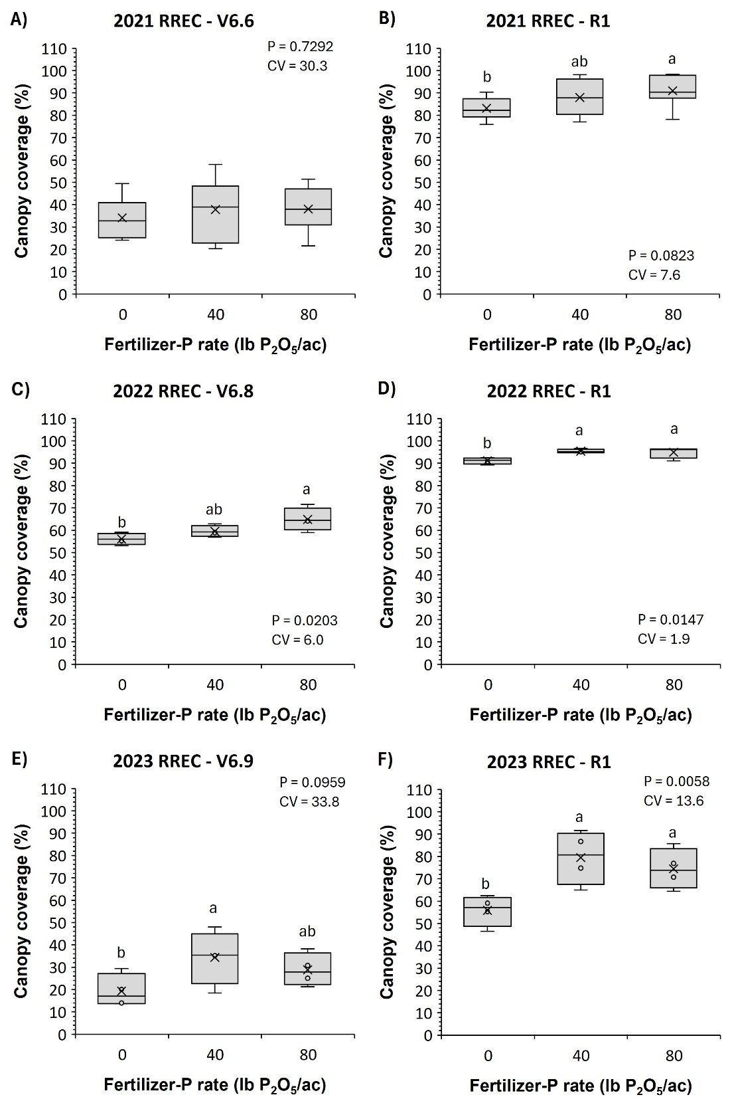
Figure 1 – Soybean canopy coverage at early vegetative (V6) and reproductive (R1) development as affected by long-term P fertilization (0, 40, and 80 lb P₂O₅/ac) during the 2021 (A and B), 2022 (C and D), and 2023 (E and F) soybean growing seasons at the Rice Research and Extension Center (RREC) near Stuttgart, AR. Lowercase letters above the box & whiskers compare the mean (×) value of fertilizer-P treatments at the 0.10 probability level.
.
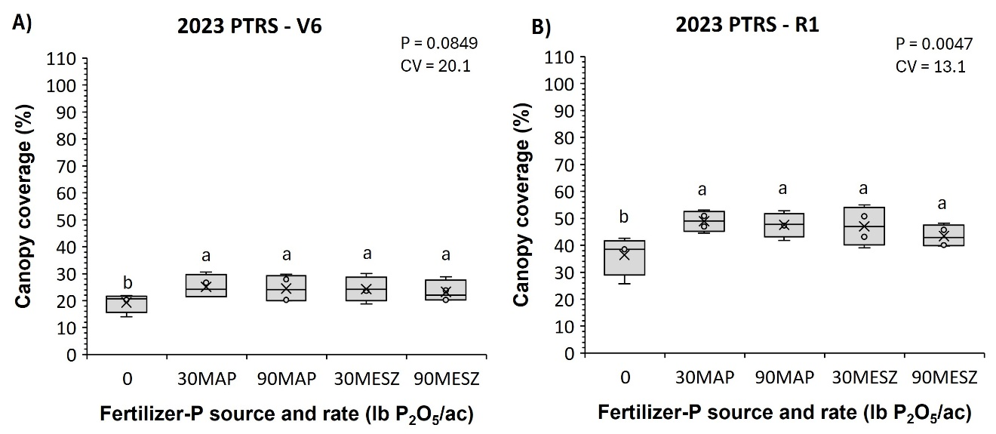
Figure 2 – Soybean canopy coverage at early vegetative (V6; A) and reproductive (R1; B) development as affected by fertilizer-P rate (0, 30, and 90 lb P₂O₅/ac) and source (monoammonium phosphate -MAP and MicroEssentials – MESZ) during the and 2023 soybean growing seasons at the Pine Tree Research Station (PTRS) near Colt, AR. Lowercase letters above the box & whiskers compare the mean (×) value of fertilizer treatments at the 0.10 probability level.

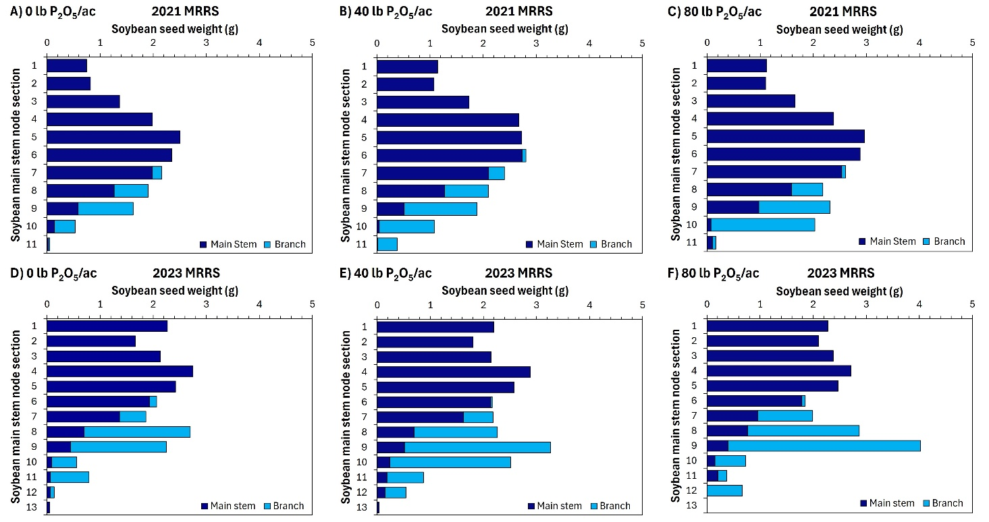
Figure 3 – Seed weight distribution among soybean plant node sections (two nodes and two internodes numbered from top to bottom) as affected by long-term P fertilization (0, 40, and 80 lb P₂O₅/ac) during the 2021 and 2023 growing seasons at the Macon Ridge Research Station (MRRS), near Winnsboro, LA.

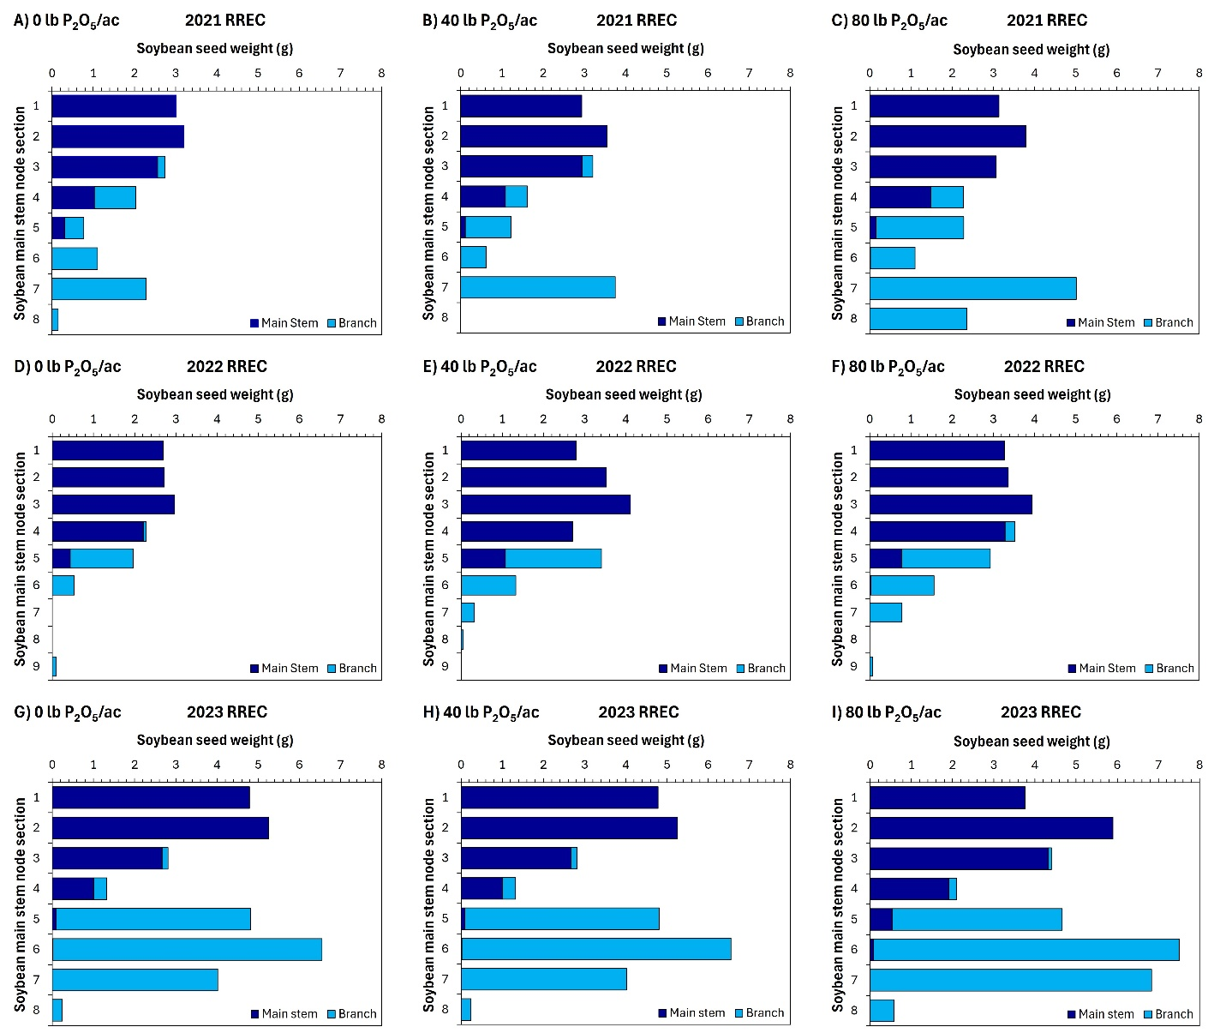
Figure 4 – Seed weight distribution among soybean plant node sections (two nodes and two internodes numbered from top to bottom) as affected by long-term P fertilization (0, 40, and 80 lb P₂O₅/ac) during 2021 (A, B, and C), 2022 (D, E, and F), and 2023 (G, H, and I) growing seasons at the Rice Research and Extension Center (RREC), near Stuttgart, AR.

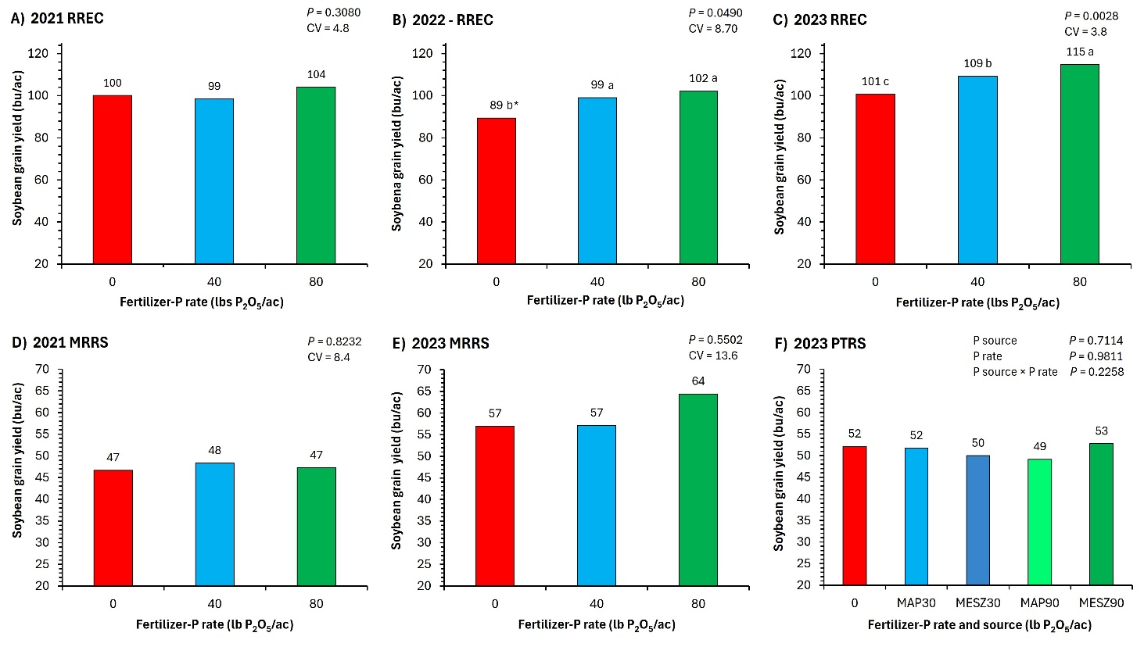
Figure 5 – Soybean grain yield as affected by P fertilization (0, 40, and 80 lb P₂O₅/ac) at the Rice Research and Extension Center (RREC), near Stuttgart, AR [2021 (A), 2022 (B), and 2023 (C)], at the Macon Ridge Research Station (MRRS), near Winnsboro, LA [2021 (D) and 2023 (E)], and the Pine Tree Research Station (PTRS), near Colt, AR (F). MAP: monoammonium phosphate; MESZ: MicroEssentials. *Means above the column followed by the same lowercase letter are not statistically different at the 0.10 probability level.

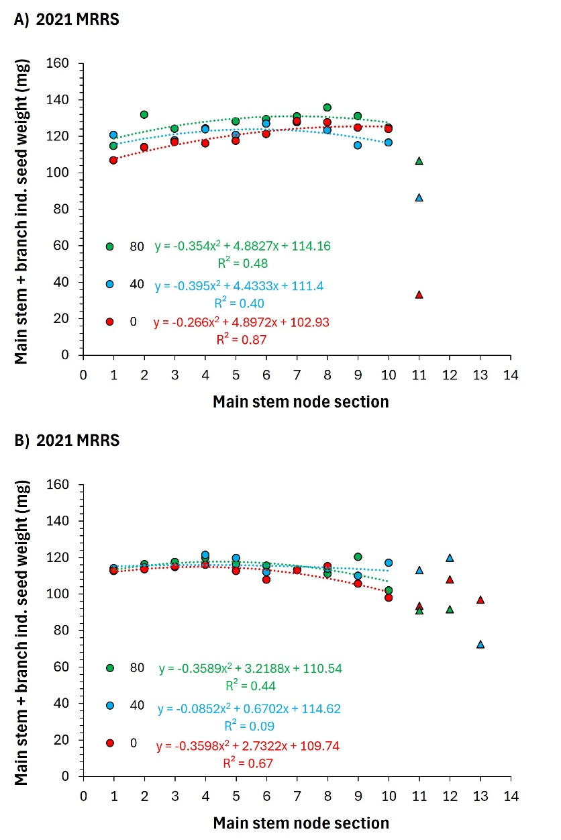
Figure 6 – Individual seed weight distribution among soybean plant node sections (two nodes and two internodes numbered from top to bottom) as affected by P fertilization (0, 40, and 80 lb P₂O₅/ac) during 2021 (A) and 2023 (B) growing seasons at the Macon Ridge Research Station (MRRS) near Winnsboro, LA.

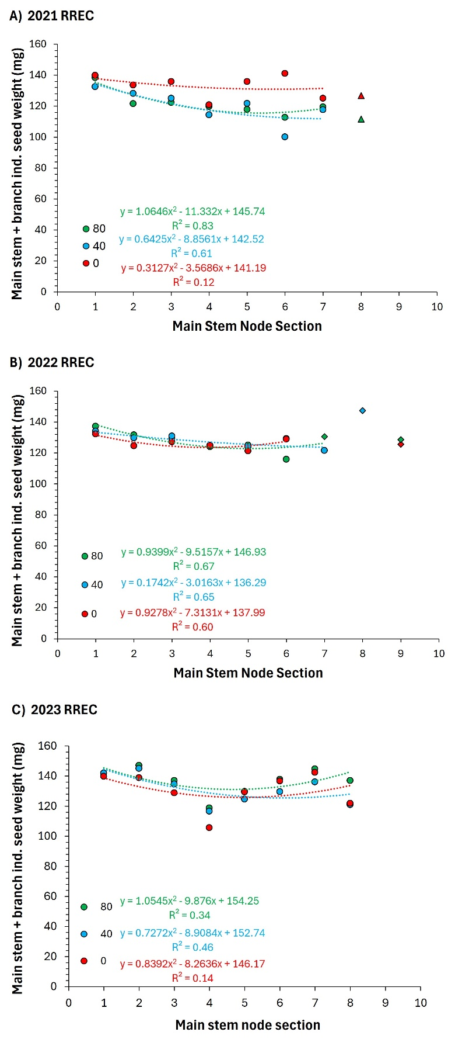
Figure 7 – Individual seed weight distribution among soybean plant node sections (two nodes and two internodes numbered from top to bottom) as affected by long-term P fertilization (0, 40, and 80 lb P₂O₅/ac) during 2021 (A), 2022 (B), and 2023 (C) growing seasons at the Rice Research and Extension Center (RREC), near Stuttgart, AR.
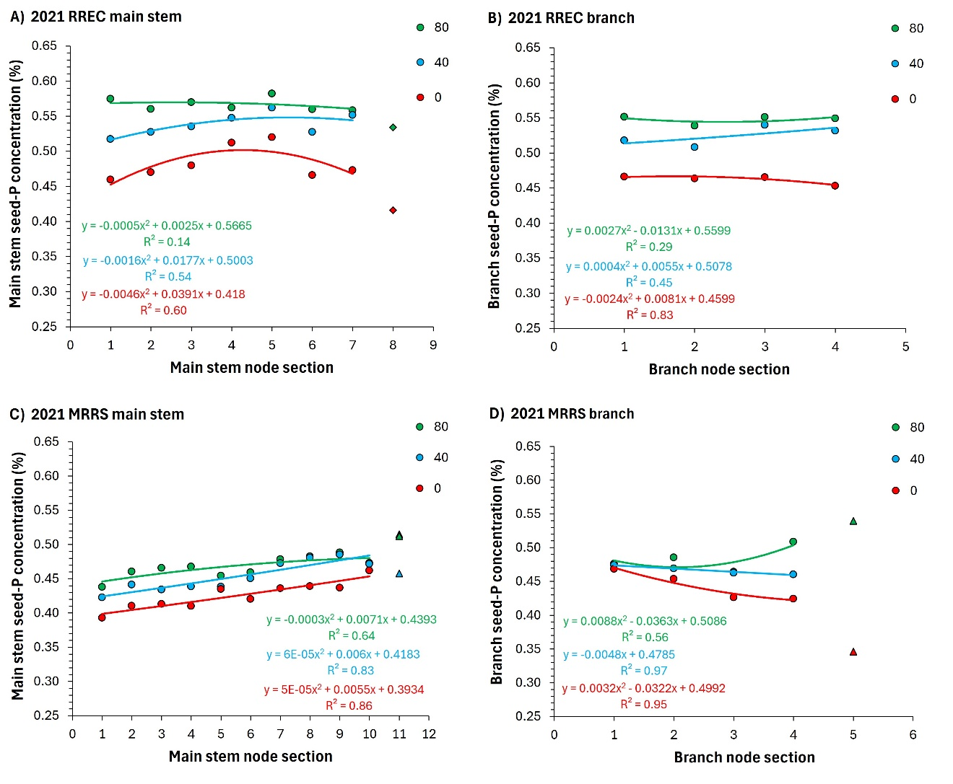
Figure 8 – Soybean seed-P concentration on mains stem (A and C) and branch (B and D) node sections as affected by P fertilization (0, 40, and 80 lb P₂O₅/ac) at the Rice Research and Extension Center (RREC), near Stuttgart, AR, and at the Macon Ridge Research Station (MRRS), near Winnsboro, LA, at the 2021 growing season.

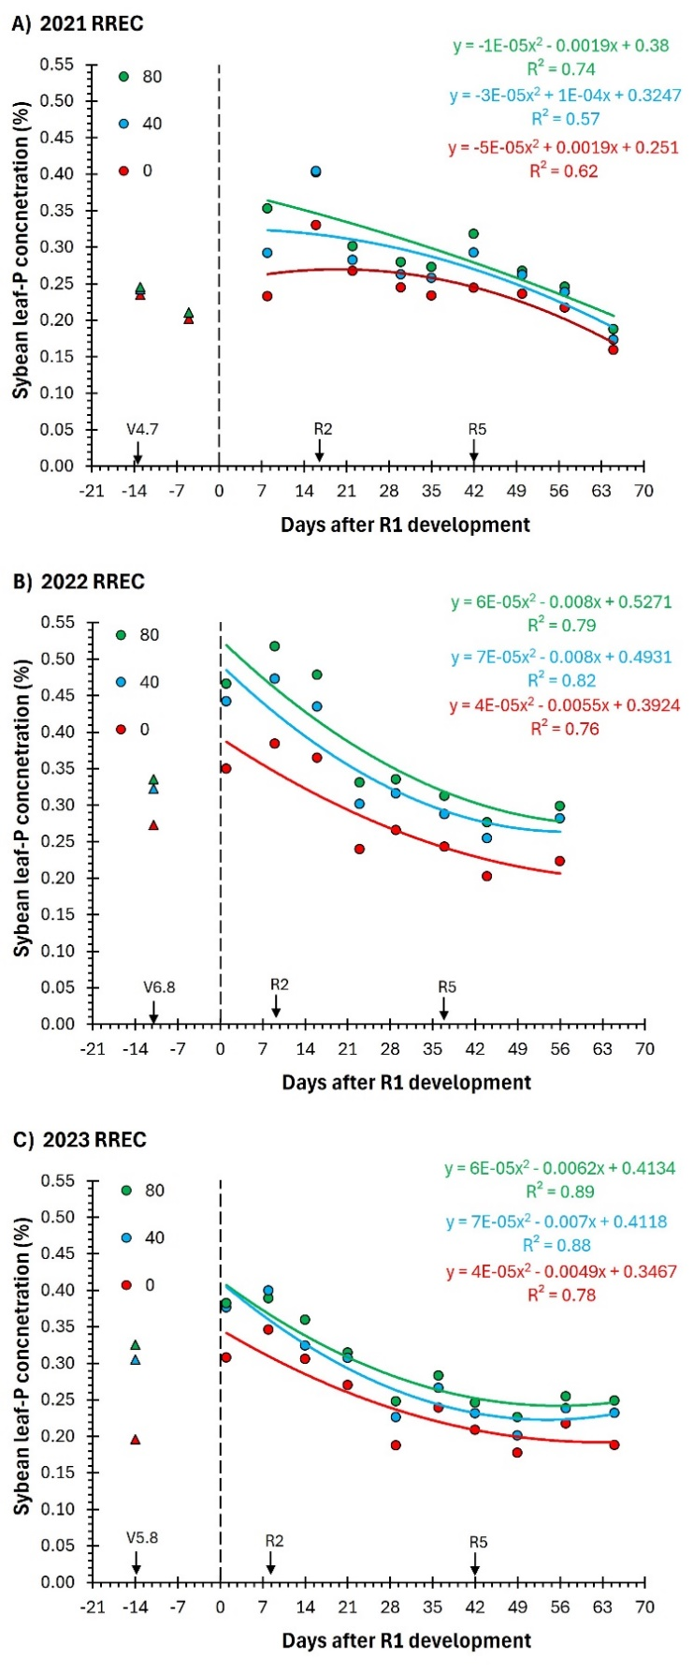
Figure 9 – Soybean leaf-P concentration as affected by long-term P fertilization (0, 40, and 80 lb P₂O₅/ac) and sampling time during 2021 (A), 2022 (B), and 2023 (C) soybean growing seasons at the Rice Research and Extension Center (RREC), near Stuttgart, AR.
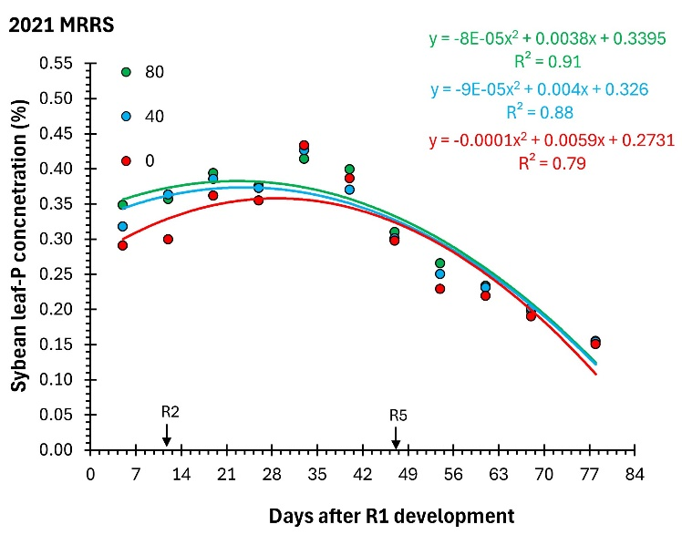
Figure 10 – Soybean leaf-P concentration as affected by P fertilization (0, 40, and 80 lb P₂O₅/ac) and sampling time during the 2021 soybean growing seasons at the Macon Ridge Research Station (MRRS), near Winnsboro, LA.

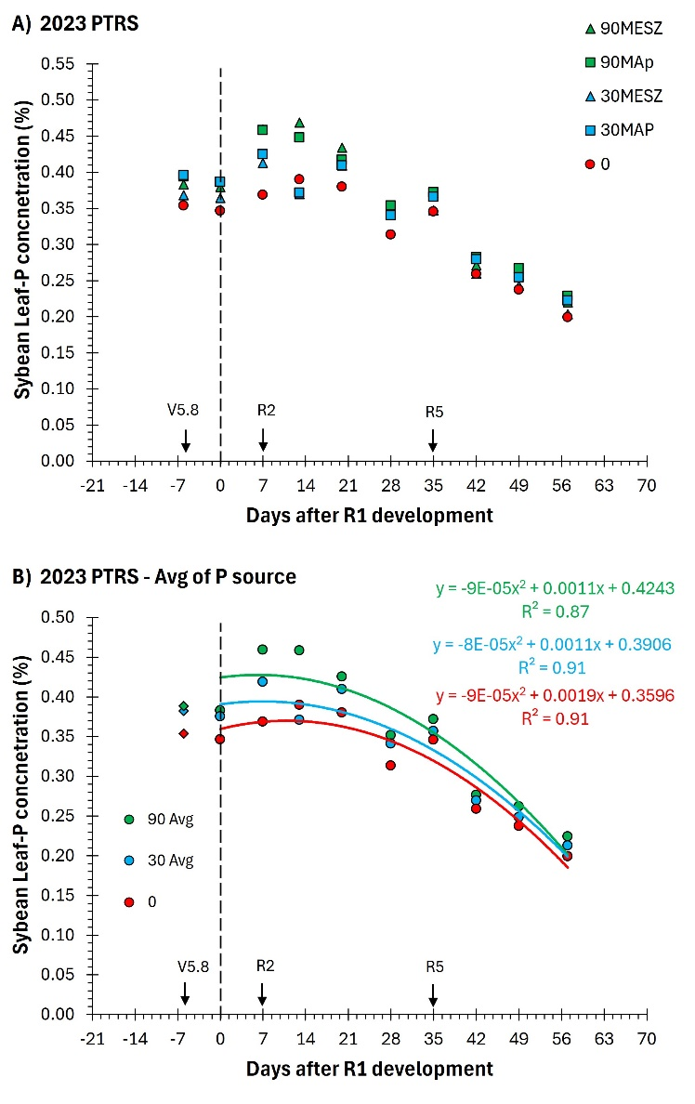
Figure 11 – Soybean leaf-P concentration as affected by fertilizer-P rate (0, 30, and 90 lb P₂O₅/ac) and source (monoammonium phosphate -MAP and MicroEssentials – MESZ; A) and the mean of fertilizer source (B) at different sampling times during the 2023 soybean growing season at the Pine Tree Research Station (PTRS), near Colt, AR.

