Project Number:
Project Title: | Screening soybean germplasm and breeding soybeans for flood tolerance
Organization: | University of Missouri-Fisher Delta Research Center
Project Lead Name: | Drs. Caio Vieira, Tessie Wilkerson, David Moseley, Chengjun Wu, Francia Ravelombola
Reporting Period:  Please select the appropriate reporting period for this report. | ☒ December ☐ March ☐ June ☐ September ☐ Final

The information included in this detailed report should reflect quantifiable results that can be used to evaluate and measure project success.

If Progress Report – What key activities were undertaken and what were the key accomplishments during this reporting period? List each key deliverable from the proposal and describe progress made (or not made) toward achieving it, including metrics were appropriate.

If Final Report – What were the key accomplishments during the life of the project? List each deliverable from the proposal and describe progress made (or not made) toward achieving it, including metrics where appropriate.
University of Missouri (Lin):

The 2024 Flood breeding pipeline at the University is summarized in Table 1.

Table 1. 2024 Flood breeding summary in Missouri
Test/Line | Description | Entry #
S12-1362 | Germplasm release | 1
S17-1146 | Germplasm release | 1
UT | USDA Regional Uniform trials | 1
AYT-FLD | Flood advanced yield trials | 5
PYT-FLD | Flood preliminary yield trails | 23
MSSB_FLD | Advanced breeding lines and promising lines | 130
MOCVT_FLD | Variety Test Flood Screening | 60
Progeny | Visual Selection | ~400
Population | F₁ to F₄ generation | 4
New Crosses | Population development | 6-7

1. 2024 Conversion flood tolerant line into herbicide trait: S20-1492, identified as a potential flood-tolerant soybean line (FDS<2 at V2 and R1) was entered in the 2024 UT, and has been sent to the winter nursery for conversion to XF. It will undergo three backcrosses to incorporate the herbicide trait.

2. 2024 Flood-tolerant germplasm potential release: The high-yielding and flood-tolerant line S12-1362 (MG5) will soon be available as conventional germplasm. Its registration manuscript is currently undergoing processing and will be published in the Journal of Plant Registrations. This line has been shared with various soybean programs via a Material Transfer Agreement (MTA). Similarly, the line S17-1146 (MG4L), high yields and flood tolerance, will also be released as conventional germplasm. Its registration manuscript is also in progress and scheduled for publication in the Journal of Plant Registrations. Like S12-1362, this line has been exchanged with different soybean programs under an MTA.

3. 2024 Regional trials: We entered S20-1492, a potentially flood tolerant line in the USDA Southern Uniform Trials. S20-1492 exhibit a flood damage score FDS<2 at V2 and R1, with yield under flooded >20 bu/ac both at V2 and R1, and high yielding (70.1 bu/ac) that not significantly different from the commercial checks under non-flooded conditions. If seed yield is satisfactory, it has the potential to be released in 2025. Preliminary results of 2024 showed a flood damage score FDS<2 at V2 (FDS=1.5) and R1 (FDS=1.3). Harvest has been done and data is being processed.

4. 2024 Flood advanced yield trials: A total of 10 MG4L, and 11 MG5E were evaluated for flooding tolerance and yield. The test lines include selections of lines with stable flood damage score and potential high yielding lines from 2023 flood advanced yield trials. One tolerant check and sensitive commercial varieties along with conventional checks have also been included. The tests were conducted in 4-row plots with 3 replications under both flooding stress conditions (at V2 and R1 stages) and non-stress conditions (non-flooded field). Flood scores were recorded at V2 and R1 stages, harvest has been done and the seed yield data will be analyzed along the flood score.

5. 2024 Flood preliminary yield trials: A total of 28 MG4 breeding lines including one tolerant check (S17-1146) along with commercial checks (AG 40XF1, P42A84E, AG 43XF2, P47A64LX) were evaluated for flooding tolerance and yield. The test entries were planted in 4-row plots in 2 replications in flooded (V2 and R1) and non-flooded fields. Flood scores were recorded at V2 and R1 stages, harvest has been done and the seed yield data will be analyzed along the flood score.

6. 2024 Flood Tolerant Progeny rows: Approximately 480 F4 plant rows from 4 crosses will be planted at Portageville, MO as a single row at the Lee Farm, Portageville, MO. A total of 98 lines with best agronomic traits were visually selected for further evaluation under flood in 2025.

7. 2024 Breeding population advancement: Four flood tolerant breeding populations were developed in 2023. The F₁ seeds of these crosses were sent to the winter nurseries where the populations will be advanced to F₄ for progeny row testing in 2025.

8. 2024 crosses for Flood tolerance: We made 7 new crosses for the season of 2024.

9. 2024 Missouri commercial variety testing for flood tolerance: We evaluated at total of 60 commercial varieties developed by different seed companies with 3 replications under flooding stress for at R1/R2 stage during and non-flooded treatment the summer of 2024 at the Lee Farm Portageville, MO (heavy clay soil). Flood scores were recorded at V2 and R1 stages. The following lines showed a flood score damage less than3 Delta Grow DG46XF54STS, AgVenture AV 45B2E, Channel 4720RXF/SR, Dyna-Gro S51XF84
USG 7435XFS, Asgrow AG35XF1 and Delta Grow DG43XF65STS. The plots haven been harvested for seed yield evaluation.

10. 2024 MSSB Flood screening for flood tolerance: The 2024 MSSB test includes 250 advanced and promising breeding lines from the University of Missouri, specifically selected for flood tolerance, along with advanced and promising lines from the University of Arkansas. These lines will undergo genotyping. Flood tolerance screening was conducted at the V2 and R1 growth stages, with three replications across multiple states, including Arkansas, Missouri, Louisiana, and Mississippi, and drone data was collected. In Missouri, lines S21-11211, S22PR-305E3, R22KB-06963, S21-7836, and S22-8718HP demonstrated flood scores below 2.5 at both V2 and R1 stages. Once data from other states is available, a stability analysis will be conducted.

11. Marker data analysis: Marker analysis for flood tolerance revealed that some lines possess markers on both Chromosome 3 and Chromosome 13 (Table 2).

Table 2. Soybean Breeding lines in the Preliminary Yield Trials that possess markers on both Chromosome 3 and Chromosome 13
Name | FT-Chr. 3 | FT-Chr. 13
S22-14160 | T | T
S22-14345 | T | T
S22-14004 | T | T
S22-14106 | T | T
S22-14124 | T | T
S22-14129 | T | T
S22-14161 | T | T
S22-14165 | T | T

University of Arkansas (Vieira):
Flood tolerance evaluation and screening for diverse soybean genotypes
In 2024 summer, a total of 441 lines, germplasms, and PIs were screened and evaluated for flood tolerance at both early vegetative (V2) and mid-reproductive (R1) growth stages in Stuttgart, AR. The screening results are summarized in Table 1. Many new lines/germplasms/PIs showed high flood tolerance with flood damage score (FDS < 2.0) at vegetative and/or reproductive stages such as S16-7922 and S17-1980, PI 408105A, PI 54608 -1, PI 587712B, PI 567685, PI 567525, R20-1429, S22-14266, S22PR-212E3, R23PR-00082E3, R23PR-00122E3, S21-17588LL55, and R23FS-00001. These flood-tolerant genotypes will be used in breeding and genetic research to improve soybean flood tolerance.

Table 1. 2024 Flood tolerance evaluation and screening in Stuttgart, Arkansas.
Test | Entry | Flooding Treatment | Tolerant No. (V2) | Tolerant No. (R1)
GXE | 96 | 7 days | 39 | 7
PFT | 80 | 7 days | 2 | 4
MSSB (Advanced lines) | 245 | 7 days | 51 | 3
FL5P (Preliminary lines) | 12 | 7 days | 1 | 1
Total | 441 |  | 93 | 14

Flood tolerance breeding and variety release
In the 2024 season, an elite line R19C-1012 has been released as high-yielding and flood-tolerant variety for soybean breeding, research, and production (Table 2). R19C-1012 is a high-yielding, conventional MG 4.6 soybean variety with improved flooding tolerance at the vegetative growth stages. From 2020 to 2023, R19C-1012 was evaluated for yield in 40 irrigated environments. R19C-1012 showed good performance with an average relative yield of 104% to the experimental lines across all environments. The grain yield mean of R19C-1012 was 4,539 kg ha⁻¹ (99 and 93% relative yield to the non-Xtend® and Xtend® commercial checks, respectively). In the 2023 flooding trial, under 5-day flooding stress at vegetative growth stages, R19C-1012 showed high tolerance to flooding stress with an average relative yield loss of -57%, while the XtendFlex® checks AG43XF2 and AG47XF2, and the test average had -81%, -86%, and -70%, respectively (Figure 1). R19C-1012 registration’s manuscript has been submitted to the Journal of Plant Registration.
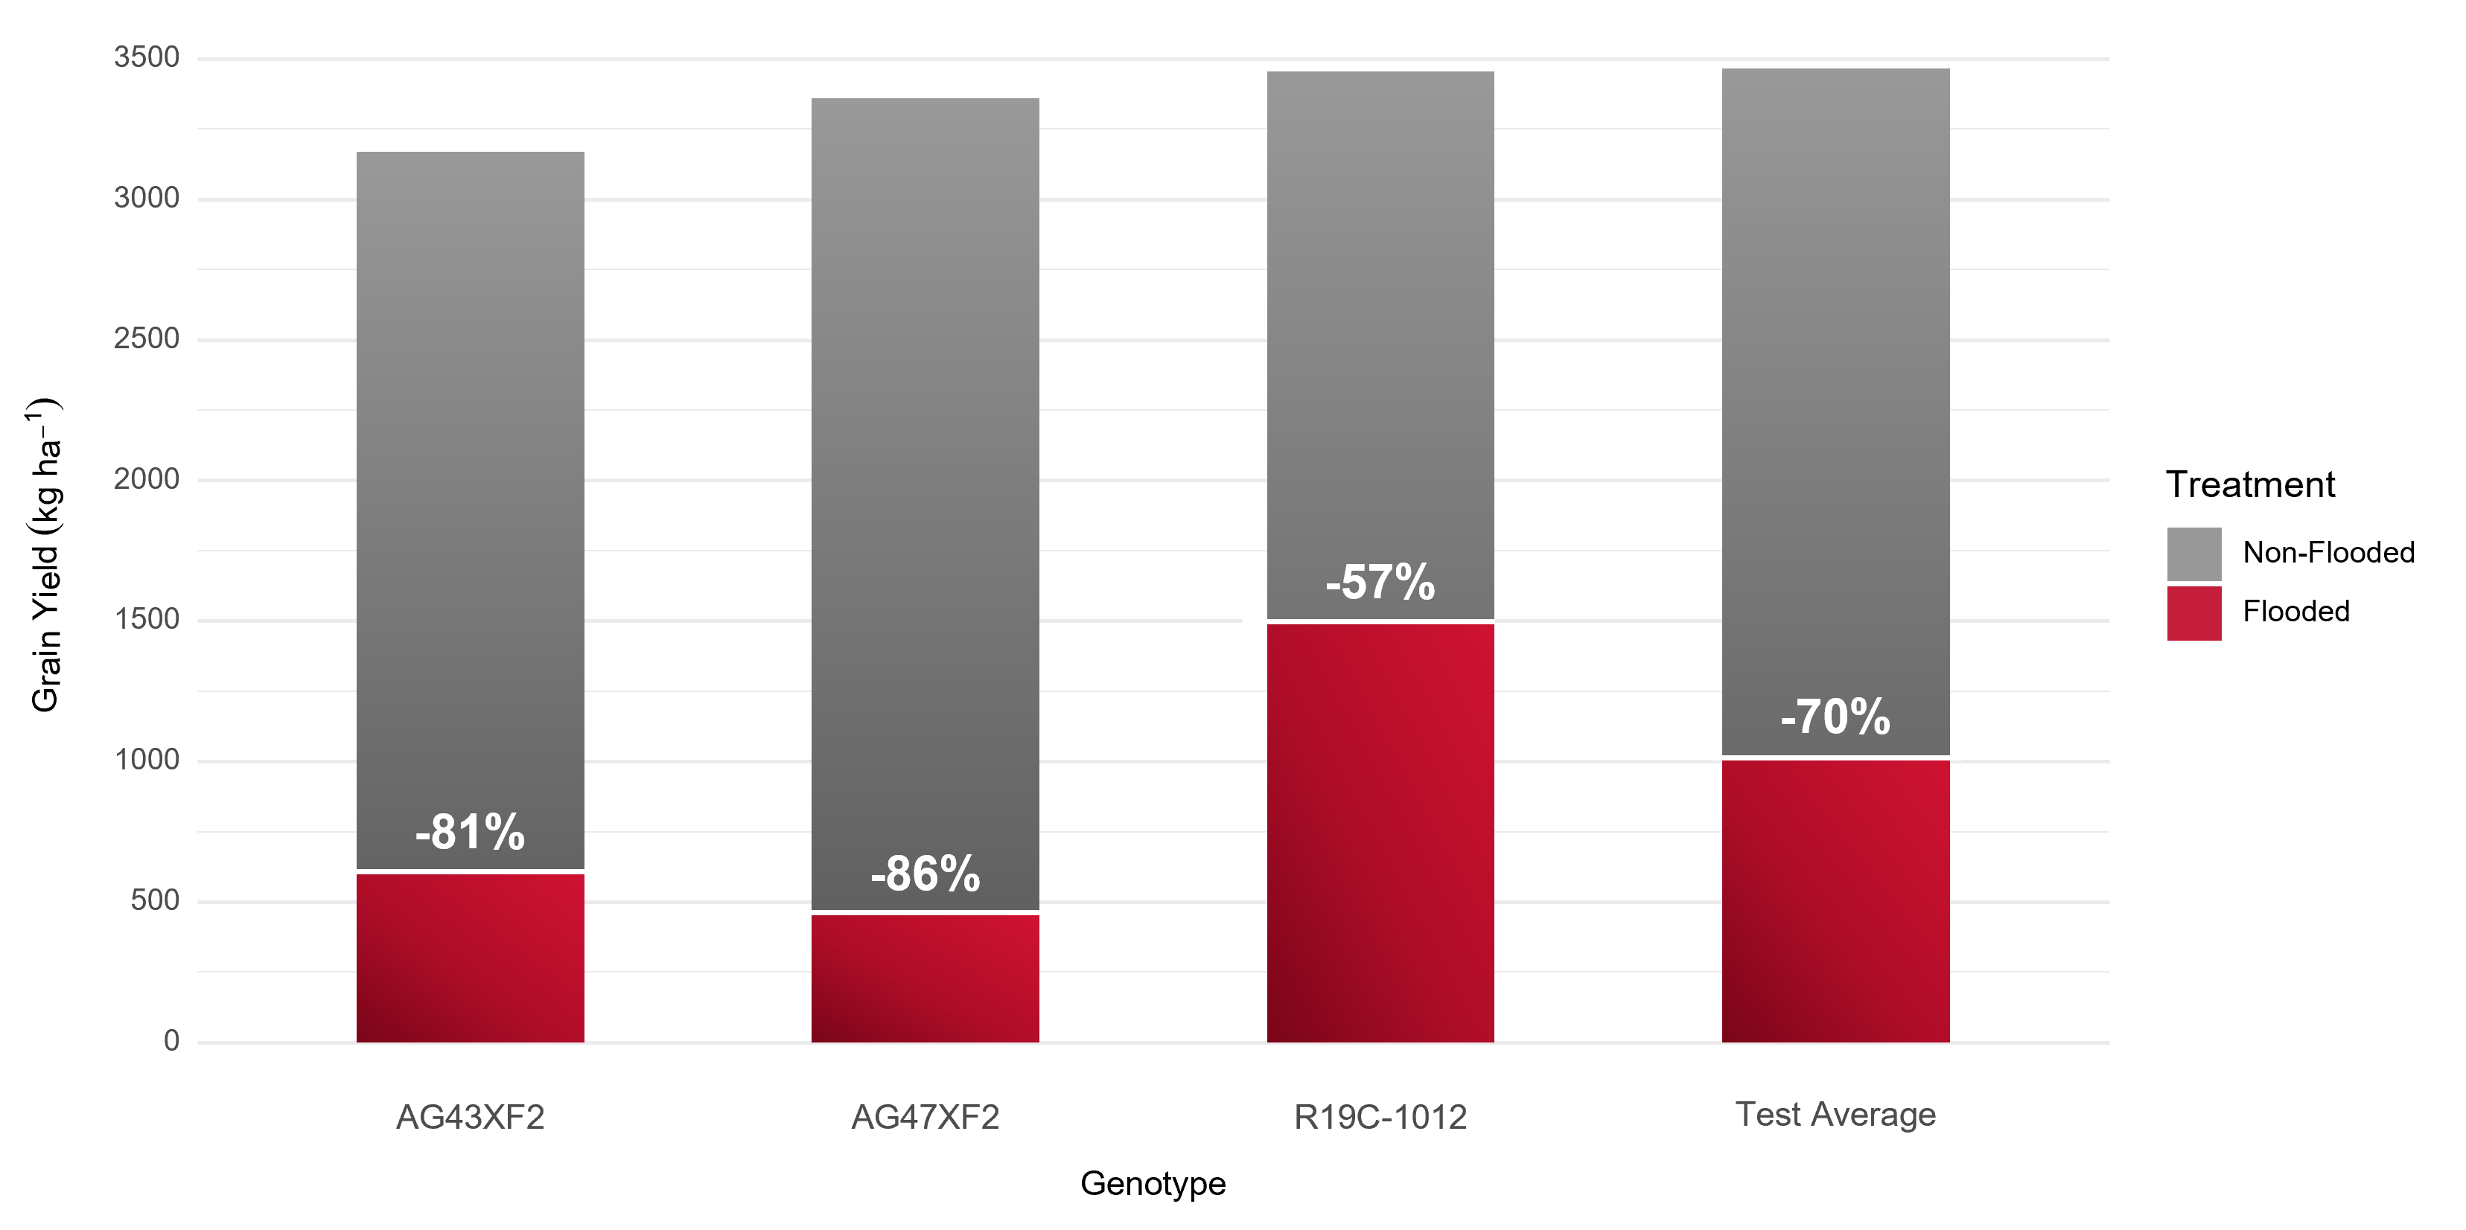
Figure 1. Average yield and yield loss (%) of R19C-1012 relative to XtendFlex® checks and test average under flooded and non-flooded conditions in the Arkansas System Division of Agriculture’s Variety Testing Program (2023).

Three elite pre-commercial MG5 lines (R20-1429, R21KB-05522, and R21KB-05122) with flood-tolerant pedigrees were evaluated for yield in multiple locations. Line R20-1429 was selected as a potential release germplasm for further evaluation in next year’s Arkansas pre-commercial yield trial and USB regional flood yield trial. This line was also selected as parent for flood-tolerant breeding. Line R21KB-05522 was selected for the 2025 USDA Uniform Regional Test (UT5) and Arkansas Variety Test to evaluate yield and flood tolerance. Fifteen preliminary lines (11 soybean and 4 soybean x soja lines) were evaluated for yield and flood tolerance in three Arkansas locations (Marianna, Rohwer, and Pine Tree). Line R23FS-00001 (NC-Railegh/PI378683) developed from flood-tolerant soja PI378683 showed high tolerance to flooding stress at both V2 (flood damage score = 1.7) and R1 (flood damage score = 1.7) stages, respectively, and was selected as parent for next year’s flood tolerance breeding. A total of 722 progeny rows with flood-tolerant pedigrees were evaluated in Kibler, AR, and 35 lines were selected for yield and flood tolerance evaluations in 2025 flood-tolerant preliminary test. Additionally, more than 30 breeding populations derived from flood-tolerant parents are being advanced in an off-season nursery. Fifteen new crosses with flood-tolerant and other diverse value-added traits were made in Fayetteville, AR, and F1 seeds were sent to an off-season nursery for generation advancement (Table 2).

Table 2. 2024 Flood tolerance breeding and variety release
Line/population | Description | Selected for 2025 Breeding Activities
R19C-1012 | Pre-commercial line | Release as flood-tolerant variety
R21KB-05522 | Advanced line | UT5 and PCM tests
R20-1429 | Advanced line | PCM and FYT tests, Crossing parent
R23FS-00001 | Preliminary lines (soybean x soja) | Crossing parent
35 progeny lines | Selected from 722 progeny rows | Preliminary test
30 populations | F1 to F4 generations | Advancement in winter nursery
15 New Crosses | Population development | Advancement in winter nursery

Flood tolerance evaluation of commercial variety
A total of 84 MG4 and MG5 commercial varieties and lines developed by seed companies and the Arkansas Soybean Breeding Program were evaluated for yield and flood tolerance at the early V5 stage in Stuttgart, AR. Under 5-days flooding stress, 53 commercial varieties and breeding lines showed flood tolerance with lower flood damage score (FDS ≤ 2.0) at the V5 stage and eight varieties/lines (Progeny P4999E3S, Progeny P4775E3S, Progeny P4947XFS, R19C-1081, R21KB-05522, Dyna-Gro S43XF85S, Revere 46-E67, and DELTA GROW DG43XF65STS) had high flood tolerance with FDS = 1.0. The yield data of 84 commercial varieties and lines under non-flooded and flooded conditions are being processed and will be reported in the next quarter report.

Identification of DNA markers and genomic prediction
A total of 254 genetically diverse soybean PIs were screened and evaluated for flood tolerance at the early vegetative (V2) stage from 2020 to 2021 in Stuttgart, AR. Five significant SNP markers (ss715587369, ss715628153, ss715628154, ss715628155, and ss715638723) associated with flood tolerance were identified on chromosomes 4, 17, and 20 (Figure 2). Additionally, genomic-based prediction models have been shown to accurately identify tolerant genotypes. This study improves the efficiency of breeding for early-season flood tolerance and supports the need to develop season-long flood-tolerant soybean genotypes. This has been submitted for publication in the Plant Genome journal.

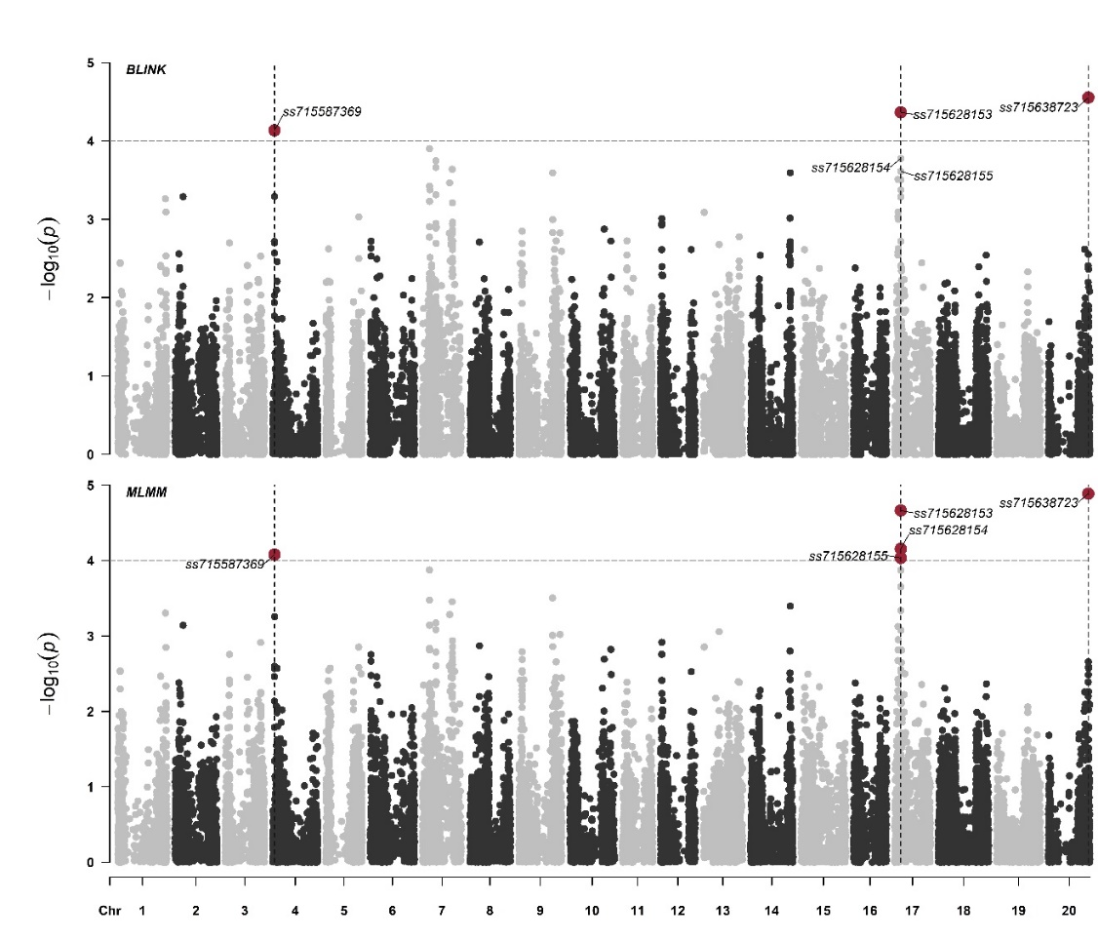
Figure 2. Manhattan plot displaying significant marker-trait associations for early-season flood tolerance identified using the BLINK and MLMM models. The threshold of marker-trait association significance was LOD ≈ 4.1.

2024 Publications for flood tolerance breeding and research
1. Caio Canella Vieira, Chengjun Wu, Derrick Harrison, Rafael Marmo, Liliana Florez-Palacios, Andrea Acuna, Daniel Rogers, Samuel Fernandes, Igor Fernandes, Grover Shannon, Heng Ye, Henry T. Nguyen. 2024. Genomic Prediction and Association Mapping of Early-Season Flood Tolerance in Soybean. The Plant Genome. In Review.

2. Caio Canella Vieira, Rafael Marmo, Chengjun Wu, Liliana Florez-Palacios, Andrea Acuna, Derrick Harrison, Daniel Rogers, Leandro Mozzoni, Trenton Roberts, John Carlin, Travis Faske, Fen. Lin, Grover Shannon, Henry T. Nguyen. 2024. Registration of R19C-1012: A Conventional Flood-tolerant Soybean Variety. Journal of Plant Registrations. In Review.

3. Chengjun Wu, Liliana Florez-Palacios, Andrea Acuna, Derrick Harrison, Daniel Rogers, John Carlin, Leandro Mozzoni, Henry, T. Nguyen, Grover, Shannon, Caio Canella Vieira. Impact of Flooding at the Early Reproductive Growth Stage on Soybean Yield and Seed Composition. Crop Science. First published: 23 October 2024 https://doi.org/10.1002/csc2.21397.

4. Chengjun Wu, Andrea Acuna, Liliana Florez-Palacios, Derrick Harrison, Francia Ravelombola, Maria Oliveira, Jushua Winter, Daniel Rogers, John Carlin, Grover Shannon, Henry T. Nguyen, Caio Canella Vieira, Leandro Mozzoni. 2024. Registration of R16-45 as a flood tolerant, high-yielding soybean germplasm line. Journal of Plant Registrations. First published: 08 January 2024 https://doi.org/10.1002/plr2.20328.

Mississippi State University (Wilkerson)
Field plots were harvested from the complete set of the MSU Official Soybean Variety Trial Located at Stoneville, MS. On October 30, 2024. Harvest data is being calculated and analyzed to determine the effect of flooding at R1/R2 on soybean yield. The entire dataset will be sent to Dr. Lin once analysis is complete.

Louisiana State University (Moseley)
The field plots for this project were not good enough to take data.

