Please use this form to clearly and concisely report on project progress. The information included should reflect quantifiable results that can be used to evaluate and measure project success. Comments should be limited to the designated boxes. Technical reports, no longer than 4 pages, may be attached to this summary report.

Project Number:
Project Title: | Screening soybean germplasm and breeding soybeans for flood tolerance
Organization: | University of Missouri-Fisher Delta Research Center
Principal Investigator Name: | Dr. Pengyin Chen
Other investigators: | Drs. M. Liakat Ali, Leandro Mozzoni, Daryl Chastain, Tessie Wilkerson and Blair Buckley
Report Period: | March 16, 2021 to June 15, 2021

Project Status: On-going

(What key activities were undertaken and what were the key accomplishments during this quarter? Please use this field to clearly and concisely report on project progress).
Missouri:

1. Evaluation of breeding lines for flooding tolerance and yield to develop commercial varieties.
i) Advanced yield trials: A total of 40 advanced breeding lines in two groups: MG-4 (20 lines) and MG-5 (20 lines) will be evaluated for yield and flooding tolerance. The test lines include selections from 2020 flood advanced yield trials, 2020 preliminary yield trials and elite breeding lines that are entered in the 2021 USDA Uniform Trials. The tests have been planted in 4-row plots with 3 replications in flooded (where flooding stress will be imposed) and in non-flooded (where no stress will be imposed) fields. One flood sensitive check and 3 commercial varieties are included in each test.

ii) Preliminary yield trial: A total of 21 MG 5 breeding lines selected from 2020 progeny rows derived from flood crosses will be evaluated for flooding tolerance and yield. The test entries have been planted in 7’ 4-row plots in 2 replications in flooded and non-flooded fields. Several commercial varieties and sensitive lines are also included as checks in the trial.

2. Yield evaluation of selected tolerant and sensitive lines in flooded and non-flooded field: A set of 20 lines (about one half was previously known to be flood tolerant and the other half was known to be sensitive) will be evaluated for flood tolerance and yield under flooding stress while in non-flooded under normal irrigation condition only yield performance will be tested. The test entries have been planted in 12’ 4-row plots in 3 replications. The lines will be exposed to flooding stress during R1/R2 (mid-season). These lines are also being grown in other locations (AR, MS, and LA). The effect of flooding stress on yield and seed composition will be evaluated.

3. Screening of recently developed elite lines for flood tolerance: A set of 107 breeding lines, recently developed at the University of Missouri-Delta Research Center and at the University of Arkansas and five checks (4 commercial cultivars and one sensitive line) will be evaluated for flood tolerance this season. The test lines include new promising breeding lines with high yield potential and lines that exhibited good flood tolerance in 2020 flood tolerance screening tests. Lines have been planted in 7’ single row plots in three replications and will be subjected to flood water during RI/R2 stage for a period of about 7 days.

4. Missouri commercial variety testing for flood tolerance: A set of about 115 commercial varieties developed by 25 different seed companies will be evaluated for flooding tolerance. The test entries have already been planted in 7-ft single row plots in 3 replications and will be subjected to flood water during R/R2I stage for a period of about 7 days.

5. Selection of new breeding lines from progeny row testing: About 900 new F_{4:5} lines derived from 9 crosses (the list of the crosses given in Table 1) will be grown in progeny rows for line selection. The F_{4:5} seeds are being processed for planting in non-flooded normal irrigated field for selection. Best performing progeny rows with high yield potential will be visually selected and will be yield-tested in preliminary yield trials in flooded field in 2022.

Table 1. List of crosses made in 2019 have been advanced in winter nursery and the new F_{4:5} lines will be grown in progeny nursery for selection.
Cross # | Parentage | Generation | Year of evaluation
S19-822 | S11-16653 x R04-342 (FT) | F_{4:5} | 2021
S19-823 | S15-10879 x PI 597459 C (FT) | F_{4:5} | 2021
S19-829 | S14-16331 (FT_) x S15-10434C | F_{4:5} | 2021
S19-832 | R07-6669 (FT) x S15-3772RY | F_{4:5} | 2021
S19-833 | S14-16235 (FT) x S16-8898C | F_{4:5} | 2021
S19-836 | R10-4892 (FT) x S13-3851C | F_{4:5} | 2021
S19-837 | RIL 48 (FT) x S11-20356GT | F_{4:5} | 2021
S19-838 | S13-15999 (FT) = x S11-20337GT | F_{4:5} | 2021
S19-839 | R11-6870 (FT) x S11-20195GT | F_{4:5} | 2021

6. New breeding populations under generation advance: Seven crosses were made in 2020 to develop new flooding tolerant high yielding soybean varieties from tolerant PIs/lines and elite breeding lines. These populations are being advanced in Costa Rica (CR) and Puerto Rica (PR), and expected to be in F₃ generation by the end of 2021. The list of the crosses is given in Table 2.

Table 2. List of the crosses made in 2020 are in generation advance from F₁ to F₄ in winter nursery.
Cross | Pedigree | Generation | Year of evaluation
S20-311 | S14-16267 (FT)x S12-1362 (FT) | F₂ | 2022
S20-312 | S12-1362 (FT) x R04-342 (FT) | F₂ | 2022
S20-313 | RIL 123 (FT) x R04-342 (FT) | F₂ | 2022
S20-314 | R11-6870 x S12-1362 (FT) | F₂ | 2022
S20-320 | S14-16267 (FT)x UA5814HP (Protein) | F₂ | 2022
S20-321 | S12-1362 (FT) x Osage (Protein) | F₂ | 2022
S20-322 | RIL 123 (FT) x R11-7999 (Protein) | F₂ | 2022

7. Crossing plan in 2021 season: About 10 new crosses between flood tolerant PIs/lines and elite breeding lines will be made with a view to develop high-yielding flood tolerant varieties.

Arkansas:

We planted our flood trials in Stuttgart on the week of 6/12.
Also, on 6/8 we suffered over 10 inches of rain in ROH (see pics attached) affecting our plots that were at R2 stage by full submersion for about 3 days. Damage was complete (see picture below), except for two genotypes from the Flood Tolerance Preliminary (FLP) test (R20-440 and R20-231) that had approximately 25% stand remaining in both reps on different parts of the field, where everything else around them were completely killed. A subset of the surviving plants were transplanted to Fayetteville, and if they are able to manage the transplant shock will be genotyped for further characterization of the response observed in the field.

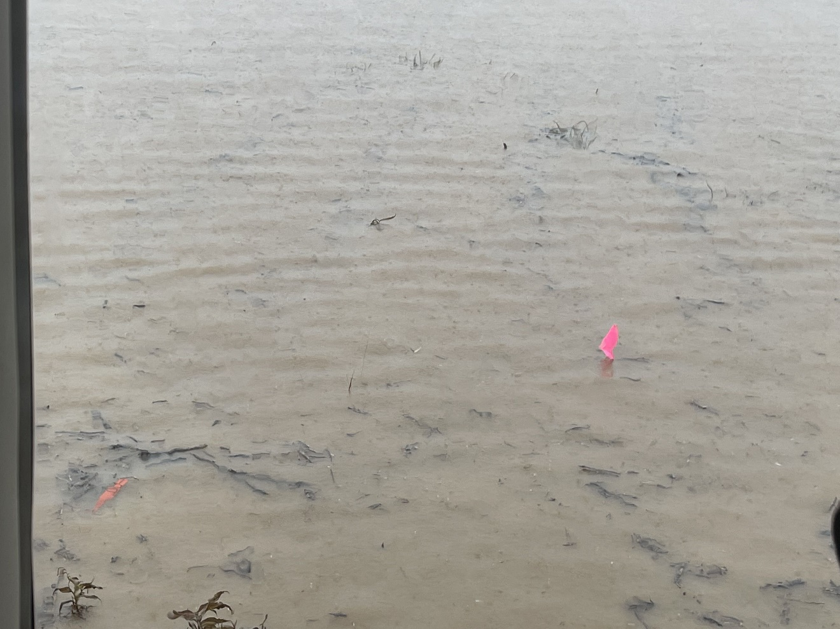

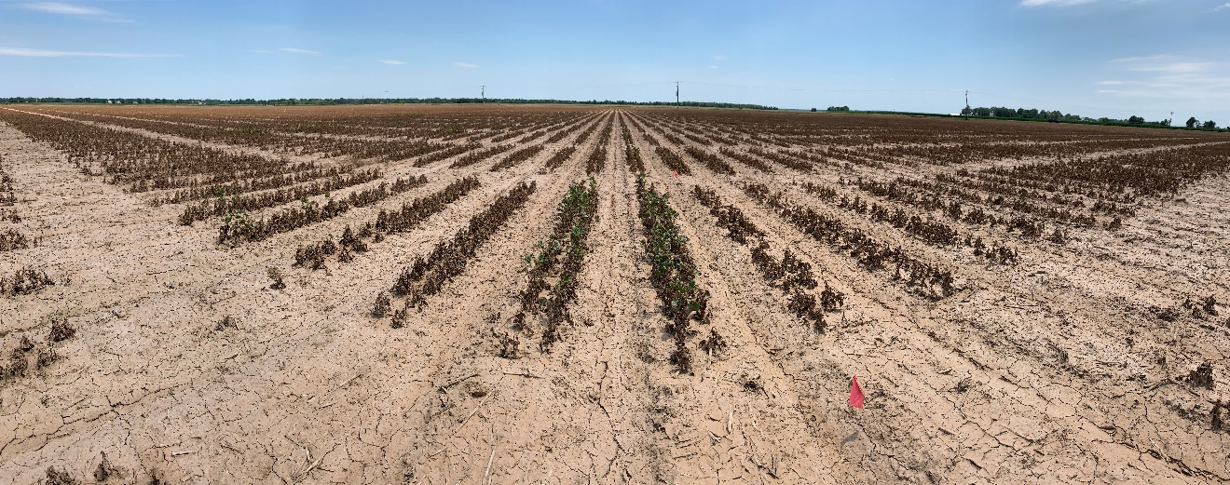

Mississippi:

Field trials have been established at the Delta Research and Extension Center to include soybean varieties from the Official State OVT trial. Approximately 900 commercial varieties will be screened for flood tolerance. Plots will be flooded at v2/v3 for 72 hours to evaluate early stage tolerance and disease incidence.

