Please use this form to clearly and concisely report on project progress. The information included should reflect quantifiable results that can be used to evaluate and measure project success. Comments should be limited to the designated boxes. Technical reports, no longer than 4 pages, may be attached to this summary report.

Project Number:
Project Title: | Identification and confirmation of natural tolerance to off-target Dicamba damage in non-Xtend soybeans
Organization: | University of Missouri
Principal Investigator Name: | Grover Shannon
Other investigators: | Caio Canella, Pengyin Chen
Report Period: | Dec 16, 2022, to March 15, 2023
Research updates:
Summary of 2022 research
In 2022, ~250 entries in our advanced yield tests across maturity groups (4E, 4M, 4L, 5E, and 5M) were exposed to off-target dicamba from adjoining fields. Results are summarized as follows:
1)Damage ratings from 1 to 4, where 1 is no damage and 4 is severe visual injury and final seed yield were highly correlated. Yield losses varied of 8 to 10% for the most tolerant lines (visual damage score of 1) to 40% or more for the most sensitive lines (visual damage score of 4.
2) Good tolerance to dicamba was observed among lines across ranges in maturity (4e to 5M) However, sensitive lines in earlier maturities showed more yield loss than later maturities which had a longer period to recover and detoxify after exposure.
3) UAV or drone imagery measuring several canopy variables to classify tolerance scored as tolerant, moderately tolerant, or susceptible was highly correlated (86 to 89%) with visual damage scores and is a useful tool to efficiently classify lines for natural tolerance to dicamba.
4) Genetic mapping studies show that major genomic regions identified on chromosomes 10 and 19 are responsible for the tolerance. Other minor alleles on other chromosomes likely affect dicamba tolerance.
5) Using a panel of over 380 PIs genotyped with the Soy50K SNP chip, two genomic regions harboring a multidrug resistance gene and a glycosyl-transferase gene, both associated with plant detoxification from herbicide were identified.
6) Lines with natural tolerance to dicamba, high yield and broad disease resistance are being advanced for release as varieties.
Research plans for 2023-and beyond
1) The second year of GWAS (Genome wide association mapping) and fine-mapping studies to narrow genomic regions and to determine other favorable genes will be conducted in Arkansas and Missouri using two mapping populations involving a tolerant exotic plant introduction x an elite non-tolerant line (see Figure 1 below) plus studies including 382 diverse accessions.
2) Confirmation and characterization of gene function of the tolerance genes on chromosome 10 and 19.
3) Identify and evaluate late group III, early group IV, late group IV, and early group V among 75 advanced and over 1000 lines in preliminary yield tests for dicamba tolerance, favorable agronomic traits, and disease resistance.
4) Selection of lines for release as soybean varieties or germplasm with excellent yield, dicamba tolerance and multiple disease resistance compared to current dicamba varieties in associated maturity groups.
5) Continue development of high yielding populations for dicamba tolerance with high yield and disease resistance.

Figure 1=-DIC-Map, which are two mapping populations derived from a tolerant PI and a susceptible breeding line, has shown excellent differentiation for dicamba exposure. These plants were phenotyped around R3 and this metric will be used for further mapping. This experiment will be repeated in 2023 for confirmation.
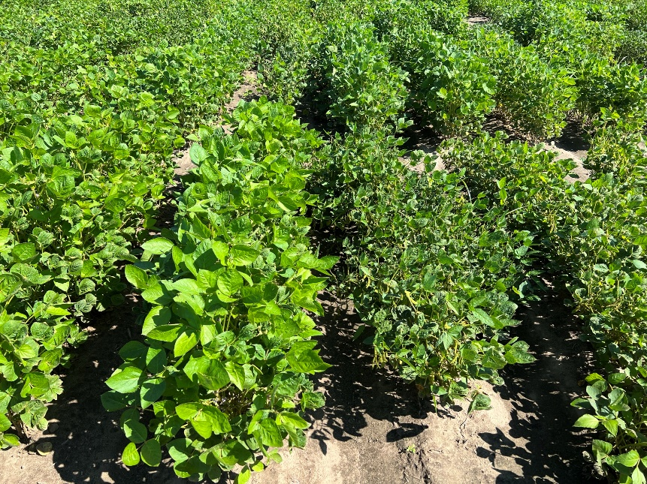
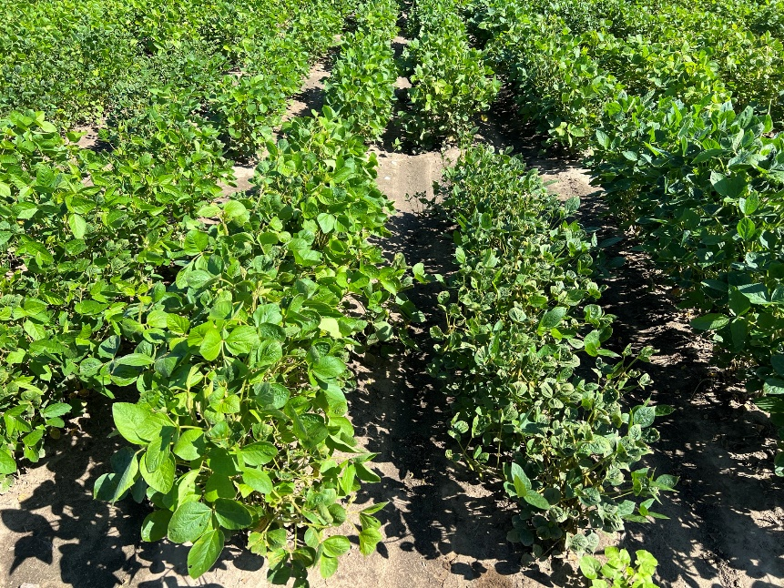
Figure 1. Mapping lines derived from a cross between a tolerant PI by a susceptible breeding line.

