United Soybean Board Domestic Programs

**Report Form**

**Project # and Title:**

2234 Effect of Planting Date, Latitude, and Environmental Factors on Choice of Maturity Group in Mid-South Soybean Production (Year 3 of 3)

**Reporting Period:**

September 16, 2013 to December 15, 2013

**Project Status:**

OVERVIEW:

Soybean producers make important production and economic decisions based upon information supplied by Extension personnel, seed companies, local seed dealers, and others. Often the information is limited, inconsistent and not applicable to either the latitudes and/or planting dates that are being considered by the producer or the crop advisor. Unfortunately, the significance of latitude and/or planting date and their individual and /or combined impact upon soybean production is not well understood. Producers need information about which MGs and which varieties within a MG they should use across the extended planting window and range of latitudes (29° to 36° N) across the Midsouthern U.S.

All soybean varieties in MGs 3 to 6 are “photoperiod sensitive”. Therefore, both latitude and planting date affect soybean growth, including seed development, seed composition and quality, and ultimately grain yield, based on day-length exposure during crop development. This project should produce data that can be used to predict the effects of latitude and planting date on the growth and development of a uniform set of commercially available soybean varieties of four different MGs (MGs 3, 4, 5 & 6). Information obtained from this uniform regional study will be reported annually to Extension soybean specialists, participating scientists, the MSSB, the USB, and participating QSSBs.

This regional effort will result in increased understanding of the effect of planting date (across a range of latitudes) on grain yield, crop growth, and phenology (stage x date), and will not only illustrate the variable agronomic responses but also document any differential exposures to weed, insect and disease pests (and could result in the refinement of scouting protocol for these pests). A better understanding of the maturation of the soybean plant would also be useful in ascertaining environmental effects upon seed composition and seed quality. At the conclusion of the study the entire results will be compiled, analyzed, summarized, and extended to producers, consultants and agri-businesses via a MSSB/USB publication.

WHO ARE THE PARTICIPANTS?

**Larry Purcell** is the Principal Investigator and is a professor at the University of Arkansas at Fayetteville, and he holds the Altheimer Chair for Soybean Research. Dr. Purcell will coordinate the overall research effort along with the postdoctoral associate hired for this purpose, **Dr. Montserrat Salmeron**. Dr. Purcell has been at the University of Arkansas for 18 years. Dr. Purcell’s research interests include optimizing the efficiency with which crops use essential resources of light, water, and nutrients through management and genetic strategies. Dr. Montserrat Salmeron is working closely with Dr. Purcell. She graduated and obtained her PhD from the University of Lleida, Spain and has experience in agronomy and crop modeling.

**Fred Bourland** is Center Director at the Northeast Research and Extension Center at Keiser, Ar. Dr. Bourland will work closely with Dr. Purcell and with the program technician at the Center, Max Wyss, in establishing and supervising the research effort at Keiser. Dr. Bourland is a cotton breeder and geneticist and has been at the Keiser station for 13 years.

**Normie Buehring** is a professor of Agronomy with Mississippi State University at the North Mississippi Research and Extension Center in Verona, Ms. Dr. Buehring is a research agronomist focused on enhancing row crop (corn, cotton and soybeans) production efficiencies for North Mississippi. His research involves evaluating varieties, planting dates, seeding rates, seed treatments, row spacing, foliar fungicides, reduced tillage systems (no-tillage, one pass land preparation systems, etc), bed height longevity on bottomland soils, and weed control.

**Larry Earnest** is Station Director at the Southeast Branch Experiment Station near Rohwer, Ar. Mr. Earnest will work closely with Dr. Purcell in establishing and supervising the research effort at Rohwer. Mr. Earnest has an MS degree in weed science and has been at the Southeast Branch Station for a number of years.

**Ed Gbur** is a Professor of Agricultural Statistics at the University of Arkansas, Fayetteville, AR. His expertise is on experimental design, regression, stochastic modeling, spatial statistics, survey sampling and agricultural applications of statistics.

**Bobby Golden** is an assistant professor of Agronomy with Mississippi State University at Stoneville, Ms. Dr. Golden’s research area focuses on nutrient management with emphasis on soil test correlation/ calibration, evaluation of foliar fertilization strategies, and evaluation of inoculant performance across multiple crop rotations. Current agronomic research includes optimizing double crop wheat-soybean systems, corn-soybean rotations, and evaluating the use of the Phaucet Program for soybean irrigation management in the Mississippi Delta.

**Travis Miller, Clark Neely, and Daniel Hathcoat** will coordinate research efforts at the research station in College Station, Tx. Dr. Miller is a professor and the associate department head and extension program leader. Dr. Miller has worked on a number of agronomic problems for Texas and was instrumental in developing the concepts of the early soybean production system for Texas. Dr. Neely received his PhD in 2013 and is currently an assistant professor and Extension Small Grains and Oilseed Specialist with the Texas A&M Agrilife in College Station. Dr. Neely will be collaborating with Dr. Miller on the project.

**Daniel Hathcoat** is the program specialist for small grains, and he will have responsibility for the day to day management of the experiment.

**Grover Shannon and Earl Vories** will coordinate research at the University of Missouri-Delta Center at Portageville, Mo. **Dr. Shannon** is the David Haggard Endowed Professor in Soybean Genetics and Breeding at the University of Missouri-Delta Center, Portageville, Mo. He has been in this position since 1999. Dr. Shannon’s research focuses on breeding for resistance to soybean cyst nematode and other biotic as well as abiotic stresses. Breeding for improved protein and oil for enhanced nutritional value for farm animals and humans is also a goal of his program. He works closely with others on campus, as well as other institutions, whose work is related to soybean production and improvement.

**Earl Vories** has been with the USDA-ARS at Portageville for 7 years, following 16 years with the University of Arkansas. Dr. Vories works with management of irrigated and rainfed crops in humid and sub-humid climates, the use of precision agricultural methods to monitor crop stress, the automation of irrigation, and water quality impacts of crop production.

**Josh Lofton** is an assistant professor with Louisiana State University Agricultural Center at the Macon Ridge Research Station in Winnsboro, La., and he is conducting research at the nearby St. Joseph Research Station. Dr. Lofton is a graduate of LSU in Agronomy with an emphasis in soil fertility, plant nutrition, and crop management.

**Dave Verbree** has joined our group with a research site at Milan, TN. Dr. Dave Verbree is a new assistant professor in crop physiology and agronomy at the Plant Sciences department of the University of Tennessee. His research areas center on irrigation and on crop-environment interaction.

**Felix Fritschi** and **Bill Wiebold** will coordinate research efforts at the new site near Columbia, MO. This will extend our experiment to 39oN with a total range of 9o latitude. Dr. Felix Fritschi is an associate professor in the Division of Plant Sciences of the University of Missouri. His main research interests are in the area of plant responses to abiotic stress. In particular, his research emphasizes the effects of water deficit and heat on plant growth and productivity.

In addition to our primary investigators, **Dr. Lanny Ashlock** and **Dr. Larry Heatherly** have played instrumental roles in project development and facilitation. Dr. Lanny Ashlock is the Research Coordinator for the Mid-South Soybean Board and Research Coordinator for the Arkansas Soybean Promotion Board. Dr. Larry Heatherly serves as Technical Advisor of the Mid-South Soybean Board and Coordinator of Research and Technology Transfer for the Mississippi Soybean Promotion Board.

**WHERE WILL THE RESEARCH BE CONDUCTED?**

We have nine locations ranging in latitude from 30.6 to 38.9oN, as shown in the table below (Table 1):

**Table 1**: List of locations, institutions and latitude.

|  |  |  |
| --- | --- | --- |
| **Location** | **Institution** | **Latitude** |
| College Stn, TX | Texas A & M | 30.6 |
| St. Joseph, LA | LSU | 32.0 |
| Stoneville, MS | Mississippi State | 33.4 |
| Rohwer, AR | University of Arkansas | 33.4 |
| Verona, MS | Mississippi State | 34.6 |
| Keiser, AR | University of Arkansas | 35.4 |
| Milan, TN | University of Tennessee | 35.9 |
| Fayetteville, AR | University of Arkansas | 36.1 |
| Portageville, MO | University of Missouri | 36.4 |
| Columbia, MO | University of Missouri | 38.9 |

**Progress Report – 15 March 2012**

Our efforts since December have been focused on planning experimental details and protocols for the coming year. On February 6, our research team, along with Dr. Lanny Ashlock and Dr. Kelly Whiting, met in Birmingham, Alabama. At this meeting we discussed experimental design, research protocols, data collection, and measurements that would be used at our eight research sites. We also went over possible varietal choices and methods to be used in scheduling irrigation. Cooperators have received a complete and finalized randomization that is uniform over all locations, spreadsheets for recording data, detailed instructions for data collection, and an irrigation scheduling program that will be used at all locations.

Dr. Ashlock and Dr. Purcell have spent considerable time this quarter in securing seed for our experiments. We have secured seed from eight companies, with four varieties in each of the maturity groups 3 through 6. A complete list of the varieties is shown in the table below (Table 2). Seed has now been delivered to all cooperators. Our first planting will begin at our most southern locations as soon as field conditions permit.

**Table 2:** List of soybean varieties for 2012.

|  |  |  |
| --- | --- | --- |
| **MG** | **Company** | **Variety** |
| III | Mycogen | 5N342R2 |
| III | Pioneer | P93Y72 |
| III | Pioneer | P93Y92 |
| III | Morsoy | RT3644 |
| IV | Armor | 42-M1 |
| IV | Asgrow | AG4732 |
| IV | Pioneer | P94Y40 |
| IV | Terrell Norris | REV49R11 |
| V | Progeny | 5811 |
| V | Asgrow | AG5332 |
| V | Asgrow | AG5532 |
| V | Pioneer | P95Y50 |
| VI | Stine | 6202-4 |
| VI | Asgrow | AG6732 |
| VI | Hornbeck | HBKR7028 |
| VI | Pioneer | P96M60 |

Dr. Purcell has successfully recruited a postdoctoral associate for this project. Dr. Montserrat Salmerón (Montse) will join the project March 29. Dr. Salmerón comes from Spain where she led multi-location tests in corn. She brings great expertise in field research, multi-location statistical methods, and crop modeling expertise. Dr. Salmerón will have responsibilities of coordinating data collection and analysis and working closely with investigators at all of our locations.

**Progress Report – 15 June 2012**

During the past quarter, our research efforts have been focused on establishing our experiments at our eight locations and on data collection. With a warmer-than-normal spring, we began planting on March 21 and we should complete the fourth planting date in mid June. Given that for each planting date we have four MGs (3 through 6) with four varieties within a MG, we have an extremely wide range of crop development and phenology that we are recording weekly. A summary of the planting dates and stages of crop development for each location are provided in the table below. Specific reports from each location are given after the table.

**Table 3:** Planting dates and phenology update from each location.



**College Station, TX – Travis Miller and Daniel Hathcoat**

The soybean project at College Station, TX is being grown on a Weswood clay loam. This soil has good water holding capacity with a pH of 8.0. The previous crop to these soybeans was castor and cowpeas. These plots are flat planted with 4 rows per plot on 15” centers and they are irrigated by linear irrigation. Weather conditions this spring have been favorable for growth with timely rainfall events and mild temperatures. This week is the first where we are going to be in the upper 90’s, so irrigation is going to be set at a weekly interval applying approximately 1.5 inches per week or as needed. Three irrigations have been made to date: 0.75” was applied each on Apr 21 and on May 1. The last irrigation (1.75”) was applied on May 22. To date, no insects have been of major concern. The first planting date was sprayed for thrips, but no significant damage was observed. Stink bugs are now beginning to appear in the first planting date and plots will be sprayed later this week. It is expected that by the end of June, there may be some of the MG 3 varieties ready to harvest from the first planting date.

**St. Joseph, LA – Theo Udeigwe and Josh Lofton**

The test was established on a heavy-textured soil (Sharkey clay). Previous crop grown was sorghum. A plot consists of two 80-inch wide beds (equivalent to a 4-row plot) with a spacing that averages approx. 20 inches (8 drills per plot). Weather condition has been favorable and no noticeable pest damage observed. Irrigation method is furrow. Overall, the test was well planted and no problems of concern as of now. Theo Udeigwe accepted a job at Texas Tech University, and Dr. Josh Lofton has agreed to assume project responsibilities at St. Joseph.

**Stoneville, MS – Bobby Golden**

At Stoneville, the experiment was planted on a Dubbs silt-loam soil, and the previous crop was cotton. There are four rows per plot on beds that are spaced 30 inches apart. There has been an extended drought in this region until the last week in May. From the last week of May to the first week in June we have around 3 inches of rainfall. We anticipate planting the 4th planting around June7 or 8th, as soon as the soil is dry enough. The first irrigation was applied to planting dates 1,2, and 3 on May 21st. Our first planting suffered from rather severe bird feeding with stand losses approaching 50% in some plots; otherwise we have not had any pest problems.

AG6732 seems to be having a problem with leaf crinkling in all planting dates (more so in PD 1 and 2). The entomologists say that it is not insect related, and it may be a virus. We are consulting with a pathologist on this. To date we have not encountered a threshold for insect sprays.

**Rohwer, AR – Larry Earnest**

The MSSB Project is located on a Herbert silt loam soil and will follow corn in an annual rotation. We started planting on the on the 29th of March on 19 inch row spacing on a flat field. When the plants reach V4 to 5 we generally try to plow a furrow that improves distribution of water down the row. Plots consistof 5 rows and the middle three rows are used for harvest. PD1 and 2 has recieved 3 irrigations and one significant rainfall on the 4th of June. Moisture should be adequatre for our final planting on or around the 20th of June. Insects have posed no problems at present and our weather has been dry. Temperatures are adequate at this point and have not caused any pod abortions that I can see

**Verona, MS – Normie Buehring**

This study is located on a Leeper silty clay loam soil. The previous crop on this study site was corn. The study was planted with two-eight inch spacing twin rows per bed on a 38-inch spacing. Rainfall in March was 27% above normal with April and May being 50 and 37% below normal, respectively. We have applied furrow irrigation on 5/24/12 and 5/30/12 to the first (3/21/12) and second (4/11/12) plantings. The third planting (5/17/12) received one irrigation on 5/30/12. The fourth planting date (projected week of 6/3/12) received one preplant irrigation (5/30/12). The Maturity Group IV, V and VI varieties with the first planting have almost closed canopy while the Maturity Group III varieties may not close canopy. Thus far no major pest problems have been observed.

**Keiser, AR – Fred Bourland and Max Wyss**

At Keiser, the experiment is on a Sharkey silty clay, and the previous crop was soybean. We are using beds spaced 38 inches apart with 7.5 inch twin rows per bed. Each plot consists of four twins. We have not encountered any insect damage or pest issues up until now. Overall weather conditions have been excellent.

**Martin, TN - Eric Walker**

The site at Martin is a Loring silt loam, and the previous crop was corn. The site was tilled, then soybean was planted flat on rows spaced 15 inches apart. Each plot contains seven rows and is 25 feet long. There have been no significant weed, insect, or disease problems, but deer feeding on some plots in the first planting was significant, and a fence was erected around the study to manage this problem. Temperatures were above average in April and below average in May. Precipitation has been below average, but timely rainfall has kept adequate moisture in the soil. No irrigation has been applied.

**Portageville, MO – Earl Vories and Grover Shannon**

The Portageville study has gone well thus far. Four-row plots are planted on beds with a 30-inch spacing. The soil is Tiptonville silt loam and furrow irrigation is used. Soybeans were grown on the field in 2011. We experienced an uncommonly warm and dry spring and applied the first furrow irrigation between the third and fourth planting dates. No unusual pest problems have yet been observed, including herbicide-resistant weeds, but resistant pigweed has become very common in the area. If current weather forecasts prove correct, the second irrigation will be applied soon after the fourth planting date.

**Fayetteville, AR – Montse Salmeron and Larry Purcell**

Although not originally part of the proposed research, we have included one planting date at Fayetteville of the 16 varieties (4 MGs with 4 varieties per MG) that we have at our other locations. The experiment was planted June 2 on a Captina silt loam. Plots consist of 4 rows, spaced 18 inches apart, 20 feet in length, and planted flat. We will irrigate the field by installing a Rainbird sprinkler system.

We will include the Fayetteville data with the other locations to understand MG response to photoperiod and temperature. We will also be making detailed measurements on leaf development and light interception for these varieties.

One major objective of this project is to develop tools that will allow the prediction of crop development stages for different MGs planted at any given day of year over a wide range of latitudes. This will allow selecting best management practices (MGs and planting date) for each location based on weather data. We have begun work with the CropGRO-soybean model (Boote et al, 1998) for predicting crop development. CropGRO is a process-based model that estimates crop growth and development, accounting for weather variables and other limiting factors (water, nitrogen) as well as management practices. CropGRO has been extensively used and given good results, but more testing and calibration in a range of latitudes, plating dates and MGs in the mid-south is needed.

CropGRO predicts crop development based upon daily temperatures and daily photoperiods in much the same way that corn development is often based upon growing degree days. Soybean MGs differ in how quickly they reach different development stages because of differing sensitivities to temperature and especially to photoperiod. To use CropGRO for predicting development, different sensitivities to temperature and photoperiod among MGs (i.e., coefficients) must be determined.

A large dataset from Stoneville, MS from 1976 to 2004 was used to evaluate CropGRO performance in predicting phenology. This dataset includes results from different phenological stages: flowering, 1st seed, 1st pod and harvest maturity. Every year includes different MGs (4 – 7) and different planting dates, but not all MGs are present every year. In total 768 combinations of MG and year and planting date were available from Stoneville, MS. A subset of the data was selected to avoid experiments where the plants had been subjected to stress. For this, only the experiments under irrigation and with a minimum yield of 40 bushels acre-1 were selected. Also experiments with the same MG, year and planting date were combined and the phenology dates averaged, resulting in a total of 173 experiments remaining.

For calibration, the odd years in the dataset were used (82 experiments). Calibration consisted of selecting the best phenology coefficient for each MG that predicted phenology with the smallest error (minimum root mean square error). For validation, a different set of data is needed to test the ability of the model to predict phenology. The even years were used then to predict phenology with the crop coefficients obtained from the calibration (91 experiments).

Figure 1 shows the model predictions without calibration, only using the default crop coefficients in DSSAT-CropGRO for each MG.



**Figure 1:** Phenology simulation results without calibration (even years). The default phenology coefficients in DSSAT-CropGRO were used. Days after planting (DAP) for both simulated and observed values are shown. The closer the data points are to the dashed line, the better the predictive ability of the model.

After calibration with the odd years, Figure 2 shows model predictions of phenology in the even years. All the statistics, RMSE, ME and d were improved after the calibration as compared to simulations with the default crop coefficients (Figure 1). The high values of ME suggest that the model is able to predict phenology better than using the average for a MG and planting date. Note in Figure 2 that data points are closer to and more evenly distributed around the dashed line than in Figure 1. This indicates that we were successful in improving model performance by determining sensitivities to photoperiod and temperature for the MGs.

Further testing of the model in a wider range of latitudes and calibration of the model under these conditions is needed and might lead to better results (smaller RMSE). The results from the project will be useful to calibrate the model obtaining robust crop coefficients across locations, and the ability of the model to predict phenology will be evaluated or improvements in the model will be performed.



**Figure 2:** Validation phenology results from the even years. The phenology coefficients from the calibration with the odd years were used. Days after planting (DAP) for both simulated and observed values are shown. The closer the data points are to the dashed line, the better the predictive ability of the model.

**Progress Report 15 September 2012**

Since the last report, our research efforts have been completing the last planting at some of our locations, collecting crop development notes, managing the experiment for irrigation, disease, and insects, and beginning harvest. At most locations, MG 3 and 4 varieties have been harvested at the first planting date. Hopefully, we will some dry weather during the next few weeks to allow harvest to continue. Larry Earnest and his workers, with help from Montse Salmeron, have developed the necessary methods for grading seed, and they will be grading seed for all locations.

**College Station, TX – Travis Miller and Daniel Hathcoat**

The soybean plots at College Station, TX continued to grow well from spring into summer. Since the last report, a total of four irrigations were made. In addition, 10 inches of rainfall fell throughout the course of this summer. In all during the past 3 months, this trial has received 15 inches of water from both rainfall and irrigation.

In June, the maximum temperature was 104 °F, while the lowest nighttime temperature was 66 °F. The average temperatures during June were 95 °F and 72 °F for daytime and nighttime, respectively. The temperatures for July ranged from 102 °F to 69 °F. The average daytime temperature was 96 °F and the average nighttime temperature for July was 73 °F. In August the temperatures for daytime and nighttime ranged from 104 °F to 69 °F, respectively. The average high temperature for August was 99 °F whereas the average low temperature was 74 °F.

Soybean pests were a problem early in the summer. Once the crops stared setting seed, multiple applications of insecticide (Dimethoate) were made to each planting date to reduce the number of green stink bugs. Some brown stink bugs were also visible during this time, but predominately green stink bugs were the targeted pest. As the summer progressed past July 10, no more chemical was applied for insect control on these plots. Grasshoppers were prevalent in these soybeans later in the summer, though control was not an option on the insects at this stage. Weed control was generally adequate around the crop with the use of Roundup following the crops emergent. However, morningglory weeds were more difficult to control once the canopy had fully enclosed. Morningglory weeds are problematic in the third and 4th planting dates. Yields may be reduced in certain plots due to the reduction on plant growth and/or harvestability of these plots.

Planting Date 1 (3/26/12): All of planting date 1 has been harvested. This planting date showed the most incidence of purple stain among the various varieties of MG 3. P93Y72 had almost 17% purple seed stain in all 4 reps of this planting date. RT3664 and P93Y92 both had about 6% purple seed stain. After this first planting date, these varieties did not show an abundance of purple seed stain on the harvested seed. Seed set from this planting date was low for all maturity groups and would be extremely difficult to harvest by machine. Grain yields from MG 3 ranged from 35-60 bu/a but averaged closer to 48 bu/a. MG 4 and 5 plots both yielded 35-70 bu/a. MG 6 yielded from 35-60 bu/a, but averages will be closer to 40 bu/a.

Planting Date 2 (4/12/12): All of this planting date has been harvested except for AG6732 (MG6), which is in R7 and nearing R8. This entry is expected to be harvested sometime within the next couple of weeks. Harvested plots from MG 4 yielded a range of 35-75 bu/a and 40-65 bu/a for MG 3. Grain yields ranged from 40-60 and 25-50 bu/a for MG 5 and 6, respectively.

Planting Date 3 (5/4/12): This planting date had the first observance of iron chlorosis among any of the tested varieties. Based upon chlorosis ratings, 42-M1, AG 5332, P93Y92, and 6202-4 seem to be more susceptible to iron chlorosis than the other soybean varieties. This could be a yield limiting factor for these varieties. At the time of this report, MG 3, 4, and 5 had been harvested. Grain yield for MG 3 ranged from 35-55 bu/a. MG 4 had a bushel yield of 35-50 bu/a. There seems to be a rep difference with MG 4 in that reps 1 and 2 have lower yields than reps 3 and 4. MG 5 had a yield range of 20-35 bu/a. MG 6 in this planting date had just reached R6 late last week and is expected to be in R7 soon.

Planting Date 4 (5/25/12): Iron chlorosis was observed early in the development of this planting date. No supplemental iron was added due to keeping each planting date uniform. The varieties AG 5332, P93Y92, 42-M1, and 6202-4 show the most susceptibility to iron chlorosis. As with planting date 3, this chlorosis could be a yield-limiting factor for grain yield. At the time of this summary, only MG 3 and P94Y40 from MG 4 had been harvested. Yields for MG 3 from this group ranged from 20-40 bu/a. MG 5 for this planting date was in the R7 stage and MG 6 had just reached R6. There were differences in maturity by replication for this planting date. MG 4 was harvested in replications 3 and 4, but plots were not yet ready in replications 1 and 2. Yields for MG 4 were from 30-40 bu/a, and are expected to be less in reps 1 and 2 as is indicative of P94Y40 which yielded around 15 bu/a in the first two reps.

**St. Joseph, LA – Josh Lofton**

All soybean planting dates and maturity groups have progressed into reproductive stages, with MG 3 and 4 of earlier planting dates already being harvested. Overall, growing conditions have been dry; however, recent wetter weather has induced poor drying conditions for earlier MG as well as the earlier planting dates. Further, hurricane Isaac caused tremendous lodging as well as high pod loss and rot for those cultivars that were nearing harvest. Therefore, due to the climatic conditions of the area, there is/will be high weathering of the earlier harvested soybeans. In addition to the wetter weather affecting drying conditions, heavy pressure from cabbage loopers, stinkbugs (green, brown, and red-banded) and Cercospora blight (purple seed stain) have been present since late-July/early-August, which is also affecting dry down conditions. The stinkbugs and soybean loopers have been suppressed for the most part through the use of Asana XL (10oz), Coragen (3oz), and Orthene (1lb). However, applied fungicides have had little effect on Cercospora blight.

For planting date 1, all MG and cultivars appear to have smaller stature compared to the later planting dates. Cultivars in MG 3 and 4 were harvested 8-27-2012, two days prior to hurricane Isaac. Yields for these two groups ranged from 20 to 52 bu/ac and 47 to 79 bu/ac for MG 3 and 4, respectively. This planting date has experienced the highest disease pressure due to the multiple precipitation events during the later reproductive stages. Furthermore, MG 5 is approaching R8 but, due to poor dry down conditions currently being experienced, will need multiple days of stem and leaf dry down prior to harvest and MG 6 is currently approaching R7.

For the second planting date, MG 3 soybeans have already been harvested, 8-27-2012, with yields ranging from 37 to 72 bu/ac. MG 4 has reached R8 and will be harvested the week of 9-3-2012. Maturity groups 5 and 6 have reaching R7 and R6, respectively, toward the latter part of August.

Maturity group 3 in the third planting date has reached R8 and will be harvested with MG4 planting date 2, the week of 9-3-2012. Maturity groups 4, 5, and 6 have reached R7 (end of August), R6 (8/16-8/18), and R6 (end of August), respectively.

The cultivars in the last planting date are still in reproductive stage with only one cultivar in MG 3 having reached R7. Maturity group 3, 4, 5, and 6 have reached R6 (8/16-8/20), R6 (end of August), R5 (8/19-8/25), and R5 (8/21-8/27), respectively. Planting dates 3 and 4 are currently presenting with the tallest stature and the least Cercospora incidence. This tall stature resulted in increased lodging rate due to hurricane Isaac.

**Stoneville, MS – Bobby Golden**

Since our last update soybean growth has progressed well with little pest pressures. Applications of fungicides were made to help minimize damage associated with late season Cercospora. Hurricane Isaac spared the trial as we received very little wind and only about 4” of total rainfall over a two day period. The 4th planting date emerged on 6/13/2012. Currently we are in the process of harvesting plots as they fully mature. To date we have harvested the MGIII varieties for planting dates 1, 2 and 3, the MGIV varieties for planting dates 1, 2, and 3, and the MGV varieties for planting dates 1 and 2. The MGVI varieties for planting date 1 and 2 are at or nearing R7. It appears that a crop desiccant application will be required to harvest the MGVI varieties.

**Rohwer, AR – Larry Earnest**

Growing conditions at the Rohwer Station persisted with above average temperatures coupled with extreme drought. Irrigation was required on average of 7 to 10 days repeatedly with beneficial rains occurring occasionally. Irrigation was actually required to establish moisture for planting later in the season. Pod set and seed fill appear adequate and overall condition of the seed looks to be improving as we move from PD1 through PD4. Soybean yields are very respectable, and as expected, yields vary within MG and overall range from an average of 30 to near 80 bu/ac so far.

At this time, we have harvested PD1, MG3, 4 and 5 and MG 6 are at R8. PD2, MG 3 & 4 are harvested and MG 5 & 6 are at R7 and 8 respectively. MG3 varieties were harvested last week from PD3 and MG4, 5 & 6 range from R5 to R7. Varieties in PD4 look very good and MG's range from R5 to R6.

Green stem has been apparent within the earlier planted MG groups. Nodal development appears to be increasing within MG's across planting dates as well. Minimal insect pressure was observed with only one treatment needed to control worms and one to control stink bugs. Neither infestation was considered high and the pest were reduced well below treatment levels. I fully expect to treat the later planted date once more for stink bug infestations. Disease pressure has been minimal so far this year.

**Verona, MS – Normie Buehring**

This study is located on a Tuscumbia silty clay loam soil. The previous crop on this study site was corn. The study was planted with two-eight inch spacing twin rows per bed on a 38-inch spacing. Rainfall for March, July and August was 27, 70 and 7% above normal, respectively. Rainfall for April, May and June was 50, 37 and 64% below normal, respectively. Mean monthly maximum air temperatures were 6, 2, 4, 3 and 2°F above normal for March, April, May, June and July, respectively. August was 3°F below normal. The first furrow irrigation (5/24/12) applied to planting dates 1 and 2; and the second (5/30/12) was applied to planting dates 1, 2 and 3. Five (6/19/12, 6/26/12, 7/03/12, 7/31/12 and 8/06/12) of seven furrow irrigations have been applied to all planting dates (3/21/12, 4/11/12, 5/17/12 and 6/06/12. The 6/06/12 planting date was the only planting that required a preplant irrigation (5/30/12).

The MG III and IV varieties in the first planting date (3/21/12) were harvested 7/30/12 and 8/22/12, respectively. The yields for MG III varieties ranged from 37 to 45 bu/ac. Yields for the MG IV varieties ranged from 58 to 60 bu/ac. The MG V and MG VI varieties in the first planting date are in the R8 and R7 development stage, respectively. The MG III varieties in the second planting date (4/11/12) were harvested 8/22/12. The yields ranged from 54 to 64 bu/ac. The MG IV varieties in the second planting date are in the R8 stage of development. Both MG V and VI varieties in the second planting date are in the R7 stage of development. The MG III, IV, V and VI varieties in the third planting date (5/17/12) are in the R7, R7, R7 and R6 stages of development, respectively. In the fourth planting date (6/06/12), both MG III and IV varieties are in the R7 development stage. The MG V and VI varieties are in the R6/7 and R5 stages of development, respectively.

No fungicides were applied to any of the varieties or planting dates. No particular diseases (frogeye leaf spot, stem canker, cyst nematode, charcoal rot, etc) were observed. Two insecticide applications have been applied during the growing season to control blister beetles (6/14/12) and stink bugs (8/04/12). Since we had good canopy closure we chose to reach over and spray the plots from the border rows with a 60 ft boom. This avoids the potential damage to the soybeans from the sprayer wheel track.

The MG III and IV varieties’ maturities in planting dates 1 and 2 ranged from 0 to 9 days differences between replications in maturity and 10 to 18 days between varieties within a MG. This resulted in harvesting 20 days after the first variety matured. These plots showed no seed shatter when evaluated just prior to harvest. However, some of the plots’ seed shattered when the combine header reel came into contact with the soybean during harvest operations. This most often resulted in lower yield for these plots which showed more yield variability between replications within a variety. The combine rate of travel and the reel turning speed were in sync (reel was not turning faster than combine rate of travel during harvest operation).

**Keiser, AR – Fred Bourland and Max Wyss**

At Keiser, weather conditions have been dry. For planting date (PD) 1, we have furrow irrigated four times for MG 3, five times for MG 4, six times for MGs 5 and 6. For PD2, we have irrigated five times for MG 3, six times for MGs 4, 5, and 6. For PD3, all MGs have been irrigated five times, and for PD4, all MGs have been irrigated four times.

We have harvested MG 3 for PD1 and PD2, and MG 4 for PD1. For PD1, the MG 5 varieties are now at R7, MG 6 varieties are at R6. For PD2, MG 4 varieties are at R7, MG 5 varieties are at R6, and MG 6 varieties are at R5. For PD3, MG 3 varieties are at late R6 to R7, MG 4 varieties are at R6, MG 5 varieties range from late R5 to R6, and MG 6 varieties are at R5. For PD4, MG 3 and 4 varieties are at R6, and MG 5 and 6 varieties are at R5.

At this point, no insecticide treatment has been necessary. Fungicide (Folicur) was applied on September 12 to MG 5 and 6 varieties in the late planting dates for control of frog eye leaf spot.

Yield ranges at this time are:

Planting date 1:

* MG 3: 47 to 67 bu/ac
* MG 4: 60 to 70 bu/ac

Planting date 2:

* MG 3: 54 to 84 bu/ac

**Martin, TN - Eric Walker**

The research site at the University of Tennessee at Martin experienced several significant setbacks. This year, the growing season was abnormally dry and hot, which delayed the last planting date until early July. Compounding the effects of the drought, we were unable to provide irrigation to the site. However, timely rains in July, August, and September aided crop development and yield potential. Early season weeds, particularly pitted morningglory, proved difficult to control, but the combination of hand removal and a second application of glyphosate provided acceptable control, and weeds have since been a nonissue. There was no significant insect or disease pressure, and there were no cultivar-specific problems. For the first and second planting dates in late April and mid-May, respectively, the MG III cultivars are at R8 and are scheduled to be harvested next week. The MG IV cultivars are at R7, and the MG V and VI cultivars are at R6. For the third planting date, the MG III cultivars are at R7, the MG IV and V cultivars at R6, and MG VI cultivars at R5. The final planting date MG III and IV cultivars are at R5 and the MG V and VI cultivars are at R4.

**Portageville, MO – Earl Vories and Grover Shannon**

This has been an abnormally hot and dry year in southeast Missouri and the test has been furrow irrigated 7 times beginning on May 24. Weed control was a problem due to the multiple planting dates and inadequate control the previous year. Even with hand weeding, morningglory was not adequately controlled. Planting date 1 was seeded April 2. MG3 plots were harvested on 8/30 and yields (bushels/acre adjusted to 13% MC) averaged 50.2 (5N342R2) to 71.8 (P93Y92). MG4 plots are ready for harvest. Most other plots are at R6. Planting date 2 was seeded April 17. MG3 plots were harvested on 8/30 and yields averaged 59.4 (RT3644) to 72.2 (P93Y92). MG4 plots are ready for harvest. Most other plots are at R6. Planting date 3 was seeded May 10. MG3 plots are ready for harvest. Other plots range from R5 to R7. Planting date 4 was seeded June 12 and plots range from R5 to R6.Sudden death syndrome (SDS) has been observed in several plots. Although not originally part of the protocol, SDS ratings will be included.

**Fayetteville, AR – Montse Salmeron and Larry Purcell**

An experiment with one planting date (June 2) was included in Fayetteville on a Captina silt loam with the 16 varieties (4 MG with 4 varieties per MG) used at the rest of locations. Plots consist of 4 rows, spaced 18 inches apart, 20 feet in length, and planted flat. The experiment was irrigated by a Rainbird sprinkler system.

Results from this experiment will be included with the other locations to study the response of crop development and yield to photoperiod and temperature for the different MGs. Furthermore, a more extensive phenology monitoring and destructive measurements of biomass, leaf area, and partitioning to pods and seeds are being conducted at this location. These data will be used for soybean crop models calibrations. A destructive measurement for harvest index and leaf area was performed on July 6th by sampling 3 plants per plot. Another destructive measurement of 0.5 m2 per plot will be performed at R6 stage for total biomass, pod and seed partitioning and leaf area. MG III cultivars were sampled already on August 30th.

All soybean MGs have progressed into reproductive stages, ranging from R6-7 stage for MGs III, to R5-6 stage in MGs VI. Severe disease and pest damage has not been observed, and only a localized treatment of Karate was applied for control of blister beetle.

Fraction of ground coverage was measured with digital images. This measurement has been found to be well related to light interception (Purcell, 2000). Pictures were taken with a digital camera set about 6 feet above the canopy twice a week. Measurements of ground coverage were taken as well at three other locations once a week: Keiser, AR; Rohwer, AR; and Stoneville, MS. Pictures were taken until canopy closure. The aim of these measurements is to explain light interception as a function of temperature, planting date, cultivar and other environmental factors to estimate the optimum row spacing to maximize light interception for every MG and planting date. Results from these locations and planting dates are shown in Figure 3.



**Figure 3**: Fraction of canopy coverage over the soybean growing season and until canopy closure at four different locations (Fayetteville, AR; Keiser, AR; Stoneville, MS; Rohwer, AR) and for every planting date (PD) studied. The x-axis is expressed as cumulative temperature calculated with a base temperature of 7 °C.

Other activities of the Postdoctoral research associate Montse Salmeron have consisted in preparing a procedure for the seed grading that is being conducted at Rohwer, AR. The seed grading will include: moisture and test weight, 100 seeds weight, % of foreign material, % of damaged seeds, and % of weather, insect or green damaged seeds.

Montse Salmeron has also participated in the AgMIP (Agricultural Model Intercomparison and Improvement Project) North America Regional Workshop held in Ames, IO from September 4th to September 7th 2012. One goal within this project is to advance in crop model improvement for simulations in conditions of climate change (elevated CO2, temperature and variable water availability). The AgMIP project creates a platform for researchers to interact. Different soybean crop models were discussed, and the potential and limitations of the different models was discussed. The present project can benefit from this interaction, as the implications of crop simulations to high temperature conditions can be relevant for soybean yield and phenology estimations in the Mid-South. The AgMIP project offers as well a soybean database that can be used for model testing. Outputs from this project will be of benefit to the AgMIP project as well for crop model testing in the conditions of the Mid-South in order to improve yield estimations and phenology predictions in our conditions.

**Progress Report 15 December 2012**

**Project highlights:**

* Plots have been harvested from all locations, and overall yields were very good.
* We have begun a preliminary analysis of yield and crop development data.
* Prediction of soybean development using a crop model agrees well with observed data and will likely improve with additional data.
* Seed from MG 3 and 4 have been graded and we have begun seed quality evaluation.
* Dr. Purcell and Dr. Salmeron presented a summary of the first year’s data at the MidSouth Soybean Board meeting in December.
* Dr. Dave Verbree will be joining our group and will have a research site at Milan,TN.
* Dr. Felix Fritschi and Dr. Bill Wiebold will also be joining our group and will have a site near Columbia, MO. This will extend our experiment to 39oN with a total range of 9o latitude.

Since the last report, our research efforts have been mainly focused on collecting the last of the development notes and harvesting plots. At all locations, all planting dates and MG have been harvested. Most seed samples have been sent to Rohwer, AR (Larry Earnest) for seed grading. At each location, the last development and harvest results are being compiled and sent to Fayetteville, AR. Further information (irrigation, soil description, weather data) is being prepared and sent to Fayetteville, AR for the modeling objective of the project.

**College Station, TX – Travis Miller and Daniel Hathcoat**

At College Station, all plots have been harvested and a seed subsamples sent to Rohwer, AR. All data collected during the during season at the end of the season has been sent to Fayetteville, AR.

Regarding pests damages, an unobserved late season infestation of red striped stink bugs delayed maturity of some of the plots in the 3rd and 4th planting dates and impacted yields.

Planting date 3 (5/4/12): The variety AG6732 succumbed to a late season infestation of the red-banded stink bugs. These plots, besides having flat pods, were still green and eventually discarded. MG 5 and 6 varieties had a yield range of 20-35 bu/a.

Planting Date 4 (5/25/12): At the time of this report, all plots have been either harvested or discarded because of stink bug damage. The later maturing plots (MG 6) for this planting date had all succumbed to the effects of the red-banded stink bug. These plots were slow to mature and most did not have any seed. Once the ratings were taken, these plots were plowed under. Grain yields for this planting date ranged from 15-40 bu/a for MG 3 and 4, and 10-25 bu/a for MG 5.

**St. Joseph, LA – Josh Lofton**

Since the last update, all soybean maturity groups and planting dates have been harvested with harvest data being successfully collected. The remainder of the growing season was favorable for late-season growth and dry-down with the exception of periods of wetter weather at the first of September and the first of October. These conditions caused minor delays in optimum harvesting times compared to others, which in-turn may influence soybean quality. Sporadic precipitation events supplied adequate water for soybean growth and no further irrigation was applied, in accordance with the irrigation scheduler. High pressure from late-season stinkbug (mostly green and red-banded) was wide-spread throughout northeast Louisiana. These were suppressed through the use of Coragen (3oz) and Orthene (1lb). As shown from other studies throughout northeast Louisiana, fungicides application had little efficacy to control Cercospora blight (purple seed stain) and cultivars showed varying degrees of susceptibility.

The trial’s soybean yield fell within current estimations of Louisiana state soybean yields. Yield data for the 2012 growing season agree with current Louisiana planting practices (as well as previously demonstrated data), with planting MG IV and V in the month of April achieving the highest and most consistent yields. Average yield ranges for each maturity group and planting dates as well as data collected at maturity shown below:

Planting date 1:

* MG III- 27 to 45 bushels per acre
* MG IV- 54 to 63 bushels per acre
* MG V- 64 to 79 bushels per acre
* MG VI- 47 to 80 bushels per acre

Planting date 2:

* MG III- 47 to 64 bushels per acre
* MG IV-60 to 70 bushels per acre
* MG V- 66 to 77 bushels per acre
* MG VI- 34 to 74 bushels per acre

Planting date 3:

* MG III- 56 to 66 bushels per acre
* MG IV- 58 to 67 bushels per acre
* MG V- 56 to 66 bushels per acre
* MG VI- 37 to 60 bushels per acre

Planting date 4:

* MG III- 45 to 52 bushels per acre
* MG IV- 52 to 62 bushels per acre
* MG V- 54 to 59 bushels per acre
* MG VI- 38 to 47 bushels per acre

**Table 4**. Measured data at maturity averaged across replication and cultivars for the 2012 growing season in St. Joseph, Louisiana.



**Stoneville, MS – Bobby Golden**

At Stoneville, since our last update all record keeping and harvest activities have been completed. All grain samples have been transported to Arkansas for analysis. Preliminary results suggest that data variability within in the trial were slightly higher than expected, but not uncommon for field trials at the DREC. Because of large footprint of the trial, soil difference undoubtedly played a role in partially explaining the variability. Also, after consideration of the experimental site, the shift from 40” row cotton production to 30” row soybean production with differing plot sizes could have contributed to the variability.

**Rohwer, AR – Larry Earnest**

All development and harvest notes were finished during this reporting period. Planting date 4 and the MG VI plots were the last to reach harvest maturity (R8) around October 20, 2012. Harvest was completed shortly after that.

Half of the samples received from all locations for seed grading have been processed and sent to the Arkansas State Plant Board for seed quality analysis (accelerated aging, standard germination, oil and protein concentrations). The only samples that have not been received yet are the ones from the Martin, TN location and the MG VI samples from Portageville, MO, but these are expected to be received soon.

**Verona, MS – Normie Buehring**

Since the last report, all data were collected and harvest yield was completed by October 22, 2012. The AG5332 soybean variety planted March 23, 2012 matured 4 weeks earlier than the other MG V varieties which resulted in seed shatter and yield loss. Seed sub-samples from each plot have been sent to the Rohwer, AR location for seed grading and quality analysis.

Fertilizer (P and K) application, land preparation and fall-winter herbicide application operations have been completed on next year’s (2013) study site location.

**Keiser, AR – Fred Bourland and Max Wyss**

At Keiser, the experiment is on Sharkey silty clay, and the previous crop was soybean. We are using beds spaced 38 inches apart with 7.5 inch twin rows per bed. Each plot consists of four twins. We finished harvesting 11-27-12. Harvesting in Keiser has been difficult because of having only one plot combine on a large station. For the last planting date, MG 6 cultivars had late-season frogeye leaf spot, which required fungicide treatment, but this was the only major pest problem we encountered. We are making plans to bed the field where this experiment will be next year; this year the field was in corn.

**Martin, TN - Eric Walker**

Since September 15, the soybean at the site in Martin, TN, reached full maturity without pest and weather stresses. However, untimely late season rains coupled with plot combine mechanical problems delayed harvest until late October, resulting in significant shattering losses of the MG III cultivars in the first planting (late April). Harvesting of all plots was completed by mid-November, and packaging of seed for shipment for analysis is nearing completion.

**Portageville, MO – Earl Vories and Grover Shannon**

This was an abnormally hot and dry year in southeast Missouri and the test was furrow irrigated 7 times from May 24 to August 24. Weed control was a problem due to the multiple planting dates and inadequate control the previous year. Even with hand weeding, morning glory was not adequately controlled and morning glory seeds were observed in the harvest samples. The location chosen for 2013 following corn should be greatly improved. Sudden death syndrome (SDS) was observed in several MG5 and MG6 plots. Although SDS ratings were not originally part of the protocol, infested plots were noted. The most affected cultivar appeared to be 6202-4. Cyst nematode samples will be collected from the 2013 site.

**Table 5**: Preliminary yield (bushels/acre adjusted to 13% MC)

|  |  |  |
| --- | --- | --- |
| Maturity Group | Maximum average yield (cultivar) | Minimum average yield (cultivar) |
| Planting date 1, seeded April 2 | | |
| MG3* | 71.8 (P93Y92) | 50.2 (5N342R2) |
| MG4 | 60.2 (P94Y90 | 54.1 (REV49R11) |
| MG5 | 56.6 (P95Y50) | 42.4 (5811) |
| MG6 | 36.0 (6202-4) | 28.9 (AG6732) |
| Planting date 2, seeded April 17 | | |
| MG3* | 72.2 (P93Y92) | 59.4 (RT3644) |
| MG4 | 62.3 (42-M1) | 53.2 (P94Y40) |
| MG5 | 49.2 (AG5332) | 43.5 (5811) |
| MG6 | 40.0 (HBKR7028) | 29.7 (AG6732) |
| Planting date 3, seeded May 10 | | |
| MG3 | 58.5 (P93Y72) | 45.5 (RT3644) |
| MG4 | 44.6 (42-M1) | 37.7 (AG4732) |
| MG5 | 55.5 (P95Y50) | 41.4 (5811) |
| MG6 | 39.5 (HBKR7028) | 28.6 (AG6732) |
| Planting date 4, seeded June 12 | | |
| MG3 | 48.7 (5N342R2) | 39.2 (RT3644) |
| MG4 | 47.9 (REV49R11) | 40.8 (AG4732) |
| MG5 | 48.8 (AG5332) | 37.7 (5811) |
| MG6 | 43.6 (6202-4) | 32.0 (HBKR7028) |

* included in previous report

**Fayetteville, AR – Montse Salmeron and Larry Purcell**

Since our last report, the experiment conducted in Fayetteville, AR with one planting date (June 2) has been harvested. Development and final seed yield notes have been taken, as well as notes taken during season data on biomass and leaf area index at R6. For the later maturity groups (5 and 6), an infestation of stink bugs was observed and treated with Karate. The last irrigation event was applied on October 4. The MG 3 plots were the first to be harvested on September 25. The MG 6 plots were harvested the latest on October 31.

During seed development, as the crop approached physiological and harvest maturity, additional measurements were taken in two cultivars of MG 5 and two cultivars of MG 6. Pictures of the pods were taken from late R6 until all the pods were dry. All the pods from three plants per plot were harvested, taken to the lab, and a picture with a green and yellow reference disk was taken. The color of the pods relative to the disks color was then analyzed with digital-imaging software (SigmaScan Pro). The seed size (100 seed weight) was monitored over time and related to the pod color and the date of observed physiological maturity (R7) in the field. Some preliminary results are shown in Figures 4 and 5. The aim of this study is to quantify if there is a significant seed size increase after R7 and to determine how this relates with the pod color. Furthermore, the variability of the responses of 4 soybean varieties with a range in mature pod color will be studied.

Figure 4 shows that for the MG V cultivars, 100-seed weight was approximately at a maximum when physiological maturity was observed (shown as the red data point in the figure), but for the MG VI cultivars, there was substantial increase in seed weight after physiological maturity was observed. Figure 5 shows that observed physiological maturity occurred at similar hue colors. These results may have important implications with regards to when to terminate irrigation or apply a harvest aid. For example, at yields of 60 bu/ac, if seed growth termination at the observed date of physiological maturity decreased the 100-seed weight from 13 g to 11 g (as shown for AG6732 in Figure 4), then yields would be decreased by 10 bu/ac.



**Figure 4:** Unit seed weight over time in the 4 soybean varieties studied. Red dots indicate the observed date of R7 in the field.



**Figure 5:** Relationship between the unit seed weight and the pod color for the 4 soybean varieties studied. Red dots indicate the observed date of R7 in the field.

Preliminary results from all locations

Development data during season and at final harvest, as well as seed weight, humidity and harvest notes have been received from most locations with the exception of Martin, TN and Portageville, MO. Rohwer, AR has submitted data collected during season but they are finalizing data collected at the end of the season.

A preliminary statistical analysis of the yield data shows a significant effect of planting date, maturity group and the varieties used within maturity group, as well as significant effect of the interaction of planting date and maturity group for each location. The best option of maturity group was dependent on each planting date and location. Soybean seed yields, averaged by planting date and maturity group for each location, are shown in Table 6.

**Table 6:** Yields for planting date and maturity groups for each location, averaged over cultivars within a maturity group. Means followed by different letters indicate differences among maturity groups within each planting date and location.

|  |  |  |  |  |  |
| --- | --- | --- | --- | --- | --- |
|  | **Locations** | | | | |
|  | **College Station, TX** | **St. Joseph, LA** | **Stoneville, MS** | **Verona, MS** | **Keiser, AR** |
|  | **------------------------------ seed yield (bu ac-1) ------------------------------** | | | | |
| **Planting date 1** |  |  |  |  |  |
| MG III | 47.3 | 34.7 c | 21.4 c | 45.3 b | 45.0 b |
| MG IV | 51.6 | 59.2 bc | 48.6 b | 61.4 a | 54.1 a |
| MG V | 48.2 | 71.0 a | 47.1 b | 58.4 a | 60.0 a |
| MG VI | 43.0 | 65.2 ab | 71.4 a | 47.6 b | 46.1 b |
| **Planting date 2** |  |  |  |  |  |
| MG III | 55.6 a | 53.4 b | 48.7 b | 59.7 b | 56.1 a |
| MG IV | 63.4 a | 66.9 a | 68.0 a | 68.2 a | 62.0 a |
| MG V | 53.3 a | 73.4 a | 60.3 ab | 63.9 ab | 56.3 a |
| MG VI | 32.3 b | 60.0 b | 60.0 ab | 43.8 c | 43.6 b |
| **Planting date 3** |  |  |  |  |  |
| MG III | 43.0 a | 62.4 a | 71.2 a | 63.6 a | 60.2 a |
| MG IV | 43.7 a | 62.6 a | 68.8 a | 57.0 b | 62.7 a |
| MG V | 26.5 b | 62.8 a | 65.0 ab | 50.1 c | 53.5 a |
| MG VI | 26.6 b | 52.2 b | 54.3 b | 37.3 d | 48.6 b |
| **Planting date 4** |  |  |  |  |  |
| MG III | 28.9 | 48.1 b | 67.3 | 52.4 a | 53.3 b |
| MG IV | 26.4 | 56.7 a | 61.4 | 49.3 a | 54.9 ab |
| MG V | 19.6 | 56.0 a | 61.0 | 41.7 b | 51.4 b |
| MG VI | 16.6 | 42.8 b | 68.6 | 27.0 c | 63.4 a |

Regarding the development data, there was a strong effect of the planting date and maturity group used on the observed dates of flowering, start of seed filling and physiological maturity. The length of the vegetative and reproductive periods increased with maturity group. Within maturity group, the duration of the reproductive period decreased as the planting date was delayed (example for Verona in Figure 6).



**Figure 6:** Scheme of the length of the vegetative period (green) and the reproductive period (orange) averaged by maturity group (MG) and planting date (PD) in Verona, MS. The beginning of the R5 period is also indicated in the figure.

The preliminary results on phenology simulation with DSSAT-CROPGRO-Soybean show a relatively good agreement with observed data for beginning of flowering (R1), beginning of seed filling (R5) and physiological maturity (R7) at all locations (Figure 7). Simulations were conducted with the default cultivar coefficient in CROPGRO-Soybean and no calibration was made.



**Figure 7**. Simulated and observed dates of beginning flowering (R1), beginning seed filling (R5), and physiological maturity (R7) expressed as days after planting (DAP). The mean observed and simulated dates for each location and the associated root mean square error (RMSE) with the model predictions is shown in the right side of the graph.

**Progress Report 15 March 2013**

**Project highlights:**

**Project highlights:**

* Datasets from 2012 with harvest data and in-season notes have been collected from all experimental sites except from Martin, TN and Portageville, MO.
* Soybean seed for 16 varieties has been ordered from Pioneer, Asgrow, Morsoy, Mycogen, Progeny, Terrell Norris, and Stine. These are commercial varieties of MGs from 3 to 6. One third of the seed has been received and we are expecting to receive the rest of the seed between March 15 and 20. Seed will be shipped as soon as possible to all locations.
* All locations have delimited the experimental field for the 2013 experiment.
* Dr. Eric Walker has left our group and Dr. Dave Verbree has joined the project and is replacing the location in Tennessee with a new research site at Milan,TN.
* Dr. Felix Fritschi and Dr. Bill Wiebold have joined our group with a new site near Columbia, MO. This new location extends the latitude range in our experiment to 39oN.
* A project meeting was held in Memphis, TN on January 25th. The experimental results from all locations were presented, and each collaborator discussed their main difficulties during the 2012 growing season. A significant improvement in field notes and management of 2013 growing season can be expected from this meeting. A representative from each experimental site was able to attend the meeting, including Dr. Felix Fritschi and Dr. Dave Verbree from the new locations.

Since the last report, our research efforts have been focused on analyzing the first year experimental results that are be presented below. Also we have been committed to getting all seed ready for the new growing season 2013.

All locations report that they are ready for planting once seed is received, frost danger has passed, and once the soil has dried sufficiently. Specific comments from some of our locations are noted below.

**Stoneville, MS – Bobby Golden.**

At Stoneville, the new field for the 2013 growing season has been delimited, but the weather conditions have been too wet to conduct any field work. If the wind and dry weather keeps up it will be possible to establish rows by the middle of this week.

**Rohwer, AR – Larry Earnest**

We have not prepared the soil at the test site this year. At present we are above rainfall and looks like we will enter this year with adequate soil moisture. Our field will follow corn in a rotation and will plant on 38" beds planted with a twin row planter. Plots will consist of 4 rows 25ft long with a 5ft alley. Plots will be trimmed to 20 ft during the season and to 16 ft for harvest. The same staff we had for 2012 will have responsibilities this year for phenology data in season as well as seed quality testing. Irrigation will be monitored according to the University of Arkansas irrigation scheduler system at 1.75 soil moisture deficit. Insect, disease and weeds will be controlled using University IPM based recommendation. Seed Analysis will begin as soon as harvested seed arrives. Standards for testing will be evaluated following this year’s results to improve results and maintain a cost effective level. Hopefully, we will receive seed within two weeks to get packaged and ready for the first planting in late March to the first of April.

**Verona, MS – Normie Buehring**

At Verona, MS, data collection sheets have been updated for 2013. Herbicides, insecticides, flag, stakes and necessary supplies have been purchased in preparation for the upcoming planting season. Repair parts for plot planter, pesticide sprayer applicators are in the process of being purchased.

**Keiser, AR – Fred Bourland and Max Wyss**

Soil conditions at Keiser are very wet and have prevented field work up to this point.

**Milan, TN – Dave Verbree**

Planning meetings at Milan, TN were held to allocate land and field equipment and to discuss crop management logistics for the trial. A workplan for the trial was submitted and approved. The trial will be located under a center-pivot at the Milan Research and Education Center. A summer worker position has been advertised and interviewed to aid in field scouting and data collection. An in-field weather station with rain gauge, electric fencing, and various inputs for the field trial were purchased. The field has remained wet due to above-normal rainfall but we expect to apply fertilizer and burn-down herbicides this week, weather permitting.

**Columbia, MO**

Field site has been selected at the Bradford Research Center at about 6 miles east of Columbia, MO. Soil type is a Mexico silt loam. The site will be planted without tillage and the previous crop is corn. Data collected from this location will form the foundation for an MS thesis. Bill Schelp has been identified as the graduate student responsible for collection data. We are waiting for seed to arrive and soil to dry so we can prepare for our first planting date.

**Fayetteville, AR – Montse Salmeron and Larry Purcell**

Datasets from 2012 with harvest data and during season notes have been collected from all experimental sites except from Martin, TN and Portageville, MO. Average yields per location and planting date are presented below (Table 7)

**Table 7:** Yields for planting date and maturity groups for each location, averaged over cultivars within a maturity group. Values in brackets indicate standard deviation.

|  |  |  |  |  |
| --- | --- | --- | --- | --- |
|  | **Locations** | | | |
|  | **Planting Date 1** | **Planting Date 2** | **Planting Date 3** | **Planting Date 4** |
|  | **------------------------------ seed yield (bu ac-1) ------------------------------** | | | |
| **College Station, TX** |  |  |  |  |
| MG III | 48 (7) | 54 (11) | 43 (6) | 29 (10) |
| MG IV | 49 (12) | 63 (13) | 44 (5) | 24 (8) |
| MG V | 48 (16) | 54 (9) | 26 (6) | 19 (6) |
| MG VI | 41 (7) | 30 (12) | 24 (5) | 13 (6) |
| **Keiser, AR** |  |  |  |  |
| MG III | 45 (9) | 56 (17) | 60 (5) | 53 (5) |
| MG IV | 54 (8) | 62 (6) | 62 (4) | 54 (9) |
| MG V | 59 (5) | 56 (7) | 53 (10) | 51 (8) |
| MG VI | 46 (12) | 43 (13) | 48 (8) | 63 (14) |
| **St. Joseph, LA** |  |  |  |  |
| MG III | 34 (8) | 53 (9) | 62 (9) | 48 (5) |
| MG IV | 59 (11) | 66 (6) | 62 (4) | 56 (5) |
| MG V | 71 (8) | 73 (6) | 62 (6) | 55 (3) |
| MG VI | 65 (13) | 59 (16) | 52 (12) | 42 (5) |
| **Stoneville, MS** |  |  |  |  |
| MG III | 21 (7) | 48 (7) | 71 (6) | 67 (14) |
| MG IV | 48 (6) | 68 (8) | 68 (8) | 61 (7) |
| MG V | 47 (21) | 60 (17) | 64 (14) | 60 (9) |
| MG VI | 71 (12) | 60 (18) | 54 (9) | 68 (13) |
| **Verona, MS** |  |  |  |  |
| MG III | 45 (7) | 59 (6) | 63 (3) | 52 (3) |
| MG IV | 61 (6) | 68 (5) | 56 (2) | 49 (5) |
| MG V | 58 (15) | 63 (9) | 50 (6) | 41 (6) |
| MG VI | 47 (9) | 43 (8) | 37 (8) | 27 (5) |
| **Rohwer, AR** |  |  |  |  |
| MG III | 51 (2) | 58 (18) | 47 (8) | 32 (6) |
| MG IV | 50 (10) | 55 (8) | 42 (9) | 43 (5) |
| MG V | 53 (5) | 53 (9) | 41 (7) | 48 (10) |
| MG VI | 50 (10) | 47 (14) | 45 (4) | 47 (4) |
| **Fayetteville, AR** |  |  |  |  |
| MG III |  |  |  | 61 (8) |
| MG IV |  |  |  | 70 (7) |
| MG V |  |  |  | 61 (7) |
| MG VI |  |  |  | 44 (6) |

A summary of the best choice of maturity group (MG) and planting date for each location is shown in Figure 8. In general, as planting dates are delayed in each location, the best option of MG shifts from later to earlier MGs. Maximum yields can be reached at each location with one or more MGs, with the exception of the most southern locations, St. Joseph and College Station, where the latest planting dates significantly reduced yields.

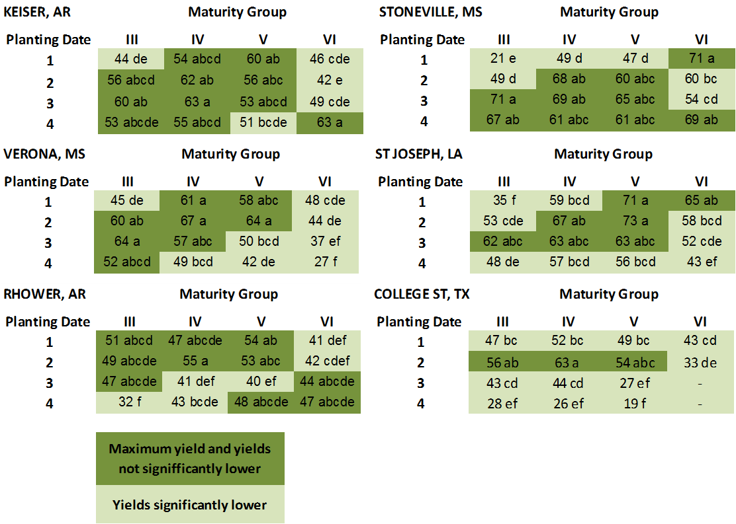

**Figure 8**: Average yields per location, planting date, and maturity group, averaged over cultivars. Cells in dark green indicate the maximum yield per location and the treatments with a yield not significantly lower than maximum yield for that location. Cells in light color indicate yields significantly lower than the maximum yield for that location.

In order to further study the effect of the choice of MG and in particular the variety effect on soybean grain yield, a stability analysis was conducted using a regression approach (Finlay and Wilkinson, 1963). An environmental yield index was obtained for each location and planting- date combination as the average yield of all varieties for that location and planting date. A regression is then obtained for each genotype plotting the yield of that variety at each location and planting day against the environmental index. Stability is measured as the slope of this regression. Slopes > 1 indicate low stability, whereas slopes < 1 indicate higher stability across environments for that genotype. An example for two varieties is shown in Figure 9. The effect of the relative maturity group on the yield stability of a given genotype is shown in Figure 10. Yield stability appears to decrease as relative maturity group of a soybean variety increases. Yield stability appears to decrease as relative maturity group of a soybean variety increases. MG 4 soybean have yields that are generally stable (slope close to 1) and their yields, when averaged over all environments, are the highest.

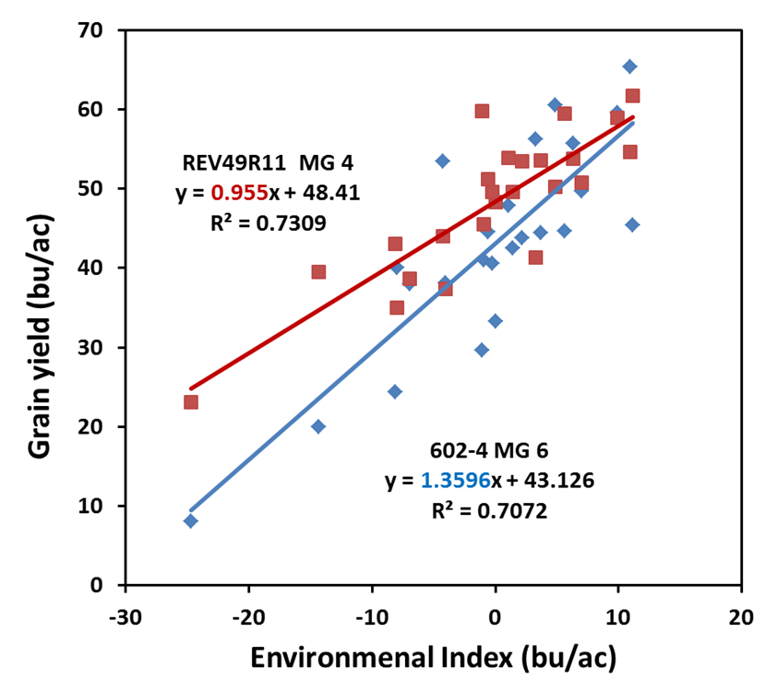

**Figure 9:** Regression of the grain yield for two varieties against the Environmental Index obtained for each combination of location and planting date. The slope of the regression indicates the yield stability for that genotype.

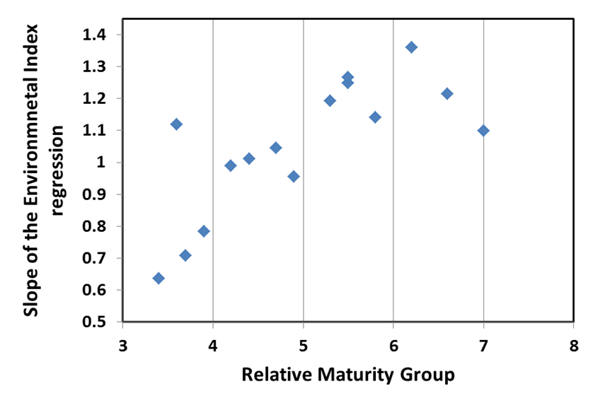

**Figure 10:** Effect of the choice of relative maturity group on the yield stability of a variety, expressed as the slope of the regression of the yield for each variety against the environmental index.

Regarding the results from seed quality analysis, an update of the analysis performed so far and some preliminary results is shown below:

* Seed grading. Seed grading is being conducted at Rohwer, AR under the coordination of Larry Earnest. Approximately 75% of the samples have been processed so far for dockage, seed size, and seed damage.
* Standard germination and accelerated aging. About 35% of the samples have been analyzed for standard germination and accelerated aging. Some preliminary results are shown below in Figure 11. Both standard germination and accelerated aging show an increase in seed quality with later planting dates and with later maturity at the early planting dates.
* Protein and oil content. Samples will be sent from Rohwer, AR to the USDA-ARS laboratory in Peoria, IL after the seed grading has been completed.

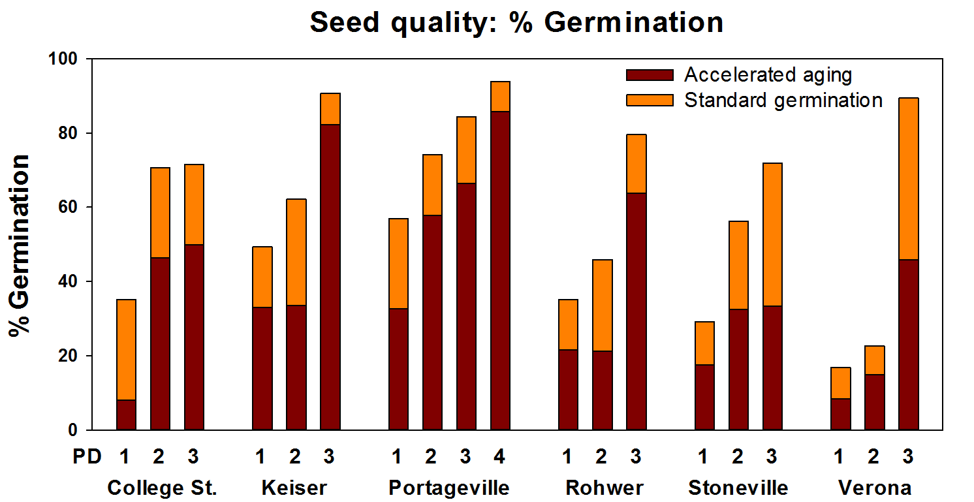

**Figure 11:** Standard germination and germination after accelerated aging at each location and planting date. Data averaged for each planting date across varieties and maturity groups.

**Progress Report 15 June 2013**

**Project highlights:**

* Soybean seed from 4 MGs and 16 varieties was received and sent to all collaborators.
* 1 to 4 planting dates have been established, depending on the location. The wet weather this year has delayed planting in most cases compared to last year.
* Seed grading results (seed size and seed damage) conducted at Rohwer, AR, have been completed.
* Two thirds of the results from germination and accelerated aging have been completed.
* An abstract for a poster entitled “Stability of soybean yield and quality over a wide range of maturities and planting dates in the Midsouth” has been submitted to the ASA, CSSA, SSSA meeting 2013, where results from the first year of the project will be presented.

Since the last report, our efforts have been focused on getting all the seed ready and shipped to all locations, as well as revising this year’s experimental protocols and experimental design for our collaborators. Our research efforts have been focused on analyzing seed quality results.

Specific comments from our locations are noted below.

**College Station, TX – Travis Miller, Clark Neely, and Daniel Hathcoat**

Soybeans were again planted this spring on a Weswood silt loam. To avoid the late freezes this spring, planting began later than last year. We have completed the fourth and final planting date. Our planting dates thus occurred on April 9, April 26, May 13, and May 30. April 9 and May 13 plantings were successful. The April 26 planting had some soil crusting after a rain event, which resulted in a somewhat lesser stand, but it is still in relatively good shape. There was another heavy rain event on June 2 and so we will have to watch emergence on the fourth planting date as well. On June 4 the topsoil was still moist and approximately 10% of seedlings had broken through. Plant development of the first planting date is around the R2 stage, followed by V5-V6 for planting two, and V2-V3 for planting three.

There was thrip pressure earlier on and some armyworms present last week; however, these were sprayed (on May 7 and May 31, respectively) before any significant damage occurred. College Station has received very near average rainfall so far this year. April was on the dry side, which required one irrigation (0.5”) prior to the second planting date, but May has provided sufficient precipitation and thus our soil moisture is in good shape. We have had no disease or weed issues to speak of.

**St. Joseph, LA – Josh Lofton**

At St. Joseph, tests were established in a mixed soil complex (Sharkey-Tunica-Newellton complex), with clay topsoil above a silt loam. The previous crop grown in our field this year was cotton. Plots consist of two 80-inch wide beds in similar configuration as the previous year (eight 20-inch drill row plots). Overall, spring weather conditions were very unfavorable for timely planting, with heavy saturation periods and late freeze conditions. This prevented soybean planting until late-April or early-May for much of the region. While planting conditions were very unfavorable at times, the test was well planted and exhibited very good emergence. The first three planting dates have been successfully planted with the final planting anticipated for the week of June 10th. Phenology data has begun to be taken on the first three planting dates and will commence shortly for the final planting date. No early season insect damage has been recorded, but all plots have received a post-emergence glyphosate application to deal with existing and early season weed pressure. No irrigation has been applied to date due to moist conditions; however, irrigation will be applied through furrow irrigation when indicated using the irrigation calculator.

**Stoneville, MS – Bobby Golden**

Currently planting dates 1 and 2 are up and have excellent stands. Planting date 1 is at R2 and V7. Planting date 2 is at V2. We received another 1.5 rain over the weekend. We will not be able to plant planting date 3 until it dries. Currently we have not had to irrigate. It seems that 5332 is acting like a late 4 not a 5. Other than that no problems have been encountered.

**Rohwer, AR – Larry Earnest**

Mid-South soybean plots at the Rohwer Research Station are following corn in 2013 on an Herbert Silt Loam soil. Plots were planted on 38" beds in a twin row system spaced 8" on top of the bed. Planting Date 1 was planted April 26th and emerged nine days later on May 5th. Stands for PD1 are excellent at 90% or better. Planting Date 2 was planted on May 20th and emerged May 27th following a hard packing rain. Two days later, we received an additional 1.54 inches of rain. Stands are fair to good with 75 to 80% emerged. Some of the plants have struggled from compaction and the cotyledons snapped at and below the soil surface. An extremely tight seal around the cotyledons under the soil line rendered a rotary hoe useless. We have managed, between rains and floods, to keep the plots clean with residual and topical applications of herbicides.  No insects or disease are present. PD 3 is scheduled to plant between the 7th and 10th of June and PD4 around June 28 to 30th. Maturity Groups III plots have reached R1 to R2 with an average of 6 nodes present and MG IV's have reached R1 and should reach R2 by the end of the week with 6 to 7 nodes present. MG V and VI are at 6 nodes on average. Average canopy closure is 42% for PD1 and 10% for PD2. PD3 and 4 sites will need another burndown and residual herbicide before planting.

Seed Grading is complete for all locations in 2012 and data are being reviewed and edited for analysis by Dr. Montse Salmeron. Kristen ,Meagon and Becky are completing the seed packets for Oil and Protein analysis and should be shipped by the end of this week. Overall the Mid-South Project is off to an excellent start for the year. Temperatures have moderated enough to stimulate normal growth and germination. Rainfall has been adequate to eliminate the need for irrigation to this point. Quite different from last year! We are later this year but last year was extremely early. Contrasting years to date that have created the need for unique and different farming/experimental practices in both years to accomplish our goals. Can't wait to see how this will turn out!

**Verona, MS – Normie Buehring**

This study is located on a Leeper silty clay loam soil. The previous crop on this study site was corn. The study was planted with two-eight inch spacing twin rows per bed on a 38-inch spacing. Rainfall in March was 102% of normal with April and May being 97 and 114% of normal, respectively. Although rainfall for March (102%), April (97%) and May (114%) were near normal, wet soil conditions, cloudy weather and below normal temperatures for March, April and May resulted in poor drying conditions which inhibited planting as scheduled for early March. Our first planting date was 4/23/13 with the second and third plantings on 5/14/13 and 5/30/13, respectively. Acceptable stands were achieved with planting dates 1 and 2. The third planting as of this report date has not emerged. The planting date 1, maturity group III’s and some of the maturity group IV’s are entering the R1 growth stage. None of the maturity groups have closed canopy, for the first planting date. We expect to plant the fourth planting date in mid-June. Thus far, no major pest problems have occurred.

**Portageville, MO – Earl Vories and Grover Shannon**

The Portageville study has gone pretty well thus far considering the weather. Four-row plots are planted on beds with a 30-inch spacing. The soil is Tiptonville silt loam and furrow irrigation is used. Corn was grown on the field in 2012. We experienced an uncommonly cool and wet spring and have not applied the first furrow irrigation as of the end of May. The first planting date was seeded on April 9. With the subsequent cool, wet conditions the plants were very slow to emerge, with most plots requiring over 2 weeks. Although emergence was uneven, acceptable stands were observed. The crop was at the V6 stage at the end of May. The second planting date was seeded on May 9. With the favorable conditions the plants emerged in a week and uniformly. The crop was at the V3 stage at the end of May. The third planting date was seeded on May 29. Conditions appear favorable for a quick and uniform emergence. The crop was not emerged at the end of May. The final planting date is expected in mid-June. No unusual pest problems have yet been observed, including herbicide-resistant weeds, but resistant pigweed has become very common in the area.

**Keiser, AR – Fred Bourland and Max Wyss**

At Keiser, the experiment is on a Sharkey silty clay. Above-normal precipitation and wet soil conditions have prevented planting yet this year. The first planting will be seeded as soon as the field is dry enough . The next planting dates will be scheduled at approximately 7-day intervals.

**Milan, TN – Dave Verbree**

Despite a very wet spring, the first two planting dates were planted timely. Planting date 1 was planted on 4/22/2013, shortly after the last frost-free date (April 19@90% certainty). However, two frosts occurred shortly after planting but did not affect the stand. Planting date 2 was planted on 5/9/2013. Pre-emergent herbicide (Prefix) was sprayed within one day of planting.

On 5/10/2013, one day after planting date 2, the field received 3.44” of precipitation (up to 1.5”/hr), causing flooding and an isolated washed-out area in rep 4. The affected plots as determined by poor stand counts are 363, 453, 457, 458, and 461. We decided not to fill-in or replant since this was mostly isolated to one replication of one planting date and because of the relatively short time between planting dates. Since 5/9/2013, the field received approximately 8.75” of precipitation and soil moisture content at 9-12” deep has not dropped below 0.313 m3 m-3 or -0.119 bars.

Emergence was extremely uniform among all varieties at each planting date and stands are acceptable except as previously noted. As of 06/03/13, planting date 1 is at grow-stage V3 and planting date 2 is at V1. We anticipate planting the third planting date as soon as the field dries up from recent rains (est. June 5, 2013) and the fourth planting date approximately when we harvest wheat in late June.

**Columbia, MO**

We have completed three planting dates with June 4 as the date for planting date 3. Dates 1 and 2 have emerged. Weather this spring has been both excessively wet and cooler than normal (7.7 and 10.4 inches of rain in April and May). Emergence for some plots for date 1 is relatively poor. Planting date 4 is planned for normal double cropping date, which for the Columbia MO area is about July 1.

**Fayetteville, AR – Montse Salmeron and Larry Purcell**

In Fayetteville, an experiment with one only planting date will be carried out like in 2012. The soil is a Captina silt loam. The seed was packaged and is ready for planting. We will have four-row plots, 20 feet in length with rows 18 inches apart. The wet weather has prevented an earlier planting but it is expected to be possible by June 10.

Planting dates for all locations are reported below (Table 8). Because planting dates were delayed due to wet weather compared to the previous year and because of the cooler conditions this year, the last planting date is expected to be as late as in the last week of June or early July for some locations.

**Table 8:** Established planting dates at each location during the 2013 season.

|  |  |  |  |  |
| --- | --- | --- | --- | --- |
| Location | Planting date 1 | Planting date 2 | Planting date 3 | Planting date 4 |
| College Station, TX | 09-Apr | 26-Apr | 13-May | 30-May |
| St. Joseph, LA | 30-Apr | 13-May | 27 - May |  |
| Stoneville, MS | 18-Apr | planted |  |  |
| Rohwer, AR | 26-Apr | 20-May |  |  |
| Verona, MS | 23-Apr | 14-May | 30-May |  |
| Keiser, AR |  |  |  |  |
| Portageville, MO | 09-Apr | 09-May | 29-May |  |
| Milan, TN | 22-Apr | 9 - May |  |  |
| Columbia, MS | 22-Apr | 14-May | 4 - June |  |
| Fayetteville, AR |  | - | - | - |

Visits to all experimental locations are planned during the months of June and July

Regarding the research progress conducted at Fayetteville, the yield and seed quality dataset from 2012 is not complete yet, but is expected to be during this period. A stability analysis will be performed with this dataset and results will be presented at the 2013 ASA, CSSA, SSSA meeting in Tampa, FL. A poster titled “Stability of soybean yield and quality over a wide range of maturities and planting dates in the Midsouth” will be presented.

Results from seed grading (seed size, foreign material, and seed damage) were completed and results for the percentage and type of seed damage are shown below (Figure 11). Percentages of damaged seeds seem to be very dependent on the location. Within each location, it is possible to see an effect of planting date and MG in most cases.

* At College Station, seed damage increased for planting dates 3 and 4, particular for MGs 5 and 6, due to weather and green damage.
* At Keiser, Martin, and Rohwer seed quality was good for all planting dates and all MGs with total damage generally being less than 10%.
* At St. Joseph, there was 10 to 15% total damage to seed for all planting dates and MGs primarily due to weather damage and stink bug damage.
* At Verona, weather damage for MGs 5 and6 was 25 to 40% for the first planting date and about 25% for MG 5 for the second planting date. Otherwise, all MGs and planting dates had less than 10%total damaged seed.

**Figure 11:** Percentages of damaged seed at different locations.

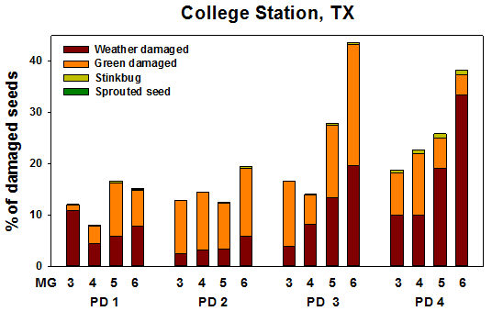

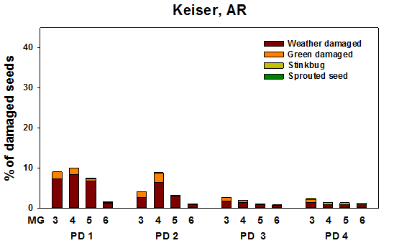

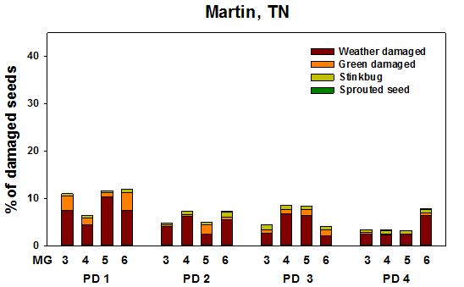

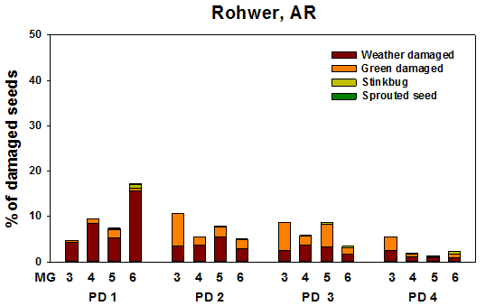

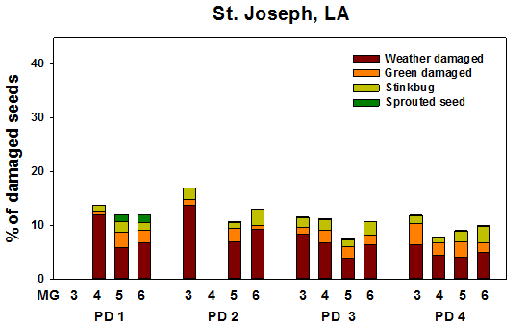

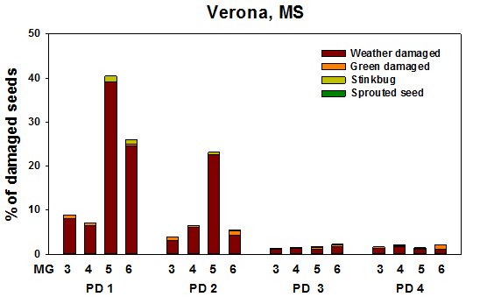

**Progress Report 15 September 2013**

**Project highlights:**

* Four planting dates were established at all locations.
* Germination and accelerated aging, oil and protein, and seed grading results were completed for samples from the 2012 growing season.
* Results from 2012, including seed quality, were presented at the Mid-South Soybean Board meeting held in Stoneville, MS.
* Soybean seed harvest has begun for most of the locations, especially for the first planting date and early maturity groups.

Since the last report, efforts from the collaborators from each location have focused on field work, including phenology monitoring, irrigation, pest and disease control, and harvest. Our research efforts have focused on analyzing 2012 data to be presented in the ASA-CSSA- SSSA International Annual Meeting 2013 to be held in Tampa, FL and for publication.

Specific comments from our locations are noted below.

**College Station, TX – Travis Miller, Clark Neely, and Daniel Hathcoat**

As of September 10, all soybeans have been harvested from Planting Date (PD) 1, except for Maturity Group (MG) 6, which are in the late R6 stage currently. These are expected to be harvested by September 19. Similar to PD 1, all maturity groups in PD 2 have been harvested except for MG 6, which remain in the early to mid R6 stage. Harvest of these plots is not anticipated until the end of September. Only MG 3 and 4 have been harvested from PD 3, though MG 5 should be ready in another week. MG 6 is still in the early R6 stage for this planting date. We have begun to harvest PD 4 (MG 3), and anticipate harvest of MG 4 (R7 stage) later this week. Maturity Group 5 was in early R6 and MG 6 was still in R5 to early R6. Stands have remained healthy all season with no disease or significant weed pressure to speak of.

Moisture was abundant until the end of May, but the weather has been hot and dry since then. We’ve experienced above average temperatures June through August, though July was close to normal and we have had below normal precipitation all three months. We are about 6 inches behind on our annual rainfall average and we’ve used irrigation multiple times.

Stink bugs have continued to be a substantial pest. Some red-banded stinkbugs are present, but in limited numbers. The common green stinkbug has been the primary threat. Grasshoppers and three-cornered alfalfa hoppers are present, but have not reached economic threshold levels. Weekly scouting by sweep net continues and spraying as needed.  A few soybean loopers are still present in PD 4 for later maturity groups, but do not pose a threat.

**St. Joseph, LA – Josh Lofton**

Overall, the 2013 soybean crop is progressing very nicely. Soybean growth has been much greater than last year, with all maturity groups at all planting dates being at least at the R5.5 or R6 growth stages. Growing conditions have been generally favorable for growth, which has resulted in high lodging ratings. However, earlier (cooler, wet conditions) and later (hot, dry conditions) soybean have experienced less than optimum conditions, which has affected growth.

The MG III and IV varieties from the first and second planting date have been harvested, and we anticipate harvesting MG V during the week of September 16th and 23rd. Yields from the first planting date for MG III and MG IV varieties ranged from 67 to 89 bu/ac and 83 to 109 bu/ac, respectively. Yields from the second planting date for MG III and MG IV varieties ranged from 65 to 102 bu/ac and 76 to 102 bu/ac, respectively. Additionally, MG III from the third planting date has been harvested, with yields ranging from 62 to 87 bu/ac.

Pest pressures have generally been low. Both stinkbug and looper pressure have been minimal with only small flights occurring throughout the growing season, which were typically remedied through the use of pyrethroids. Disease pressure, while minimal, has occurred throughout the season. An early season incidence of downy mildew occurred throughout the region; however, its effects were minimal and fungicides were used to limit further growth. Leaf spots incidence began late July due to rainy conditions; however, drier conditions in August have limited incidence in the earlier maturing groups and planting dates, while later maturing varieties and planting dates have been more greatly affected.

**Stoneville, MS – Bobby Golden**

Since our last update, we have planted the 3rd and 4th planting dates on July 12 and June 8, respectively. All planting dates look very well. On, August 16 a field day was held at Stoneville, MS for the Mid-South Soybean Board.  During the meeting the members toured the plots and heard presentation from Dr. Salmeron on last year’s progress and 2013 progress to date.  Mississippi State University also used the trial as a learning tool to inform producers about proper irrigation termination and determination of soybean growth stage with an irrigation field day held Aug 30. Many consultants and producers toured the plots and were very interested in the outcomes. The majority of attendees noted that a computerized scheduling tool would be a great benefit to soybean producers.

Currently we have harvested the PD1 MGIII varieties.  We are currently at R8 for MG IV varieties planted at PD1 and MGIII varieties planted at PD2, with most of the MG V varieties in the first two planting dates at or approaching R7. Most all of the maturity groups for PD3 are currently in the R6 Stage, while PD4 MGs range between R5 and R6. Very limited disease pressure has been observed throughout the growing season. Blanket applications of fungicides were applied to all plots near the R3-R4 growth stage. Two insecticide applications have been applied to help control stinkbug populations. Currently we have observed leaf injury from bean leaf beetle on many of the plots. Entomologists at the DREC suggested that the injury was not yield limiting, but are continuing to monitor the plots for threshold levels.

**Rohwer, AR – Larry Earnest**

Soybean plantings were delayed due to rain and low temperatures early in the season when compared to 2012 (Table 8). Therefore, each planting interval averaged about 21 days apart compared to about 30 days last year. All seedlings emerged greater than 80% within 7 to 10 days. Early season vigor was excellent and no evidence of early season disease was noted. Weed control was very effective throughout the year with standard applications of both Pre-emergence and Post-emergence applications at recommended rates of Dual, Round-Up Power Max, Prefix and FlexStar. The occasional Palmer Amaranth–Pigweed was controlled by old conventional standards, pulling.

Seasonal insect pressure has been minimal but applications were used to control a mix of injurious species that were present in the plots but not at treatment levels of any one specie that cause economic loss. These included relatively low numbers of Green and Brown Stink bugs, Soybean Loopers, Corn Ear Worms, Alfalfa Hoppers, and Bean Leaf Beetles. Applications of Bifenthrin, Acephate, and Belt were used and effectively controlled pests to date. Headline fungicide was used to control Downey Mildew in PD 1 and 2. Mildew was more prevalent on determinate varieties. Low levels of Sudden Death Syndrome, SDS, were noted in some of the varieties along with Root Knot Nematodes, RKN.

Irrigation was a major component in the production scheme even though ambient air temperatures averaged less this year compared to 2012. During planting our last significant rainfall occurred June 6th with 1.6 inches accumulated. PD2 and 3 had supplemental water applied to provide moisture for planting and weekly irrigations were required to maintain adequate moisture for plant growth and development most of the season. All planting dates and varieties within each maturity group have progressed well (Table 9). Nodal developments and pod set looks to be excellent and plot yields are indicating this as well.

The USB-Midsouth study was featured at the Soybean Management Study Day, held at the Southeast Branch Experiment Station in Rohwer on August 22nd. Approximately 150 producers, consultants, and industry representatives attended.

Harvest began 8-30-2013 in PD1 and 2 with Group III varieties. Preliminary plot yields to date have ranged from 65 to 95 bushels/acre. Seed quality appears to be good to excellent with test weights around 54 lbs/bu. A few seed samples from College Station have arrived the last few weeks and put into cold storage for “Seed Quality Testing”, in the near future. To date, the Mid-South Project continues to progress and looks great.

Table 8: Planting Date, Emergence Date, and Harvest Date.

|  |  |  |  |  |  |
| --- | --- | --- | --- | --- | --- |
|  | Planting Date | Emergence Date | Harvest Date |  |  |
| PD1 | 4-26-13 | 5-5-13 | 8-30-13 Grp 3 |  |  |
| PD2 | 5-20-13 | 5-26-13 | 9-04-13 Grp 3 | (7 of 16 harvested) |  |
| PD3 | 6-10-13 | 6-17-13 | - |  |  |
| PD4 | 6-28-13 | 7-8-13 | - |  |  |

Table 9: Reproductive Status, Date occurred, and Comments.

|  |  |  |  |
| --- | --- | --- | --- |
|  | Reproductive Status | Date | Notes and Comments |
| PD 1: |  |  |  |
| Group 3 | R8 | 8-23-13 | Harvested on 8-30-13 |
| Group 4 | R8 | 9-9-13 |  |
| Group 5 | R7 | 9-9-13 |  |
| Group 6 | R6 | 8-30-13 |  |
| PD 2: |  |  |  |
| Group 3 | R7 & R8 | 8-26-13 & 9-2-13 | Harvested 7 of 16 plots |
| Group 4 | R7 | 9-9-13 |  |
| Group 5 | R6 | 8-27-13 |  |
| Group 6 | R5 | 8-18-13 | Currently in between R5 and R6 |
| PD 3: |  |  |  |
| Group 3 | R6 | 8-30-13 | Currently in between R6 and R7 |
| Group 4 | R5 | 8-9-13 | Currently in between R5 and R6 |
| Group 5 | R5 | 8-19-13 | Currently in between R5 and R6 |
| Group 6 | R5 | 8-26-13 |  |
| PD 4: |  |  |  |
| Group 3 | R6 | 9-5-13 |  |
| Group 4 | R5 | 8-20-13 |  |
| Group 5 | R5 | 8-26-13 |  |
| Group 6 | R5 | 8-30-13 |  |

**Verona, MS – Normie Buehring**

This study is located on a Tuscumbia silty clay loam soil. The previous crop on this study site was corn. The study was planted on twin rows with eight-inch spacing between twins and centered on 38-inch spacing. Rainfall for March and May was 2 and 14% above normal, respectively. Rainfall for April, June, July and August were 88, 97, 67 and 48% of normal, respectively. Mean monthly maximum air temperatures for March, April, May, June, July, and August were -7, -2, -3, 0, -3 and -2 below normal, respectively. All irrigations were applied after soybean emergence and were based on the “Arkansas Irrigation Scheduler” computer program. A total of 12 irrigations (6/19/13, 6/25/13, 7/02/13, 7/08/13, 7/15/13, 7/24/13, 7/30/13, 8/06/13, 8/20/13, 8/27/13, 9/05/13, and 9/11/13) have been applied to all planting dates (4/23/13, 5/14/13, 5/30/13 and 6/17/13), except the 6/19/13 irrigation. The first furrow irrigation (6/19/13) was only applied to planting dates 1, 2 and 3.

The Maturity Group (MG) III varieties’ maturity in the first planting (4/23/13) ranged from 8/24/13 to 9/04/13. The MG IV, V and VI varieties in the first planting (4/23/13) are in R7/R8 stages of development, respectively. The MG III, IV, V and VI varieties in the second planting date (5/14/13) are in the R7/R8, R7, R6/R7 and R6 stages of development, respectively. The MG III, IV, V and VI varieties in the third planting date (5/30/13) are in the R7/R8, R6/R7, R6/R7 and R5/R6 stages of development, respectively. In the fourth planting date (6/17/13), MG III, IV, V and VI varieties are in the R7, R6, R5/R6 and R5 stages of development, respectively.

Except for frogeye and stem canker, no other diseases (cyst nematode, charcoal rot) have been observed. Frogeye leaf disease was beginning to develop on most varieties across all planting dates. Therefore, a fungicide application of Quadris + Tilt was applied on 8/26/13. In the first planting date, all varieties except two MG III varieties (5N342R2 and P93Y92), did not exhibit stem canker disease (identified by plant pathologist). In planting date 2, thus far, all MG VI varieties, P94Y40 (MG IV), AG 5532 (MG V) and P95Y50 (MG V) varieties have been identified with stem canker. In planting date 3, AG6732 (MG VI), P95Y50 (MG V), P94Y40 (MG IV) and REV 48R33 (MG IV) varieties are infected with stem canker. So far, stem canker has not shown up in the 4th planting date.

One insecticide application (8/19/13) has been applied during the growing season to control stink bugs. Since we had good canopy closure, we chose to reach over and spray the plots from the border rows with a 60 ft boom. This avoided the potential damage to the soybeans from the sprayer wheel tracks.

The MG III varieties’ maturities in the 1st planting ranged from 0 to 4 days differences between replications and 0 to 11 days between varieties. These plots showed very little or no seed shatter, which was evaluated just prior to harvest. These were harvested 9/10/13 and the yields ranged from 59 to 74 bu/acre.

**Portageville, MO – Earl Vories and Grover Shannon**

The study is progressing on schedule, with no treatments for insect pests thus far. Harvest will begin soon, with some of the plots having reached the R8 growth stage. The study was discussed as part of a presentation on soybean irrigation management at the Fisher Delta Research Center Field Day on August 29. Planting Date 1 (April 9) has treatments ranging from R5 through R8 growth stages; planting Date 2 (May 9) has treatments ranging from R5 through R7 growth stages; planting Date 3 (May 29) has treatments ranging from R5 through R6 growth stages; and planting Date 4 (June 20) has treatments ranging from R2 through R6 growth stages.

**Keiser, AR – Fred Bourland and Max Wyss**

At Keiser, we encountered some heavy rains in late July early August. We developed heavy Johnson grass pressure in PD2 and PD3. Johnson grass was controlled with 16oz Select applied in two applications. Furrow irrigation for PD1/MG3&MG4 was recently terminated. Development Stages: PD1 (planted 6/13) has reached R6/R7 for MGs 3&4, MGs 5&6 are at R5/R6. For PD2 (planted 6/26), MG 5&6 have reached R5, MGs 3&4 are at R6. For PD 3 (planted 7/8), MGs 5&6 are at R4/R5 and MGs 3&4 are at R5/R6. For PD 4 (planted 7/17), all MGs have reached R2 and the MG 3 varieties are at R5. We are taking pictures for canopy coverage development for PDs 3&4 at present.

**Milan, TN – Dave Verbree**

The past few weeks were warmer with a little less rainfall which allowed the crop to progress nicely. The maturity group (MG) 3 & 4 varieties from planting date (PD) 1 & 2 (planted on 4/22 and 5/9, respectively) are drying down and we expect to begin harvesting next week. Some rows appeared stunted possibly caused by Prefix sprayed at planting or herbicide carryover from the previous crop but the exact cause could not be identified. Care was taken to ensure that all measurements were made on non-stunted plants.

Due to the unusually wet weather, SDS pressure in PD 1 & 2 has been high for certain varieties. The following lines were found to be susceptible to SDS on multiple replications: highly susceptible: AG4732; moderately susceptible: 6202-4, P6710RY, 42-M1, P93Y92, and REV48R33; and somewhat susceptible: AG5332, P93Y72, P94Y40, and 5N342R2. In most cases, the SDS did not cause substantial defoliation until after pods were full. Lodging is also evident for some varieties that were responsive to irrigation/rainfall.

As of 9/12/13, only PD 1 & 2 / MG 3 & 4 are at R7, PD 2 & 3 / MG 6 and PD 4 / MG 5 & 6 are at R5, and the rest of the MGs and PDs are at R6. Insecticide was sprayed on all PDs/MGs at R3 for PD 1/MG 3 primarily to control green stink bugs and fungicide was sprayed on all PDs/MGs at R3 for PD 3 / MG 3 as a preventative.

**Columbia, MO – Bill Wiebold and Felix Fritschi**

Planting of all four dates hit reasonable targets. The last planting date was June 25, the date when double-cropping would occur in central Missouri. Less than four inches of rain has been received at the research site from July 1 through September 13. Irrigation has been applied according to recommendations. Some sudden death syndrome has occurred at research farm but not in area used for this project. Harvest of MG3 varieties of the first planting date will occur in about 10 days.

No major problems to report except for weather conditions.

**Fayetteville, AR – Montse Salmeron, Ed Gbur, and Larry Purcell**

In Fayetteville, the experiment was planted on June 7 on a Captina silt loam, in four-row plots, 20 feet in length with rows 18 inches apart. Only one planting date was sown at this location, but each plot was planted twice to allow for destructive samplings during the vegetative and reproductive period, as well as pod sampling for pod color analysis during the R7 stage.

At this date, MG 3 varieties are in late R6 stage, MG 4 varieties are in R6, MG 5 varieties are close to R6, and MG 6 reached R5 two weeks ago. The experiment was sprayed with Karate when stink bugs were detected over threshold values. No other incidences with pests and/or diseases have been detected by this time.

Ground cover pictures were taken for light interception estimation until canopy coverage was complete. Destructive samplings were performed at V8 stage, at R3, R5, and at R6 to determine leaf area index and leaf weight, which are important inputs for our model.

Regarding the research progress conducted with the 2012 dataset, results from seed quality were completed during this period and some results are shown below. Seed oil concentration showed a significant relationship with air temperature during seed filing (Figure 12). Protein seed concentration did not respond to temperature, but showed an expected inverse relationship with oil concentration. That is, as protein concentration increased, oil concentration decreased. In general, oil concentration was highest for the earliest MGs for all planting dates and decreased as MG increased. Conversely, protein concentration tended to be highest for MG 6 varieties and decreased for earlier MGs. Both oil and protein seed concentration had a significant effect of the location, MG and variety (Figure 13 and 14) that could allow for site-specific management recommendation for maximizing profits.

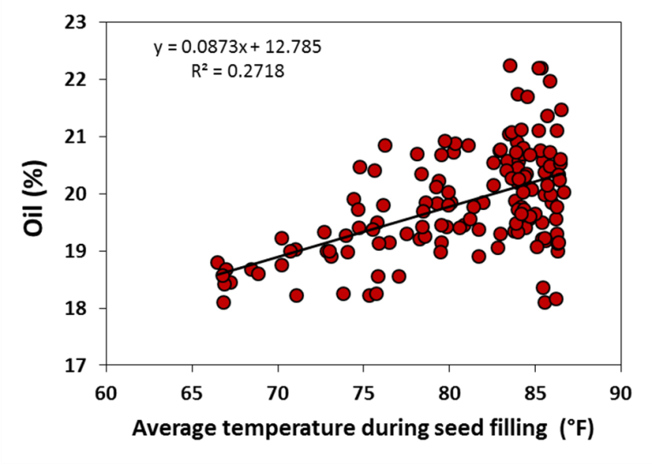

**Figure 12.** Relationship between the seed oil concentration and the air temperature during seed filling.

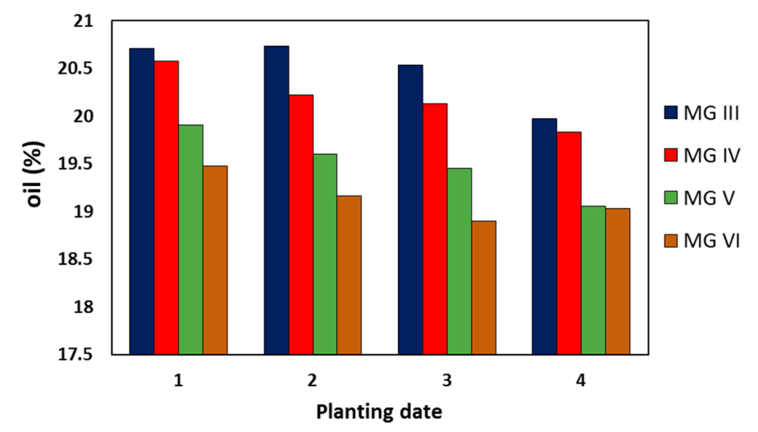

**Figure 13.** Oil concentration in soybean seed averaged by planting date and soybean maturity groups.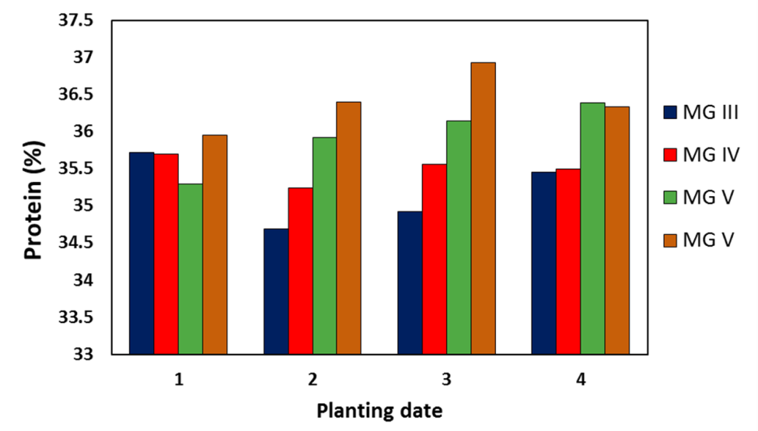

**Figure 14.** Protein concentration in soybean seed averaged by planting date and soybean maturity groups.

Seed grading from 2012 has been completed and clearly show that grades for our more southern locations (College Station, Rohwer, St. Joseph, Stoneville) were lower than our more northern locations (Portageville, Keiser, Martin, Verona) (Figure 15). The highest seed grades tended to be for the last planting date and with the later MGs, presumably because seed matured in cooler temperatures.

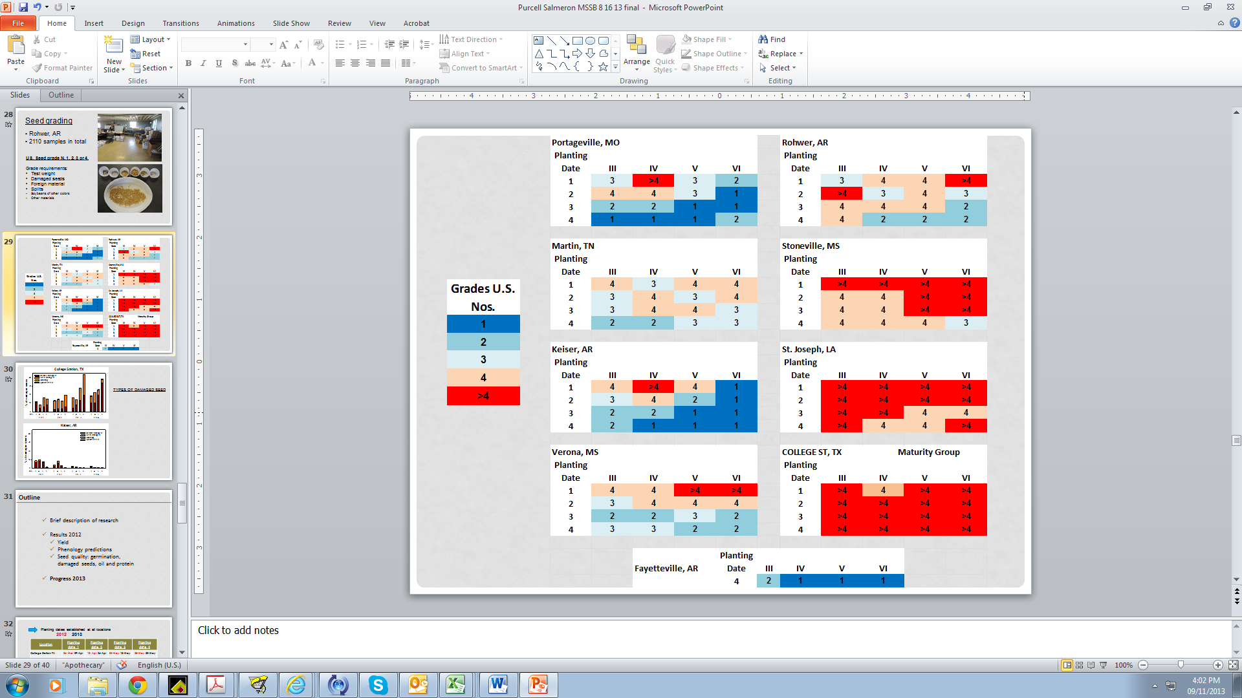

**Figure 15:** Summary of U.S. Soybean seed grade averaged by location, planting date, and maturity group.

Another activity carried out within the project was the soil sampling of each experimental field for particle size analysis to obtain more accurate information on soil texture. This information will improve the estimation of water retention parameters used for crop simulation. Soils were sampled by different depths intervals, depending on the location. A total of 50 soil samples from our respective locations were analyzed for texture at the soil physics laboratory of the University of Arkansas in Fayetteville.

**Progress Report 15 December 2013**

**Project highlights:**

* The experiments were conducted successfully at all locations.
* Plots at all locations have been harvested and a subsample sent for seed grading, seed germination and accelerated aging, and oil and protein analysis.
* Yield results and in-season notes are being compiled.
* Stability analysis of yield and seed quality data from 2012 were presented at the ASA, CSSA, SSSS Annual Meeting in Tampa, FL.
* Cooperators met at the ASA,CSSA,SSSA meetings in Tampa to review results and discuss progress on data analysis.

Since the last report, efforts from the collaborators from each location have focused on taking the end of season notes and grain harvest. Our research efforts have focused on the analysis of 2012 data and preparing a manuscript on yield and oil and protein stability for publication.

Specific comments from our locations are noted below.

**College Station, TX – Travis Miller, Clark Neely, and Daniel Hathcoat**

On November 18, all remaining soybeans were harvested regardless of maturity stage as there was little to no change in their leaf drop and/or number of green pods during the previous month. These plots consisted of all MG 6 varieties at all planting dates, except for 6202-4, which matured by October in planting dates 1 and 2. These samples had high seed moisture and likely low quality and had to be dried in the oven. Many of these plots did not produce enough seed to take accurate moisture or test weight measurements. A summary of the previous harvest times by MG and PD are listed below:

PD 1 MG 3 harvested in late July/Early Aug  
PD 1 MG 4 harvested in mid-August  
PD 1 MG 5 harvested late August/Early September  
PD 1 MG 6 only 6202-4 harvested late Sept/early Oct

PD 2 MG 3 harvested in mid-August  
PD 2 MG 4 harvested in late August  
PD 2 MG 5 harvested in early Sept  
PD 2 MG 6 only 6202-4 harvested in mid-Oct

PD 3 MG 3 harvested in mid- late August  
PD 3 MG 4 harvested in late Aug/early Sept  
PD 3 MG 5 harvested in mid-Sept  
PD 3 MG 6 did not reach R8 stage

PD 4 MG 3 harvested in late Aug/early Sept  
PD 4 MG 4 harvested in late Sept  
PD 4 MG 5 harvested in early/mid-Oct  
PD 4 MG 6 did not reach R8 stage

Green and red-banded stinkbugs may have exacerbated delayed maturity to some extent and were sprayed on September 23. Disease and weed pressure were not a problem. Temperatures were above average in September, but were near normal for October and November. Moisture was above average for September, October, and November with 124% of normal rainfall for the three month total.

**St. Joseph, LA – Josh Lofton**

Since the last report, all yield data as well as phenological measurements have been collected. Additionally, at the time of this report, all soybean sub-samples have been submitted for quality analysis.

Overall, trial yields were higher than the previous years by a substantial margin. However, this can be expected since many growers in northern Louisiana achieved record soybean yields this season. While not as high as the earlier timings, higher than expected yields were found with later planting date (PD3) as well as the simulated double crop planting (PD4). With the above average growing conditions, all maturity groups by planting dates combinations showed increased growth (judging by final height measurements) compared to the previous year. This was especially shown with the maturity group V soybeans. The excessive growth led to high lodging rates. However, these highly lodged soybeans did not typically decrease yields due to the combine’s ability to pick a majority off the ground.

Where the previous year’s crop had high green stem rating, required a desiccant to completely dry down, and had a high rate of visually damaged seed, these complications were largely absent this year. This was a result of near perfect maturation conditions that were present for the majority of August and September. Green stem ratings were generally low with little distinct pattern of maturity group or planting date. In most years, producers in Louisiana must utilize desiccants to aid in dry down of the maturing soybean crop as well as a tool to minimize late-season seed decay. However, due to dry-down conditions present, no desiccants were utilized.

Within the last several weeks, planning for the 2014 growing season has begun. The field for next season has been identified, bedded, and soil samples for nutrient recommendations have been collected. Both P and K applications will be made as soil conditions allow in early part of 2014.

**Stoneville, MS – Bobby Golden**

Since our last update, we have harvested all soybean varieties and taken all phenological measurements. Some of the group 6 varieties had to be harvested at high moisture due to weather conditions.  The bean leaf beetle problem we experienced in the last update never manifested into a population that would influence yield. To date most harvest information has been recorded. We are currently lacking seed index values as we have had to shift resources to different areas, but will get back to seed indexing soon. Samples are currently in cool storage awaiting seed indexing and grading. Find below a preliminary yield table for 2013 trials (Table 10). Outlying data with studentized residuals greater than 3.0 were removed from the preliminary analysis.

Table 10: Average yields by planting date and maturity group (MG):

|  |  |  |  |  |
| --- | --- | --- | --- | --- |
| Planting Date | Maturity Group | | | |
| III | IV | V | VI |
| - - - - - - - - - -Soybean Yield (bu ac-1)- - - - - - - - - - | | | |
| April 18 | 81.38 | 64.88 | 69.04 | 59.73 |
| May 20 | 63.87 | 63.63 | 86.95 | 66.85 |
| June 12 | 53.28 | 75.65 | 66.88 | 54.76 |
| June 27 | 59.42 | 64.67 | 47.32 | 43.28 |

**Rohwer, AR – Larry Earnest**

Harvest was completed in October with no complications other than a delay with some plots due to excessive and frequent rainfall periods. This did not affect quality or yield. No shattering or significant lodging occurred. Later planted soybean plot yields and seed quality remained good to excellent. However, yields appear to be lower for the later planting dates, and yields are much greater this year compared to 2012. Plots were treated for frogeye leaf spot and mildew. Slight levels of SDS were seen on a few plots at late reproductive stages in the early planted date. Slight levels of root-knot-nematode were found in the test site area. This year’s planting followed corn and 2014 test site will follow corn.

Seed grading rating is going well and is about 40% complete. To date, quality appears better this year compared to last year. Our most southern latitude, College Station, has some of the worse seed quality seen at this time. Quality is averaging better than 80% for many of the varieties. Quality rating for Rohwer is complete and are excellent compared to last year. Heat and insect damage were negligible. The one consistent negative factor seen at our location and further south of is lower test weights. Northern locations appear to have higher test weights.

**Verona, MS – Normie Buehring**

All 2013 data collections, including yield data was completed on October 28. Stem canker disease was noted on the first planting date (4/22/13) for all maturity group (MG) III, IV and V varieties except 5N342R2 and Pioneer P93Y92; and it was noted in all MG VI varieties in the first and second planting dates (5/15/13). Pioneer 94Y40 (MG IV) and Pioneer 95Y50 (MG V) on the first 3 planting dates (4/23/13, 5/15/13 and 5/30/13) also were infected with stem canker. Tilt + Quadris at 4 + 6 oz/acre was applied to the whole study on 8/26/13 for control of cercospora leaf blight and frogeye leaf spot. The highest yields ranged from 70 to 76 bu/acre with the lowest yield of 8 bu/acre for AG6732 (MG VI) planted 4/23/13. Across all planting dates, the MG VI varieties had lower yield than all other MG varieties. The MG III and IV variety yields generally were slightly higher than MG V varieties. Fertilizer (P and K) application, land preparation and fall-winter herbicide application operations have been completed on next year’s (2014) study site location.

**Portageville, MO – Earl Vories and Grover Shannon**

2013 harvest was completed on 4 November for the MG VI cultivars and the MG V cultivars from the 20 June planting date. Sub-freezing temperatures were recorded on 25 October and probably impacted some of the MG VI cultivars from the 20 June planting date. Although SDS was observed in a different part of the same field in 2012, no disease was observed in 2013. Stinkbugs were observed, but not in sufficient numbers for treatment.

Yields were very good, with the best performing treatment combination, AG5332 (MG V) from 9 April planting date, averaging 83 bushels/acre (5.6 MG/ha). Similarly, the MG V varieties from the 9 April planting date averaged 75 bushels/acre (5.0 Mg/ha). Even the poorest performing treatment combination 6202-4 (MG VI) planted 20 June averaged 48 bushels/acre (3.2 Mg/ha).

Samples of seed from every plot have been sent to Rohwer for grading and samples from many of the locations have been sent to Portageville for determination of protein and oil content.

**Keiser, AR – Fred Bourland and Max Wyss**

At Keiser, all planting dates were harvested. The plots at Keiser were planted on twin (7.5 inch spacing) on 38” raised beds on a Sharkey clay soil. The harvested length was 16 feet for all planting dates. Irrigation was stopped on MG 3 varieties for planting date 1 on 9/4/13. As for the other varieties in other planting dates, last irrigation event was on 9/12/13. Ground cover pictures were taken weekly until canopy closure. The last set of pictures was taken on 9/25/2013. We were able to locate a few possible locations for next year and have begun field preparation. In the table below, planting dates (PD) and harvest dates (HD) from Keiser are displayed (Table 11).

Table 11: Planting and harvest dates for each MG and planting date treatment at Keiser, AR.

|  |  |  |  |
| --- | --- | --- | --- |
| planting date | Maturity | PD | HD |
| 1 | 3 | 13-Jun | 10-Oct |
| 1 | 4 | 13-Jun | 10-Oct |
| 2 | 3 | 26-Jun | 21-Oct |
| 2 | 4 | 26-Jun | 21-Oct |
| 3 | 3 | 8-Jul | 21-Oct |
| 4 | 3 | 17-Jul | 21-Oct |
| 3 | 4 | 8-Jul | 30-Oct |
| 4 | 4 | 17-Jul | 30-Oct |
| 1 | 5 | 13-Jun | 15-Nov |
| 2 | 5 | 26-Jun | 15-Nov |
| 3 | 5 | 8-Jul | 15-Nov |
| 4 | 5 | 17-Jul | 15-Nov |
| 1 | 6 | 13-Jun | 15-Nov |
| 2 | 6 | 26-Jun | 15-Nov |
| 3 | 6 | 8-Jul | 15-Nov |
| 4 | 6 | 17-Jul | 15-Nov |
|  |  |  |  |

Below are the varieties harvest rankings (Table 12):

Table 12: Varieties harvest yield rankings by maturity group and planting date.

|  |  |  |  |  |  |
| --- | --- | --- | --- | --- | --- |
| **Ranks** | **Maturity** | **Planting Date 1** | **Planting Date 2** | **Planting Date 3** | **Planting Date 4** |
| **1** | 3 | P93Y92 | P93Y92 | P93Y92 | P93Y92 |
| **2** | 3 | R2 36X82N | R2 36X82N | R2 36X82N | 5N342R2 |
| **3** | 3 | P93Y72 | P93Y72 | P93Y72 | R2 36X82N |
| **4** | 3 | 5N342R2 | 5N342R2 | 5N342R2 | P93Y72 |
| **1** | 4 | REV48R33 | AG4732 | REV48R33 | REV48R33 |
| **2** | 4 | P94Y40 | 42-M1 | AG4732 | AG4732 |
| **3** | 4 | AG4732 | REV48R33 | 42-M1 | 42-M1 |
| **4** | 4 | 42-M1 | P94Y40 | P94Y40 | P94Y40 |
| **1** | 5 | AG5332 | P95Y50 | AG5532 | P95Y50 |
| **2** | 5 | P5711RY | P5711RY | P5711RY | AG5332 |
| **3** | 5 | P95Y50 | AG5332 | AG5332 | AG5532 |
| **4** | 5 | AG5532 | AG5532 | P95Y50 | P5711RY |
| **1** | 6 | P6710RY | P6710RY | P6710RY | P6710RY |
| **2** | 6 | AG6132 | AG6132 | AG6732 | AG6732 |
| **3** | 6 | 6202-4 | 6202-4 | 6202-4 | AG6132 |
| **4** | 6 | AG6732 | AG6732 | AG6132 | 6202-4 |

**Milan, TN – Dave Verbree**

Frequent rainfall and cool, cloudy temperatures delayed dry down and harvest for most varieties. Equipment (combine) bottleneck due to late corn harvest also delayed harvest at times. However, damp weather prevented potential shattering problems.

The trial was located under a center-pivot irrigation system. Therefore, applying a specific irrigation rate by planting date and maturity group was not feasible. Once the earliest varieties approached harvest maturity, irrigation was terminated for all varieties. However, continued irrigation would not likely improve yields due to adequate, if not excessive, rainfall. In addition, data recorded by soil moisture sensors throughout the season in the group 3 early planted beans suggests that the prescribed calculation of irrigation water to apply overestimated the amount of water actually required by the crop for this location especially given the wet year with frequent morning fog.

Maturity groups 3 and 4 varieties for all planting dates were harvested on Oct. 9. Maturity group 5 varieties of planting dates 1 and 2 were harvested on Oct. 10. Maturity group 5 varieties of planting dates 3 and 4 and maturity group 6 for all planting dates were harvested on Nov. 11.

Twelve MG IV and MG V plots had elevated moisture content at harvest but the harvest moisture content of plots within each harvest pass (MG and PD) was highly variable. The samples were all allowed to dry to under 13% and were shipped for grain quality analysis.

The project overview including yield data for this location was presented at West TN Inservice and will be presented at other UT Extension inservice and county meetings this winter.

**Columbia, MO – Bill Wiebold and Felix Fritschi**

Weather during the end of the summer was much drier than normal. Monthly precipitation amounts for August and September were 1.7 and 1.5 inches, irrigation was required to maintain yield potential.

No insect pests were observed. Dry weather, even with irrigation, limited foliar disease pressure.

Columbia is the furthest north location of the study. Most farmers plant late MG III to mid-IV varieties. The first freezing temperature was Oct 23, a little earlier than normal. Our late maturing varieties planted on later dates were killed before maturity. P6710RY did not mature for planting dates 2, 3, and 4. Other varieties that did not mature before frost when planted on date 3 were: P5711RY and 6202-4. Seven varieties, 3 MG V and all MG VI, were killed by frost before maturity.

We harvested all plots, even those that had been killed by frost, for yield and seed quality analysis.

**Fayetteville, AR – Montse Salmeron, Ed Gbur, and Larry Purcell**

The experiment conducted in Fayetteville with one planting date was harvested from Oct 1 to Nov 14. The experiment was sprinkler irrigated according to water requirements and allowing a 30 mm deficit. There were no relevant insect or disease problems. Average yields by cultivar and maturity group are presented in Table 13. Notes during the growing season and at harvest were recorded. Plot length was doubled in order to make several during-season destructive measurements. Total biomass, leaf area, and pod and seed weight were estimated at R3, R5 and R6 for later use in model calibration. A one pound subsample of soybean seed from each plot was sent to Rohwer, AR for seed quality analysis.

Table 13: Average soybean yields (bu ac-1, 13%) by cultivar and maturity group (MG)

|  |  |
| --- | --- |
| **Maturity group (MG) and cultivar** | **Grain yield 13% (bu ac-1)** |
| **MG III (avg)** | **69** |
| 5N342R2 | 67 |
| P93Y72 | 67 |
| P93Y92 | 72 |
| R2 36X82N | 69 |
| **MG IV (avg)** | **69** |
| 42-M1 | 68 |
| AG4732 | 77 |
| P94Y40 | 72 |
| REV48R33 | 59 |
| **MG V (avg)** | **72** |
| AG5332 | 75 |
| AG5532 | 76 |
| P5711RY | 71 |
| P95Y50 | 66 |
| **MG VI (avg)** | **61** |
| 6202-4 | 59 |
| AG6132 | 62 |
| AG6732 | 59 |
| P6710RY | 64 |

At Fayetteville, AR and at three more locations (Keiser, AR; Rohwer, AR; Stoneville, MS), ground cover pictures were taken with a digital camera positioned about 6 feet above the canopy every week until canopy closure. The images were analyzed with digital-imaging software (SigmaScan Pro) to obtain the fraction of ground coverage and an estimate of light interception (Purcell, 2000).

Parallel to the project objectives, additional measurements were taken in selected cultivars to quantify the seed weight gain from before physiological maturity (R7) to harvest maturity (R8) and how this relates to pod color. Pods from three plants per plot were harvested every 1 to 4 days and taken to the lab. Pictures of the pods were taken with a green and yellow reference disk. The color of the pods relative to the disks color was then analyzed with SigmaScan Pro. Pods were dried and seed size was measured for every plot and sampling date. Some preliminary results are shown in Figure 16 and 17.

Physiological maturity has long been considered the stage at which seed reach their maximum dry weight and is defined by Fehr and Caviness (1977) as “one normal pod on the main stem that has reached its mature pod color”. When 50% of the plants in a plot have met these criteria for R7, we have designated this as the date of R7.

In Figure 16, the average seed weight of 100 seeds is plotted against dates that seed were harvested from a subsample for several different varieties in MGs 3, 5, and 6. The red data points in this figure indicate the dates at which the varieties reach R7. In all cases, the average seed weight increased after this date. For example, P93Y72 seed weight increased from about 15 g/100 seed at R7 to a maximum of about 17 g/100 seed.

Figure 17 shows how weight of 100 seed changes versus the hue of pods (relative to a green reference disk) when harvested at different dates. When plants reach R7, the average relative hue of pods is still quite high (about 0.6 to 0.7) but seed weight continues to increase until average relative hue of pods is about 0.4. These results have implications concerning when harvest aides can be applied without affecting yield.



**Figure 16:** Unit seed weight over time in soybean cultivars from MG 3 to 6. Red dots indicate the observed date of physiological maturity (R7) in the field.



**Figure 17:** Relationship between the unit seed weight and the pod color. Red dots indicate the observed date of R7 in the field.

Regarding the research progress conducted with the 2012 dataset, we have worked closely with Professor Ed. Gbur on the statistical analysis. Stability of yield and seed quality were analyzed by fitting yield and each seed quality measurement to a straight-line regression model with an environmental index as the independent variable. The slopes and intercepts of the lines were initially allowed to depend on MG and varieties within MG. Analysis of covariance techniques were used to determine whether or not MG or varieties within MG had a significant effect on the slopes and intercepts. The environmental index was calculated for each location x planting date combination (n=33) as the mean for a given environment minus the grand mean.

Results from the stability of yield and seed quality were presented at the 2013 ASA-CSSA-SSSA Annual Meeting in Tampa, FL. Some of the results are shown below (Figure 18). In case of yield (Figure 18, upper graph), MG 3 showed the most stable yields (i.e., least steep slope) across all the environments studied. For the most unfavorable environments, yields of MG 3 and 4 were similar, but yields of MG 4 were superior to all MGs where yields were above average (environmental index >0). Overall, these results indicate that MG 3 varieties were the most stable in yield, but MG 4 varieties had yields that were similar to or superior to MG 3 varieties, making MG 4 the best choice across all the environments. Yield stability depended on the choice of MG, but was not different among cultivars within a same MG (data not shown).

Stability of oil and protein concentration was affected by both the MG choice and the cultivar within a MG. The most stable cultivars for achieving high protein concentration in most environments were the MG 6 cultivars (Figure 18, middle graph). In case of oil concentration (Figure 18, bottom graph), the MG 3 cultivars were the least stable, with large differences across environments, but still showed significantly higher oil concentrations than the other MG choices studied.

|  |  |
| --- | --- |
|  | **Figure 18:** Regression of the environmental index vs. yield (upper graph), protein (middle) and oil concentration (bottom) by maturity group (MG). Solid lines indicate MG significantly greater than MG with dashed lines (P<0.10). Horizontal black lines at the bottom of the graph show environmental index values for each Location x Planting date combination. |

**Activities planned between now and the next reporting period**

During the next period, research work will focus on the analysis and publication of results. Field work at each location has been completed and will consist only in preparation of the experimental fields for the 2014 growing season.

Seed quality analysis will continue at Rohwer, AR, together with the oil and protein analysis and the germination and accelerated aging.

**Problems, obstacles, new developments or market/industry/research changes that impacted or may impact the completion date, cost or scope of the project.**

There are no major problems anticipated at the present time.

**Message, questions, comments or requests.**

The researchers on this project are all grateful for the opportunity to be involved in this important and ambitious project. We appreciate the financial support from the USB Production Committee and the MSSB for the development of resource materials that will help ensure profitable soybean production in the Midsouth. If USB or MSSB members have comments on how we can better address their needs and improve our reporting, please let Larry Purcell know.

**Presentations and Publications**

Salmeron, M, L.C. Purcell, F. M. Bourland, N.W. Buehring, L. Earnest, E. Gbur, B. Golden, D. Hathcoat, J. Lofton, T. D. Miller, G. Shannon, T. K. Udeigwe, M. Wyss, and E.D. Vories. Stability of Soybean Yield and Quality Over a Wide Range of Maturities and Planting Dates in the Midsouth. ASA-CSSA- SSSA International Annual Meetings. 3-6 November. Tampa, FL.

Verbree, D. Cotton and Soybean Research Update. 2013 Western Tennessee Row Crops Agents In-Service. 10 Dec, 2013. Jackson, TN.

Verbree, D. Cotton and Soybean Research Update. 2013 Middle Tennessee Row Crops Agents In-Service. 12 Dec, 2013. Murfreesboro, TN.

Vories, E.D. 2013. Soybean irrigation management by maturity group. Fisher Delta Research Center Annual Field Day Report, p. 30. 29 August 2013. Portageville, MO.

Salmeron, M and L.C. Purcell. Effect of planting date, latitude and environmental factors on the choice of maturity group in Mid-South soybean production. Mid-South Soybean Board.16 July 2013. Stoneville, MS.

Purcell, L.C., M. Salmeron, and L. Earnest. Selecting the optimum soybean maturity group from March to June from Texas to Missouri. Soybean Management Study Day, 22 August 2013. Rohwer, AR.

Salmeron, M., and L.C. Purcell. Soybean experiments in the Mid-South. Agricultural Model Inter-comparison and Improvement Project (AgMIP). North American Regional Workshop. 4-7 September 2012. Ames, IA.

Purcell, L.C., and M. Salmeron. Effect of planting date, latitude and environmental factors on the choice of maturity group in Mid-South soybean production. North Mississippi Research and Extension Center Row Crop Field Day. 9 August 2012. Verona, MS.

Purcell, L.C., M Salmeron, E. Vories, and G. Shannon. Effect of planting date, latitude, and environmental factors on choice of maturity group in Mid-South soybean production. Southern Soybean Breeders’ Tour. 5 September 2012. Portageville, MO.

Salmeron, M. and L.C. Purcell. Comparison of different modeling approaches to predict soybean phenology in the Mid-South. ASA-CSSA- SSSA International Annual Meetings. 21-24 October. Cincinnati, OH.

Purcell L.C. and M. Salmeron. Effect of planting date, latitude and environmental factors on the choice of maturity group in Mid-South soybean production. Arkansas Soybean Promotion Board. 4 December 2012.

Purcell, L.C. and M. Salmeron. Effect of planting date, latitude and environmental factors on the choice of maturity group in Mid-South soybean production. Mid-South Soybean Board. 5 December 2012. St. Louis, MO.

Purcell, L.C., M. Salmeron, and L.O. Ashlock. 2013. Soybean growth and development. Arkansas Soybean Handbook. (in review).

Purcell, L.C., M. Salmeron. 2013. Effect of planting date, latitude and environmental factors on the choice of maturity group in Mid-South soybean production. 57th Annual Tri-State Soybean Forum. 4 January 2013. Stoneville, MS.

Purcell, L.C., M. Salmeron. 2013. Effect of planting date, latitude and environmental factors on the choice of maturity group in Mid-South soybean production. Louissiana Technology & Management Conference. 14 February 2013. Marksville, LA.

Webinar.

Midsouth planting date/maturity group research. (video summary from the University of Arkansas) <http://www.youtube.com/watch?v=uxGx-dM_XS0>

Soybean planting dates by maturity group. (video summary from the University of Arkansas) <http://www.youtube.com/watch?v=x0IHeyTcEeY>