Project Number:
Project Title: | Screening soybean germplasm and breeding soybeans for flood tolerance
Organization: | University of Missouri-Fisher Delta Research Center
Project Lead Name: | Drs. Caio Vieira, Tessie Wilkerson, David Moseley, Chengjun Wu, Francia Ravelombola
Reporting Period:  Please select the appropriate reporting period for this report. | ☐ December ☒ March ☐ June ☐ September ☐ Final

The information included in this detailed report should reflect quantifiable results that can be used to evaluate and measure project success.

If Progress Report – What key activities were undertaken and what were the key accomplishments during this reporting period? List each key deliverable from the proposal and describe progress made (or not made) toward achieving it, including metrics were appropriate.

If Final Report – What were the key accomplishments during the life of the project? List each deliverable from the proposal and describe progress made (or not made) toward achieving it, including metrics where appropriate.
University of Missouri (Lin and Ravelombola):

Publication:
Argenta, J., Lin, F., Ravelombola, F., Adeva, C., Chen, P., Viera, C, Wu, C., Ye, H., Shannon, G., Nguyen, HT. Registration of ‘S12-1362’: a productive and flood-tolerant soybean germplasm. Journal of Plant Registrations. Under Author Review.

The 2025 Flood breeding pipeline at the University Missouri is outlined in Table 1. The soybean breeding and genetics program at MU FDREEC screens over 5,000 plots annually for flood tolerance.

Table 1. 2025 Flood breeding summary in Missouri

Test/Line | Description | Entry #
S20-1492 | Germplasm | 1
AYT-FLD | Flood advanced yield trials | 10
PYT-FLD | Flood preliminary yield trails | 98
MSSB_FLD | Advanced breeding lines and promising lines | >150
MOCVT_FLD | Variety Test Flood Screening | >300
Progeny | Visual Selection | ~500
Population | F₁ to F₄ generation | 4
New Crosses | Population development | 6-7

1. 2025 Flood-tolerant germplasm potential release:
S20-1492 has the potential to be released as germplasm for flood tolerance. It demonstrated a flood damage score (FDS) of <2 at both the V2 and R1 growth stages, with yield exceeding 20 bu/ac under flooded conditions at these stages. Additionally, under non-flooded conditions, it exhibited a high yield of 70.1 bu/ac, which was not significantly different from the commercial checks. Data from multiple states and environments will be analyzed to further assess its performance and stability.

2. 2025 Flood advanced yield trials: A total of 10 MG4L, will be evaluated for flooding tolerance and yield. The test lines include selections of lines with stable flood damage score and potential high yielding lines from 2024 flood yield trials. One tolerant check and sensitive commercial varieties along with conventional checks have also been included. The tests will be conducted in 4-row plots with 3 replications under both flooding stress conditions (at V2 and R1 stages) and non-stress conditions (non-flooded field).

3. 2025 Preliminary Flood Tolerance Screening: We will include 98 potentially flood-tolerant lines (MG4E and MG4L) in the Preliminary Flood Tolerance Screening. These lines will be evaluated for flood tolerance at V2 and R1 stages, with three replications, grown in single 7-foot rows across four different states. Additionally, the lines will be grown in Loam soil with two replications in 12-foot-long, four-row plots for yield evaluation and seed increase.

4. 2025 Flood Tolerant Progeny rows: Approximately 500 F₄ plant rows from 5 crosses will be planted at Portageville, MO as a single row at the Lee Farm, Portageville, MO. Individual F4 plants are in the process of being harvested in the off-season nursery and will be processed for planting this summer.

POPULATION | PEDIGREE
CR23-132 | S17-1146/S19-17313
CR23-134 | S17-1494/S19-17313
CR23-157 | S19-10701/PI 407788 A
CR23-158 | S12-1362/PI 407788 A
CR23-159 | S12-1362/PI 567305

5. 2025 Breeding population advancement: Four flood tolerant breeding populations were developed in 2024. The F₁ seeds of these crosses were sent to the winter nurseries where the populations will be advanced to F₄ for progeny row testing in 2026.

6. 2025 crosses for Flood tolerance: We will attempt 6 to 7 new crosses for the season of 2025.

7. 2025 Missouri commercial variety testing for flood tolerance: We will evaluate commercial varieties developed by different seed companies with 3 replications under flooding stress for at R1/R2 stage during and non-flooded treatment the summer of 2025 at the Lee Farm Portageville, MO (heavy clay soil).

8. 2025 MSSB Flood screening for flood tolerance: The 2025 MSSB test includes approximately 250 advanced and promising breeding lines from the University of Missouri, specifically selected for flood tolerance, along with advanced and promising lines from the University of Arkansas. These lines will undergo genotyping. Flood tolerance screening was conducted at the V2 and R1 growth stages, with three replications across multiple states, including Arkansas, Missouri, Louisiana, and Mississippi, and drone data was collected.

9. Marker data analysis: Lines entered in the preliminary flood screening (PFT-24) will be screened for the 2 flood markers and other markers including salt and root knot nematode

University of Arkansas (Vieira and Wu):
2024 High-yielding and flood-tolerant variety R19C-1012 release
In 2024, R19C-1012 (conventional MG 4.6) was released as a high-yielding soybean variety with improved flooding tolerance at the early vegetative growth stages. From 2020 to 2023, R19C-1012 yielded an average 104% relative to experimental lines across 40 environments (Figure 1). Additionally, R19C-1012 had flood tolerance with an average relative lower yield loss of -57%, while the XtendFlex® checks AG43XF2 and AG47XF2, and the test average had -81%, -86%, and -70%, respectively. The manuscript R19C-1012 has been submitted to Journal of Plant Registrations for registration and publication.

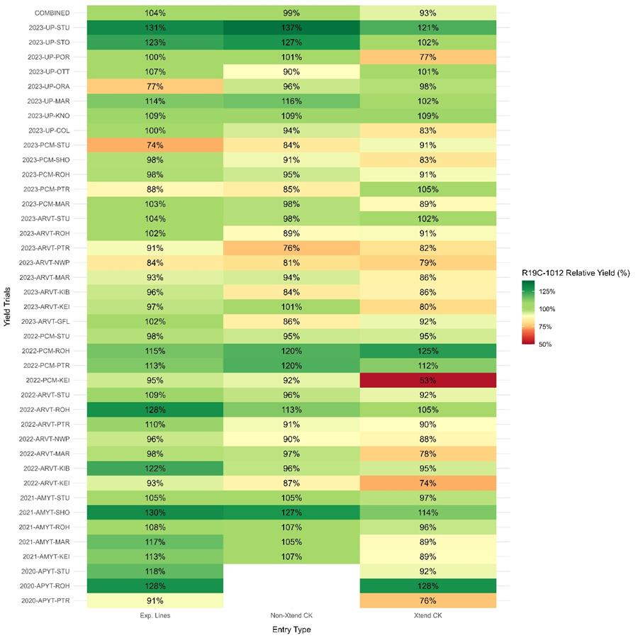
Figure 1. Relative yield (%) of R19C-1012 to experimental lines, non-Xtend® checks, and Xtend® checks crossing 40 environment yield trials from 2020 to 2023.

2024 Identification of DNA markers and genomic prediction
In 2024, five SNP markers (ss715587369, ss715628153, ss715628154, ss715628155, and ss715638723) associated with flood tolerance at the early vegetative growth stage were identified on chromosomes 4, 17, and 20. In addition, genomic-based prediction models were developed with an accuracy of 0.64. Our results aim to improve the efficiency of breeding for early-season flood tolerance and support the need to develop season-long flood-tolerant soybean genotypes. The manuscript has been submitted to The Plant Genome Journal for publication.

2024 Flood tolerance evaluation and screening for breeding lines of AR and MO
In 2024, a total of 245 advanced lines developed by AR and MO soybean breeding programs were evaluated for flood tolerance in both early vegetative (V2/V3) and mid reproductive (R1/R2) growth stages with 3-reps in Stuttgart, AR. For the 7-days flooding treatment test in early vegetative stage, there were significant variations (p < 0.0001) among these 245 lines with flood damage score (FDS) ranging from 1.0 to 5.0. Twenty-seven lines showed flood tolerance with lower flood damage score (FDS < 2.0) compared with the test mean FDS = 2.9. Four lines (S22PR-212E3, R23PR-00082E3, R23PR-00122E3, and S21-17588LL55) showed high flood tolerance with FDS = 1.0 and three lines (S22-13412, R22KB-03138, and R22KB-03662) were very susceptible to flooding stress with FDS = 5.0. For the 7-days flooding treatment test in mid reproductive stage, there were significant variations (p = 0.0012) among these 245 lines with flood damage score (FDS) ranging from 2.0 to 5.0. Three lines (R22KB-16680, S22-9025, and S21-17588LL55) showed flood tolerance with FDS = 2.0 and six lines had moderate flood tolerance with 2.0 < FDS < 3.0 compared with the test mean FDS = 4.1. Thiry-one lines were very susceptible to flooding stress with FDS = 5.0. These screening results will be used for flood tolerance breeding and genomic selection research.

2024 Flood tolerance evaluation of commercial variety and lines
In 2024, a total of 84 MG4 and MG5 commercial varieties and breeding lines developed by seed companies and the Arkansas Soybean Breeding Program were evaluated for yield and flood tolerance at early V2/V3 growth stage in Stuttgart, AR. Under 5-days flooding stress, there were significant variations (p value < 0.05) between non-flooded (78.2 bu/ac) and flooded test means (53.6 bu/ac). The average yield loss between treatments was 24.6 bu/ac (31.5%) (Table 1). The yield of each commercial variety was also significantly different with p value < 0.05 (Table 3).

Table 1. Yield comparison of several tolerant and susceptible commercial varieties between non-flooded and flooded conditions.
Variety/Line | MG | Non-flooded yield (bu/ac) | Flooded yield (bu/ac) | Yield loss (bu/ac) | Yield loss % | Flood stress
Pioneer P48A14E | 4.8 | 84.9 | 79.7 | 5.2 | 6.2 | Tolerant
Revere 49-F36 | 4.9 | 85.1 | 77.5 | 7.6 | 8.9 | Tolerant
Progeny P4947XFS | 4.9 | 83.3 | 74.4 | 9.0 | 10.7 | Tolerant
AG46XF3 | 4.6 | 78.8 | 71.0 | 7.8 | 9.9 | Tolerant
R19-45980 | 5.4 | 75.9 | 67.7 | 8.2 | 10.8 | Tolerant
R21KB-05522 | 5.3 | 78.0 | 67.5 | 10.5 | 13.5 | Tolerant
R21C-02232 | 4.6 | 72.8 | 63.7 | 9.0 | 12.4 | Tolerant
R19C-1035 | 4.5 | 76.8 | 59.0 | 17.8 | 23.1 | Tolerant
Progeny P4691XFS | 4.6 | 79.4 | 27.7 | 51.7 | 65.2 | Susceptible
Progeny P4806XFS | 4.8 | 77.7 | 25.3 | 52.4 | 67.4 | Susceptible
NK43-W1XFS | 4.3 | 82.7 | 23.6 | 59.1 | 71.5 | Susceptible
Grand Mean |  | 78.2 | 53.6 | 24.6 | 31.5

2025 High-yielding and flood-tolerant lines development and potential release
In 2025, two elite pre-commercial MG5 lines (R21KB-05522 and R20-1429) with flood-tolerant pedigrees were entered for testing in the 2025 USDA regional yield trials (UP/UT), Arkansas pre-commercial yield trial (PCM), Arkansas variety test (VT), flood yield trial (FYT), and flood screening test (Table 2).

Table 2. Two elite lines yield performance in 2024.
2024 Test | Line | Pedigree | Yield (bu/ac) | Check % | 2025 Test Plan
PCM5E | R21KB-05522 | R16-141/R13-13997 | 65.5 | 99 | UT5/VT/PCM/FYT
PCM5E | R20-1429 | S12-1362/Walters | 60.9 | 92 | UP5/PCM/FYT/Parent
 | Check mean |  | 66.2
 | Test mean |  | 60.7
UP5E | R21KB-05522 | R16-141/R13-13997 | 51.4 | 93 | UT5/VT/PCM/FYT
 | Check mean |  | 55.6
 | Test mean |  | 51.6

2025 Flood tolerance preliminary yield and screening trials
In 2025, a total of 35 entries with flood-tolerant pedigree will be evaluated for yield and other agronomic traits in 2-replicate preliminary tests (FLP) in three Arkansas locations (Stuttgart, Pine Tree, and Rohwer). Additionally, these lines will be evaluated for flood tolerance under 7-day flooding stress at both early vegetative (V2/V3) and mid reproductive (R1/R2) growth stages in Stuttgart, AR.

Mississippi State University (Wilkerson):
Field plots were harvested from the complete set of the MSU Official Soybean Variety Trial Located at Stoneville, MS. On October 30, 2024. Harvest data is being calculated and analyzed to determine the effect of flooding at R1/R2 on soybean yield. The entire dataset will be sent to Dr. Lin once analysis is complete.

Louisiana State University (Moseley):
The LSU program is preparing the field for 2025 flood trials.

