Project Number:
Project Title: | LADDER (Large Agricultural Database that Drives Extension and Research)
Organization: | Mississippi Water Resources Research Institute (MWRRI); Mississippi State University
Project Lead Name: | Zach Reynolds
Reporting Period:  Please select the appropriate reporting period for this report. | ☐ December ☒ March ☐ June ☐ September ☐ Final

The information included in this detailed report should reflect quantifiable results that can be used to evaluate and measure project success.

If Progress Report – What key activities were undertaken and what were the key accomplishments during this reporting period? List each key deliverable from the proposal and describe progress made (or not made) toward achieving it, including metrics were appropriate.

If Final Report – What were the key accomplishments during the life of the project? List each deliverable from the proposal and describe progress made (or not made) toward achieving it, including metrics where appropriate.
Objective 1: Determine the effects of environment, i.e., CEC, pH, slope, climatic data, and agronomic practices including irrigation, precision ag technology, nutrient management, planting systems, and tillage systems on soybean productivity and profitability at the farm scale.

-The API into MyJohnDeere is still our main method for obtaining grower geospatial data. We are continually working on the code written in Python which streamlines the analysis of grower data to answer agronomic questions. We are continuing to talk with growers about the importance of collecting this data and how the soil sample data is an integral part of this process. With these samples generally pulled by third parties, some are unwilling to share the shapefiles, even with the grower due to proprietary reasons. Even if growers can only share planting and harvest data, we can show them value through LADDER. Since the last report, we have added the ability to pull in Web Soil Survey data along with connecting to weather stations. Below are the analyses a grower can benefit from right now in LADDER with and without soil data along with some visual examples.

Examples of analyses a grower can benefit from now if no soil sample data:
-Yield x variety
-Yield x seeding rate
-Yield x planting date
-Yield x soil type
-Yield x weather data (temp, soil temp, humidity, etc)
-Can analyze multiple things at once also: Yield x variety x seeding rate x planting date x soil type x weather data
-Anything else recorded on planter or combine

If a grower has soil data, can benefit from everything listed above in addition to any recorded soil metric. An example of this could be yield by p level, or yield x p level x soil type, etc. A few of these examples are listed on the following pages.

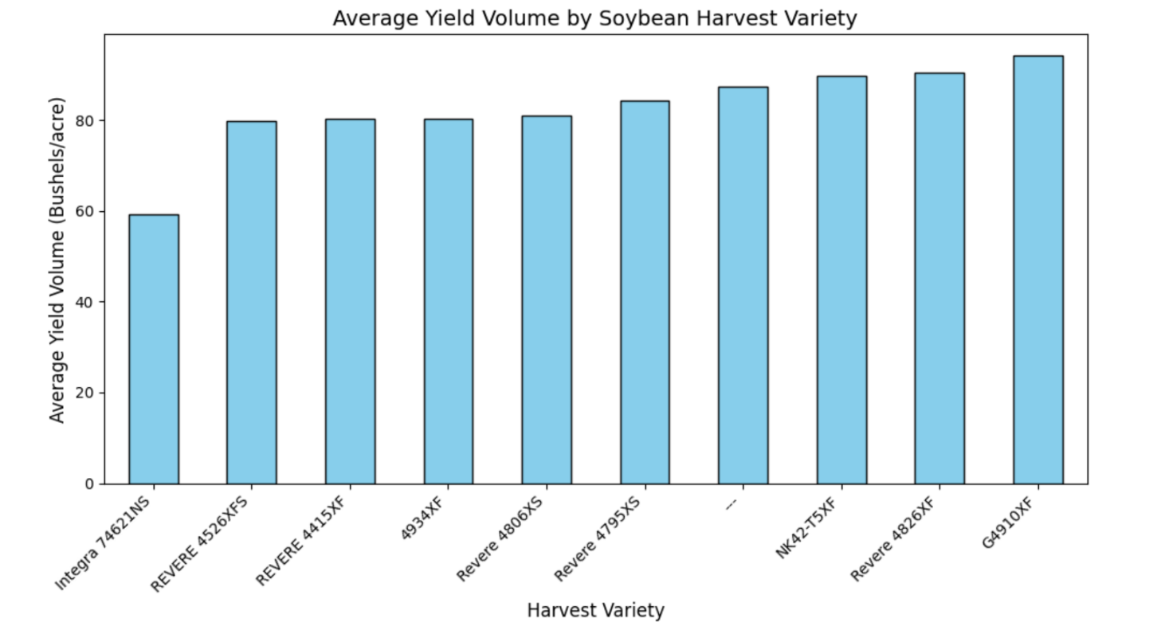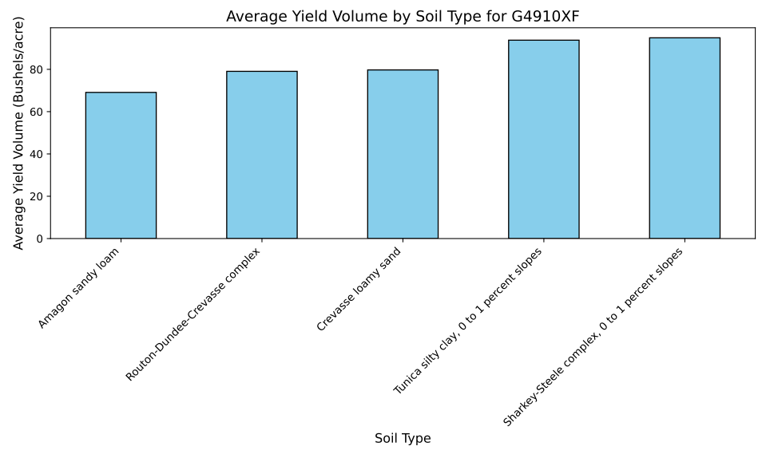

Lots of producers are collecting geospatial planting and harvest data. If we are a partner in MJD, we can provide examples such as those above and on the next page looking at how certain varieties yielded, how they did on certain soil types (based on web soil survey), and overall yields across soil types. There can be multiple combinations of these parameters.
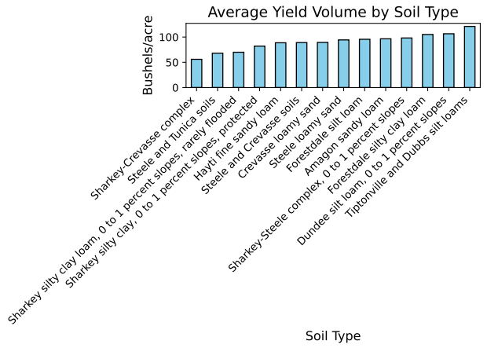

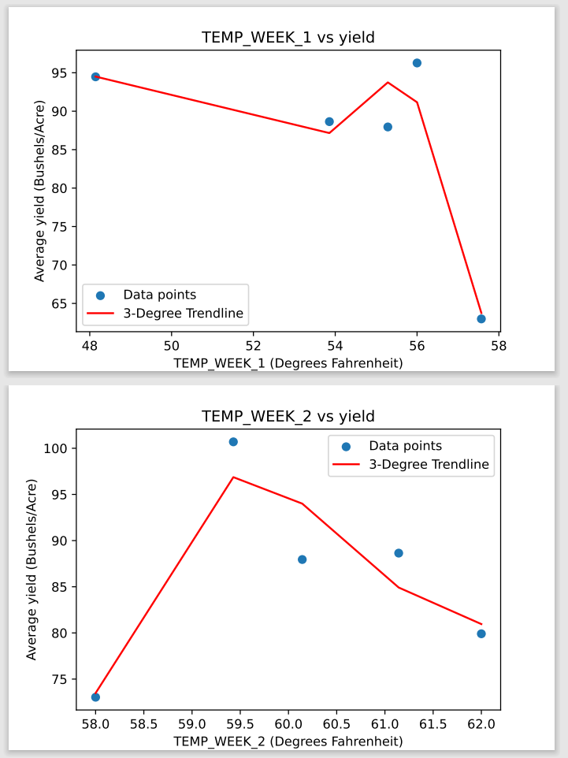
-LADDER now has the ability to utilize weather data from weather stations and trendlines can be made based on temp, precipitation, humidity, etc. by dates or weeks after planting etc. The trendline above has very limited data so the line looks a little odd but wanted to include to illustrate what is possible.

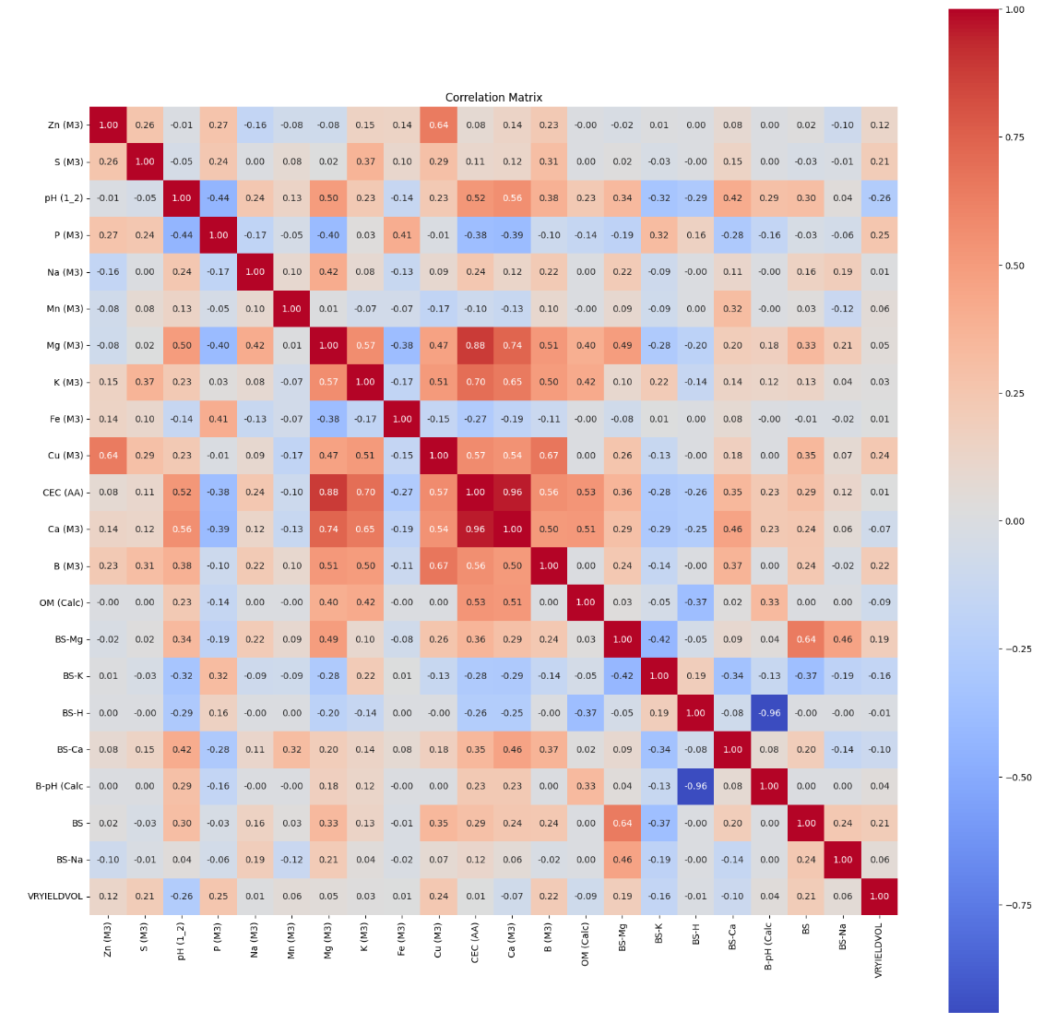
Along with the correlation analysis discussed in last report, we also have developed the ability to create the graphic below which indicates which soil chemical or physical parameters are most influential on yield based on a dataset in question.

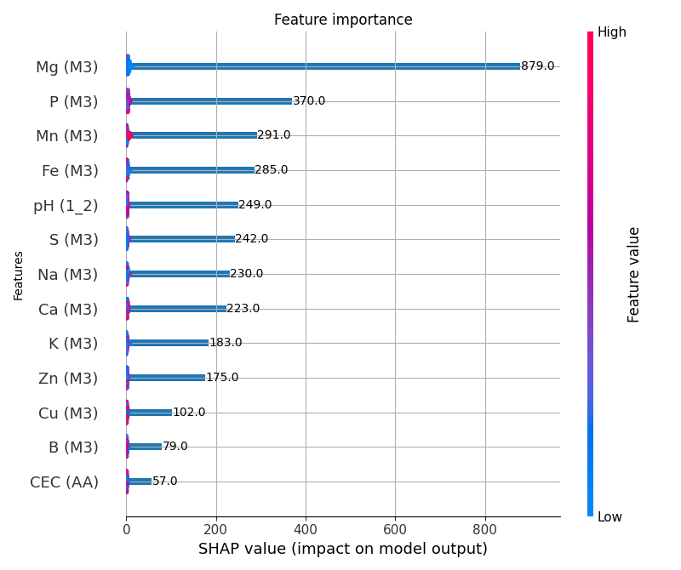
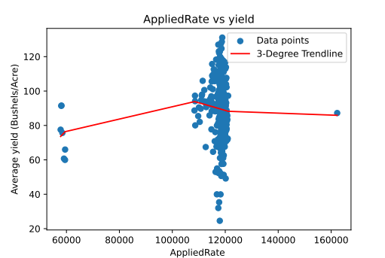
-With prices and input costs staying high, growers are looking to optimize all applications and seeding rate has been a topic of discussion in multiple conversations. Something simple such as the trendline above can be created with one or multiple producer’s data to analyze optimal seeding rates.

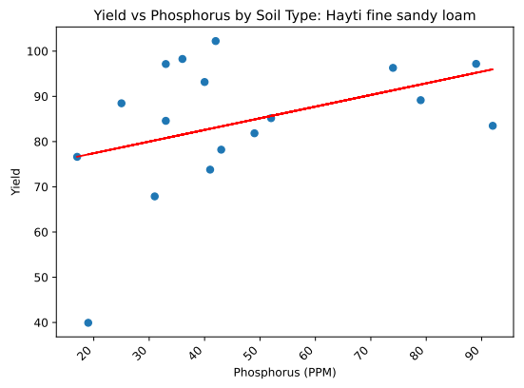
-As mentioned above, LADDER can analyze multiple factors at one time. The last report displayed trendlines illustrating how yield is affected based on soil fertility level. The trendline above is an example of this same analysis, but within a certain soil type. This can be done by variety, geography, etc.

-The last report discussed our model for predicted/actual values we are working towards in LADDER. A component of this is the “slide-bar.” The way this works is, specific parameters can be adjusted to predict an outcome based on actual data. For instance, if a grower is planning to make a fertility application, they could adjust the bar of the nutrient in question to the soil test level (or application amount) they are trying to achieve and see how it affects yield. This goes hand in hand with the trendlines in that it can help indicate the likelihood of eliciting a positive yield response from increasing certain nutrient levels. With fertility prices staying very elevated, tools such as these will be beneficial for growers to know they are getting or will likely get a positive response from an application versus making a blind application even if they are pulling samples and variable rate applying fertilizer.

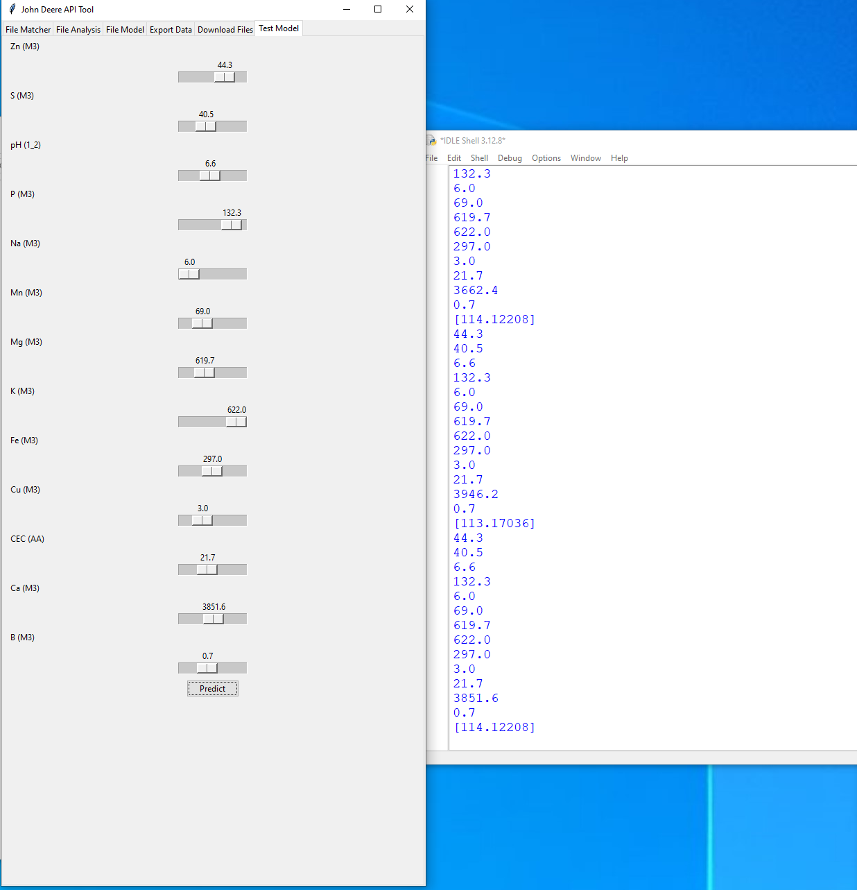

Objective 2: Deliver research-based Extension programing to soybean producers in the Mid-South to stimulate the adoption and proper implementation of geospatially specific agronomic practices that improve grain yield, net returns, and sustainability.

-I presented some of this data along with the overall status and implementation of LADDER at the Cotton and Rice meeting in Memphis. This LADDER data was also presented at multiple county meetings this winter which were comprised of growers, industry, along with university employees. I have also met with multiple growers this spring that have shared more data which we are currently on-boarding.

