Please use this form to clearly and concisely report on project progress. The information included should reflect quantifiable results that can be used to evaluate and measure project success. Comments should be limited to the designated boxes. Technical reports, no longer than 4 pages, may be attached to this summary report.

Project Number:
Project Title: | Development of climate-smart high-yield practices associated with high-end biological treatments and soybean-related microbiome resiliency.
Organization: | University of Texas-Arlington
Project Lead Name: | Woo-Suk Chang
Report Date: | September 15, 2023
In the Progress Summary section below, please provide a brief summary of project progress in lay language that will be shared publicly in the National Soybean Checkoff Research Database. Do not include any confidential or proprietary information. If no lay language is provided, the contents of this entire report will be published in the National Soybean Checkoff Research Database.

Progress Summary (in non-proprietary lay language suitable to be shared publicly):
Since the last update on June 15th, we have completed mid-harvest sampling in the following locations: Corpus Christi, TX; Port Lavaca, TX; Portageville, MO; Colt, AR; Winnsboro, LA; Leland, MS; and Norborne, MO. All plots were sampled for nodulation, plant biomass, leaf/tissue analysis, and soil physicochemical properties. All fields were maintained rainfed (non-irrigated conditions). Due to extreme drought/heat stress conditions this summer, harvest data (e.g., soybean yields) is/will be not available for Corpus Christi, TX, Leland, MS, and Winnsboro, LA. A second round of sampling will be conducted in Colt, AR and Norborne, MO to collect rhizosphere soils for both the conventionally tilled field and the no-tilled field at harvest.

Detailed Progress Status – Expand upon the above section. What key activities were undertaken and what were the key accomplishments during this reporting period? List each key deliverable from the proposal and describe progress made (or not made) toward achieving it, including metrics were appropriate.
Table 1. Summary of 2023 field work.
Location | Collaborators | Planting Date | Sampling Date | Harvest Date | Cultivar Used | MG | No-tilled field
Corpus Christi, TX | Dr. Josh McGinty | 3/28 | 5/30 | NA | Pioneer, Lynda, Pamela | 4L, INDT, INDT | NO
Port Lavaca, TX | Dr. James Grichar | 3/29 | 5/31 | 8/24 | Pioneer, Lynda, Pamela | 4L, INDT, INDT | NO
Portageville, MO | Dr. Grover Shannon | 5/23 | 7/11 | TBD | Ellis | 4L | NO
Colt, AR | Dr. Shawn Clark | 5/24 | 7/11 & 7/12 | TBD | Ellis, S14-9017R | 4L, 5 | YES
Winnsboro, LA | Dr. Trey Price | 5/26 | 7/14 | NA | Ellis | 4L | YES
Leland, MS | Dr. Tessie Wilkerson | 6/9 & 7/21 | 8/10 | NA | Ellis | 4L | YES
Norborne, MO | Dr. Eric Oseland | 5/1 | 8/17 | TBD | TBR | 4 - 4L | YES
* TBD: To be determined.
* NA: Not available due to severe drought/heat stress conditions.
* TBR: To be reported in the next quarterly report.

Table 1 Shows the current summary of the 2023 fieldwork, including location, planting date, sampling date, harvest date, cultivar information, and planting in no-tilled fields.

The research site in Corpus Christi, TX was planted on March 28th and consisted of 3 soybean cultivars: Pioneer-P47A25BX, Lynda-GT, and Pamela-GT with three inoculant treatments and five replicates. Each plot consisted of 2 x 35’ with a seeding rate of 11 seeds per foot. The field was sampled on May 30th. Sampling consisted of six whole plants for biomass (n=270), height, and nodule numbers. Data for plant dry weight, height, and nodule numbers are shown in Figures 1, 2, and 3, respectively. Additionally, rhizosphere soils were collected from each plot. This was performed by carefully removing the plant from the ground and preserving the soil ball, shaking the plant to remove the excess soil, and collecting the rhizosphere soil in a Ziplock bag. The samples where immediately placed in ice for transportation. Unfortunately, the field did not receive rain after June 5th based on preliminary weather data. According to the station manager, Dr. Josh McGinty, the soybeans have undergone continued drought/heat stress and there will be no yield (Fig. 4). The research site in Port Lavaca, TX was planted on March 29th and sampled on May 31st following the same procedure as in Corpus Christ, TX, and each plot consisted of 2 x 30’ with a seeding rate of 11 seeds per foot (n=216). Plant dry weight and height measurement, and nodule counts have been completed for the Port Lavaca, TX field stie. Data for dry plant biomass, height, and nodule numbers are shown in Figures 5, 6, and 7, respectively. The field’s harvest was completed on August 24th and soybean yields are shown in Figure 8.

Plant leaves, root nodules, and rhizosphere soils were sampled (n=108) in the Portageville, MO conventional tilled field on July 11th and harvest is expected to be completed by the end of the September. We sampled soybean leaves, root nodules, and rhizosphere soils in both no-till fields (n=72) and conventionally tilled fields (n=216) in Colt, AR on July 11th and 12th. The pods are still green, and harvest is expected to occur the first week of October. No-till and conventionally tilled fields in Winnsboro, LA were planted on May 25th and both fields were sampled (e.g., no-till [n=72] and conventional tillage [n=90]) on July 14th. The conventionally tilled fields in Leland, MS were planted on June 9th. However, due to rainfall, planting in the no-till fields was delayed until July 21st. Unfortunately, the planting was not successful (Fig. 9A). In addition, the conventional field was sprayed with herbicide Cobra, resulting in death of all soybeans. However, we were able to sample two TXVA plots and two TAG plots (n=24) on August 10th. We are continuing to analyze data of plant biomass, height, and nodule numbers for Portageville, Colt, Winnsboro, and Leland.

Six soybean fields near Norborne, MO were sampled in collaboration with Dr. Eric Oseland, Director of Agronomy and Research for the Missouri Soybean Association on August 17th. (Fig. 9B). Each field was sampled at 10 different spots taking six plants from each spot, and this was repeated for all six fields. Included are four no-till fields, one minimally tilled field, and one conventionally tilled field.

Figure 1. Dry plant biomass for the Pioneer, Lynda, and Pamela cultivars
planted in Corpus Christi, TX. (TXVA, drought-tolerant inoculant;
Control, no inoculant; TAG, TagTeam)

Figure 2. Plant height for the Pioneer, Lynda, and Pamela cultivars
planted in Corpus Christi, TX. (TXVA, drought-tolerant inoculant;
Control, no inoculant; TAG, TagTeam)

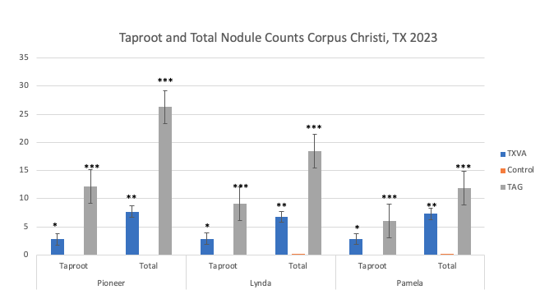
Figure 3. Taproot and total root nodulation from the Corpus Christi, TX field site.
*=P<0.05, **=P<0.01, ***=P<0.001.

Figure 4. Weather data for the growing season in Corpus Christi, TX in 2023.

Figure 5. Dry plant biomass from the Port Lavaca, TX field site.

Figure 6. Plant height from the Port Lavaca, TX field site.

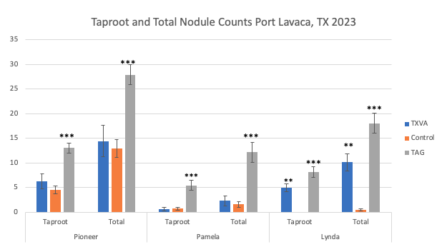
Figure 7. Taproot and total root nodulation from the Port Lavaca, TX field site.
*=P<0.05, **=P<0.01, ***=P<0.001.

Figure 8. Final soybean yield (bu/A) from the Port Lavaca, TX field site.

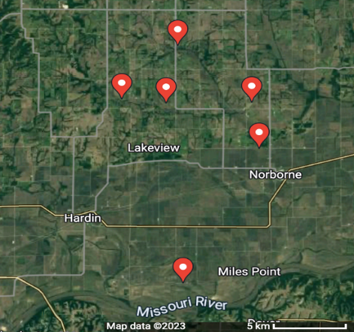
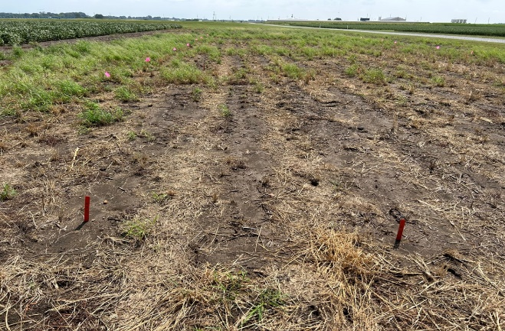
B
A

Figure 9. (A) A picture of the no-till fields from the Stoneville, MS field site. (B) Map of the six soybean fields sampled in Norborne, MO.

