Please use this form to clearly and concisely report on project progress. The information included should reflect quantifiable results that can be used to evaluate and measure project success. Comments should be limited to the designated boxes. Technical reports, no longer than 4 pages, may be attached to this summary report.

Project Number:
Project Title: | Identification and confirmation of natural tolerance to off-target Dicamba damage in non-Xtend soybeans
Organization: | University of Arkansas
Principal Investigator Name: | Caio Canella Vieira
Other investigators: | Feng Lin/Grover Shannon
Report Period: | June 15 – September 15, 2024
OBJECTIVE 1: Development of breeding populations stacking various sources of tolerance

The University of Arkansas and University of Missouri soybean breeding programs continue the development of high-yielding non-Xtend materials with tolerance to off-target dicamba. Efforts are being made to incorporate tolerance into both Enlist-E3 and conventional backgrounds. Field notes have been completed and harvesting has started. Breeding decisions will be made in the next couple of weeks regarding materials advancement and conversion to Enlist-E3.

Vieira, University of Arkansas:

Development of Enlist-E3 materials with off-target dicamba tolerance: Population advancement is ongoing in an off-season nursery in Puerto Rico, with an expected return as F_{4:5} progeny rows in 2025. Entries will be genotyped with the Soy3KSNP chip and tolerance will be predicted based on our recently published genomic prediction model (Figure 1, Canella Vieira et al., 2023).

Figure 1. Genomic prediction models based on Random Forest and Support Vector Machine algorithms indicate high precision in identifying tolerant and susceptible genotypes.

Lin, University of Missouri:

2024 Yield Trials: A total of 98 advanced breeding lines were planted in Portageville, MO (2 local environments) and 6-8 locations across IL, AR, TN, and MO. Among these lines, four derived from the cross between natural tolerant line S16-12774 with high yielding parents. Two lines showed almost no cupping under off-target dicamba exposure (Figure 2)

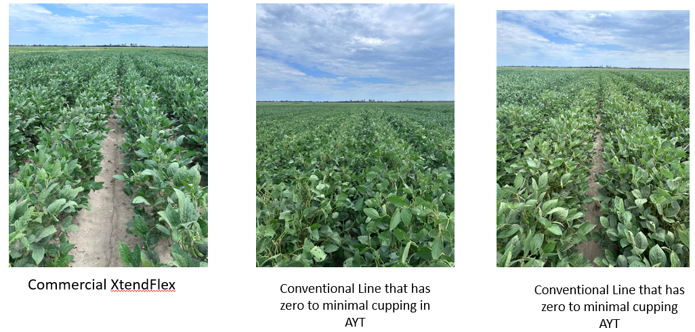
Figure 2. Comparison of commercial XtendFlex with conventional line exhibiting potential natural off-target dicamba tolerance

Progeny rows and population development: A total of 598 F_{4:5} single plants from five crosses involving dicamba-tolerant parents will be grown in single rows in the progeny testing in 2024. Lines with best agronomic traits will be visually selected for further evaluation in 2025. We attempted novel crosses by combining high-yielding lines with natural dicamba-tolerant line and plant introductions (PI) in our breeding program.

OBJECTIVE 2: Study the underlying genetic and physiological basis of this tolerance

Dicamba QTL mapping populations: Two RIL mapping populations derived from a tolerant PI and a susceptible breeding line were visually phenotyped at the R3-R4 growth stages for dicamba tolerance during the summer of 2024 in Arkansas and Missouri. The genotyping of the populations will be conducted in collaboration with a seed company. Scores were highly consistent between Arkansas and Missouri, and many RILs were identified in both ends of response – highly tolerant and highly susceptible (Figure 3).

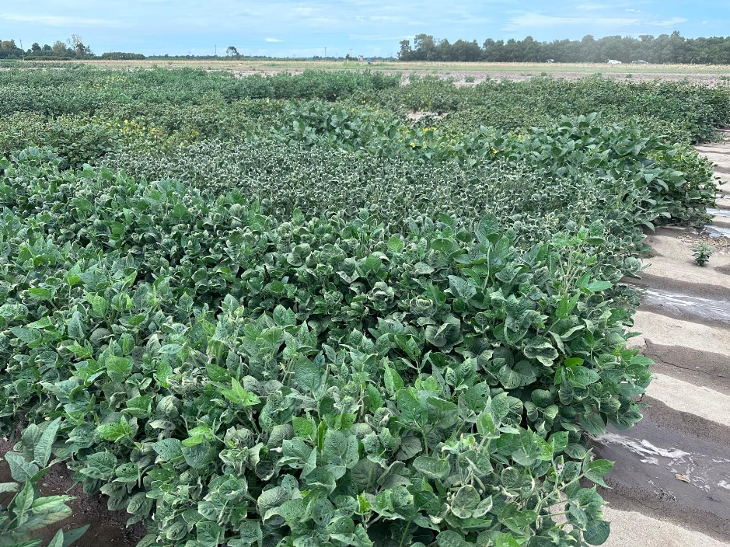
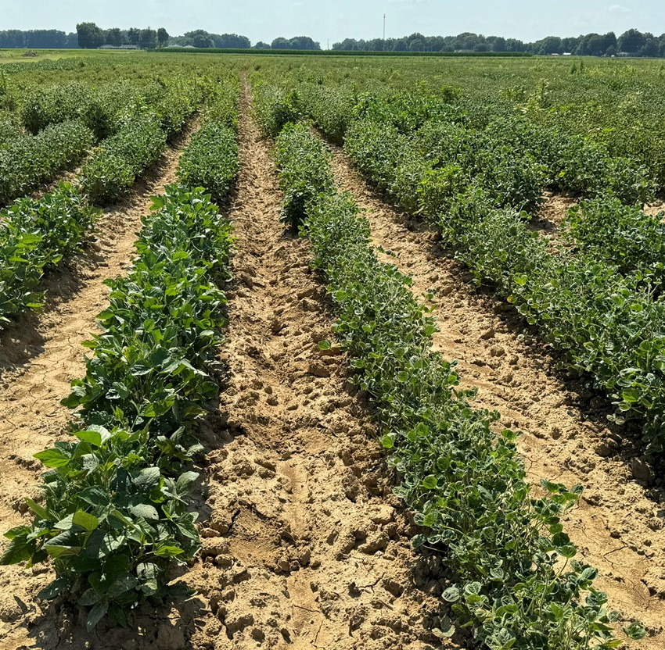
Figure 3. Response to off-target dicamba in two mapping populations derived from a tolerant plant introduction and a susceptible breeding line.

