Project Number:
Project Title: | LADDER (Large Agricultural Database that Drives Extension and Research)
Organization: | Mississippi Water Resources Research Institute (MWRRI); Mississippi State University
Project Lead Name: | Zach Reynolds
Reporting Period:  Please select the appropriate reporting period for this report. | ☒ December ☐ March ☐ June ☐ September ☐ Final

The information included in this detailed report should reflect quantifiable results that can be used to evaluate and measure project success.

If Progress Report – What key activities were undertaken and what were the key accomplishments during this reporting period? List each key deliverable from the proposal and describe progress made (or not made) toward achieving it, including metrics were appropriate.

If Final Report – What were the key accomplishments during the life of the project? List each deliverable from the proposal and describe progress made (or not made) toward achieving it, including metrics where appropriate.
Objective 1: Determine the effects of environment, i.e., CEC, pH, slope, climatic data, and agronomic practices including irrigation, precision ag technology, nutrient management, planting systems, and tillage systems on soybean productivity and profitability at the farm scale.

-In the last report, I mentioned we were working on creating an API with MyJohnDeere to automatically retrieve data. We have completed this by growers making us partners and code written in Python/Jupiter notebook. This process being accomplished will provide a streamlined process for onboarding machine data. We have access to/have imported over 300K acres worth of harvest and planting data. However, the soil data is much more difficult to obtain because it is usually done by a retailer, consultant, etc. Obtaining soil data that matches with our other agronomic data will be one of our main goals in the coming months.

-As far as answering agronomic and environmental questions with this geospatial grower data, I have attached multiple examples from actual data collected. After MWRRI’s process for cleaning, sorting, etc. have been applied to grower data, we can run lots of correlations/analyses. The following pages are illustrating the LADDER tool that we have built.

-Once all layers of data are imported, we can select which of these parameters we want to analyze against each other to get a relationship.

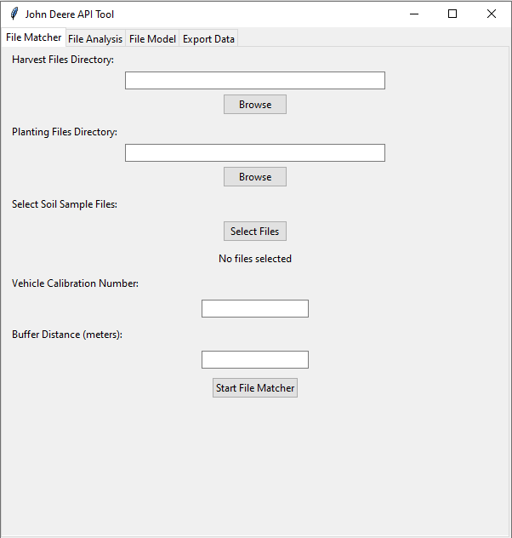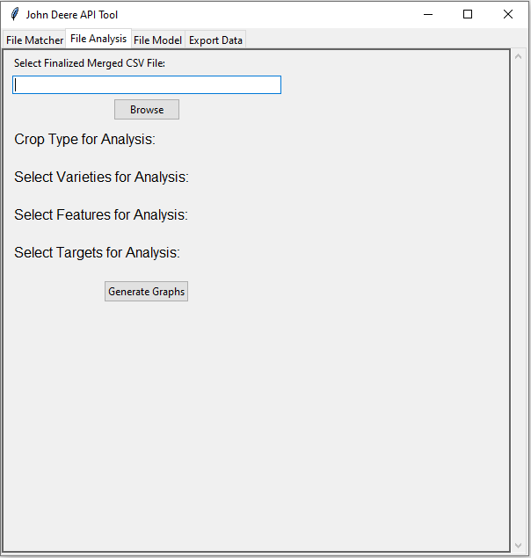

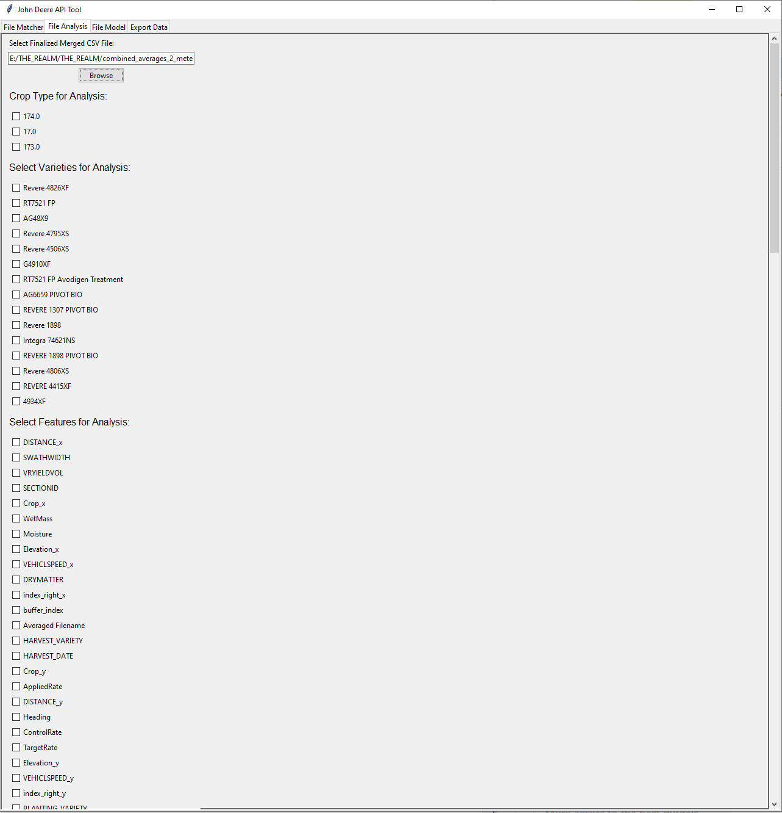

-We now can run a simple correlation as displayed or create trendlines to show relationships between various parameters.
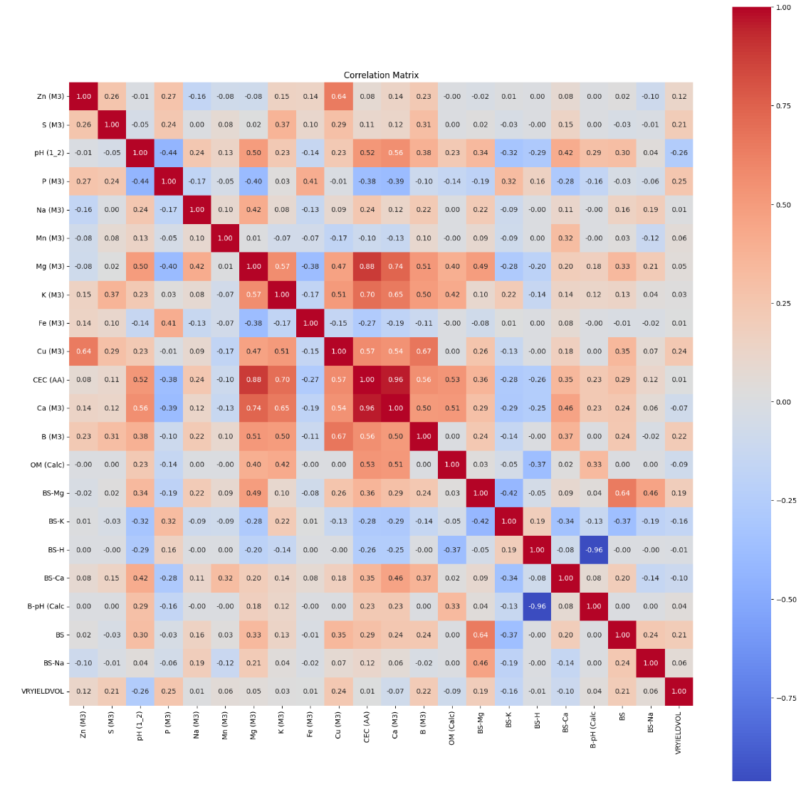

-The trendlines below show the relationship between soybean yield and soil test levels. This analysis indicates that as P levels increase, yield doesn’t always increase with it. However, this doesn’t mean that we should stop applying P, but rather other parameters may be influencing yield. Further analysis showed that there is a positive relationship between soil S/soil B and yield indicating these could be some of the “lowest holes in the bucket.”
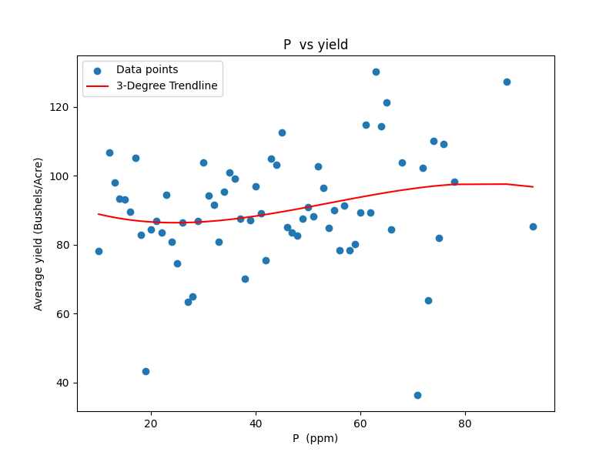

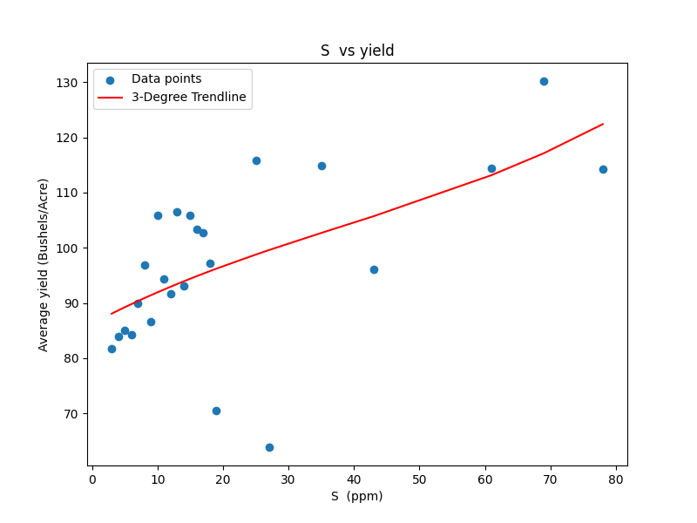

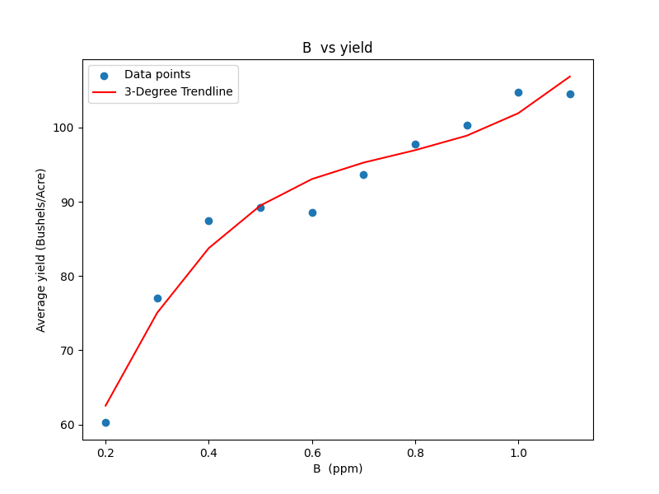
-While data such as this may tempt us to go out and apply lots of sulfur or boron, we still think it is wise to use this data to recognize potential trends and test on-farm before making a significant financial decision. We work with lots of growers implementing these “plot prescriptions” on their farms as shown below. This gives the grower the power to look at lots of replications of a certain rate, product, etc. with little to no risk financially. We have done this with growers of all management styles and levels of precision ag technology use. Using LADDER along with this on-farm verification approach, we believe can make huge strides in just one season to answering questions that will make significant impacts to the grower’s bottom line.
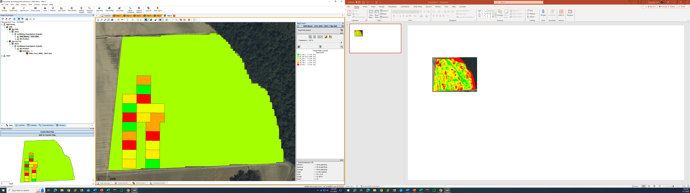
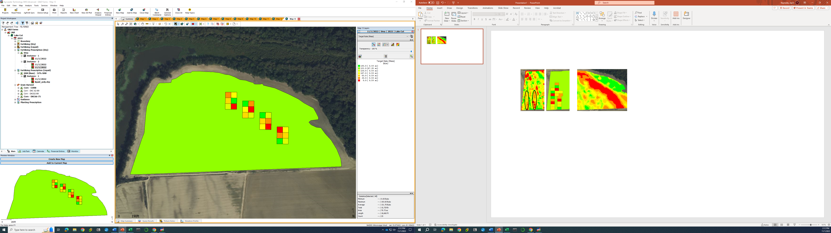

-The LADDER program will automatically display data in multiple fashions. Below is a simple but impactful image of soybean yield by variety. The image of the map is blurry due to being spread out but can also make a “heatmap” of any yield correlation such as how a variety or soil P test level is affecting soybean yield across the landscape.

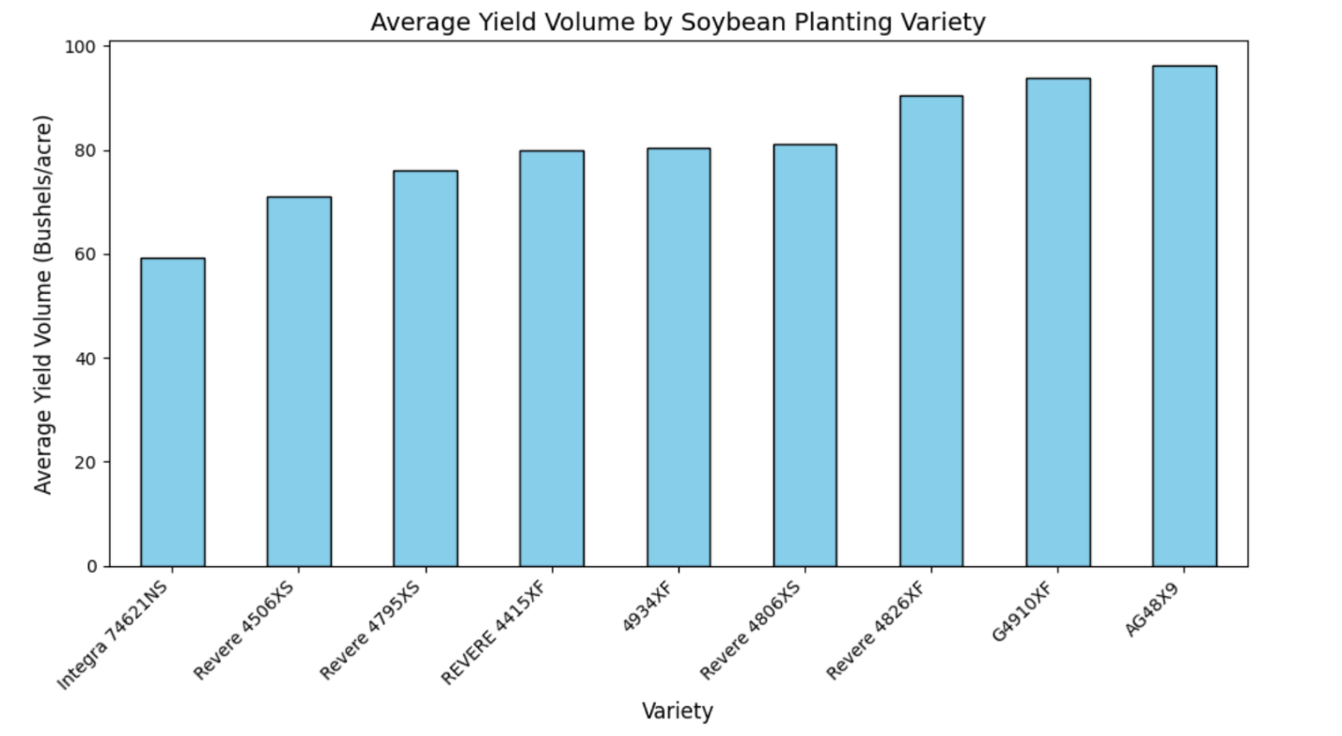

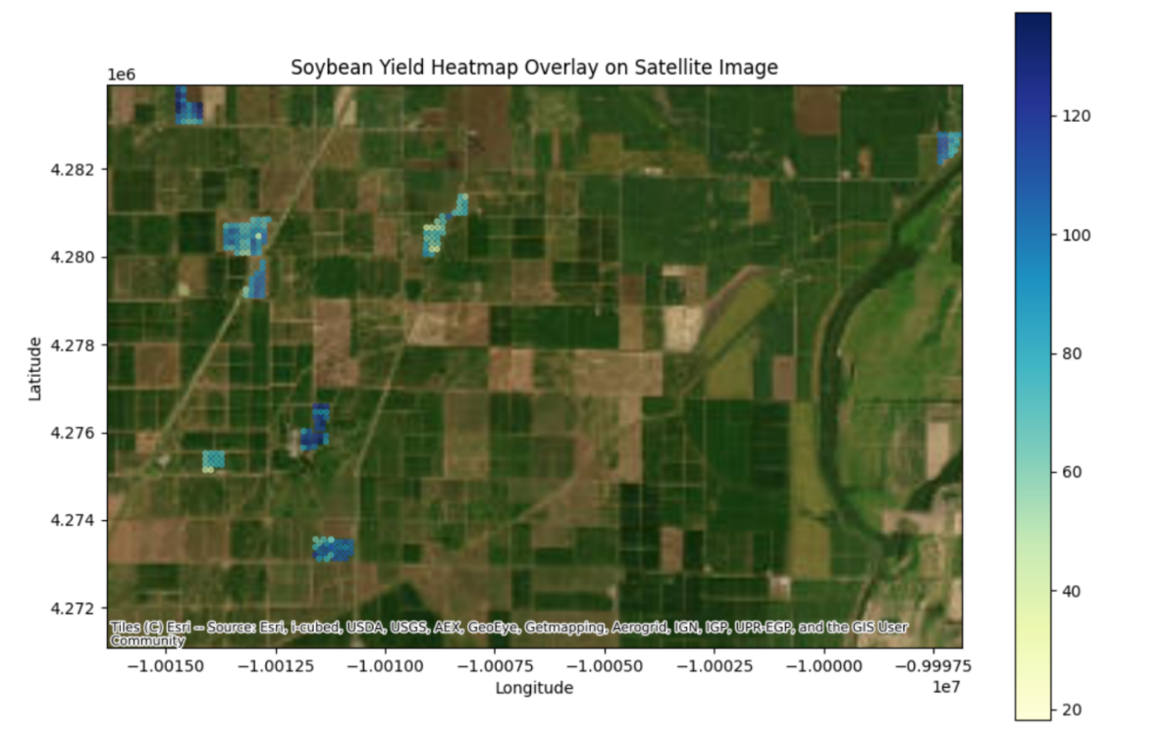
-As we obtain more data (soil data in particular), the LADDER tool will become increasingly more impactful. We are also working on a model to predict yield based on the analyzed parameters within LADDER (displayed below). The value of this would be predicting yield if you changed certain parameters to hypothetically match what has been analyzed in LADDER. This could speed up the process of having confidence to adopt a change in management. As the model improves, we believe it will be possible to predict yield based on soil or other recorded parameters on acreage that is currently under production. This model will hopefully provide insight on areas to improve within a grower’s current management or may suggest it would be more profitable to make a significant change in their production system(s). While data shown has been displayed in trendlines, graphs, etc., these data can also be exported as a CSV and run through any statistical software such as SAS.

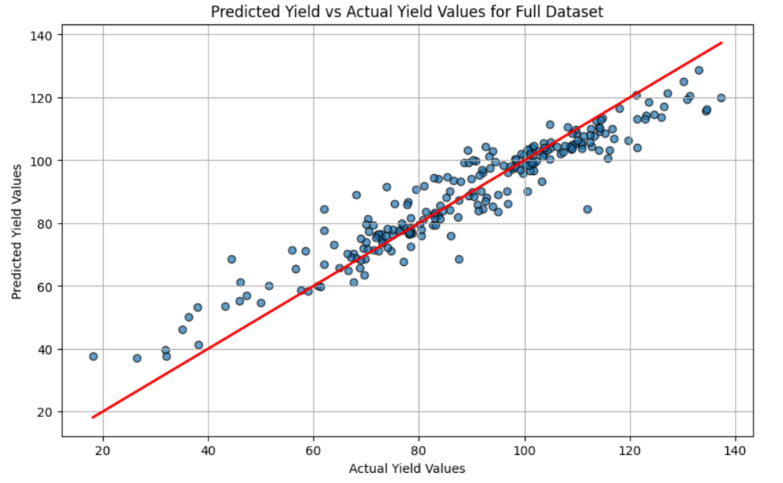
-Along with collecting more data, we are working towards appending other sources such as Web Soil Survey and climatic data that can be added to the previously mentioned LADDER processes and included in analysis/correlations. This will give us more layers for comparison across the landscape.

Objective 2: Deliver research-based Extension programing to soybean producers in the Mid-South to stimulate the adoption and proper implementation of geospatially specific agronomic practices that improve grain yield, net returns, and sustainability.

-I will be presenting some of the preliminary data and status of LADDER at the Cotton and Rice conference in Memphis. I have also planned to meet with growers individually at this meeting and after to present what we have done so far. I believe this will give them an idea of what LADDER has the potential to be with more people/data involved. We will have local county meetings this winter where I also plan to present LADDER along with the need for data/on-farm verification per enterprise or entity.

