Please use this form to clearly and concisely report on project progress. The information included should reflect quantifiable results that can be used to evaluate and measure project success. Comments should be limited to the designated boxes. Technical reports, no longer than 4 pages, may be attached to this summary report.

Project Number:
Project Title: | Screening soybean germplasm and breeding soybeans for flood tolerance
Organization: | University of Missouri-Fisher Delta Research Center
Principal Investigator Name: | Dr. Grover Shannon
Other investigators: | Drs. Caio Vieira, Tessie Wilkerson, David Moseley ChengjJun Wu Francia Ravelombola
Report Period: | June 16, 2023 to September 15, 2023

Project Status: On-going

(What key activities were undertaken and what were the key accomplishments during this quarter? Please use this field to clearly and concisely report on project progress).
Outline of MSSB Flood Tolerance Report
- Complimentary Research from Co-PIs of this project
  - A Arkansas- Breeding and Screening R1-R2 and V2-V4
  - B) Missouri- Breeding and screening R1-R2 and V2-V4
  - C) Louisiana- Screening
  - D) Mississippi- Screening
  - E) Highlight lines at R2_R3 that show tolerance across states
F) List tolerant AR & MO lines in both breeding pipelines at V2-V4 and R1-R2 stages

Picture of 2023 flood screening trials at the R2 stage at Portageville, MO
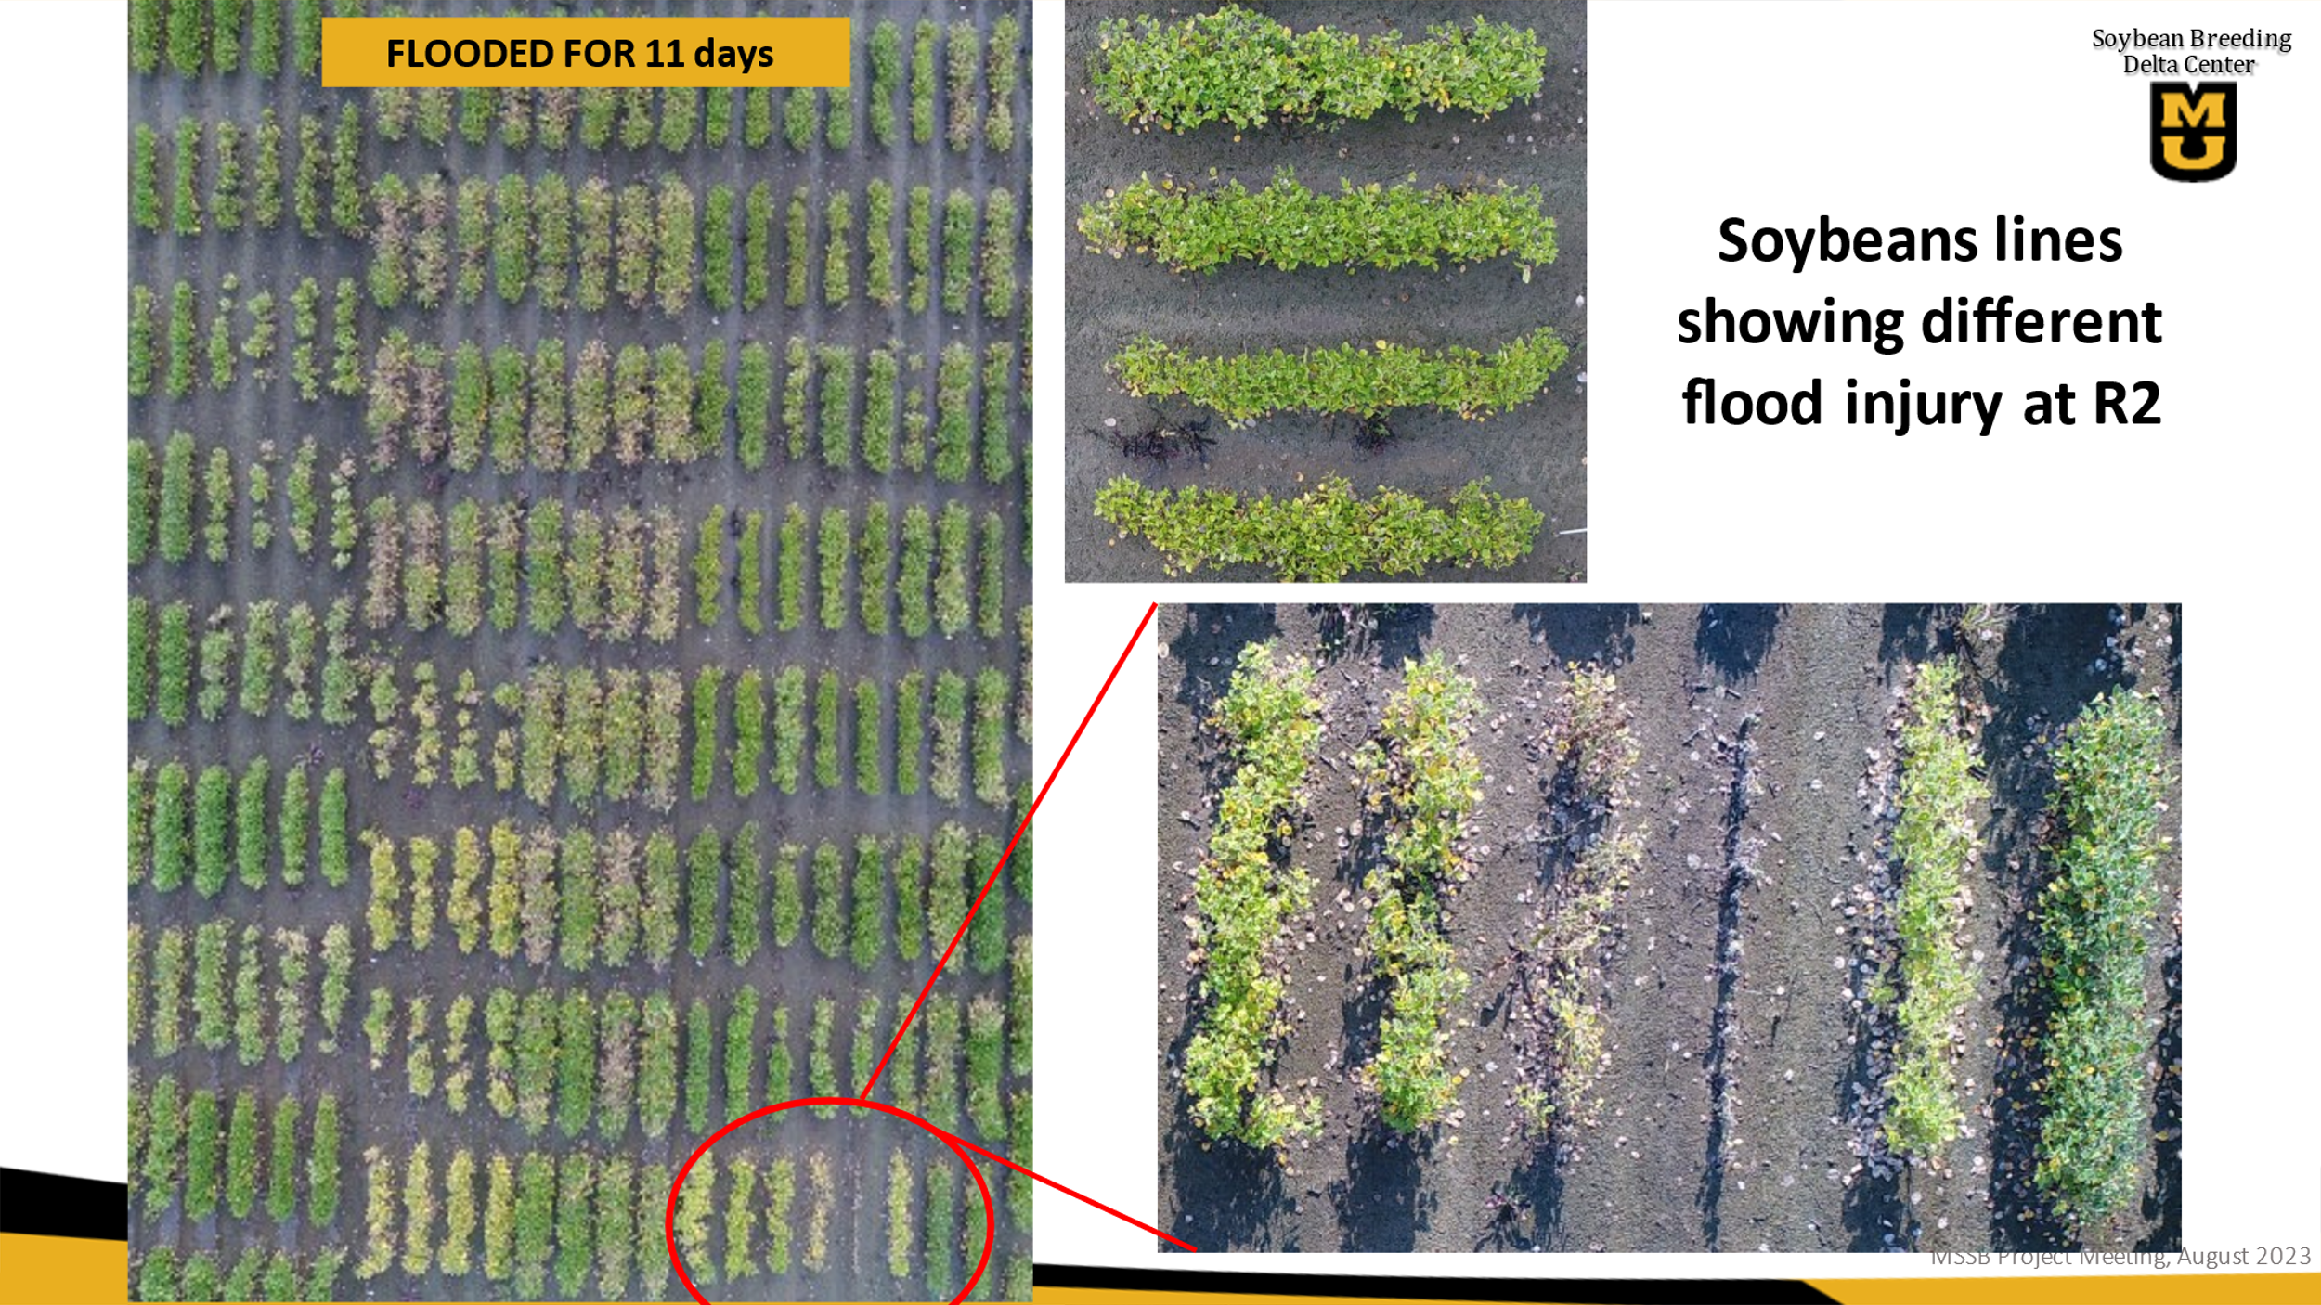

Arkansas (Vieira):
2023 Flood-tolerant germplasm release:

The conventional germplasm R16-45 with high-yielding and flood-tolerance traits was released in 2023. The manuscript for R16-45 registration was accepted in July and is being processed for publication in the Journal of Plant Registrations. The purified seeds of R16-45 with buff hilum color are being increased in Fayetteville, AR, and will be submitted to the ARS Seed Storage in October.

2023 Flood tolerance evaluation for AR and MO elite lines at R1/R2 stages:

A total of 90 elite lines developed by the breeding programs in AR and MO were evaluated for flood tolerance at R1/R2 growth stages in Stuttgart, AR with three replications. Sixteen lines showed high tolerance under 7-day flooding stress (Table 1).

Table 1. Flood-tolerant lines entered in the 2023 MSSB flood test
Line | FDS | Line | FDS
S19-12459 | 3.3 | R19-45980 | 4.0
R18CR-287 | 3.3 | R18-11770 | 4.0
S19-2082 | 3.3 | S19-17667 | 4.0
S17-17644 | 3.3 | R18-10919 | 4.0
R19C-1081 | 3.3 | R18CR-83 | 4.0
S19-1176 | 3.3 | R19-4593 | 4.0
R19C-1035 | 3.7 | S20-1492 | 4.0
S20-15411 | 3.7 | S19-19741 | 4.0

2023 Flood tolerance evaluation for AR and MO lines at V2/V3 stages:

Forty-three advanced lines from AR and MO were evaluated for flood tolerance at early V2/V3 growth stages in Stuttgart, AR with three replications. Twelve lines showed good tolerances under 11-day flooding stress (Table 2).

Table 2. Flood-tolerant lines entered in the 2023 GXEV2 flood test
Line | FDS | Line | FDS
UA5014C | 1.3 | R19-42848 | 3.0
R16-259 | 2.7 | R19C-1081 | 3.3
R07-6669 | 2.7 | S18-6005 | 3.7
S16-7922 | 3.0 | S12-1362 | 3.7
S14-4034 | 3.0 | R06-4433 | 3.7
R19-43217 | 3.0 | R19C-1001 | 3.7

2023 Arkansas advanced yield and flood trials:

A total of 19 advanced lines (7 MG4 and 12 MG5) with flood-tolerant pedigrees were evaluated for flood tolerance under 7-day flooding conditions at R1/R2 growth stages in Stuttgart, AR. Five lines showed good flood tolerance (Table 3). Additionally, these 19 advanced lines are being evaluated for yield and other agronomic traits in replicated trials in four Arkansas (Marianna, Pine Tree, Rohwer, and Stuttgart) and one Missouri (Fisk) locations. The purified breeder seeds of these lines are being increased in Fayetteville, AR.

Table 3. Flood-tolerant breeding lines entered in the 2023 Flood Finals Trial
Line | Pedigree | MG | FDS
R21KB-05522 | R16-141/R13-13997 | 5E | 3.3
R20-353 | RA-452/R05-3239 | 5E | 3.7
R20-393 | RA-452/R05-3239 | 5E | 3.7
R21KB-01732 | R07-6669/PI614732 | 5E | 4.0
R20-440:002i | S13-15764/R05-3239 | 4L | 4.0

2023 Progeny Rows:

A total of 136 new lines derived from flood-tolerant pedigree (R16-45/R15-2422) are being evaluated as single progeny rows in Kibler, AR. Lines will be selected based on pod load and overall agronomic traits and will be entered in 2024 preliminary yield trials for yield and flood tolerance evaluations.

2023 Population advancement and development:

A total of 37 breeding populations (F1 to F4 generation) with flood-tolerant pedigrees are being advanced in the U.S. and off-season nurseries. Eight new crosses between flood-tolerant and elite/value-added parental lines were made at Fayetteville, AR in the 2023 summer season. F1 seeds will be sent to an off-season nursery for generation advancement and will return as F4:5 progeny rows in 2025.

2023 Commercial varieties evaluation for yield and flood tolerance:

A total of 86 commercial varieties (60 MG4 and 26 MG5) are being evaluated for yield and flood tolerance under 5-day flooded and non-flooded conditions (side-by-side tests) at early V2/V3 growth stages in Stuttgart, AR. Nineteen varieties exhibited good flood tolerances with lower FDS < 4.0 under 5-day flooded stress. The yields of these commercial varieties under both flooded and non-flooded conditions will be obtained in harvesting season and reported in the next quarterly report.

Missouri (Shannon etal.)
Yield tests
A total of 24 and 28 elite advance breeding lines in maturity group IV and V, respectively were evaluated under both 10 day flooded and non-flooded conditions at both the V2-V4 and R2-R3 growth stages. Also, 28 maturity group IV preliminary breeding lines selected from flood tolerant crosses were evaluated under both flooded and non flooded conditions at both early and reproductive. Yield of lines under flooded and non flooded conditions in these advanced and preliminary tests will be compared. Those lines with least yield loss under flooding at both the V2-V4 and R2-R3 gorwth stages compared to commercial checks will be listed in the next report. .

2023 Flood tolerance evaluation for AR and MO elite lines at R1/R2 stages:
A total of 80 elite lines developed by the breeding programs in AR and MO were evaluated for flood tolerance at R1/R2 growth stage at Portageville, MO with three replications. Lines were scored for tolerance and data from these scores will be processed and reported in the following report. In addition, 100 elite lines from AR and MO in 2023 regional Uniform tests; other lines stable for tolerance across years and widely grow commercial checks were evaluated under flooding at R1/R2 stages. Newer elite lines will be compared to existing flood tolerant lines. The goal is to find newer tolerant elite lines with better agronomic traits versus checks and lines with known tolerance .

Fllod Tolerant Progeny rows
Two ihundred F4:5 plant roows from two crosses directed to improved flooding tolerance are being grown at Portageville, MO. Best lines based on visual appearance, yield and other agronomic traits will be selected for 2024 yield tests. These crosses are as follows:
S12-1362 x S18-3460
S18-3555 x S12-1362

2023 crosses for Flood tolerance
Four crosses aimed at improving flooding tolerance are as follows:
S17-1146 x A19-17313
S17-1146 x S19-17693
S17-1494 x S19-17313
S17-1494 x S19-17693

Evaluation of commercial varieties in the U of MO variety test
Fifty-five commercial varieties were scored for flood tolerance at the R2-R3 growth stage. Data is being analyzed and varieties with the least flood damage will be identified.

Mississippi State University- Wilkerson
One complete set of the Mississippi State University official variety trial was planted on June 1, 2023. Plots were planted 2 rows wide and 12 ft in length to allow for harvest. Plots were flooded on August 28, 2023 at R3/R4 growth stage for 96 hours (Figure 1). Flood incidence and severity will be evaluated 7 days post flood removal according to previous year scale (1-5). Plots will be allowed to mature and harvested for yield.
Hill plots consisting of seed sent from both Arkansas and Missouri were also established (hand planted) on June 1, 2023 with 3 replications. Plots were flooded on August 28, 2023 at R3/R4 growth stage for 96 hours (Figure 2). Flood incidence and severity will be evaluated 7 days post flood removal according to previous year rating scale (1-5).

Louisiana State University- Moseley
Flloding tolerance scores were ttaken on the official 2023 LSU variety tests based on a scale of on a 1 is good and 5 is very poor. In addition, about 90 lines from Missouri and Arkansas with known or potential tolerance to excess water were evaluated for flood tolerance. Data is being tabulated with results to be provided in the next report. Flloding scores from 2022 variety tests as well as 2022 entries from Arkansas and Missouri soybean breeding programs were analyzed in a genotype by environment study across AR, MO, and LA locations. Lines with the best tolerance scores across sites and growth stages the two are listed in the tables below:

Lines from AR and MO with best tolerance across locations from AR, LA and MO at R1-R2 and V2-V4
List of breeding lines with the best mean flood damage scores based on a scale of 1.0 is best and 5.0 is worst at R1-R2 across LA, AR and MO locations from 2022 trials.
Mean scores showing lines with best overall flooding tolerance across three locations at R1-R2 is shown in the table below:

LINE | FL SCORE-AR | FL SCORE-LA | FL Score-MO | MEAN Score 3 states
R18-16839 | 2.3 | 2.4 | 1.7 | 2.2
R18-13387 | 2.2 | 2.4 | 2.0 | 2.2
R18-67F | 2.0 | 2.6 | 1.7 | 2.1
S17-1494C | 2.3 | 2.3 | 1.2 | 1.8
S19-17313 | 1.7 | 2.3 | 1.2 | 1.7
S20-24521 | 2.2 | 2.5 | 1.3 | 2.0
S20-24524 | 1.2 | 3.2 | 1.3 | 1.9

Identification of AR and MO breeding lines based on 2022 data with flood tolerance across locations (MO, AR ) from a genotype x environment analyses at the V2-V4 and R1-R2 growth stages.
List of flood tolerant lines flooded at both V2-V4 and R1 R2 growth stages averaged from AR and MO flood tests.
Breeding lines averaged for tolerance at V1-V2 and R1-R2 growth stages and the average across both grow stages are as follows: Several lines showed cross tolerance to flooding at both growth stages. This indicates that lines can show flood tolerance at both early vegetative and the early reproductive growth stages.

Line | Mean flood score from MO & AR at V2-V4 | Mean flood score from MO & AR at R1-R2 | Mean flood score from MO & AR across V2-V4 and R1-R2
S16-7922 | 1.1 | 2.1 | 1.6
S17-2066 | 1.8 | 2.4 | 2.1
S18-13892 | 1.9 | 1.9 | 1.9
S12-1362 | 2.3 | 1.7 | 2.0
S19-6013 | 1.6 | 2.2 | 1.9
S14-4034 | 1.9 | 2.1 | 2.0
S18-6005 | 1.7 | 2.4 | 2.1
S16-14869 | 1.3 | 2.1 | 1.7
R14-1422 | 1.4 | 1.8 | 1.6
R18-13309 | 1.3 | 2.1 | 1.7
R07-6669 | 1.9 | 2.2 | 2.1
R04-342 | 1.5 | 1.9 | 1.7
R16-45 | 2.1 | 2.3 | 2.2
S17-1931 | 1.8 | 2.4 | 2.1
S17-13496 | 1.8 | 2.3 | 2.1

